Year 10 – Week beginning 6th July
Please look at the PSHE resources – https://www.waltonledale.lancs.sch.uk/curriculum/what-are-students-learning-now/pshe
Please look at the Weekly Reflection – https://www.waltonledale.lancs.sch.uk/curriculum/thought-for-the-week
If you need to catch up on previous weeks then you will find them at this link - https://www.waltonledale.lancs.sch.uk/curriculum/what-are-students-learning-now/other-curriculum-maps
English | This week you are going to be revising ‘Great Expectations’. Most of you will have read this in Year 9. I want you to complete Tasks 1 and 2 this week. Your teacher will upload a PowerPoint of tasks for you to work through in the Assignments area of Teams. This work should last you 2 weeks. Task 1 asks you to revise the story. Your teacher will upload a shortened verion of the story and a plot summary for you to read. There is also a copy of the PowerPoint and a link to watch the old fashioned version of the film online, which can be accessed using the link below:  https://ia800307.us.archive.org/17/items/GreatExpectations1946/GreatExpectations1946_512kb.mp4  When you have done this, I want you to summarise what happens in the story using 100 words.  Task 2 asks you to look at some online lessons to help you revise the novel on BBC Bitesize. You can access these by clicking on the link below:  https://www.bbc.co.uk/bitesize/topics/zc7bwxs  I have pasted the slides that you will need below:  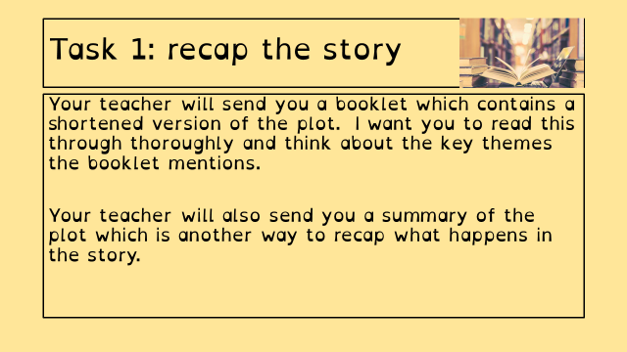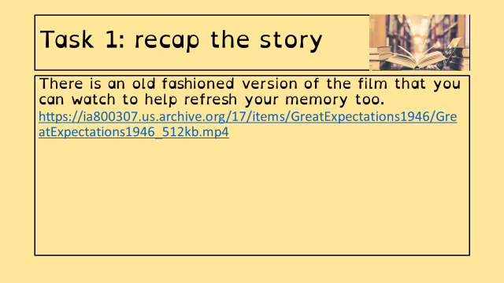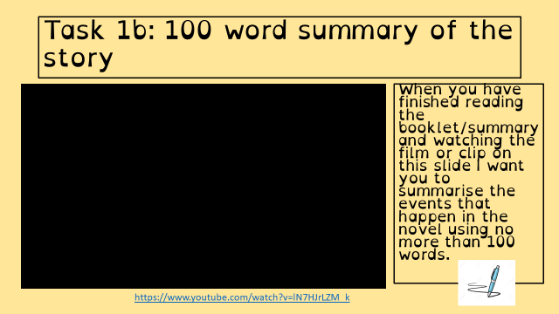  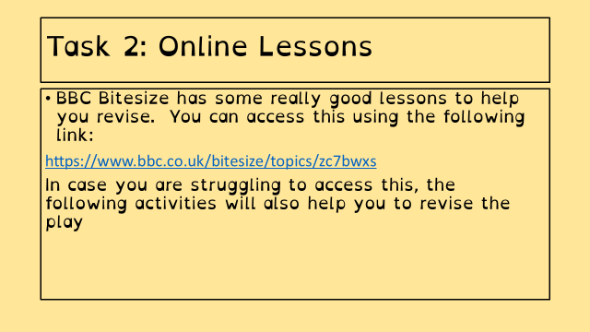  If you feel you need some extra work to complete, you can access daily lessons from the Oak National Academy and BBC Bitesize using the links below:  https://classroom.thenational.academy/subjects-by-year/year-10/subjects/english  https://www.bbc.co.uk/bitesize/tags/zr7447h/year-10-and-s4-lessons  You can also download some free audiobooks and escape the world for a while using the link below:  https://stories.audible.com/start-listen  Take care and I hope that you are all safe and well. ☺
Maths | 10W1 | 10W2 |  | 10W3 | 10W4 | 10W5 | 10D1 | 10D2
Year 10 students will be given a set of tasks based on Hegarty maths and its use in recovering the curriculum.
You have been asked to complete two exam papers a non-calculator and a calculator paper.
We will email out a copy of the two documents needed to direct you to the correct place in Hegarty maths so that you can complete (hopefully!) all questions on the exam papers.
Science | 10W1 | 10W2 |  | 10W3 | 10W4 | 10W5 | 10D1 | 10D2
 | Biology – continue to revise B2 Organisation by revisiting the heart, blood vessels and how to control heart rate. I will email all resources and tasks on Monday.  Physics – students will be completing the revision of the final topic P4 and completing a task on Seneca. There is also an interleaving task on topic P3.  Chemistry –this week students have been asked to ensure any outstanding SENECA tasks have been completed | Biology – revise B2 Organisation by revisiting the digestive system and enzymes. I will email all resources and tasks on Monday.  Physics – students will be completing the revision of the final topic P4 and completing a task on Seneca. There is also an interleaving task on topic P3  Chemistry –this week students have been asked to ensure any outstanding SENECA tasks have been completed |  | Biology – continue to revise B1 Cells and Microscopy by revisiting microscopy and calculations. I will email all resources and tasks on Monday.  Physics – students will be completing the revision of the final topic P4 and completing a task on Seneca. There is also an interleaving task on topic P3  Chemistry –this week students have been asked to ensure any outstanding SENECA tasks have been completed | Continuing with the past papers introduced in school last week. See the email from Miss Hand if you weren’t in school.  Email Mr Martin or Miss Hand if you need any further help. | Continuing with the past papers introduced in school last week. See the email from Miss Hand if you weren’t in school.  Email Mr Martin or Miss Hand if you need any further help. | Complete the P1 and P2 Revision assignment on Seneca. . | DMA- I will be setting some work via a web-based app called Seneca, to help in the revision of the topics covered this year.  Work to be emailed by Monday
Computer Science | Thankyou to those who have contacted me and been able to install a working copy of PyScripter from here: https://sourceforge.net/projects/pyscripter/files/latest/download  Work for this week is to complete the latest assignment set on Microsoft Teams, priority will be to complete last weeks assignment first if you havent already done so, as this coming weeks assignment continues on from that and will be posted Monday morning at 10.30am  I will see most of you next week in school to iron out any problems. Look forward to seeing you all again!
Enterprise | Year 10 Enterprise WK Comm 6th July  As for previous weeks, all work will be set on MS Teams. Instructions will be provided via email on the Monday before each week. Our next short term focus will be on Pass 4 and Pass 5 how a business is affected by the economy · Materials to completed these passes are available via the Team ‘Files’ tab.  Please check the examples and Component 1 Assignment brief regularly to check how you should approach the tasks. Once completed have a look at Merit 1 and then log on to Nearpod and begin the revision for your next task. Click the link to access it https://share.nearpod.com/vsph/Gc2qzWSoMu  which is about trade between nations and how the effect on supply and demand, and how that affects the enterprises you are planning for your coursework. Please post any questions to the General Team channel with regards to the work or message Mr Turner directly.
French | - This half-term we are working from Theme 3, Module 6.  - You will be working from the Module 6 Powerpoint, Studio for AQA and a word document.  - You can turn in or email your work.  - Go to Teams to find complete instructions for this week’s assignment, dated Monday 6th July.
Geography | - Complete the tasks assigned on Doddle.  - Tasks are on urban change and sustainability.  - Read through the information and complete mini quizzes.
Food & Nutrition | Food Labelling and Marketing influences  This is week two of your two-week mini project.  What is the information required by law that must be included on food packaging? What is the FSA? What are some examples of non-mandatory information that is often put on food packaging? Give three examples of these.  Think about shopping for food and how supermarkets influence the food we buy and give some examples e.g. special offers, buy one get one free. Even the place on the shelves where food is stacked can influence our food choice. Find a food label at home stick it on paper and write about the fat content per serving/100gm, the saturates per serving/100gm, sugar per serving/100gm, fibre per serving/100gm. Then conclude is this a healthy product and give reasons.  Email your work to my school email address
History | AQA 9-1 History: Conflict and Tension The membership and structure of the League of Nations  - Use the PowerPoint to help you to complete tasks 6-10 in the League of Nations booklet. There is a challenge task for anyone that wants to push themselves. On the PowerPoint there are links to video clips and there are audio buttons. If you click on the audio buttons you will get a bit more details/support.  - Log in to SENECA and join using the class code: cvtu5kulqs  Take care and keep safe.
RE | You will be emailed a PowerPoint to help you to revise Islamic practises. This will also include a checklist that you should go through. You should make sure that you research and revise the topics from the checklist.
Art | Detailed work will be set by email on Office 365 and if possible, students should respond to the teacher’s email to let them know they have completed the work.  MAIN TASK: Continue your work on the ‘Life in Lockdown’ mini project, including:  - grid portraits from your own photos  - artist analysis page  - working in the style of your chosen artist to complete further portraits  - annotation of your work  - presenting your work neatly in your sketchbook  This project will not continue into Year 11 and therefore must be completed/concluded before September.  If you need any help or advice, please email me.  Mr Sharples
Technology | Investigating the Work of Others  - By now you should have a good idea of what design ‘problem’ you are going are going to investigate. You have done mind maps, a visual mind map and attempted page 1. These should be uploaded to teams.  - You need to have checked with Mr Hull that the idea your thinking of is suitable before continuing.  - This week we are going to complete the page ‘Investigating the Work of Others’ Look at the powerpoint in teams titled Investigating the work of Others (and emailed out to you) to you explain what needs to be done.  Good luck, keep in touch and upload your work to teams regularly please.
Graphics | Identifying a Need  This week you will be looking at how we gather information in order to identify the ‘need’ that you need to address in your coursework:  1) Fill out the Survey sent out by Mr Cassidy if you haven’t already.  2) Create your own survey using ‘Survey Monkey’ when you have done it, copy the link and send it to Mr Cassidy for feedback. When we are both happy with the questions you will be sending out your surveys to people to fill them out, so that we can gather some real data!  3) Devise 10 questions for an interview with your ‘Client.’  Please also continue to revise Unit 2. We will be having an assessment next week!  Good luck, keep in touch and upload your work to teams regularly please.
Health & Social Care | Component 2 Learning Aim B  So far we have  - Planned an arts and crafts activity and explained how the care values would be met for each individual  - Planned an activity to help and elderly person and explained how the care values would be met for the individual  Continuing with last week’s work you need to plan a party with a group of young adults with learning disabilities (Scenario 3 in your pack).  I have emailed further instructions on how to complete this task
Psychology | Revision  - Debates & Criticisms – we will revise the three key debates and how to evaluate theories and studies.  - For those attending the in-school lesson on Thursday, we will be looking at research methods. Remember to bring a pen, pencil and ruler!  - For anyone not attending on Thursday, I will add copies of the worksheets to Teams.
Performance | Unit 1: Unlocking Creativity  Choose from one of the following stimuli (theme):  Growing Pains  Or  Barriers  I want to know how you would create a whole production for one of these themes. You must tell me in a creative way:  - Where the production will be held  - What costumes will be worn.  - Hair and make-up ideas.  - Set design ideas.  - The general overview of what the production will be like eg Music, Dance, Acting, Musical Theatre. These can also be combined.  - How much will it cost to put on your show.  Practical Element  You must include a practical example or extract of something that will be in the production but you will have to do this alone. This could be a dance, a monologue or an explanation of a set design that you have made. You must film yourself and you must email it to me.  DEADLINE: Thursday 16th July
GCSE PE | Continue revision on Seneca and activities on Doddle  Create a knowledge organiser on Sports Psychology using the following topic areas:  Characteristics of skilfull movement  Classification of skills  Goal Setting  Mental Preparation  Types of guidance and Types of feedback  Any problems let me know
Sport | RO51 Revision. I have uploaded the PowerPoint which has the main details of each lesson we have covered on the exam content to teams and I have emailed it to each of you. Please read slides 29-39 make notes and send me a picture of the notes you have written-these can be in any format you wish (hand written on paper, mind maps, typed, in your books - whatever you prefer). You have completed the tasks already in class. If there any that you still think you need to work on please repeat the task and send me evidence. Mrs Eastham  Mr Moore set you assignment work to be working on a number of weeks ago. If you are not up to date with this, please complete it and upload it. You can find previous week’s work on the website and emailed to you. Any problems please send either of us an email.
ICT |  |  | Lesson code: ZJAYC
This week, we are continuing our new topic for your component 3 exam about cyber security.
You should go to https://nearpod.com/student/ on your computer or download the ‘Nearpod’ app on your smart device. When prompted, enter the code ‘ZJAYC’ to complete the interactive lesson ‘B5 – Policy, Backups and Data Recovery’. Enter your full name (and class) so your teacher knows you have completed it.
Read the slides and watch the videos carefully. You must complete all the activities, including the quizzes and exam questions. I am monitoring your participation in these activities and will continue to award ClassCharts points.
If students or parents have any questions, they should contact Mr Moorcroft via email (j.moorcroft-jones@waltonledale.lancs.sch.uk) or I am available throughout the school day on Teams.
Core  PE | EXPLORE – In rounders, the bowler is important in any team. Find a ball or an alternative. You will also need a hoop or piece of paper. Stand 10 yards away from a wall. How many times can you hit the same spot on the wall from the same distance? How many ways can you bowl the ball? Underarm? Overarm? Different arms? Different trajectories? In rounders, the ball must always be bowled underarm. Research the best technique and try this exercise out again using an effective under arm technique.  PRACTICE – You will need a family member. Bowl with the correct technique to your partner. Will they catch it between their head and knee? If so, that ball will count in a game. If not, it is a no ball. How many balls can you bowl correctly in 30 seconds? For a more difficult challenge, can you stand further away?  DEVELOP – Effective bowlers use different techniques to make it difficult for batters. You will now try a SPIN CHALLENGE. But a hoop or a piece of paper where the batter would stand. Spinning your wrist clockwise when you release the ball, can you still hit your target? Discuss with your family member why it may be difficult for the batter to hit this ball.

