Year 10 – Week beginning 22nd June
Please look at the PSHE resources – https://www.waltonledale.lancs.sch.uk/curriculum/what-are-students-learning-now/pshe
Please look at the Weekly Reflection – https://www.waltonledale.lancs.sch.uk/curriculum/thought-for-the-week
If you need to catch up on previous weeks then you will find them at this link - https://www.waltonledale.lancs.sch.uk/curriculum/what-are-students-learning-now/other-curriculum-maps
English | The work this week will be centred around revising ‘A Taste of Honey’. You will hopefully remember reading it in Year 9 and know that it is one of the plays you are asked to study at GCSE. This week I want you to focus on revising the story and everything that happens in the play. Your teachers will email you a PowerPoint of activities to work through, a copy of the book to re-read, a plot summary and a copy of your knowledge organiser for ‘A taste of honey’. These will also be uploaded to Teams. This week I would expect you to complete tasks 1-3. Task 1 requires you to read the plot summary and re-read the play. Task 2 asks you revise the plot and characters of the play using the BBC Bitesize lessons that you can access by clicking here. Task 3 asks you to watch a short clip of the playwright, Shelagh Delaney’s daughter talking about the reasons why her mother wrote the play. When you have watched the clip I want you to list 5 things that you learn. You can watch the clip by clicking here.  To make it clearer, there are some images of the tasks I want you to complete below:  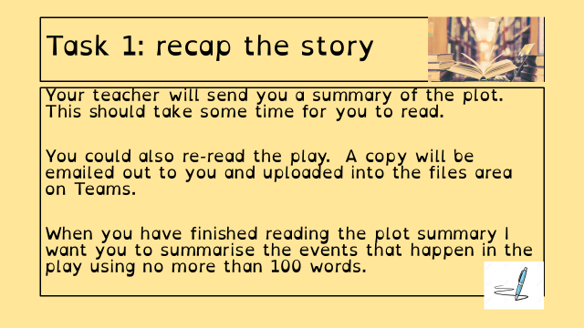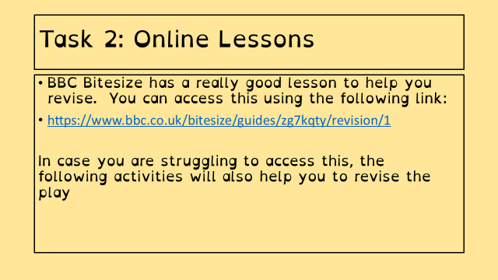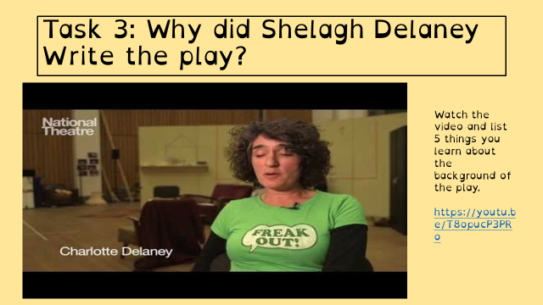  If you need some extra work to complete you can access daily lessons from BBC Bitesize and Oak National Academy using the links below:  https://classroom.thenational.academy/subjects-by-year/year-10/subjects/english  https://www.bbc.co.uk/bitesize/tags/zr7447h/year-10-and-s4-lessons  Why not escape the world for a bit and read a book? There are free books and audiobooks available using the following links and you could even use the library’s Borrowbox service to borrow e-books. Use the links below to help you access these:  https://www.amazon.co.uk/b?ie=UTF8&node=21173577031  https://stories.audible.com/start-listen  https://www.borrowbox.com/  Please remember to submit and send in any work that you complete so that we can check you understand the work and are making good progress.  Stay safe and take care. ☺
Maths | 10W1 | 10W2 |  | 10W3 | 10W4 | 10W5 | 10D1 | 10D2
 | 1) Use the answers to the last week’s activities (emailed out on Monday) to check and correct work. Seek help if there is anything you are unsure of  2) 5-a-day starters:  https://corbettmaths.com/wp-content/uploads/2015/09/june-22.pdf  https://corbettmaths.com/wp-content/uploads/2015/09/june-23.pdf  https://corbettmaths.com/wp-content/uploads/2015/09/june-24.pdf  https://corbettmaths.com/wp-content/uploads/2015/09/june-25-pdf3.pdf  3) Watch the YouTube video (link sent by email) on circumference and area of circles (with and without a calculator)  4) Oak Academy lessons:  https://classroom.thenational.academy/lessons/circumference-of-a-circle-1/  https://classroom.thenational.academy/lessons/area-of-a-circle-1/  https://classroom.thenational.academy/lessons/circumference-of-a-circle-2/  https://classroom.thenational.academy/lessons/area-of-a-circle-2/  The first two are finding values using a calculator, the second two are non-calculator methods where you leave your answers in terms of π  5) MathsWatch exercise on circumference and area of circles (will appear on Monday)  Additional help can be found by watching MathsWatch clip #117 and #118, in the ActiveLearn textbook – pages 213-216, and in the ActiveLearn revision guide – page 83 |  |  | Week beginning 22nd June 2020 Sequences work  - Starter is dated June 22nd 2020  - Support for this topic can be found on Oak Academy by following the following instructions:  Oak academy online  Oak national academy  Classroom  Find lessons  Year 10  Subjects  Maths  Algebra (lesson 8)  Start lesson  Start quiz  Click on next to access the video lesson  Move on to lesson 9 and watch this one too.  - You can also watch Maths watch video clip 37 and 102 if you prefer.  - Complete the worksheets from clips 37 and 102  - Complete worksheet on nth terms.
Science | 10W1 | 10W2 |  | 10W3 | 10W4 | 10W5 | 10D1 | 10D2
 | Physics -This week we are starting our revision and review work of the topic P4 Atoms and radiation. Students will use resources email to revise and complete 2 Seneca tasks, one of which looks back on previous learning.  Chemistry - This week students will continue with a series of tasks set on Seneca by Mrs McClelland designed to help revision and assess level of understanding of the Chemistry curriculum. This weeks tasks relate to the topic C4 chemical changes.  Biology – continue to revise B1. This week we are looking at exchanging substances and how surface area can affect the rate of exchange and active transport. Please see my email on Monday for resources and tasks. | Physics -This week we are starting our revision and review work of the topic P4 Atoms and radiation. Students will use resources email to revise and complete 2 Seneca tasks, one of which looks back on previous learning.  Chemistry - This week students will continue with a series of tasks set on Seneca by Mrs McClelland designed to help revision and assess level of understanding of the Chemistry curriculum. This weeks tasks relate to the topic C4 Chemical changes.  Biology – continue to revise B1. This week we are looking at Diffusion and the rate of exchange depending on the surface area. Please see my email on Monday for resources and tasks. |  | Physics -This week we are starting our revision and review work of the topic P4 Atoms and radiation. Students will use resources email to revise and complete 2 Seneca tasks, one of which looks back on previous learning.  Chemistry - This week students will continue with a series of tasks set on Seneca by Mrs McClelland designed to help revision and assess level of understanding of the Chemistry curriculum. This weeks tasks relate to the topic C4 Chemical changes.  Biology – start revision of B1 by looking at cell specialisation. Please see my email on Monday for resources and tasks. | Physics – This week we are going to finish off the revision of the electricity topic and have a mini test. The work will be emailed out by Monday.  Biology: This week, I will be setting you an educake task based on areas we need to improve on from the “mini mock”. Details emailed on Monday. | Biology: This week, I will be setting you an educake task based on areas we need to improve on from the “mini mock”. Details emailed on Monday. | Biology paper 1 Revision  Seneca assignment covering different aspects of the first four Biology topics.  Chemistry Topic 1 Revision  Details on Teams. | Physics – This week we are going to finish off the revision of the electricity topic and have a mini test. The work will be emailed out by Monday.  Also, we will start chemistry revision.
Computer Science | As always, please check Teams on Monday morning for your latest assignment. If you have not completed last week’s work can you please complete and upload to Teams for marking. Last weeks work was to catch up on assignments that you have not yet completed. As mentioned, there are several of you with work outstanding and I’d like this to be caught up. Well done to all of those who used last week to catch up on the gaps from previous weeks.  If you’re still struggling to access work on Teams then continue to progress on SoloLearn. Please provide evidence of your progress on a weekly basis to me via teams or email by taking screenshots.  A reminder to those students who are capable of downloading and installing a working copy of PyScripter, to do so. I will add weekly programming challenges on Monday mornings along with the usual weekly assignment.  Regards. Mr Christie
Enterprise | Year 10 Enterprise WK Comm 24th June  As for previous weeks, all work will be set on MS Teams. Instructions will be provided via email on the Monday before each week. Our next short term focus will be on Pass 4 and Pass 5 how a business is affected by the economy · Materials to completed these passes are available via the Team ‘Files’ tab.  Please check the examples and Component 1 Assignment brief regularly to check how you should approach the tasks. Once completed have a look at Merit 1 and then log on to Nearpod and begin the revision for your next task. Click the link to access it https://share.nearpod.com/vsph/KIRxTJW4Mu which is about supply and demand how it affects enterprises. Please post any questions to the General Team channel with regards to the work or message Mr Turner directly.
French | - This half-term we are working on Theme 3, Module 6.  - You will be working from the Module 6 Powerpoint and the online version of the “Studio for AQA” text book.  - You can turn in or email your work.  - Go to Teams to find complete instructions for this week’s assignment, dated Monday 22nd June.
Geography | Use the link below to work through flood plains and River Tees work sheets, use the PowerPoints, Video Explainer and Webpage in the table on the page  http://www.coolgeography.co.uk/GCSE/AQA/Physical_Landscapes_Home_Study.php.  Complete page 15 of booklet.  If you need any help email your teacher. We are more than happy to help you.
Food & Nutrition | Pasta  How is pasta made? Produce a flow chart showing each step of making pasta. What type of flour is used to make pasta? What are the functions of each ingredient used in pasta making? Add hygiene and safety to  Your flow chart showing what hygiene and safety measures you would put in place at each step of making. Also add temperatures for cooking and reheating pasta. Is pasta a high-risk food? What ingredients are used to colour pasta? You can buy black, red, green and pink pasta. Find out what ingredients are used in pasta to create these colours. These are quite interesting! How many times can you reheat pasta? Send your flow chart to my school email please. What is the nutritional value? Look on the back of a packet of dried pasta. How does it fit into the Eat Well guide? You could add some pictures from the internet showing each stage of making. If you are Coeliac what ingredient would be changed to make pasta?
History | AQA Paper 1 - Conflict and Tension: The Inter-War Years  - Please complete any outstanding parts of your booklet. If you need a new copy of the booklet - please email your history teacher. If you feel overwhelmed or unsure of where to start then get in touch with your teacher or with Miss Main. We are all here to help you. If you ask for help – you are not going to get told off or be made to feel embarrased. We will happily help you.  - Log onto SENECA (a free revision app). Use the class code: cvtu5ku1qs & complete the assignments.  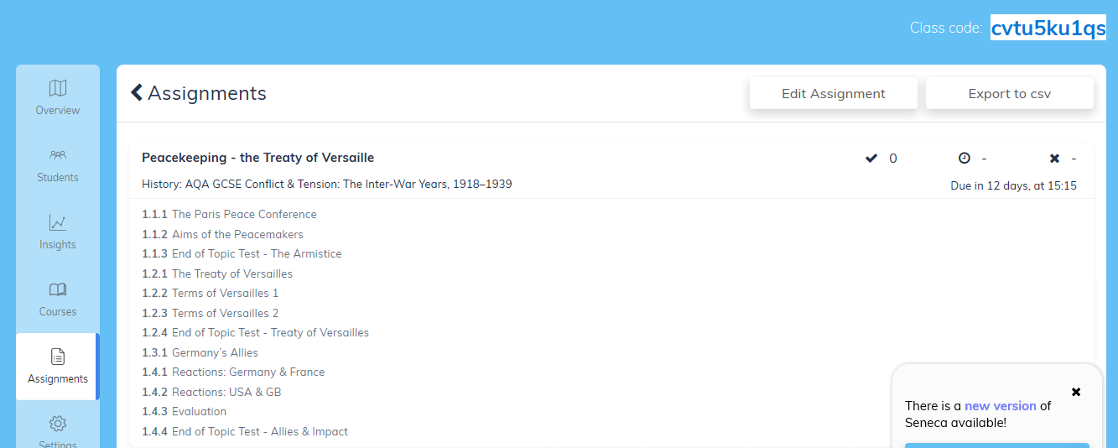
RE | Continue to work through the resources sent to you about Islamic practices. This includes Prayer, festivals and Sunni and Shia differences. The PowerPoint has a voice over with more detailed explanations. To listen to this you should click the sound icon on each slide. You should also complete the two exam questions.  Explain two ways in which Muslims practise salah (4)  “Celebrating Ashura is not helpful.” Evaluate this statement (12)  The PowerPoint contains information, instructions and guidance to help you to plan and structure your answer to each of these questions. There are also sample answers included.  This will all be emailed to you again, so check your school email.  Please email your exam answers to me for feedback. You can email rough drafts and plans first if you would prefer.
Art | Detailed work will be set by email on Office 365 and if possible, students should respond to the teacher’s email to let them know they have completed the work.  ***If you haven’t already, please email Mr Sharples with an update on what work you have done so far and also with the name of the artist and why you have chosen them (see below)***  Main Task: (Continued) To support your “lockdown portraiture” work which you have been doing for the last few weeks, I would like you to do some independent artist research. Please look online (or in books!) for some portraiture artists that you like the style of and that you think could support your lockdown artwork. I will send some examples and some websites for you to look at in the email. You should complete a double page spread artist analysis page on the artist (as you have done a couple of times before for Picasso and Loui Jover/Mark Powell/Natalie Foss) which includes information about the artist, images of their artwork (if you have a printer – if not, don’t worry – just leave some spaces), your opinions about their artwork, why you have chosen them, how they support your work, etc. and the page should be put together in a way that shows a visual understanding of the artist’s work/style.
Technology | GCSE Coursework (priority work over the theory but do both if you can) – By now hopefully you have:  - thought about the three contextual challenges (and have some record of your thoughts I.e. mind maps) and chosen an idea to investigate further (check with Mr Hull if at all unsure);  - Have had a go at page 1 of your project in line with the instructions emailed out for week beginning 15th June;  Now using the internet complete a visual mood board for you chosen idea / topic. This will be the second slide of your powerpoint project. This page should inspire your future designs. Look for examples similar to what your thinking, perhaps look at colours, materials, surface textures, other design eras or other designers’ work. Examples / instructions will be emailed out to you and, as always, put on teams.  Any problems as always please email Mr Hull at b.hull@waltonledale.lancs.sch.uk  Theory – Okay, we have spent the last four weeks advising you to look through Unit 2 – Energy, Materials, Systems and Devices. I suggest this week be used as a recap / catch up time for this unit. Ask yourself, if we were to sit the assessment for this unit, which areas would I not feel confident about? Which areas of unit 2 are you yet to cover? Which areas interested you most? (perhaps smart materials, electronics, mechanical devices….), look those topics up on the internet to gain some greater understanding.
Graphics | Coursework – Up to this point I have asked you to complete the following pages:  1) Written mind map and page entitled Choosing a Context (all three contexts – good range of written ideas)  2) Visual mind map of your chosen context (just your chosen context – good range of images exploring possibilities for that context)  3) ‘Investigating the context’ and ‘Identifying a Need’ – Please see the guide sheet for further information in completing this.  Please continue to work through the above work. In addition to this I’d like you to create an account on Survey Monkey It’s completely free, but you will need to give some data, so check with parents before you do. You can use your school email address. You will be putting a survey together for your ‘Identifying a Need’ page. For now, just get your account set up.  Think about the kinds of questions that you will ask, who your survey will be aimed at and how you will reach that group of people. The idea is that this information will help you to understand the direction of your project.  Your work this week – Make sure you are up-to-date with the above, and…  1) Compete the Peer Assessment task set last week.  2) I have done an example survey for you fill out here. It will tell me how you feel you’re getting on with your coursework so far. Please fill this out as soon as you can.  3) Write out 10 questions that you might ask the Client in order to find information that will help you to proceed with this project eg. What is your budget for graphic products? Who are you aiming this project at?  Theory: You will be completing an assessment in the coming weeks, so please look through all Theory work for Unit2. I will send out a list of topics. Please let me know if you are missing any. Ask yourself, if we were to sit the assessment for this unit, which areas would I not feel confident about? Which areas of unit 2 are you yet to cover? Which areas interested you most? (perhaps smart materials, electronics, mechanical devices….), look those topics up on the internet to gain some greater understanding.  Further information/ Examples / instructions will be emailed out to you and put on teams.  Any problems as always please email Mr Cassidy at m.cassidy@waltonledale.lancs.sch.uk
Health & Social Care | Component 2 Learning Aim B  So far we have planned an arts and crafts activity and explained how the care values would be addressed for each individual. We are now going to move onto the second activity.  Scenario – You work in a care home for the elderly and a resident has asked you to help them put their coat on but they have difficulty moving their arms.  - Ask someone at home to help you and practise putting a jacket.  - In your coursework use the plan to how you will ensure that the care values are being followed if you were doing this activity.
Psychology | Research Methods  - Ensure that you have completed last week’s end of topic assessment. This is a priority!  - Continue revising research methods. Details on Teams.  - You will be set a brief to design a psychological study in a Teams assignment. You must not attempt to carry out the study, merely plan it.
Performance | Creative Research week:  Choose from one of the following practitioners:  - Drama: Willy Russell  - Dance: Matthew Bourne  - Music: David Guetta  Find out as much as you can about this person.  Create a shoebox that includes 10 items that in some way link to the practitioner.  This could link to their life or work.  Record yourself explaining or write down an explanation of how each item links. Take some pictures of the box and submit on the assignments page in teams
GCSE PE | Revision - Continue to use SENECA and Doddle for revision purposes  TASK – Create a Knowledge Organiser or Mind map for Components of Fitness  This can be done in your books, on a piece of paper or designed on the computer.  Please ensure that you email me your work once completed. If you have completed it in your books, please ensure you photograph it and send me the evidence.  Any problems please email me.  I hope you are all well
Sport | RO51 Revision. I have uploaded the PowerPoint which has the main details of each lesson we have covered on the exam content to teams and I will also email it to each of you. Please read slides 1-24, make notes and send me a picture of the notes you have written-these can be in any format you wish (hand written on paper, mind maps, typed, in your books - whatever you prefer). You have completed the tasks already in class. If there any that you still think you need to work on please repeat the task and send me evidence. Mrs Eastham.
ICT |  |  | Lesson code: CFZXT
This week, we are continuing our new topic for your component 3 exam about cyber security.
You should go to https://nearpod.com/student/ on your computer or download the ‘Nearpod’ app on your smart device. When prompted, enter the code ‘CFZXT’ to complete the interactive lesson ‘B3 – User Restrictions and Finding Weaknesses’. Enter your full name (and class) so your teacher knows you have completed it.
Read the slides and watch the videos carefully. You must complete all the activities, including the quizzes and exam questions. I am monitoring your participation in these activities and will continue to award ClassCharts points.
If students or parents have any questions, they should contact Mr Moorcroft via email (j.moorcroft-jones@waltonledale.lancs.sch.uk) or I am available throughout the school day on Teams.
Core  PE | Joe wicks on Youtube – Monday, Wednesday and Saturday from now on, keep up the good work you have been doing. If you have not already done any physical activity, it's never too late. Go for a bike ride or a long walk, anything is better than nothing. All previous PE lesson by Joe Wick are available on his Youtube channel.  It’s National School Sports Week next week – Please look out for an email from Mrs Sweeney which will have an attachment giving you lots of different ways to take part in this week.

