Year 10 – Week beginning 29th June
Please look at the PSHE resources – https://www.waltonledale.lancs.sch.uk/curriculum/what-are-students-learning-now/pshe
Please look at the Weekly Reflection – https://www.waltonledale.lancs.sch.uk/curriculum/thought-for-the-week
If you need to catch up on previous weeks then you will find them at this link - https://www.waltonledale.lancs.sch.uk/curriculum/what-are-students-learning-now/other-curriculum-maps
English | This week I want you to continue to revise ‘A Taste of Honey’. You will have read this in Year 9 and it is one of the texts you will be studying at GCSE. Your teachers have emailed you a copy of the text and a summary of the story so there is plenty for you to do. You have also had a copy of the knowledge organiser and the text which you will need to help you to complete some of the tasks this week. Your teacher has already emailed you a copy and it should also be on Teams. This week I want you to complete Tasks 4, 5 and 6. Task 4 asks you to look at the characters, whilst Task 5 asks you to use the knowledge organiser to create quizzes for key sections. Finally, Task 6 asks you to complete a multiple choice quiz to check your understanding of the play. You can find this by clicking here.  To make things easier, I have put the slides I want you to work through below:  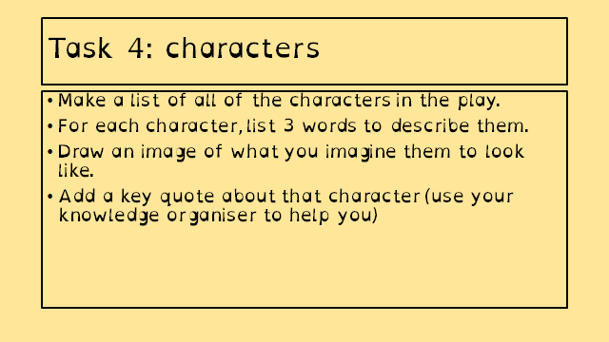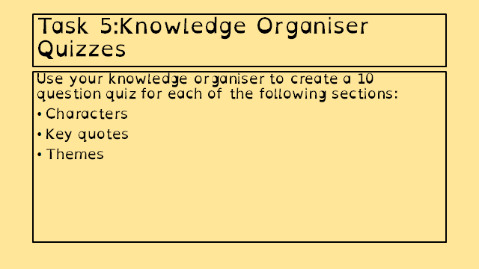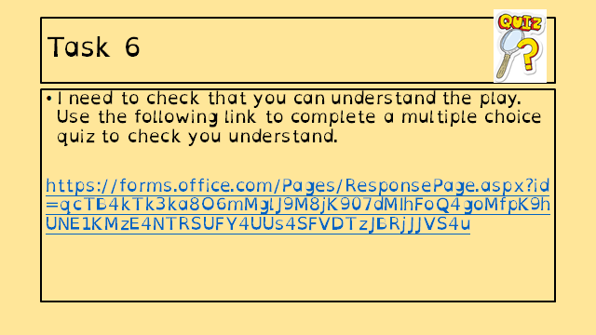  If you need some extra work to complete you can access online lessons from BBC Bitesize and the Oak National Academy. You can access these by clicking the links below:  https://classroom.thenational.academy/subjects-by-year/year-10/subjects/english  https://www.bbc.co.uk/bitesize/tags/zr7447h/year-10-and-s4-lessons  If you fancy escaping the world for a bit, why not read a book? You can access some free books and audiobooks online using the links below:  https://stories.audible.com/start-listen  https://www.amazon.co.uk/b?ie=UTF8&node=21173577031  Take care.
Maths | 10W1 | 10W2 |  | 10W3 | 10W4 | 10W5 | 10D1 | 10D2
 | You will be sent a set of two higher past papers (one calculator and one non-calculator) on Friday. Please try and attempt those before your day in school next week – we will be spending that time going through some of the key questions and it will be a more useful session if you have tried the questions in advance.  You will also get a login to a new website – HegartyMaths – during the day in school next week (or emailed to you if you are absent). Please complete the tasks set to get to know the site – we will be using this over the summer and into year 11 for your ongoing catchup and revision |  |  | You will be sent a set of two foundation past papers (one calculator and one non-calculator) on Friday. Please try and attempt those before your day in school next week – we will be spending that time going through some of the key questions and it will be a more useful session if you have tried the questions in advance.  You will also get a login to a new website – HegartyMaths – during the day in school next week (or emailed to you if you are absent). Please complete the tasks set to get to know the site – we will be using this over the summer and into year 11 for your ongoing catchup and revision
Science | 10W1 | 10W2 |  | 10W3 | 10W4 | 10W5 | 10D1 | 10D2
 | Physics -This week we are continuing our revision and review work of the topic P4 Atoms and radiation. Students will use resources email to revise and complete 2 Seneca tasks, one of which looks back on previous learning.  Chemistry - This week students will continue with a series of tasks set on Seneca by Mrs McClelland designed to help revision and assess level of understanding of the Chemistry curriculum. This weeks tasks relate to the topic C5 Energy changes.  Biology – start revision of B2 Organisation by revisiting The Digestive System and Enzymes. All resources and tasks will be emailed on Monday. | Physics -This week we are continuing our revision and review work of the topic P4 Atoms and radiation. Students will use resources email to revise and complete 2 Seneca tasks, one of which looks back on previous learning.  Chemistry - This week students will continue with a series of tasks set on Seneca by Mrs McClelland designed to help revision and assess level of understanding of the Chemistry curriculum. This weeks tasks relate to the topic C5 Energy changes.  Biology – complete the revision of B1 cells and Microscopy by revisiting active transport. All tasks and resources will be emailed on Monday. |  | Physics -This week we are continuing our revision and review work of the topic P4 Atoms and radiation. Students will use resources email to revise and complete 2 Seneca tasks, one of which looks back on previous learning.  Chemistry - This week students will continue with a series of tasks set on Seneca by Mrs McClelland designed to help revision and assess level of understanding of the Chemistry curriculum. This weeks tasks relate to the topic C5 Energy changes.  Biology – continue to revise B1 Cells and Microscopy by revisiting cell differentiation. All resources and tasks will be emailed on Monday. | Chemistry: This week you will have an educake assignment based on areas for improvement from the “mini-mock”. Details emailed on Monday.  Physics -This week we are continuing our revision and will start to revise topic 3. This topic was named the particle model of matter. Worksheets and links will be sent by Monday. | Chemistry: This week you will have an educake assignment based on areas for improvement from the “mini-mock”. Details emailed on Monday.  Physics -This week we are continuing our revision and will start to revise topic 3. This topic was named the particle model of matter. Worksheets and links will be sent by Monday. | Complete the C2, C3 and C4 Seneca assignment. | Physics -This week we are continuing our revision and will start to revise topic 3. This topic was named the particle model of matter. Worksheets and links will be sent by Monday.
Computer Science | Hello all!  I hope you managed to use last week as a week to get caught up on any activities that you haven’t yet completed. It’s been fantastic to see some of you emailing me work that is really great and well presented. It is also nice to see a few of you working together with a friend which is absolutely fine.  Can I firstly please ask you to message me on Teams to let me know if you can/have been able to download the latest version of PyScripter and test that it runs OK. This will help me for planning a live programming lesson and issuing extension tasks.  Can you also please let me know if Monday or Thursday next week is best for a live lesson. I will be contacting you individually to ask this, but to make things easier could you please let me know via Teams if possible.  Next week’s work will be split into 3 parts; one part will be a programming activity for those with a working copy of PyScripter installed. The second and third parts will be a mixture of paper based and electronic activities so that if you struggle electronically, you can take a picture of your completed work on paper and email it to me or post it on Teams for me to see.  Work will be live Monday, 10.30am.
Enterprise | Year 10 Enterprise WK Comm 29th June  As for previous weeks, all work will be set on MS Teams. Instructions will be provided via email on the Monday before each week. Our next short term focus will be on Pass 4 and Pass 5 how a business is affected by the economy · Materials to completed these passes are available via the Team ‘Files’ tab.  Please check the examples and Component 1 Assignment brief regularly to check how you should approach the tasks. Once completed have a look at Merit 1 and then log on to Nearpod and begin the revision for your next task. Click the link to access it https://share.nearpod.com/vsph/1F4M5HrEMu which is about currency and how the effect on supply and and how that affects the enterprises you are planning for your coursework. Please post any questions to the General Team channel with regards to the work or message Mr Turner directly.
French | - This half-term we are working on Theme 3, Module 6.  - You will be working from the Module 6 Powerpoint and the online version of the text book.  - You can turn in or email your work.  - Go to Teams to find complete instructions for this week’s assignment, dated Monday 29th June.
Geography | This week Geography work is to use Doddle. It is to work through the PowerPoints and mini quiz on urban land use.  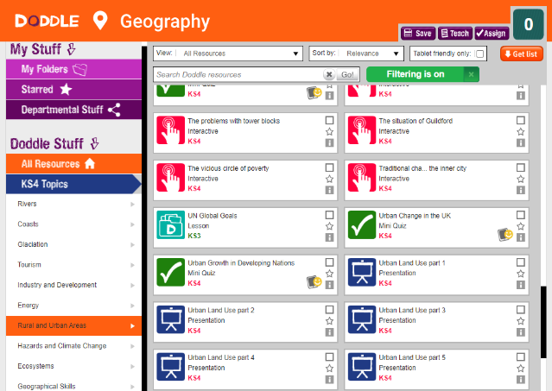
Food & Nutrition | PRIMARY FOOD PROCESSING  Milk is heat treated to destroy bacteria, but other non – harmful bacteria are lost.  Research the following types of milk production. Pasteurisation, UHT, Sterilisation and Microfiltration. You can find out about what happens to the milk when pasteurised, UHT (what does it mean? What is involved in the process? Does the milk taste different? How is milk Sterilised? Why do we sterilise milk? What is Microfiltration? What does it involve?  Look at the temperatures involved in all these processes. How these types of milk are packaged? Vitamins lost during the process. Extra work – look at the nutritional profile of each of these milks and comment on which it the healthiest and why? Any problems email me, and I will help you.
History | AQA History 9-1 Conflict and Tension: The Interwar Years 1918-1939  This week you will be starting part 2 of the Interwar Unit – the League of Nations.  Your teacher will email and put on TEAMS – a copy of a PPT and a booklet with tasks in for you to complete. The PPT has a video clip for you to watch.  If you need any help, support or encouragement - please email your class teacher or Miss Main. Take care and look after yourself.
RE | You will be emailed a PowerPoint about Sunni and Shi’a Muslims. You should read through the information and follow the instructions. This includes some revision, some brain breaks and should help you practice memory techniques.  The work will also be saved to our class ‘Teams’ folder.  Good website links for this week  https://www.bbc.co.uk/bitesize/guides/zdxdqhv/revision/2  https://www.bbc.co.uk/bitesize/guides/z78g4qt/revision/7  https://www.tutor2u.net/religious-studies/blog/sunni-and-shia-divide-explained  https://www.reonline.org.uk/islam-gcse-support-material/sunni-and-shia-succession-and-imams/
Art | Detailed work will be set by email on Office 365 and if possible, students should respond to the teacher’s email to let them know they have completed the work.  I have heard back from quite a few of you in the last week, which is great. Anyone who has not emailed me to update me on their work, please can you do so this week.  For this week please concentrate on catching up with any unfinished work and gathering all your artwork together (if you have done any large scale pieces or worked outside your sketchbook) in anticipation for hopefully coming into school to see me at some point before the summer. You should now be working on either artist analysis or completing portraits in the style of your chosen artist, as I have explained in recent emails (please read them again if you are unsure what to do).  If you need any help or advice, please email me.  Mr Sharples
Technology | GCSE Coursework – Checklist – This week please check that you have completed:  - Mindmap(s) of the three topics – Teenage Lifestyle, Multifunctional living and Nature and the Environment. Compare yours with the examples sent out and add other examples to your work if needed to complete yours in more detail. Keep these safe and (if possible) photograph them and upload into your Powerpoint work.  - Decided what topic and product you are going to investigate further ( for instance a typical response might be ‘I have chosen Teenage Living and have decided to research further into storage for my room because I always have things lying around, getting lost and damaged etc – plus my parents are always on at me to be tidier!) PLEASE to avoid potentially wasting your time check this with Mr Hull before going any further.  - Completed a visual mindmap / moodboard about the theme you are investigating.  - Completed pg 1 of your project (in line with the ppt sent to you (and on teams)  I suggest this week you look back over the above work and either catch up or make improvements. This is GCSE work and as such needs to be top quality. You should have received examples of work (also on teams). Compare yours, use ideas from other work and make improvements to your own. Again, please send me your work regularly (preferably by uploading as an assignment to teams) so I can give you generic feedback and make sure you are doing it correctly. We are here to help you complete this rather than ‘tell you off’ for what you may not have done.  Theory - Test Yourself! I have put unit 2 Assessment onto Teams. I suggest firstly having a go at the test (just write answers down on paper if you cannot edit on the screen) then for the questions you are not sure of, look back through the PowerPoints to try and find the answers. In this way you will learn far more than just leaving what you did not know. I will put answers out there next week. Please email to let me know how you are getting on. (b.hull@waltonledale.lancs.sch.uk)
Graphics | So far you should have:  1) Written mind map exploring all three contexts.  2) Visual mind map of your chosen context.  3) Investigating the Context page, looking at what you could make with the context (see guide sheet on Teams)  4) Identifing a Need page, looking at End User and Client need including your survey findings and Client interview (see guide sheet on Teams)  This week:  Coursework: You need to ensure you are up-to-date with the above. We will be moving on to the next stage of your coursework project next week, so it is important that you have completed the work in order to do so.  Theory: Test Yourself! I have put unit 2 Assessment onto Teams. I suggest firstly having a go at the test (just write answers down on paper if you cannot edit on the screen) then for the questions you are not sure of, look back through the PowerPoints to try and find the answers. In this way you will learn far more than just leaving what you did not know. I will put answers out there next week. Please email m.cassidy@waltonledle.lancs.sch.uk to let me know how you are getting on.
Health & Social Care | Component 2 Learning Aim B  So far we have  - Planned an arts and crafts activity and explained how the care values would be met for each individual  - Planned an activity to help and elderly person and explained how the care values would be met for the individual  This week we are going to plan a party with a group of young adults with learning disabilities (Scenario 3 in your pack).  I will email further instructions on how to complete this activity.
Psychology | Research Methods continued  Continuing revision of research methods with a focus on data analysis and forming conclusions.  Details on Teams.
Performance | This week you need to have a look back through your Unit 3 Revision Booklet.  Have a go at some past paper questions and send your answers to Mrs Mcleod.  Join in the “Live Lessons” every Friday morning at 10am  Ensure that your skills audit and workshop write ups are complete and email evidence to Mrs Mcleod or upload on the assignments page on teams
GCSE PE | As always please use SENECA and Doodle for revision purposes. Also use BBC bitesize they have some great activities on there.  TASK – Please create a knowledge organiser on Preventing injury in physical activity and training, use any information you already have including powerpoints that have been sent out. If you require any help please let me know.
Sport | RO51 Revision. I have uploaded the PowerPoint which has the main details of each lesson we have covered on the exam content to teams and I will also email it to each of you. Please read slides 24-29 make notes and send me a picture of the notes you have written-these can be in any format you wish (hand written on paper, mind maps, typed, in your books - whatever you prefer). You have completed the tasks already in class. If there any that you still think you need to work on please repeat the task and send me evidence. Mrs Eastham
ICT |  |  | Lesson code: WXPSI
This week, we are continuing our new topic for your component 3 exam about cyber security.
You should go to https://nearpod.com/student/ on your computer or download the ‘Nearpod’ app on your smart device. When prompted, enter the code ‘WXPSI’ to complete the interactive lesson ‘B4 – Data Level Protection’. Enter your full name (and class) so your teacher knows you have completed it.
Read the slides and watch the videos carefully. You must complete all the activities, including the quizzes and exam questions. I am monitoring your participation in these activities and will continue to award ClassCharts points.
If students or parents have any questions, they should contact Mr Moorcroft via email (j.moorcroft-jones@waltonledale.lancs.sch.uk) or I am available throughout the school day on Teams.

Core  PE | The Lancashire School Games are approaching....this is when schools across Lancashire take part to represent their district  Obviously we can’t do this, this year instead here’s a link which gives you some activities to take part in. I will also email it to you all on Monday  https://lancashireschoolgames.co.uk/resources-for-teenagers-secondary-schools/  I hope you are all well.

