Year 7 – Week Beginning 4th May
English | Task 1  Weekly Writing Challenge: Aim to write 200 words. Include the word ‘wasteland’-you will need to find out what this word means. Write down a definition.  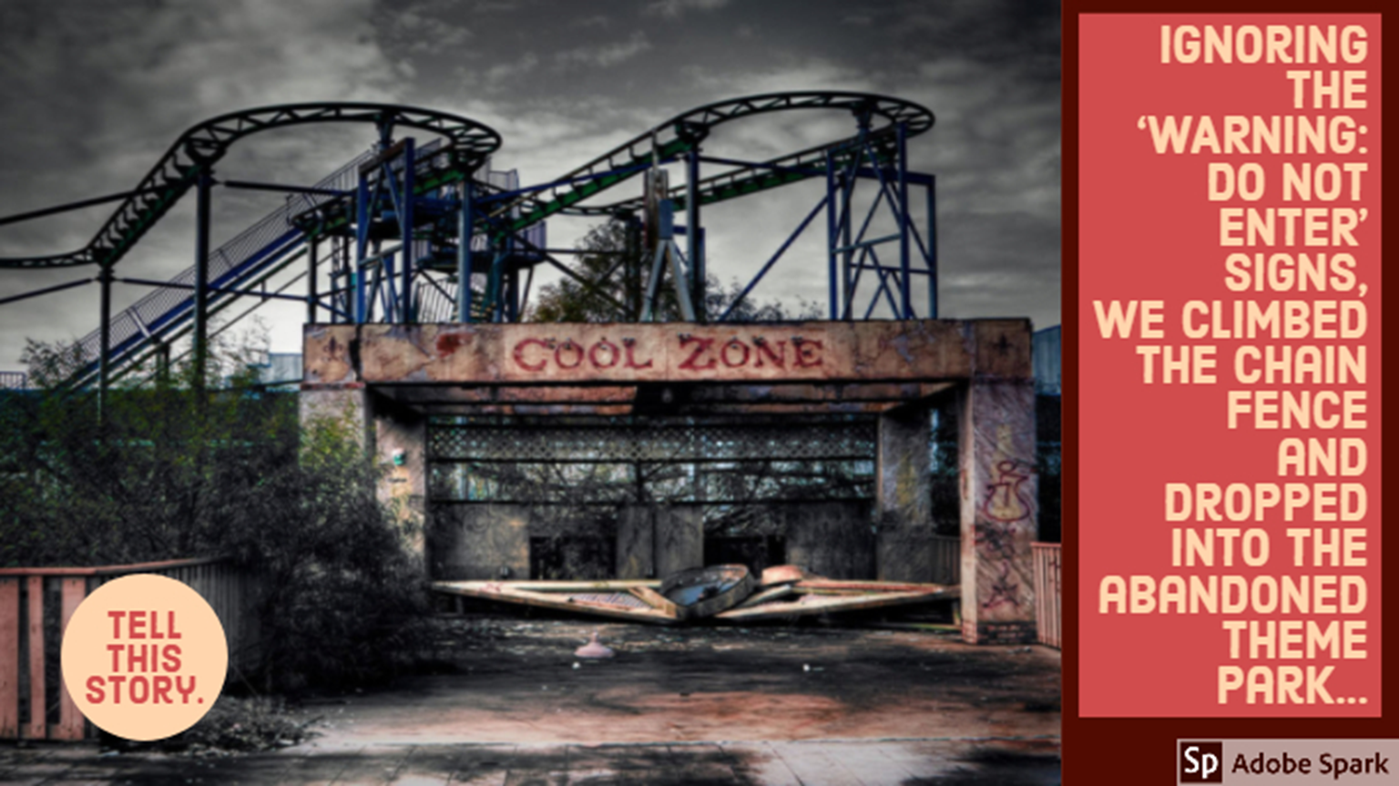  Task 2  Design a poster advertising/persuading people to read/watch your favourite book or TV programme. You must include a rhetorical question. Make sure your poster is brightly coloured. You can hand draw your poster, take a picture and email it to your teacher or you could create your poster online. I am really looking forward to finding out what you enjoy reading and watching!  Task 3  Complete the reading challenge and answer the 5 questions at the bottom. Your teacher will email you a copy of this.  Task 4  Use the following link to access English lessons from BBC Bitesize: https://www.bbc.co.uk/bitesize/articles/zd8c47h  If you fancy a bit of reading you can get lots of audiobooks for free from Audible: https://stories.audible.com/start-listen. You can listen to them and escape the world for a bit. There are still some activities available for you to complete on Doddle. Stay safe and take care.
Maths | 7A1 | 7A2 |  | 7A3 | 7B1 | 7B2 |  | 7B3
 | Algebra – Substitution  - Complete starter questions  - Read through explanations and examples on substitution  - Attempt the example questions  - Try the extension task using problem solving. | Algebra – Substitution  - Complete starter questions  - Read through explanations and examples on substitution  - Attempt the example questions  - Try the extension task using problem solving. |  | Algebra – Substitution  - Complete starter questions  - Read through explanations and examples on substitution  - Have a go at the ‘Try it out’ questions  - Try the extension task if you have time | - Algebra – Substitution  - Complete starter questions  - Read through explanations and examples on substitution  - Have a go at the ‘Try it out’ questions  - Try the extension task if you have time | - Algebra – Substitution  - Complete starter questions  - Read through explanations and examples on substitution  - Have a go at the ‘Try it out’ questions  - Try the extension task if you have time |  | - Algebra – Substitution  - Complete starter questions  - Read through explanations and examples on substitution  - Have a go at the ‘Try it out’ questions  - Try the extension task if you have time
Science | 7A1 | 7A2 |  | 7A3 | 7B1 | 7B2 |  | 7B3
 | Continuing with the variation topic this week the pupils are to look at genetic inheritance in more detail.  Then we will advance onto genetic engineering and it's applications.  Work to be emailed by Monday | Starting P4: energy resources  Lesson 1: energy from the sun  Lesson 2 & 3: forming and using fossil fuels  All lessons emailed to pupils on Monday |  | Students will be conducting a research project on the various ways we can generate electricity with renewable sources.  HLA- we are looking at how to classify plants this week, watch the video sent via email with tasks to do on Monday. You can also go outside and see if you can classify some plants in your garden! | Start C4 Solutions. This week's lessons are; mixtures and dissolving. I have emailed the resources out on Monday. There are some fun practical tasks you can try at home! | Starting P4: energy resources  Lesson 1: energy from the sun  Lesson 2 & 3: forming and using fossil fuels  All lessons emailed to pupils on Monday |  | Continuing with topic P4: Energy Resources  Complete the Educake and Seneca tasks set. More details on Teams.
Technology | Graphics |  | Resistant Materials |  | Textiles |  | Food Technology
 | Continuing with the typography theme,  Watch the following video guides:  How to make 3D letters using one-point perspective.  How to create 3D letters using a 'block' technique.  Use either one of these techniques to create a positive message using 3D letters. Ask you parents or carers if you can display your message in the window at home. Let’s try to think of something original, that people might not have already seen such as ‘We’ve got this’ or ‘Let’s support each other!’ I’m sure you will have your own ideas. It should aim to inspire people who see it.  Please email a photo of your work to me when it is done. |  | Using Doddle Mr Hull’s classes have been assigned a unit of work on Smart Materials. (if for any reason Doddle does not work for you, use the internet to search for Smart Materials – you will get lots of resources to learn from) You will have seen some of these in use but perhaps not realised how they work. |  | Using Doddle Mrs Miller’s classes have been assigned a unit of work on Classifying Textiles which links to the work completed at the beginning of the project on types of fabrics and materials. |  | Produce a one-page profile on storing food in your fridge. What foods are stored on the top, middle and bottom shelf of your fridge? Also, the correct temperature of your fridge. What is it? Find a picture of a fridge and add this to your work then email it to my school email please.
OM | VE Day Celebration.  We are going to take a break this week from the topic you are currently studying to focus on VE Day which will be remembered and hopefully celebrated in some ways this Friday. I think it is important for us all to think about this special moment in our nation’s history when people who had made huge sacrifices and had worked together could eventually celebrate peace and a look forward to better lives. Hopefully this will inspire and encourage us as we are all living in a strange and for some difficult time at the moment.  There are a number of activities to do in the task booklet and can be done on the computer or paper, and there is also an extension activity pack if anyone wants to do something more creative to celebrate. We would love to see your work and if possible, photos of any completed creative tasks.
PE | This week’s challenge is a skill challenge (mostly).  We want to see your skills!  What can you do?  Suggestions  Juggling - https://www.youtube.com/watch?v=dCYDZDlcO6g  Football tricks - https://www.youtube.com/watch?v=ZJvVihqO1NM  Cups stacking - https://www.youtube.com/watch?v=82DNYqurkxo  Cup song - https://www.youtube.com/watch?v=weqDCGg0GYs  Card shuffling - https://www.youtube.com/watch?v=zvXn5ppVB2c  Body position (GYM) - https://www.youtube.com/watch?v=tM2FtvOVFGc  Dribbling like CR7 - https://www.youtube.com/watch?v=faYZCdHF2Bo  BSL - https://www.youtube.com/watch?v=gMNHvXSW4iE  Also there are many great sports films and documentaries available across all different platforms, let me know what you enjoy, suggestions I enjoyed below.  - Class of 92 (12)  - More than a game (u)  - ESPN 30 for 30 (various)  - Coach Carter (pg13)  - The Blind side (pg13)  - Invictus (gp13)  - Remember the Titans (pg13)  - Space Jam (pg)
ICT | Continue to work through tasks set on Doddle.  All students have been set an ongoing practical project to create a web journal of their experiences during Social Distancing. Each week must be documented on a separate webpage written using html code. We are now up to the fourth week of the web page. The video tutorial students have been emailed shows students how to link their pages together and insert hyperlinks to other websites of interest.  This week students need to follow the instructions in the powerpoint video tutorial to link their pages together to create a website complete with hyperlinks to other sites.
Art | Detailed work will be set by email on Office 365 and if possible, students should respond to the teacher’s email to let them know they have completed the work.  Main Task: Modigliani-style celebrity portrait (stretched head) - students should lightly sketch/plan the line drawing stage of their stretched celebrity portrait. Information and help sheet will be emailed to students. Students could use the images provided on help sheet if they print it out or cut up a magazine/newspaper. Failing that, they could just draw the face from looking at their computer screen.  Homework Drawing Challenge: Draw a patterned object from observation. Use the whole page and add tonal shading/colour. Try to spend at least 20 minutes on the drawing.
Drama | Having now done some research and started to write your list of interesting places that you would like to visit across the world:  - Create a collage or scrap book of these places with with pictures, it can contain places that you have already been to and an explanation of why you would like to visit the new places or why you would like to visit again.  - Having been on your virtual journey it is time for you take up the challenge and tell me your own story.....  Stay tuned for next weeks task.
Music | Who is Gustav Holst? Find 5 facts about Holst. He wrote the planets suite, but what else did he compose?  Use the information to create either a fact file or a poster about him.  Send it to your teacher.  If you have not had chance yet why don’t you have a go at the 14 Day Music Challenge set by Mrs Rawson.  Email Mrs McLeod if you would like another copy.  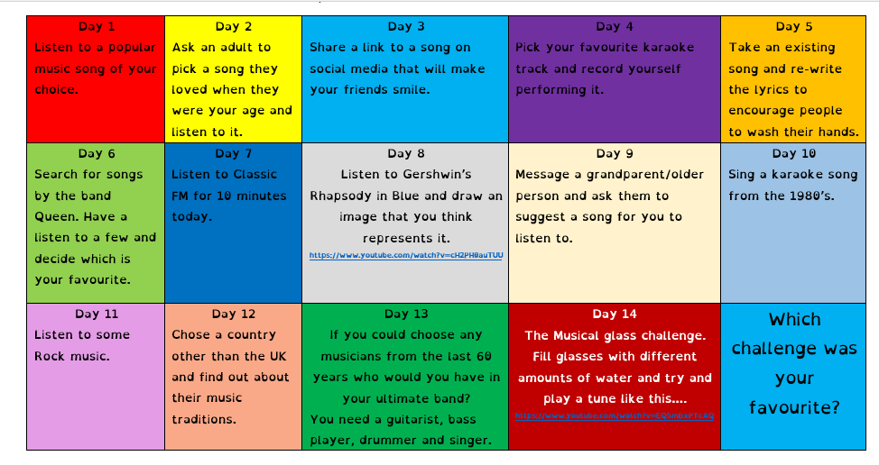
French | - This half-term we are learning how to talk about life at home.  - We will cotinue this week by looking at family members.  - You will be working from a Powerpoint document and a word document.  - You can turn in or email your work.  - Go to Teams to find complete instructions for this week’s assignment dated Monday 4th May.

