Year 7 – Week Beginning 8th June
Please look at the PSHE resources – https://www.waltonledale.lancs.sch.uk/curriculum/what-are-students-learning-now/pshe
Please look at the Thought for the Week – https://www.waltonledale.lancs.sch.uk/curriculum/thought-for-the-week
If you need to catch up on previous weeks then you will find them at this link - https://www.waltonledale.lancs.sch.uk/curriculum/what-are-students-learning-now/other-curriculum-maps

English | Sherlock Holmes  Over the course of the next few weeks, you will be studying two short stories by Sir Arthur Conan Doyle. These both feature the famous fictional detective Sherlock Holmes. Your teacher will email you a PowerPoint of activities to work through and this will also be uploaded to the files area of Teams for your class. There will be other resources that you need there too, and you will need to produce some writing – either on paper or on a word processor such as Word. You should complete tasks 1-3 this week.  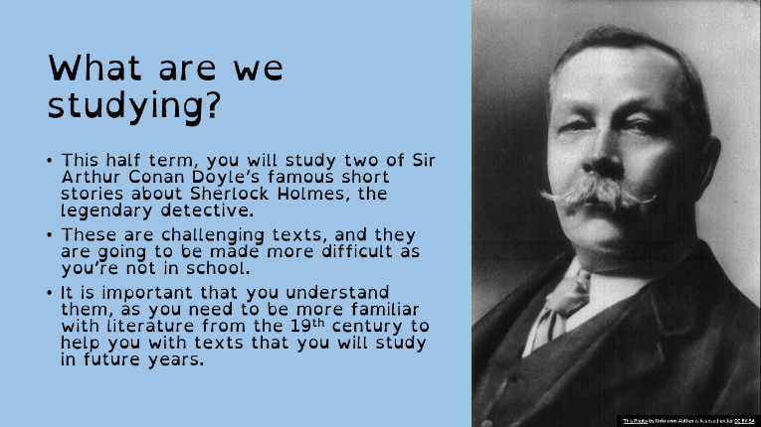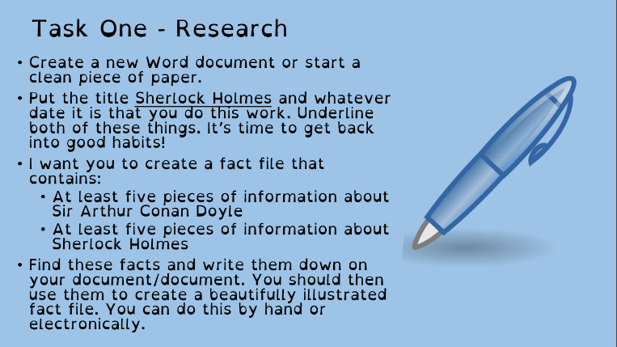  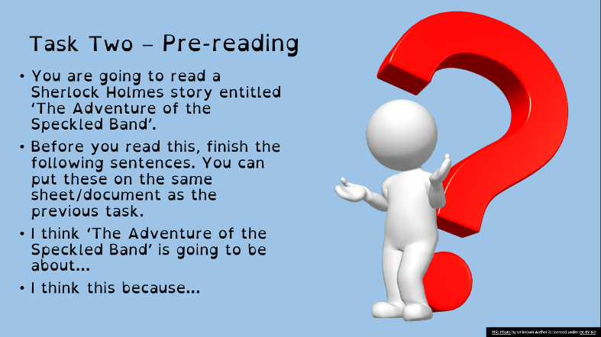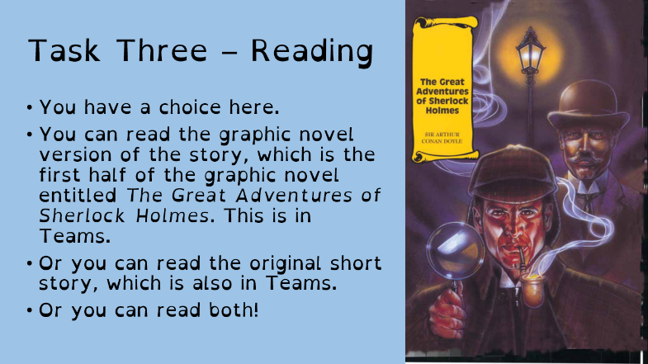  You can also use the following link to access lessons from BBC Bitesize: https://www.bbc.co.uk/bitesize/articles/zkgfvk7 You can also access lessons from the Oak Academy using the following link: https://www.thenational.academy/online-classroom/year-7/english#subjects If you fancy a bit of reading you can get lots of audiobooks for free from Audible: https://stories.audible.com/start-listen. You can listen to them and escape the world for a bit. There are some new activities available for you to complete on Doddle. Stay safe and take care.
Maths | 7A1 | 7A2 |  | 7A3 | 7B1 | 7B2 |  | 7B3
 | FRACTIONS  New topic from this week. Some will be revision and will then lead onto further understanding.  - Complete the starters.  - Complete the quick recap questions on addition and subtraction.  - Revise multiplying and dividing fractions.  - Complete extension questions.  - Complete mathswatch. | FRACTIONS  New topic from this week. Some will be revision and will then lead onto further understanding.  - Complete the starters.  - Complete the quick recap questions on addition and subtraction.  - Revise multiplying and dividing fractions.  - Complete extension questions.  - Complete mathswatch. |  | Multiplying and Dividing Fractions  - Complete the starter questions  - Read the examples and notes on the worksheet  - Complete Question 1 – Multiplying Fractions  - Complete Question 2 – Dividing Fractions  - Have a go at the Challenge Questions (Parts 1 & 2) | Multiplying and Dividing Fractions  - Complete the starter questions  - Read the examples and notes on the worksheet  - Complete Question 1 – Multiplying Fractions  - Complete Question 2 – Dividing Fractions  - Have a go at the Challenge Questions (Parts 1 & 2) | Multiplying and Dividing Fractions  - Complete the starter questions  - Read the examples and notes on the worksheet  - Complete Question 1 – Multiplying Fractions  - Complete Question 2 – Dividing Fractions  - If you feel confident, have a go at the Challenge Questions (Parts 1 & 2) |  | Multiplying and Dividing Fractions  - Complete the starter questions  - Read the examples and notes on the worksheet  - Complete Question 1 – Multiplying Fractions  - Complete Question 2 – Dividing Fractions  - If you feel confident, have a go at the Challenge Questions (Parts 1 & 2)
Science | 7A1 | 7A2 |  | 7A3 | 7B1 | 7B2 |  | 7B3
 | DMA – This week we will finish off the energy resources topic and start revision for the 3 recent topics for the next test which will be set for the following week. | This week, we will be revising the three topics we have recently covered:  - Pure & impure substances  - Energy resources  - Variation & classification  All details will be emailed on Monday |  | This week’s task will be related to revising the topics P4 energy resources and C4 solutions for a test next week.  HLA – revision of B4 – see the email on Monday for more information. | Revision of the 3 topics in preparation for next week's test.  - Variation and classification  - Energy resources  - Pure and impure substances.  See my email on Monday for more information. | This week, we will be revising the three topics we have recently covered:  - Pure & impure substances  - Energy resources  - Variation & classification  All details will be emailed on Monday |  | This week, we will be revising the three topics we have recently covered:  - Pure & impure substances  - Energy resources  - Variation & classification  Details will be shared on Teams.
Technology | Graphics |  | Resistant Materials |  | Textiles |  | Food Technology
 | Firstly, don’t forget to email last week’s work. I’ve really enjoyed seeing your research! Now that we have done some research on the artist Robert Sabuda, we are going to have a go at making a pop-up card using the same technique.  1) Read through the PowerPoint presentation and, if you can play all of the videos.  2) I have emailed you all a planning sheet. You can either print this off and draw onto it or simply draw onto plain paper, drawing the boxes out yourself with a ruler. You then need to photograph your drawings and email them to me.  3) Once you have done this you need to design the front of your card. You should use the same theme in your design as the pop-up element of your card. Again, please photograph this and email it to me. |  | This will add to last week’s ‘plastics’ work on Doddle:  1) Look around the home at items and see what is made from plastic. Look carefully at it (perhaps underneath) You should see a number and / or letters inside a recycling symbol on rigid items or names of plastics on the label of fabrics (many of which are actually plastic!)  2) Google what the plastic recycling symbols mean.  3) Try to get better at guessing what the plastic item is made from before you look at the symbol.  4) Items going into your plastic recycling bin are a particularly good hunting ground!  5) Next time your shopping – try to avoid buying as much single use plastic packaging! |  | Basics in textiles  This week to build on the Health & Safety work you completed last week you will be sent two worksheets by email on Monday. You can complete electronically, print off if you are able to and complete by hand or write the answers on paper as best as you can.  The first looks at equipment that you will use in the Textiles studio and a quick little fibre quiz to test your prior knowledge.  The second is a fabric treasure hunt as I would really like you to start thinking carefully about different fabrics, what they are made from and how to care for them. |  | Fridge safety  This week I would like you to find a picture of an open fridge and label the fridge showing what foods go in which areas of the fridge and why. What area does raw meat, cooked meat, dairy, vegetables and cheese go in your fridge?  What temperature should your fridge be?  Why is it this temperature?  What happens if the temperature is higher/hotter than the recommended temperature?  This can be a one page word document that you can email to my school email address.
OM | Thematic Social History Project – migration to Britain  This is the 4th lesson in our social history project about migration to Britain, over time. This lesson focuses on the 20th Century and the migrants that came to Britain mainly for economic reasons.  - Read the information on the PowerPoint  - Use the character cards to fill in worksheet 1.  - Complete timeline sheet 4.  Send your work or photographs of your work to your OM teacher and kepp all of your work safe.  The final lesson on the history of migration to Britain will be next week.  Take care and keep safe, we are missing all of you!
PE | As we move into the Summer season, we are going to focus on some Summer sports. This week, we will be focussing on Cricket fielding.  This week, we will be focussing on a Bronze, Silver and Gold skill, with each skill becoming more difficult as you move up the ranking.  Bronze: A ball is needed, a soft toy or some socks rolled up. Try and pass the ball around different parts of your body, such as your waist, head, legs etc. Change the direction. How many times can you do this in a minute? Which body parts are more difficult to move around and why? Extension: Can pass the ball through your legs in a figure of 8 motion? ONLY HAVING ONE HAND ON THE BALL AT ONE TIME!  Silver: More space will be needed for this activity. Firstly, put the ball on the floor and practice picking it up quickly in one hand and then putting it back down. How many times can you do so in a minute? Following this, put the ball on the floor and practice running up to it and picking up and getting into a throwing motion before putting it back down, how many times can you do this in a minute? Finally, either roll it yourself or get a family member to do so, and practice running towards a rolling ball, picking it up and getting ready to throw it at the stumps!  Gold: Fielding in Cricket and being able to throw it at the stumps is a vital part of the game. You are going to develop a turn and throw game to help you with this. Make a target (outside, or if inside, something that won’t break/soft ball), and practice turning around with the ball/turning around a picking up the ball and throwing it at the target. Ensure you make up a scoring system to help you gage your progress. If it's too easy, make the target smaller.  Extension task: Geography – In England, there are 18c county Cricket Clubs. Warwickshire Play in Birmingham. Find out where the other 17 Counties play, what city they play in, and find it on a map.
ICT | This week’s tasks are set on Doddle. Students are completing tasks to practise using databases.  Adobe Flash player might need to be downloaded for some tasks/presentations.  In addition to this please read the following articles: https://www.liquidweb.com/blog/ten-ways-databases-run-your-life/  https://kids.kiddle.co/Database  https://www.bbc.co.uk/bitesize/topics/zf2f9j6/articles/z8yk87h  If you have any issues accessing or completing any of this work, please contact Mr Cassidy.  Thanks also to the many students submitting fantastic web journals. If students wish to continue their COVID-19 learning journals, giving updates about their experience of this very unusual time, please do so. I have really enjoyed reading them! I will continue to award Class Charts points for those who do so.
Art | Detailed work will be set by email on Office 365 and if possible, students should respond to the teacher’s email to let them know they have completed the work.  Main Task: Modigliani Self-Portrait – this week you should add lots of detail to your self-portrait and start to make it look like you. If you can, try to use a mirror (small handheld ones work fine) to look at yourself. If you don’t have a mirror you could look at a photo of yourself. Remember to continue to focus on elongated proportions of your face and facial features. You can start to add little bits of tonal shading this week but don’t go mad and shade in your whole face! Just shade small areas to help make your features look bolder (e.g. around your nose, eyes, and lips).  Homework Drawing Challenge: A towel. Focus on the texture, folds, and creases! Use the whole page and add tonal shading/colour. Try to spend at least 20 minutes on the drawing.
Drama | - For the next few weeks you are going to be working through a Drama Skills booklet tracking your skills and keeping a journal of your experiences.  - Your Drama teacher will email you the booklet.  - If you need a hard copy some will be available in reception or contact Mrs McLeod and she will send you one in the post.  - Log on to teams and the resources will be there for you to access.
Music | Week 2  What is a Raga?  Can you create your own raga scale and send it to you teacher. Your teacher wil email you al the resources you need.  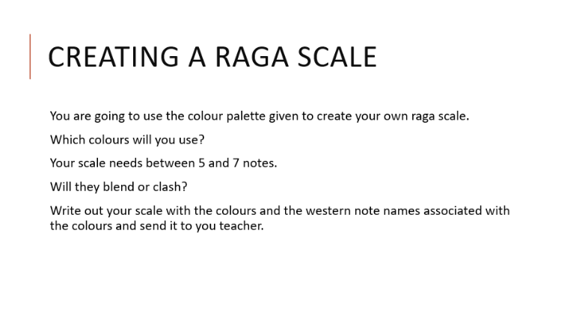
French | - This half-term we are going to be learning how to talk about making plans in the future, places in town and weekend activities.  - This week we will be focusing on places in town and the verb “aller”.  - You will be working from a Powerpoint document and Dynamo online.  - You can turn in or email your work.  - Go to Teams to find complete instructions for this week’s assignment, dated Monday 8th June.

