Year 7 – Week Beginning 15th June
Please look at the PSHE resources – https://www.waltonledale.lancs.sch.uk/curriculum/what-are-students-learning-now/pshe
Please look at the Weekly Reflection – https://www.waltonledale.lancs.sch.uk/curriculum/thought-for-the-week
If you need to catch up on previous weeks then you will find them at this link - https://www.waltonledale.lancs.sch.uk/curriculum/what-are-students-learning-now/other-curriculum-maps
English | Sherlock Holmes  You are continuing with your study of Sherlock Holmes. Your teacher has already emailed you a PowerPoint of activities to work through and this has also been uploaded to the files area of Teams for your class. There will be other resources that you need there too. You should complete tasks 4 and 5 this week.  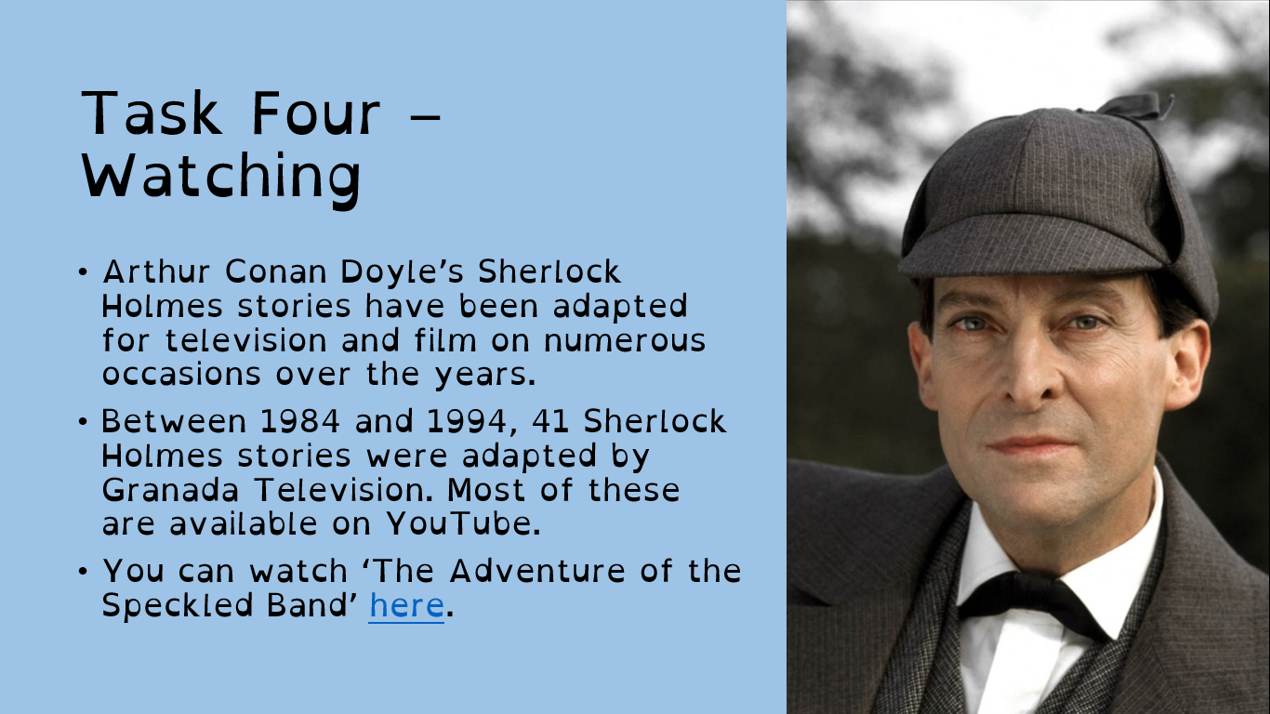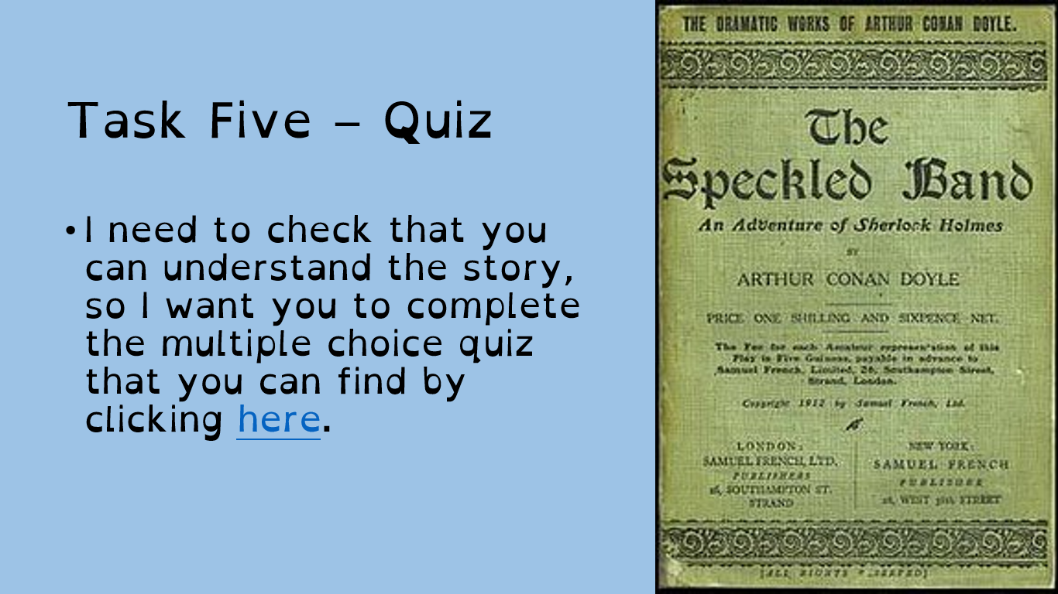
Maths | 7A1 | 7A2 |  | 7A3 | 7B1 | 7B2 |  | 7B3
 | Fractions  - Mark last week’s work and submit to your teacher.  - Complete starter questions.  - Read through the information on fractions of amounts.  - Complete questions.  - Look at extension activities.  - Complete mathswatch. | Fractions  - Mark last week’s work and submit to your teacher.  - Complete starter questions.  - Read through the information on fractions of amounts.  - Complete questions.  - Look at extension activities.  - Complete Mathswatch |  | Prime, Square and Cube Numbers  - Complete the starter questions on the worksheet  - Read through the notes and examples about each type of number  - Have a go at the ‘Try it out’ questions  - Complete the three ‘Learning Review’ questions | Prime, Square and Cube Numbers  - Complete the starter questions on the worksheet  - Read through the notes and examples about each type of number  - Have a go at the ‘Try it out’ questions  - Complete the three ‘Learning Review’ questions | Prime, Square and Cube Numbers  - Complete the starter questions on the worksheet  - Read through the notes and examples about each type of number  - Have a go at the ‘Try it out’ questions  - Complete the three ‘Learning Review’ questions |  | Prime, Square and Cube Numbers  - Complete the starter questions on the worksheet  - Read through the notes and examples about each type of number  - Have a go at the ‘Try it out’ questions  - Complete the three ‘Learning Review’ questions
Science | 7A1 | 7A2 |  | 7A3 | 7B1 | 7B2 |  | 7B3
 | This week all of Year 7 will need to complete Tri test 4 which will be set on Educake.
Technology | Graphics |  | Resistant Materials |  | Textiles |  | Food Technology
 | Last week students made the ‘sections’ and background for their pop-up card. This week students are going to assemble their pop-up card.  Tasks for this week are:  1) Carefully cut out the sections that you drew out last week.  2) Follow the video and other instructions that will be emailed out to you in order to assemble your card (you will need glue for this bit)  3) Write out 3 points that you feel have gone well with the assembly of your card and 3 points that you would improve upon if you were to do this again.  Please email Mr Cassidy with any questions or queries you may have. |  | Using Doddle Mr Hull’s classes have been assigned a unit of work on Smart Materials. (if for any reason Doddle does not work for you, use the internet to search for Smart Materials – you will get lots of resources to learn from) You will have seen some of these in use but perhaps not realised how they work. Next week we will be looking at smart materials in our everyday lives, perhaps get a head start now you know what you are looking for. |  | Using Doddle Mrs Miller’s groups have been assigned a unit of work on Health & Safety to reinforce the work completed over the last two weeks. |  | THE DANGER ZONE  Produce a one page-profile on the Danger Zone. Email your work to my school email address please.  Research the danger zone and find out what happens at each temperature above, below and in the danger zone. You could draw and label your own danger zone. Also find out what the correct temperature is for a fridge, freezer, ambient and the rules for cooling hot food.
OM | A thematic history of migration to Britain  This is the last lesson in the history of migration to Britain. This lesson is about multicultural Britain. It is very relevant to what is happening in Britain, the USA and the rest of the world today with the ‘Black Lives Matter’ protests.  If you are interested in finding out why the protests are happening – there is a link below to a Newsround Special:  https://www.bbc.co.uk/newsround/52978346  work to do:  - Look at slide 2 and think about which image, you think is the odd-one-out, and why you have chosen it?  - Use the information on slide 5 to complete the graph on worksheet 1.  - Look at the cards about multiculturalism (worksheet 2) and complete the activity on slide 6 of the PowerPoint.  - Complete the task on slide 7 of the PowerPoint – read the instructions on the slide and then Use your thoughts to write a creative account of this Celt’s experiences and opinions of multicultural Britain.  - Complete the last part of the timeline (worksheet 3).  - Put all of your timeline sheets together and complete the task on slide 9.  Email your work to your OM teacher.
PE | All work this week will be emailed to you, there are written tasks and practical tasks let us know how you get on.  It’s important that you are staying as active as possible whether it’s going out for a walk, run or bike ride or even doing a little workout at home.  Physical activity does wonders for our mental health and wellbeing.  Have a great week and check your emails for the powerpoint
ICT | Tasks have been set on Doddle for students to complete online. Please contact Mr Cassidy if you have any problems logging in to Doddle.  Tasks this week look at the cultural and legal impact of ICT. This is a pertinent subject in a world where ICT has enabled people to do fantastic things in the face of huge adversity. In addition to this, students should look at the following blogs and articles:  https://www.bbc.co.uk/bitesize/guides/zbxbkqt/revision/1  https://www.ictskillnet.ie/news/5-ways-the-internet-of-things-will-change-our-world/
Art | Detailed work will be set by email on Office 365 and if possible, students should respond to the teacher’s email to let them know they have completed the work.  Main Task: Add colour to your Modigliani self-portrait – this week we want you to add colour and lots of detail to your self-portrait. Originally, this was intended to be a painting you would have done at school. If you have access to paints and brushes – that's great. However, lots of you will not have paints at home, so you can use whatever materials you have (and are allowed to use!) to add colour, e.g. felt-tips, pastels, biros, coloured pencils, markers, coloured paper collage, old magazine/newspaper collage, etc. If you don’t have any of these, don’t worry – you can focus on tonal shading with just pencil. Before you start, look again at Modigliani’s paintings and hink about the colour palette he used. What colours should you choose to make your portrait look like his work? Would bright rainbow colours look like his work? Or would dull greens, blues and greys work better?  Homework Drawing Challenge: Your school tie. Focus on the pattern, shape, and details. Use the whole page and add tonal shading/colour. Try to spend at least 20 minutes on the drawing.
Drama | KS3 Drama Booklet  - Your teacher should now have sent you or told you where to find the KS3 Drama Booklet that you can work on up until the summer.  - Try and focus 40 mins – 1 hr a week on your Drama work, think of it as a lesson.  - You can choose the order in which you complete each activity, but focus on 1 a week.  - If you can’t print the booklet do not worry, just create the work in any means you can.  - There are some actual booklets at school in reception if somebody can come and collect or Mrs McLeod will send some out in the post if you let her know.  - There are some extension tasks at the back that you can work on if you have more time.  Enjoy the work and let your teachers know how you are getting on even if it’s just a quick message in teams or by email.
Music | Week 3  Can you write the Indian scale you created last week out using Indian note names? When you have worked it out send it to your teacher.
French | - This half-term we are learning how to talk about making plans in the future, places in town and weekend activities.  - This week we will continue to focus on places in town and the verb “aller”.  - You will be working from a Powerpoint document and a Word document.  - You can turn in or email your work.  - Go to Teams to find complete instructions for this week’s assignment dated Monday 15th June.

