Year 7 – Week Beginning 29th June
Please look at the PSHE resources – https://www.waltonledale.lancs.sch.uk/curriculum/what-are-students-learning-now/pshe
Please look at the Weekly Reflection – https://www.waltonledale.lancs.sch.uk/curriculum/thought-for-the-week
If you need to catch up on previous weeks then you will find them at this link - https://www.waltonledale.lancs.sch.uk/curriculum/what-are-students-learning-now/other-curriculum-maps
English | Sherlock Holmes  Your study of ‘The Adventure of the Speckled Band’ continues this week. This week you should complete tasks 3 and 4 on the PowerPoint in Teams. If you have any questions, please contact your English teacher via email or Teams.  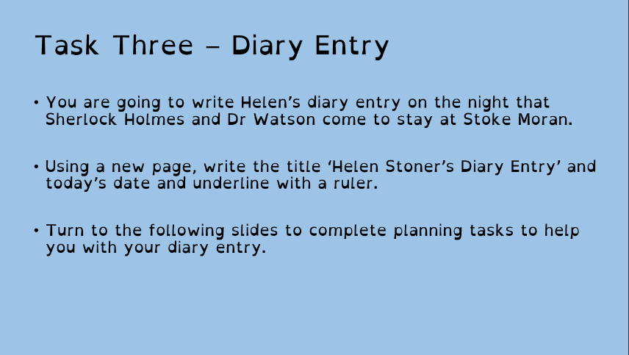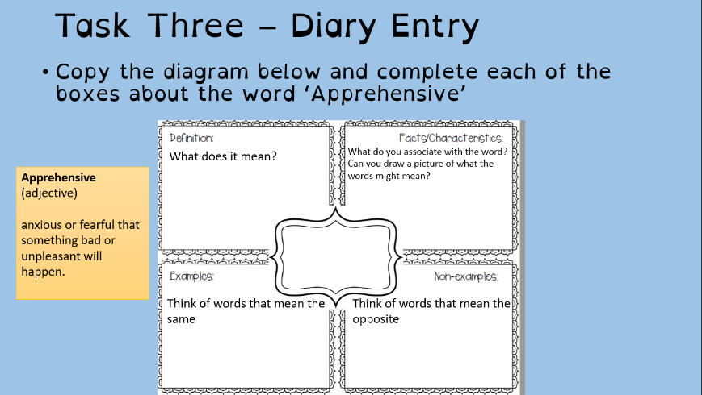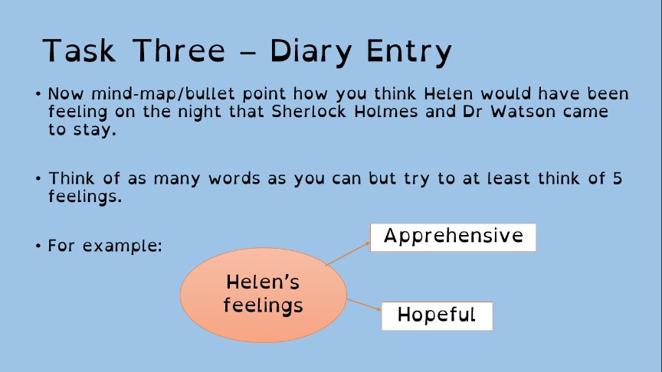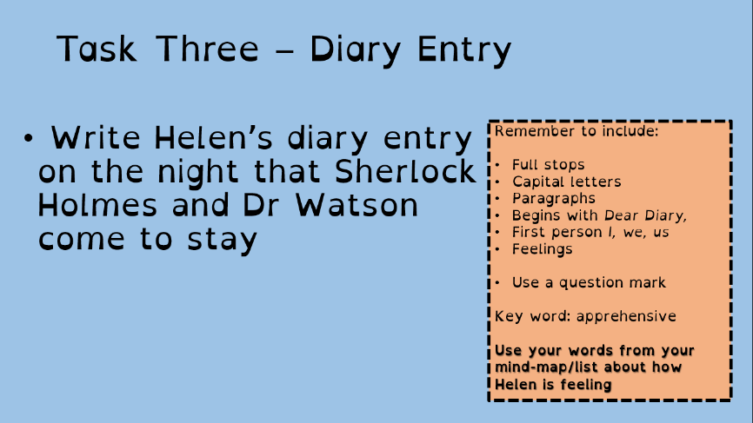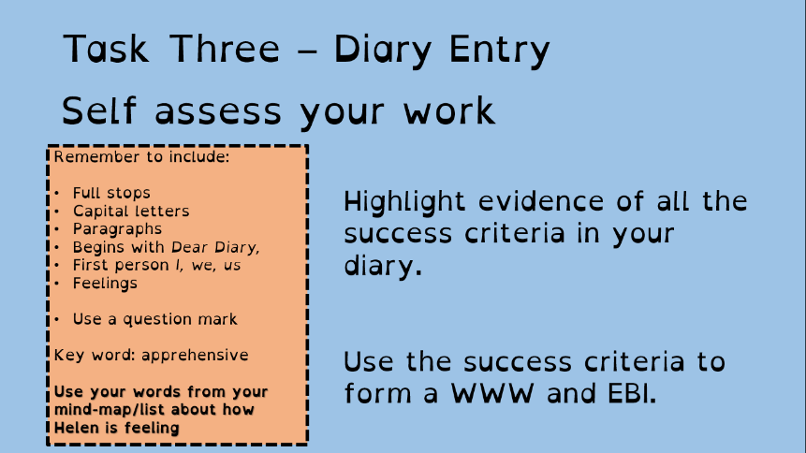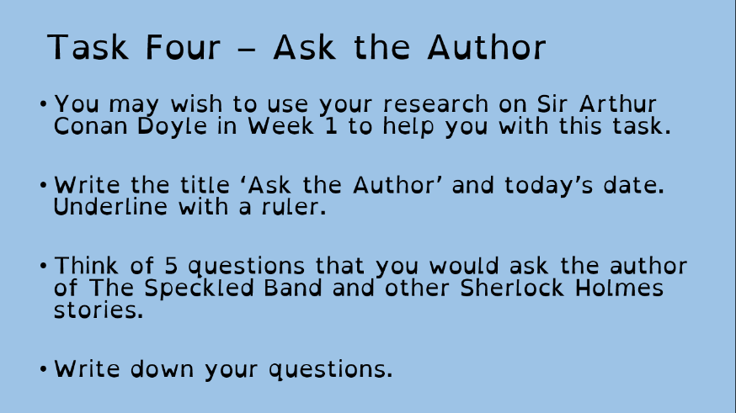
Maths | 7A1 | 7A2 |  | 7A3 | 7B1 | 7B2 |  | 7B3
 | LCM & HCF  - Mark work from last week  - Complete starters  - Work through the PowerPoint and use mathswatch videos as needed.  - Compete questions  - Complete extension work – investigation.  - Send in to your teacher! | LCM & HCF  - Mark work from last week  - Complete starters  - Work through the PowerPoint and use mathswatch videos as needed.  - Compete questions  - Complete extension work – investigation.  - Send in to your teacher! |  | Ordering Decimals  - Complete starter questions  - Read explanations in ‘Basics’ section of worksheet  - Complete ‘Try it Out’ questions  - Have a go at the Challenge Question  - Complete Extension Task (optional) | Ordering Decimals  - Complete starter questions  - Read explanations in ‘Basics’ section of worksheet  - Complete ‘Try it Out’ questions  - Have a go at the Challenge Question  - Complete Extension Task (optional) | Ordering Decimals  - Complete starter questions  - Read explanations in ‘Basics’ section of worksheet  - Complete ‘Try it Out’ questions  - Have a go at the Challenge Question  - Complete Extension Task (optional) |  | Ordering Decimals  - Complete starter questions  - Read explanations in ‘Basics’ section of worksheet  - Complete ‘Try it Out’ questions  - Have a go at the Challenge Question  - Complete Extension Task (optional)
Science | 7A1 | 7A2 |  | 7A3 | 7B1 | 7B2 |  | 7B3
 | This week we will be reviewing topics B1, C1 and P1. Work and educake to be sent by Monday. | We will continuing reviewing previous topics, focusing on B1, C1 and P1.  This will include mini experiments to do at home!  Details emailed on Monday |  | As part of a review of all learning done this year students will be asked to complete progress tracking sheets with key questions on topics C2, B2 and P2 | Complete the Educake ‘Revision of B2, P2, C2’. | We will continuing reviewing previous topics, focusing on B1, C1 and P1.  This will include mini experiments to do at home!  Details emailed on Monday |  | Complete the Educake revision task for B2, C2 and P2.
Technology | Graphics |  | Resistant Materials |  | Textiles |  | Food Technology
 | This week you will be assembling your pop-up card using the three layers and your design for the front.  This week’s work:  1) Read through the presentation on Doddle all about the properties of papers and boards and compete the short interactive task.  2) Cut the slots and feed through the tabs from the bottom of each layer. Use tape or glue if you have it to attach the layers. Next you need to add the ‘spacers’ between each layer to make sure that all the layers fold together in parallel when you open/close the card.  This can be quite tricky so make sure that you email Mr Cassidy if you’re not sure about anything. |  | This week we are going to combine technology and history and make your own timeline.  1) Using Doddle learn there are a couple of interactive examples for you to have a go at (and hopefully learn something in the process – I know I did)  2) Look around you, everything man made was invented by someone at some point in history. Choose some items that interest you, look them up and write the objects name, the year it was invented and the inventors name (if you can find it) on a small piece of paper or post it note. When you have a few of them, put them in order. You could stick them around your room, peg them to a line etc. to show a timeline. Add to it as the days go by – perhaps a new item for every day of lockdown? They may be household items such as the invention of elastic bands, canned food, microwave, chocolate (!) or major events such as walking on the moon, building of the colosseum or periods of historical note. Enjoy learning about the world we are lucky enough to live in. |  | As you have completed a number of different theory tasks I would like you to now design an apron for an astronaut while in space.  You will be sent the worksheet via your school email, you can complete the task digitally or by hand either by printing off the worksheet or drawing out on plain paper.  Please return work by email (using your school email address) or via Teams. |  | Food Spoilage  Produce a one age profile on the following and email to my school email address.  - What are the 4 key conditions microorganisms need to multiply?  - Make a list of at least 5 high, medium and low risk foods.  - What temperature should raw meat reach when cooked?  - BBQ – lovely but why are they dangerous?  - List the rules to BBQ safely without causing food poisoning. Add pictures.
OM | This week you should continue to work through our new unit by completing ‘Green Travellers booklet 2’. This will be emailed to you as well as saved in Teams. You should investigate eco-tourism around the UK and in the North West, then you should use what you have learned to design your own eco-friendly holiday destination. You can find copies of each booklet in Teams, go to your OM folder in Teams then click on ‘Files’. Then click on class materials and each booklet is saved there. Don’t forget to download each piece of work and save it to your own documents before you start it.
PE | The Lancashire School Games are approaching....this is when schools across Lancashire take part to represent their district  Obviously we can’t do this, this year instead here’s a link which gives you some activities to take part in. I will also email it to you all on Monday  https://lancashireschoolgames.co.uk/resources-for-teenagers-secondary-schools/  I hope you are all well.
ICT | All work is set on Doddle. This week’s work includes revision tasks and so students are revisiting topics previously touched on throughout the year.  Please read through all presentations carefully and complete the assessment quizzes as fully as you can.
Art | Detailed work will be set by email on Office 365 and if possible, students should respond to the teacher’s email to let them know they have completed the work.  Main Task: Final lesson on your Modigliani self-portrait plus self-evaluation. This week we want you to finish your self-portrait, including final touches to your hair (adding texture), clothes (creases, folds, etc.) and the background. When you have completed the self-portrait, you should complete a self-evaluation of your artwork. This self-evaluation should be similar to the WWW and EBI you usually do in school but more in-depth. For example, you could write about three things you think have gone well, and then two things you think you could do better.  Things to include in your self-evaluation:  - Have you captured the style of Modigliani? (Elongated features and neck, etc.)  - Does the self-portrait look like you?  - Have you used an appropriate colour scheme? (Similar to Modigliani’s)  - Have you added detail and texture to the hair and clothes?  - Have you included a background?  Pease email your Art teacher and show them your Modigliani self-portrait to receive feedback on what to improve.  Homework Drawing Challenge: Something cold! See below for examples. Use the whole page and add tonal shading/colour. Try to spend at least 20 minutes on the drawing.  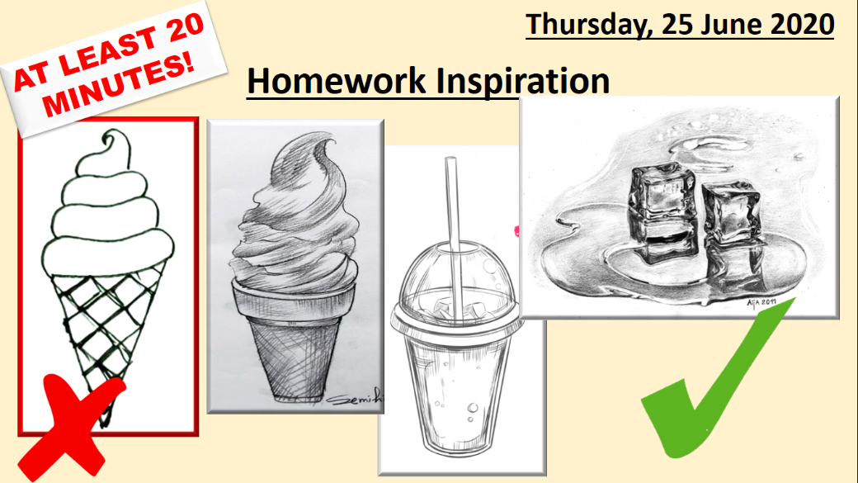
Drama | KS3 Drama Booklet  · Your teacher should now have sent you or told you where to find the KS3 Drama Booklet that you can work on up until the summer.  · Try and focus 40mins – 1hr a week on your Drama work, think of it as a lesson.  · You can choose the order in which you complete each activity, but focus on 1 a week.  · If you can’t print the booklet do not worry just create the work in any means you can.  · There are some actual booklets at school in reception if somebody can come and collect or Mrs McLeod will send some out in the post if you let her know.  · There are some extension tasks at the back that you can work on if you have more time.  Enjoy the work and let your teachers know how you are getting on even if it is just a quick message in teams or by email.
Music | Week 5  Modern Indian music.  Listen to the 2 pieces of modern Indian music then answer the questions and send them to your teacher as a word document or a picture of your handwriting.
French | - This half-term we are learning how to talk about making plans in the future, places in town and weekend activities.  - This week we will focus on ordering food and drink in a French café.  - You will be working from 2 PowerPoint presentations and the online text book.  - You can turn in or email your work.  - Go to Teams to find complete instructions for this week’s assignment, dated Monday 29th June.

