Year 7 – Week Beginning 6th July
Please look at the PSHE resources – https://www.waltonledale.lancs.sch.uk/curriculum/what-are-students-learning-now/pshe
Please look at the Weekly Reflection – https://www.waltonledale.lancs.sch.uk/curriculum/thought-for-the-week
If you need to catch up on previous weeks then you will find them at this link - https://www.waltonledale.lancs.sch.uk/curriculum/what-are-students-learning-now/other-curriculum-maps
English | Sherlock Holmes  This week you will read a different Sherlock Holmes story - ‘The Boscombe Valley Mystery’. You should complete tasks 1-3 on the PowerPoint in Teams. If you have any questions, please contact your English teacher via email or Teams.  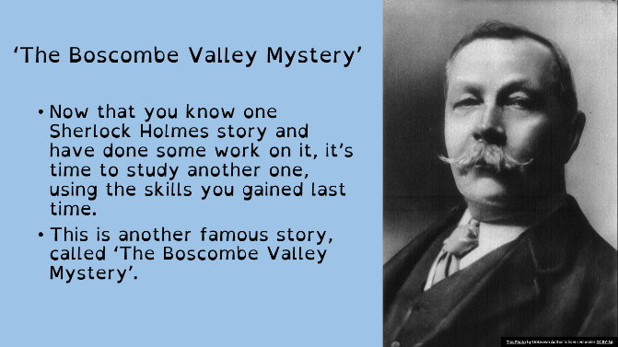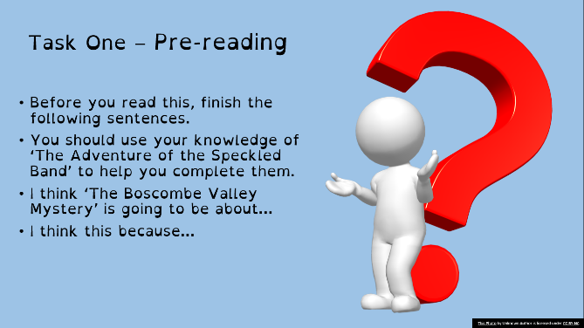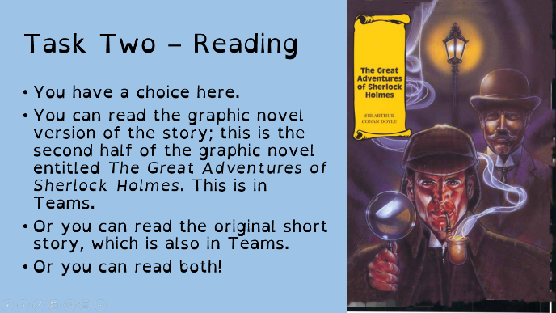
Maths | 7A1 | 7A2 |  | 7A3 | 7B1 | 7B2 |  | 7B3
 | Angles – parallel lines and polygons  - Mark and upload last week’s work.  - Complete each section of work – each begins with a starter.  - Complete lesson on basic angles revision.  - Read information on identifying angles in parallel lines and complete questions.  - Read information on calculating angles in regular polygons and complete the questions.  - Complete extension questions. | Angles – parallel lines and polygons  - Mark and upload last week’s work.  - Complete each section of work – each begins with a starter.  - Complete lesson on basic angles revision.  - Read information on identifying angles in parallel lines and complete questions.  - Read information on calculating angles in regular polygons and complete the questions.  - Complete extension questions. |  | Angles  - Complete the starter questions  - Recap on the basic angle facts by reading the examples & explanations  - Complete the ‘angles on a straight line’ questions  - Complete the ‘angles at a point’ questions  - Complete the ‘vertically opposite angles’ questions  - Complete the Learning Review questions | Angles  - Complete the starter questions  - Recap on the basic angle facts by reading the examples & explanations  - Complete the ‘angles on a straight line’ questions  - Complete the ‘angles at a point’ questions  - Complete the ‘vertically opposite angles’ questions  - Complete the Learning Review questions | Angles  - Complete the starter questions  - Recap on the basic angle facts by reading the examples & explanations  - Complete the ‘angles on a straight line’ questions  - Complete the ‘angles at a point’ questions  - Complete the ‘vertically opposite angles’ questions  - Complete the Learning Review questions |  | Angles  - Complete the starter questions  - Recap on the basic angle facts by reading the examples & explanations  - Complete the ‘angles on a straight line’ questions  - Complete the ‘angles at a point’ questions  - Complete the ‘vertically opposite angles’ questions  - Complete the Learning Review questions
Science | 7A1 | 7A2 |  | 7A3 | 7B1 | 7B2 |  | 7B3
 | We will be continuing with the revision of topics covered this year. This week will be the topic 3’s.  Work to be emailed by Monday. | We are continuing to recap previous topics, looking at unit 2 this week!  Details emailed on Monday. |  | Students will be completing 3 question based tasks on topics P3, C3 and B3 to review and consolidate learning for the year. | Complete the Educake ‘Revision of B3, C3, P3’. | We are continuing to recap previous topics, looking at unit 2 this week!  Details emailed on Monday. |  | Complete the ‘topics B3, C3 and P3’ on Educake.
Technology | Graphics |  | Resistant Materials |  | Textiles |  | Food Technology
 | Step-by-Step.  If you haven’t assembled your pop-up card then I’d like you to have a go at that this week. Contact Mr Cassidy if you are not sure how to do this.  In addition to this I would like you to make a step-by-step guide showing how to do it. There are some different ways you might do this.  1) Take photographs of your project as you make it and upload these to the boxes on the worksheet to demonstrate each stage of the making. Type comments to say which arts you found difficult and why.  2) You could make drawings and then photograph them as above and type your comments.  3) You could print off the worksheet and fill it in by hand using drawings and written comments to describe how you made your card. |  | Environmental Issues  1) Using Doddle Learn please watch the interactive powerpoint Environment and Sustainability 1 that has been assigned to your classes.  2) Watch the two short video clips on the internet:  https://www.youtube.com/watch?v=6R8YObQbE88  https://www.youtube.com/watch?v=B5NiTN0chj0&safe=active  3) For the challenge mentioned in the powerpoint rather than your classroom, design a recycling station for use at home – I know we could use one in our house! Draw your designs on paper or using the computer.  4) The powerpoint suggests you read further into environmental issues such as: Greenhouse effect; Greenhouse gasses; Melting of the polar Ice caps and Global warning. Use the internet and talk to people to find out more about these issues which will undoubtedly have a huge impact during your lifetime. |  | This week I would like you to focus on DESIGNING for the textiles industry and the stages within the design process.  Work thorough the presentations and interactive tasks on Doddle all focussed upon designing. The work will go live on Monday 6th July and is due by Monday 13th July. |  | Vitamins fat soluble.  Produce a one-page profile on the following fat-soluble vitamins.  Vitamin A, D, E and K.  Why do we need these vitamins? What foods are they found in? How much do we need of each per day? What happens if we have too much of each vitamin? What happens if we are deficient of these vitamins?  You can add pictures to make your work interesting.  Please send your work to my school email address.
OM | This week you should continue to think about eco tourism and work through the final booklet ‘Green travellers booklet 3’. This will be emailed to you by your OM teacher and saved on Teams.
PE | EXPLORE – In rounders, the bowler is important in any team. Find a ball or an alternative. You will also need a hoop or piece of paper. Stand 10 yards away from a wall. How many times can you hit the same spot on the wall from the same distance? How many ways can you bowl the ball? Underarm? Overarm? Different arms? Different trajectories? In rounders, the ball must always be bowled underarm. Research the best technique and try this exercise out again using an effective under arm technique.  PRACTICE – You will need a family member. Bowl with the correct technique to your partner. Will they catch it between their head and knee? If so, that ball will count in a game. If not, it is a no ball. How many balls can you bowl correctly in 30 seconds? For a more difficult challenge, can you stand further away?  DEVELOP – Effective bowlers use different techniques to make it difficult for batters. You will now try a SPIN CHALLENGE. But a hoop or a piece of paper where the batter would stand. Spinning your wrist clockwise when you release the ball, can you still hit your target? Discuss with your family member why it may be difficult for the batter to hit this ball.
ICT | Tasks have been set on doddle. Please complete all revision tasks’ and the assessment quizzes set. This week you are being assessed on your knowledge of HTML and web design.  If you have made any progress on your COVID journal web page please email it to Mr Cassidy for feedback.
Art | Detailed work will be set by email on Office 365 and if possible, students should respond to the teacher’s email to let them know they have completed the work.  Main Task: Create an evaluation page for your ‘Core Skills’ and ‘Portraiture’ projects to show all the things you have learnt this year. Your Art teacher will send you a list of topics/skills you have covered this year, along with further instructions and examples, and you will need to create your evaluation page based on these. This can be done digitally on a computer or by hand, and can include illustrations, drawings, images, colour, mind maps, etc. to make it more visually appealing.  Homework Drawing Challenge: Something summery! See below for examples. Use the whole page and add tonal shading/colour. Try to spend at least 20 minutes on the drawing.
Drama | KS3 Drama Booklet  · Your teacher should now have sent you or told you where to find the KS3 Drama Booklet that you can work on up until the summer.  · Try and focus 40mins – 1hr a week on your Drama work, think of it as a lesson.  · You can choose the order in which you complete each activity, but focus on 1 a week.  · If you can’t print the booklet do not worry just create the work in any means you can.  · There are some actual booklets at school in reception if somebody can come and collect or Mrs McLeod will send some out in the post if you let her know.  · There are some extension tasks at the back that you can work on if you have more time.  Enjoy the work and let your teachers know how you are getting on even if it is just a quick message in teams or by email.
Music | Week 6  Read the worksheet that will be sent out to you and answer the questions in full sentences. Send your teacher the answers as a word document or take a picture of your handwriting
French | - This half-term we are learning how to talk about making plans in the future, places in town and weekend activities.  - This week we will focus on saying what you would do in Paris and using the future tense.  - You will be working from a PowerPoint presentation, the online text book and a word document.  - You can turn in or email your work.  - Go to Teams to find complete instructions for this week’s assignment, dated Monday 6th July.

