Year 8 – Week Beginning 6th July
Please look at the PSHE resources – https://www.waltonledale.lancs.sch.uk/curriculum/what-are-students-learning-now/pshe
Please look at the Weekly Reflection – https://www.waltonledale.lancs.sch.uk/curriculum/thought-for-the-week
If you need to catch up on previous weeks then you will find them at this link - https://www.waltonledale.lancs.sch.uk/curriculum/what-are-students-learning-now/other-curriculum-maps
English | The Merchant of Venice  Your study of The Merchant of Venice continues this week. Please complete tasks 1 and 2 on the new PowerPoint in Teams. If you have any questions, please contact your English teacher via email or Teams. There is quite a lot of information on these slides, so please ask about anything you’re unsure of.  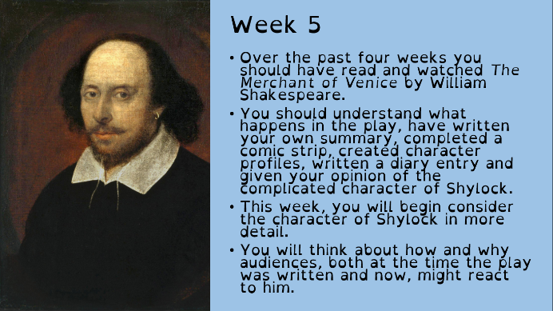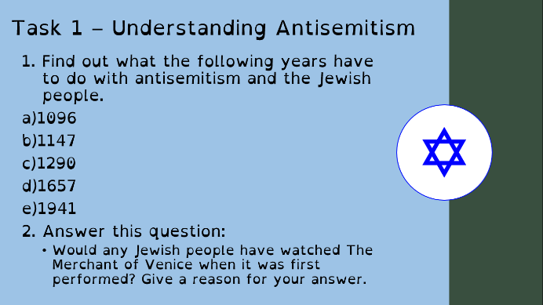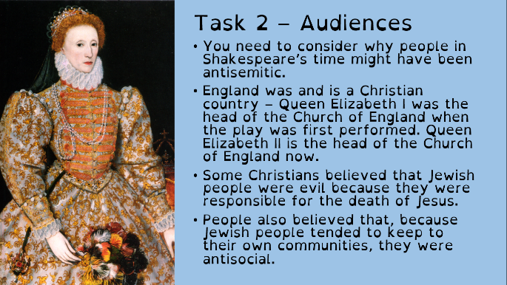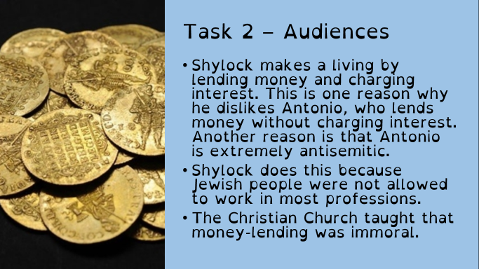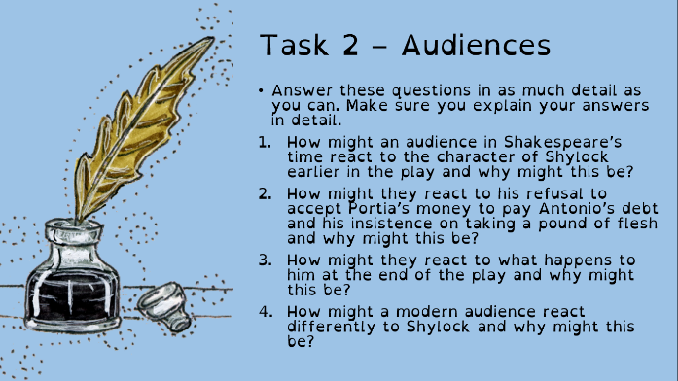
Maths | 8A1 | 8A2 |  | 8A3 | 8B1 | 8B2 |  | 8B3
 | Surface area and volume of cylinders  1) Complete the starter  2) Watch the videos and make notes where appropriate  3) Attempt all questions.  4) upload your work back to your teacher. |  |  | Change of topic for this week.  Subsitution.  Complete the starters in the PowerPoint.  Read through and understand the examples.  Complete the questions.  Complete the Mathswatch task titled Substitution.
Science | 8A1 | 8A2 |  | 8A3 | 8B1 | 8B2 |  | 8B3
 | Next we begin the topic of inheritance and genetics. Work will be eamiled on Monday. | For the last 2 weeks of school students will be set 3 educake assignments which give student the opportunity to review and consolidate the work done this year in science. These tasks can be completed over this week and next week |  | Continue with the Educake set last week.  DMA- I will be setting some work via a web-based app called Seneca, to help in the revision of the topics covered this year.  Work to be emailed out by Monday | Next we begin the topic of inheritance and genetics. Work will be eamiled on Monday. | Complete the Seneca assignment ‘6 July’ to revise the all chemistry covered this year. |  | DMA- I will be setting some work via a web-based app called Seneca, to help in the revision of the topics covered this year.  Work to be emailed by Monday
Technology | Graphics |  | Resistant Materials |  | Textiles |  | Food Technology
 | ‘Assemble’ your Poster:  This week we would be printing our posters and t-shirts using our own ‘blocks.’ Now since we can’t do any physical printing, we are going to have a go at doing a digital version on Powerpoint using the ‘binary’ images that you drew last week.  1) Import your images into Powerpoint and use your skills to copy/paste/recolour/resize your images to make a poster for your climate campaign.  You should also use the ‘remove background’ function in Powerpoint to cut individual shapes and images out of the background.  2) Download images of different merchandise items like t-shirts/flags/banners or anything else you can think of (think big!) and use Powerpoint (or Photoshop if you have it!) to add images from your campaign to create some prototype images for your campaign products.  Mr Cassidy will be In touch with further details. |  | Environmental Issues  1) Using Doddle Learn please watch the interactive powerpoint Environment and Sustainability 1 that have been assigned to your classes.  2) Watch the two short video clips on the internet:  https://www.youtube.com/watch?v=6R8YObQbE88  https://www.youtube.com/watch?v=B5NiTN0chj0&safe=active  3) For the challenge mentioned in the powerpoint rather than your classroom, design a recycling station for use at home – I know we could use one in our house! Draw your designs on paper or using the computer.  4) The powerpoint suggests you read further into environmental issues such as: Greenhouse effect; Greenhouse gasses; Melting of the polar Ice caps and Global warning. Use the internet and talk to people to find out more about these issues which will undoubtedly have a huge impact during your lifetime. |  | This week I would like you to focus on MANUFACTURING within the Textiles industry, considering mass and batch production.  Work thorough the presentations and interactive tasks on Doddle all focussed upon manufacturing. The work will go live on Monday 6th July and is due by Monday 13th July. |  | Vitamins fat soluble.  Produce a one-page profile on the following fat-soluble vitamins.  Vitamin A, D, E and K.  Why do we need these vitamins? What foods are they found in? How much do we need of each per day? What happens if we have too much of each vitamin? What happens if we are deficient of these vitamins?  You can add pictures to make your work interesting.  Please send your work to my school email address.
Geography | Virtual fieldtrip to the Bahamas.  For this week your task is to go on a virtual fieldtrip to evaluate if tourism should be developed in the Bahamas.  There will be a PowerPoint and a worksheet both will be in Assignments in TEAMS.  The PowerPoint has instructions on about what you need to do and there will also be a checklist to help you.  You need to complete the tasks and hand it in to your teacher on TEAMS via Assignments by 10th of July.
History | How were criminals caught in Victorian times?  Work to do  This week’s work is about the setting up of the Metropolitan Police Force. This is the first professional police force in Britain. Work to do:  1.Use slide 4 for context and underline the words which suggest there was a need for a police force  2.Draw a stick man and annotate around him what he might need to be a policeman (explain why next to each picture) See notes for the red herrings!  3.Complete the true or false quiz and challenge by correcting the false statements (answers on the notes section- so that you can self-assess your answers).  4.Use the video to make notes and /or the written information to build upon knowledge  5.Complete the question organiser to check your understanding check understanding  You can upload your work or take a photo and upload it - for feedback and ASPIRE.  Take care and keep safe.
RE | This week you should continue to work through the Shinto booklet from Eastern Religion and Philosophy booklet 3. This was emailed to you last week and is also saved in your Teams group.  Task 1- Make sure that you fill in the similarities and difference table in detail. In order to add more detail to this table you can do some extra research into Buddhism so that you can compare Shinto to Buddhism. See the website link below.  https://www.bbc.co.uk/bitesize/topics/znkxpv4  Task 2- Design or create your own Shinto shrine. This can be hand drawn or done on the computer. It should be labelled and you should provide a description. Challenge- Create a modal of the shrine. See the website below for more information, photos and inspiration  https://www.japan-guide.com/e/e2059.html
PE | EXPLORE – In rounders, the bowler is important in any team. Find a ball or an alternative. You will also need a hoop or piece of paper. Stand 10 yards away from a wall. How many times can you hit the same spot on the wall from the same distance? How many ways can you bowl the ball? Underarm? Overarm? Different arms? Different trajectories? In rounders, the ball must always be bowled underarm. Research the best technique and try this exercise out again using an effective under arm technique.  PRACTICE – You will need a family member. Bowl with the correct technique to your partner. Will they catch it between their head and knee? If so, that ball will count in a game. If not, it is a no ball. How many balls can you bowl correctly in 30 seconds? For a more difficult challenge, can you stand further away?  DEVELOP – Effective bowlers use different techniques to make it difficult for batters. You will now try a SPIN CHALLENGE. But a hoop or a piece of paper where the batter would stand. Spinning your wrist clockwise when you release the ball, can you still hit your target? Discuss with your family member why it may be difficult for the batter to hit this ball.
ICT | Tasks have been set on doddle. Please complete all revision tasks’ and the assessment quizzes set. This week you are being assessed on your knowledge of web researching techniques.  If you have made any progress on your COVID journal web page, please email it to Mr Cassidy for feedback.
Art | Detailed work will be set by email on Office 365 and if possible, students should respond to the teacher’s email to let them know they have completed the work.  Main Task: Create an evaluation page for your ‘Pop Art’ and ‘Islamic Art’ projects to show all the things you have learnt this year. Your Art teacher will send you a list of topics/skills you have covered this year, along with further instructions and examples, and you will need to create your evaluation page based on these. This can be done digitally on a computer or by hand, and can include illustrations, drawings, images, colour, mind maps, etc. to make it more visually appealing.  Homework Drawing Challenge: Something summery! See below for examples. Use the whole page and add tonal shading/colour. Try to spend at least 20 minutes on the drawing.  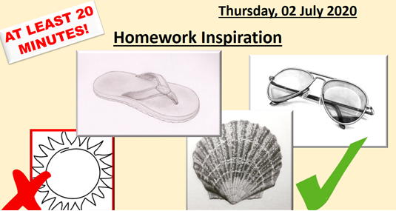
Drama | KS3 Drama Booklet  · Your teacher should now have sent you or told you where to find the KS3 Drama Booklet that you can work on up until the summer.  · Try and focus 40mins – 1hr a week on your Drama work, think of it as a lesson.  · You can choose the order in which you complete each activity, but focus on 1 a week.  · If you can’t print the booklet do not worry just create the work in any means you can.  · There are some actual booklets at school in reception if somebody can come and collect or Mrs McLeod will send some out in the post if you let her know.  · There are some extension tasks at the back that you can work on if you have more time.  Enjoy the work and let your teachers know how you are getting on even if it is just a quick message in teams or by email.
Music | Week 6  African music worksheet. The following worksheet will be sent out to by email or on teams. Answer the questions in full sentences and send to your teacher.  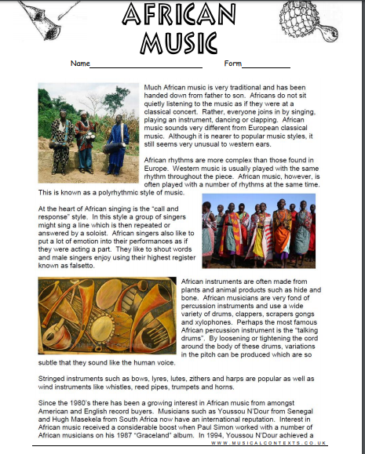
French | Information for 8a1 / 8a2 / 8a3  - This half term we are learning about sport, directions, injury and illness and using 3 tenses  - We will continue this week by learning how to talk about keeping fit. You will complete tasks in listening, reading and writing.  - You will be working from the powerpoints provided and the electronic version of the text book. Your work can be emailed or submitted on Teams.  - Your work for this week will be on Teams, dated Monday 6th July: “La forme”.  Information for 8b1 / 8b2 / 8b3  - This half term we are learning how to talk about sport in France, directions, illness and injury.  - This week we will be working on the topic of fitness.  - You will complete tasks in listening, reading and writing.  - You will be working from Powerpoint, the electronic version of the text book and YouTube.  - Your work can be emailed or submitted on Teams.  - Your work for this week will be on Teams, dated Monday 6th July: “La forme”.
German | - This half-term we are learning to talk about holiday plans and tourism in German.  - This week we will be consolidating our learning of how to recognise and use the future tense.  - We will be developing our language awareness and research skills.  - You will be working from the online text book, YouTube and Powerpoint.  - There is an extension task and a fun quiz for you to complete.  - You will find complete instructions for this week’s assignment, dated Monday 6th July, on Teams.

