Year 8 – Week Beginning 11th May 2020
English | Task 1  Weekly Writing Challenge: Aim to write 200 words. Include the word ‘Ubiquitous’-you will need to find out what this word means. Write down a definition.  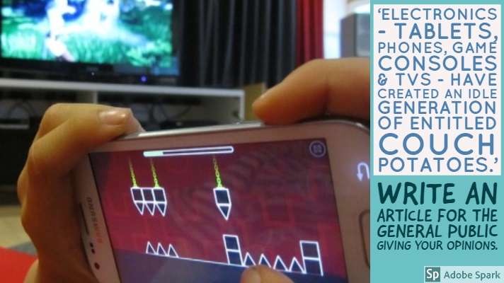  Task 2  Make a list of at least 5 things you have grown to appreciate more since the lockdown and coronavirus happened. You should draw or find an image to illustrate each item on your list. I think we have all appreciated lots of things. To help you get started, here are a few of mine:  - Family  - Hugs  - school  Task 3  Use the following link to access online lessons from the Oak Academy:  https://www.thenational.academy/online-classroom/year-8/english#subjects  Task 4  Use the following link to access English lessons from BBC Bitesize: https://www.bbc.co.uk/bitesize/articles/zvp8wty  If you fancy a bit of reading you can get lots of audiobooks for free from Audible: https://stories.audible.com/start-listen. You can listen to them and escape the world for a bit. There are some new activities available for you to complete on Doddle and you can keep working on the lessons on Bedrock. Stay safe and take care.
Maths | 8A1 | 8A2 |  | 8A3 | 8B1 | 8B2 |  | 8B3
 | This week we will be working on substitution.  1) Complete starter activity working on key skills  2) Read through all examples and watch any necessary videos  3) Complete the exercises  Keep pushing yourself. Work to your best. |  |  | This week’s work will continue on the topic of fractions.  Complete the starter tasks.  Complete the task on mixed numbers and improper fractions.  Complete the task on multiplying fractions.  Attempt extension questions.
Science | 8A1 | 8A2 |  | 8A3 | 8B1 | 8B2 |  | 8B3
 | JSC  This week we start and new set of three topics. We will begin a Biology topic called Muscles and Bones. Tasks will be emailed on Monday. | Students will start a topic on light.  They have 3 tasks to do using links and you tube videos. They will learn about:  Light and the electromagnetic spectrum, Reflection and refraction. |  | HLA – continue with current biology topic (muscles and bones). This week we’re looking at muscles. Resources and tasks will be emailed on Monday.  DMA – We are to look at how the eye works and what colour is. Work to be emailed by Monday. | JSC  This week we start and new set of three topics. We will begin a Biology topic called Muscles and Bones. Tasks will be emailed on Monday. | HLA – start a new biology topic (muscles and bones). This week were looking at the skeleton and its role and trying to name some bones. I will email resources and tasks on Monday. |  | DMA – Physics topic light.  You are to look at the human eye and how it works.  Colour and light- why things look the colour they do?  Work to be emailed by Monday.
Technology | Graphics |  | Resistant Materials |  | Textiles |  | Food Technology
 | We have been looking at nets. So far you will have created a paper bag and a dice. These both use nets to create simple 3D structures. This week I’d like you to create a more complex net, one for a character you will come up with yourself. Be imaginative! It could be a superhero (NHS or otherwise), an imaginary or real character, like a celebrity.  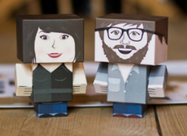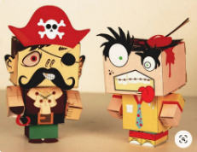  The images above show three different approaches to this task. There is also help with this task from Youtube.  1) Draw a 3D version of your design and add colour. You character could be made of more than one box.  2) Use a ruler to draw out the net to scale on a sheet of A4paper and add colour. Identify the fold and cut lines using dotted or solid lines.  3) Cut out your character and assemble.  Please email a photograph of your work to Mr Cassidy. |  | Last week using doddle (hopefully!) you learned about Smart Materials. This week let's build on that and look at them in use. What examples have you come across in use? (Sunglasses that darken, frying pans with red spots etc) Also enjoy having a look at the following links (copy and past them into your internet browser)  https://www.youtube.com/watch?v=BvTkefJHfC0  https://www.youtube.com/watch?v=IhVuc6RNyaw  https://www.youtube.com/watch?v=gzm7yD-JuyM  https://www.youtube.com/watch?v=JJfppydyGHw  Now have a look for some of your own. If you find something interesting, please email me the link. Thanks, Mr B.Hull |  | Create a ‘Guide to Textiles at WLD’ which could be given to the new Year 7 before starting in September. Create on an A4 piece of paper.  - What Health & Safety rules do you think they should definitely know?  - What textiles skills would you recommend them practicing before starting at WLD?  - Was there anything you wish you had known before starting Textiles?  Illustrate your guide with pictures and diagrams which help to explain your advice. |  | Vitamins fat soluble.  Produce a one-page profile on the following fat-soluble vitamins.  Vitamin A, D, E and K.  Why do we need these vitamins? What foods are they found in? How much do we need of each per day? What happens if we have too much of each vitamin? What happens if we are deficient of these vitamins?  You can add pictures to make your work interesting.  Please send your work to my school email address.
Geography | Coast Booklet  Complete questions 1-6 in the Coasts booklet found in TEAMS in your Geography class under “files”.  Use the website below to help you answer the questions  HTTPS://WWW.BBC.CO.UK/BITESIZE/TOPIC.S/Z6BD7TY
History | Who was the greatest Victorian?  Your task is to design and create a display cabinet/poster/video for a museum about the greatest Victorian. You will also need to make a short presentation or written account of why you think that person is the greatest Victorian.  Your teacher will give you further details about who can choose to research and criteria.  Please send photos of anything you create and your presentations/accounts to your history teacher. There will be history related prizes!  This project will last for 2 weeks.
RE | Read through the remote learning pack ‘Religions around the world- Eastern religion and Philosophy’.  Then complete the activities and questions from the booklet.This should be saved in your class Teams folder and can be emailed to you if you ask your RE teacher. Email your completed work to your RE teacher by Friday 21st May
PE | - Keep getting up and starting the day with Joe Wicks on Youtube  or  - Try a sally up challenge (see week two and youtube vid)  or  - Try a new fitness app  or  - Smash my 2.6k time or set your own and beat it. (see youtube vid)  or  - Try a skill challenge (week 6) or a different one  or  - Discover a great sports documentary and let us know about it
ICT
Art | Detailed work will be set by email on Office 365 and if possible, students should respond to the teacher’s email to let them know they have completed the work.  Main Task: Students to create a “half and half” drawing of an everyday object. One half of the drawing should be in their ordinary drawing style and one half should be in the style of their chosen artist (Andy Warhol, Claes Oldenburg, Roy Lichtenstein). Examples will be emailed to students to give them some creative ideas.  Homework Drawing Challenge: Draw a flower from observation. Use the whole page and add tonal shading/colour. Try to spend at least 20 minutes on the drawing.
Drama | The nest part of the task may take you through the next couple of weeks  Having been on your virtual journey it is time for you take up the challenge and tell me your own story.  - Imagine that you have been sent on this adventure like the contestants in the television programme to many countries.  - You have only 80 days to get from London and back.  - No flights on an aeroplane. I suggest you create a virtual/online diary and make an entry every day. An example:  - Day 1 March 25th: I boarded Euro Star a St Pancras station. As usual there was a long queue, the train was running late and when I got on the train someone was sat in my seat even though the reserve seat ticket was clear. The man in my seat was clearly annoyed about having to move. At last the train pulled out of the station Paris bound.  - Noon I arrive in Paris, I locate a taxi and arrive at the Café Royale, I sample delicious coffee and a freshly baked pain au chocolate before taking a sail along the Seine to view the remains of Notre Dame Cathedral.  Before setting out plan your journey of how you intend to travel and where you will stay.  One day when you are old enough to travel you may try your own travel log out .  Jules Verne, the author was a very interesting man.  - Find out about the author and the other books that he has written.  ENJOY!
Music | Lyric writing exercise – Follow the power point to help you write your own blues lyrics. The power point it loaded into Teams, or added as an assignment.
French | Information for 8a1 / 8a2 / 8a3  - This half term we are learning about the weather, local area, household chores, daily routine, town and countryside.  - We will continue with using the language we have learnt to translate a text.  - You will begin to write descriptions of photos, using the relevant language we have learnt.  - You will be working from the powerpoints provided and the electronic version of Dynamo 2 (rouge).  - Your work can be emailed or submitted on teams.  - Your work for this week will be on Teams, dated Monday 11th May: “ma région”  - Please note: 8A1 and 8A2, as you only have one lesson of French a week, you will be expected to complete fewer tasks than 8A3. HOWEVER, PLEASE FEEL FREE TO COMPLETE MORE!  Information for 8b1 / 8b2 / 8b3  - This half term we are going to be learning about the weather, local area, household chores, daily routine, town and countryside.  - We will continue with learning about how to talk about where people live. We will consolidate learning from previous tasks and learn to understand and make different sentence types.  - You will be working from the powerpoints provided and the electronic version of Dynamo 2 (vert).  - Your work can be emailed or submitted on teams.  - Your work for this week will be on Teams, dated Monday 11th May: “ma région”  EXTENSION: THERE ARE CHALLENGE TASKS AT THE END OF THE POWER POINT.  PLEASE FEEL FREE TO HAVE A GO!
German | - This half-term we are learning how to talk about our local area in German.  - This week we will continue our learning about shopping for gifts and souvenirs.  - We will develop our listening, reading and writing skills.  - You will be working from a worksheet and Doddle.  - You can turn in or email your work.  - Go to Teams to find complete instructions for this week’s assignment dated Monday 11th May.

