Year 8 – Week Beginning 8th June
Please look at the PSHE resources – https://www.waltonledale.lancs.sch.uk/curriculum/what-are-students-learning-now/pshe
Please look at the Thought for the Week – https://www.waltonledale.lancs.sch.uk/curriculum/thought-for-the-week
If you need to catch up on previous weeks then you will find them at this link - https://www.waltonledale.lancs.sch.uk/curriculum/what-are-students-learning-now/other-curriculum-maps

English | The Merchant of Venice  Over the next few weeks, you will be studying The Merchant of Venice by William Shakespeare. Your teacher will email you a PowerPoint of activities to work through and this will also be uploaded to the files area of Teams for your class. There will be other resources that you need there too, and you will need to produce some writing – either on paper or on a word processor such as Word. You should complete tasks 1-2 this week.  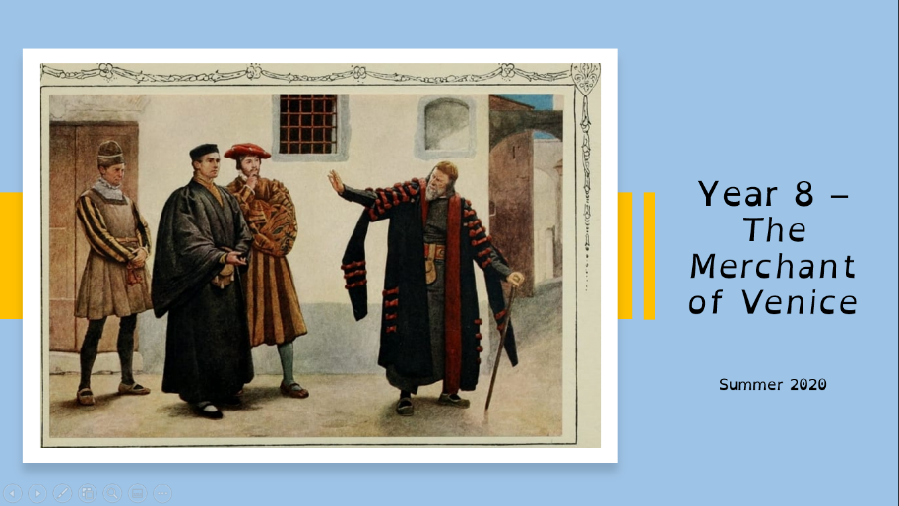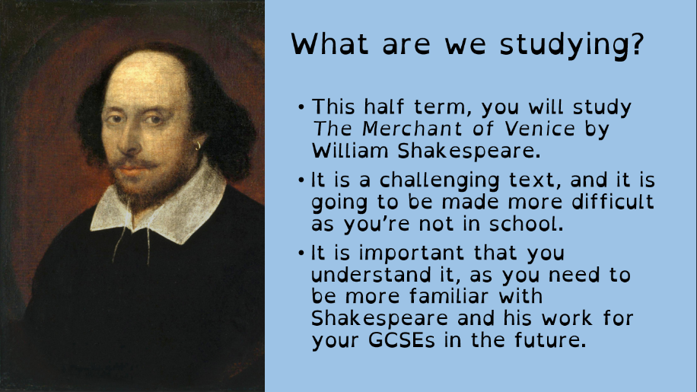  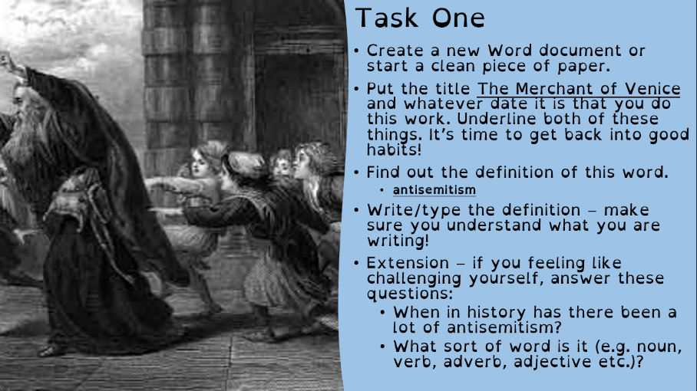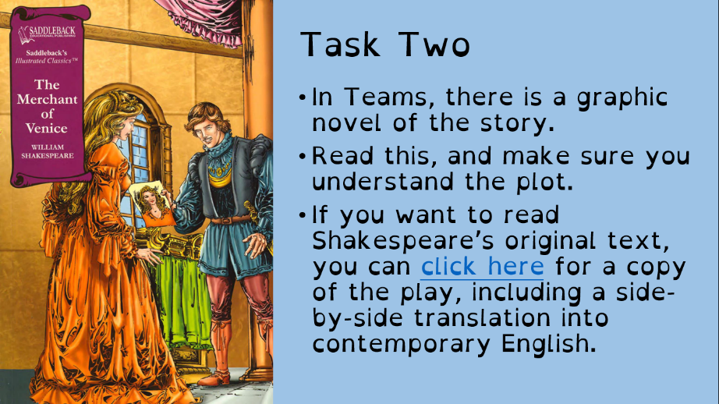  You can also use the following link to access daily lessons from BBC Bitesize:  https://www.bbc.co.uk/bitesize/articles/zrmwqp3  You can also access English lessons from the Oak Academy using the following link:  https://www.thenational.academy/online-classroom/year-8/english#subjects  If you fancy a bit of reading you can get lots of audiobooks for free from Audible: https://stories.audible.com/start-listen. You can listen to them and escape the world for a bit. There are some new activities available for you to complete on Doddle and you can keep working on the lessons on Bedrock. Stay safe and take care.
Maths | 8A1 | 8A2 |  | 8A3 | 8B1 | 8B2 |  | 8B3
 | Hi all,  1) Complete starter activity.  2) Read notes on Volume of prisms.  2b) If you need to recap last weeks work, do it.  3) Complete the questions  4) Attempt the challenge questions.  5) Get your work back! |  |  | A change of topic now. We will be looking at Averages and Range.  Complete the starter tasks.  Look through and understand the examples.  Answer the questions.
Science | 8A1 | 8A2 |  | 8A3 | 8B1 | 8B2 |  | 8B3
 |  | This week we will be continuing with the topic C9. The tasks are lesson 3 and 4 on Neutralisation and reactions with oxygen. |  | HLA – revision of B9 Muscles and Bones. See my email on Monday for more information.  DMA – we will finish off the reactions of acids and recap on the Physics light topic. |  | HLA – this week we’re having a look at prosthetic limbs, I’ve got a podcast for you to listen to and a TV program for you to watch. See my email on Monday for more information. |  | DMA- This week we will start the biology topic B9 about muscles and bones. Starting with bones. Work to be emails by Monday.
Technology | Graphics |  | Resistant Materials |  | Textiles |  | Food Technology
 | Continuing with our project ‘Designing the Rebellion’ in which we will be creating our own ecological activism group, this week we will be thinking about how we will organize our group and the rules they will need to follow. We will do this by looking at a case study as an example, this is the environmental activist group Extinction Rebellion. I’m sure many of you will have heard of them. There is a great deal of discussion about them in the news. We will also design the logo that will be the symbol of our campaign.  Tasks this week:  1) Read through the PowerPoint and play any videos if you can.  2) Look in detail at the images and keywords on Slide 6. Write a paragraph to answer the question under the heading: ‘You have the right to protest but is it the right thing to do?’ You must use as many of the keywords on the screen as you can.  3) Next you need to think of a name for your group. It’s a good idea to link it to what your group stands for. Write one sentence to explain this, for example: ‘Reefkind is a group who want to raise awareness about the devastating damage being caused to the Great Barrier Reef and to encourage people to be kinder to it.’  4) Design the logo for your group. It should incorporate symbols that relate to what you’re fighting for.  5) Finally, look at the ‘Rebel Agreement’ example given on the slide. Under the heading ‘Rebel Rules’, I want you to write your own 5 rules, that your campaign members must follow. Include one final rule that states what your group stand for. |  | This will add to last week’s ‘plastics’ work on Doddle:  1) Look around the home at items and see what is made from plastic. Look carefully at it (perhaps underneath) You should see a number and / or letters inside a recycling symbol on rigid items or names of plastics on the label of fabrics (many of which are actually plastic!)  2) Google what the plastic recycling symbols mean.  3) Try to get better at guessing what the plastic item is made from before you look at the symbol.  4) Items going into your plastic recycling bin are a particularly good hunting ground!  5) Next time your shopping – try to avoid buying as much single use plastic packaging! |  | Going forward I would like you to be thinking about where different fibres come from and how they are processed to make different fabrics and materials. Therefore, please watch the following YouTube clips on fabric production. On a Word.doc please make notes on the processes, are there any similarities between them? How are they different? Which process did you find the most fascinating? If possible, email across your notes or send via Teams.  Cotton - https://www.youtube.com/watch?v=QHgNoSYlhYs  Fleece - https://www.youtube.com/watch?v=T29w8KkFaV0  Silk - https://www.youtube.com/watch?v=eqFm_7KyfHI |  | Fats  On a word document that can be emailed to my school email I would like you this week to research fats.  Good fats and bad fats. What are they? Why are some good and some bad? What do the bad fats do to our body if we eat too much of these? What happens if we don’t eat the correct amount or not enough fat? Why do we need fats? What foods are fats found in. Add pictures of different types of fats good and bad.  What types of illness can bad fats cause?  How can obesity be reduced? Come up with 5 points how to reduce obesity.
Geography | Coasts Booklet  Complete sections 16 and 17 about coastal landforms.  Use the following website to help:  https://www.bbc.co.uk/bitesize/guides/zxj6fg8/revision/1
History | Medicine in the 18th and 19th Centuries  Last week you learnt about 19th Century Industrial towns and what it was like to live in them and the dangers to health. This week you are going to study medicine in this period. This was a crucial time in the history of medicine – the first ever vaccine was discovered and then the real cause of disease – germs were discovered.  Use the link below:  - Read the information on the website.  - Watch the 3 videos on the website.  - Use all of the information to create an information poster about medicine in the 19th Century. Include at least 10 facts, 5 key names and make it as colourful and eyecatching as you can.  - Email your work or a photograph of your work to your teacher.  https://www.bbc.co.uk/bitesize/articles/zk3djhv
RE | Continue to work through the second booklet about Buddhism that was sent to you. This is also saved in your Teams group area. Email your RE teacher if you need assistance in accessing this work . Don’t forget to send in photo’s of your Buddhist prayer flags. This could be a hand drawn picture or you could get creative and use a piece of old material, paints/ felt tips/recycled products.  You could also use the following websites for more information  https://www.bbc.co.uk/bitesize/topics/znkxpv4  https://www.youtube.com/watch?v=JjmTnEaA1v4
PE | As we move into the Summer season, we are going to focus on some Summer sports. This week, we will be focussing on Cricket fielding.  This week, we will be focussing on a Bronze, Silver and Gold skill, with each skill becoming more difficult as you move up the ranking.  Bronze: A ball is needed, a soft toy or some socks rolled up. Try and pass the ball around different parts of your body, such as your waist, head, legs etc. Change the direction. How many times can you do this in a minute? Which body parts are more difficult to move around and why? Extension: Can pass the ball through your legs in a figure of 8 motion? ONLY HAVING ONE HAND ON THE BALL AT ONE TIME!  Silver: More space will be needed for this activity. Firstly, put the ball on the floor and practice picking it up quickly in one hand and then putting it back down. How many times can you do so in a minute? Following this, put the ball on the floor and practice running up to it and picking up and getting into a throwing motion before putting it back down, how many times can you do this in a minute? Finally, either roll it yourself or get a family member to do so, and practice running towards a rolling ball, picking it up and getting ready to throw it at the stumps!  Gold: Fielding in Cricket and being able to throw it at the stumps is a vital part of the game. You are going to develop a turn and throw game to help you with this. Make a target (outside, or if inside, something that won’t break/soft ball), and practice turning around with the ball/turning around a picking up the ball and throwing it  at the target. Ensure you make up a scoring system to help you gage your progress. If it's too easy, make the target smaller.  Extension task: Geography – In England, there are 18 County Cricket Clubs. Warwickshire Play in Birmingham. Find out where the other 17 Counties play, what city they play in, and find it on a map.
ICT | All tasks this week are set on Doddle.  This week students are completing tasks to practise extracting data effectively to develop their researching skills.  Adobe Flash player might need to be downloaded for some tasks/presentations.  In addition to this please read the following articles: https://www.cultofpedagogy.com/retrieval-practice/  https://blog.dmtraining.net/blog/bid/337833/5-strategies-for-successful-information-gathering  If you have any issues accessing or completing any of this work, please contact Mr Cassidy.  Thanks also to the many students submitting fantastic web journals. If students wish to continue their COVID-19 learning journals, giving updates about their experience of this very unusual time, please do so. I have really enjoyed reading them! I will continue to award Class Charts points for those who do so.
Art | Detailed work will be set by email on Office 365 and if possible, students should respond to the teacher’s email to let them know they have completed the work.  Main Task: This is the last week for you to finish off your Pop Art logo squares. Focus on how you arrange and present your squares. Do you have enough squares to form a piece of artwork in a rectangle or square? Try to complete as many individual logo squares as possible and then arrange them into your overall piece of artwork. If you don’t have the right number of squares to form a big square or rectangle then you could arrange in a special way (see example below). Please send a photo of your finished designs to your teacher if you can!  Homework Drawing Challenge: A towel. Focus on the texture, folds, and creases! Use the whole page and add tonal shading/colour. Try to spend at least 20 minutes on the drawing.  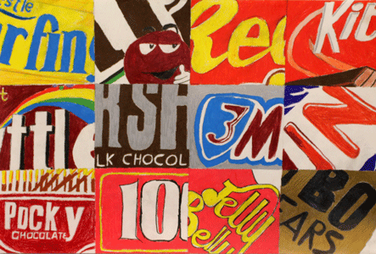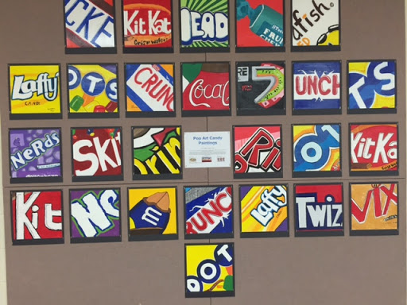
Drama | - For the next few weeks you are going to be working through a Drama Skills booklet tracking your skills and keeping a journal of your experiences.  - Your Drama teacher will email you the booklet.  - If you need a hard copy some will be available in reception or contact Mrs McLeod and she will send you one in the post.  - Log on to teams and the resources will be there for you to access.
Music | Week 2: Your teacher will email you all the resources that you need.  Chanting.  African music uses a lot of chanting.  This week you are going to learn the chant/song O Ye Narimbo.  Listen to the example of the song.  There is also a sound clip to help you with your pronunciation of the words.  It is unaccompanied. Can you record yourself performing the song and send it to your teacher?  Could you teach it to the people you live with and perform it together?
French | Information for 8a1 / 8a2 / 8a3  - This half term we are going to be learning about the weather, local area, household chores, daily routine, town and countryside.  - We will continue our learning with the daily routine topic. You will complete tasks in listening, reading and writing.  - You will be working from the power points provided, the electronic version of Dynamo 2 (rouge) and YouTube.  - Your work can be emailed or submitted on teams.  - Your work for this week will be on Teams, dated Monday 8th June: “ma routine, ta routine”  Information for 8b1 / 8b2 / 8b3  - This half term we are going to be learning about the weather, local area, household chores, daily routine, town and countryside.  - We will continue our learning with the daily routine topic and we will revisit the past tense. You will complete tasks in listening, reading and writing.  - You will be working from the powerpoint provided, the electronic version of Dynamo 2 (vert) and YouTube.  - Your work can be emailed or submitted on teams.  - Your work for this week will be on Teams, dated Monday 8th June: “Ma routine, ta routine”
German | - This half-term we will be learning to talk about holiday plans and tourism in German.  - This week we will consolidate our work on recognising verbs, so that we can then start to work in more depth on the future tense.  - We will be developing our language awareness and dictionary skills.  - You will be working from an explanatory worksheet, an online dictionary and a powerpoint.  - There is an extension task for you to complete.  - You will find complete instructions for this week’s assignment, dated Monday 8th June, on TEAMS.

