Year 8 – Week Beginning 15th June
Please look at the PSHE resources – https://www.waltonledale.lancs.sch.uk/curriculum/what-are-students-learning-now/pshe
Please look at the Weekly Reflection – https://www.waltonledale.lancs.sch.uk/curriculum/thought-for-the-week
If you need to catch up on previous weeks then you will find them at this link - https://www.waltonledale.lancs.sch.uk/curriculum/what-are-students-learning-now/other-curriculum-maps

English | The Merchant of Venice  You are continuing with your study of The Merchant of Venice by William Shakespeare. Your teacher has already emailed you a PowerPoint of activities to work through and this has also been uploaded to the files area of Teams for your class. There are other resources that you need there too, and you will need to produce some writing – either on paper or on a word processor such as Word. You should complete tasks 3-5 this week.  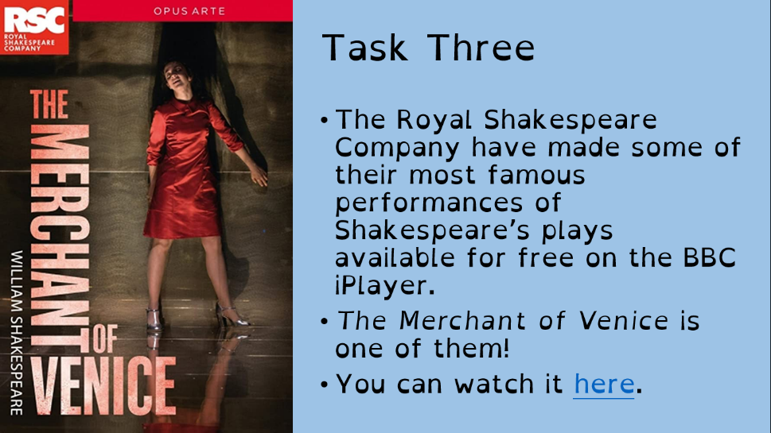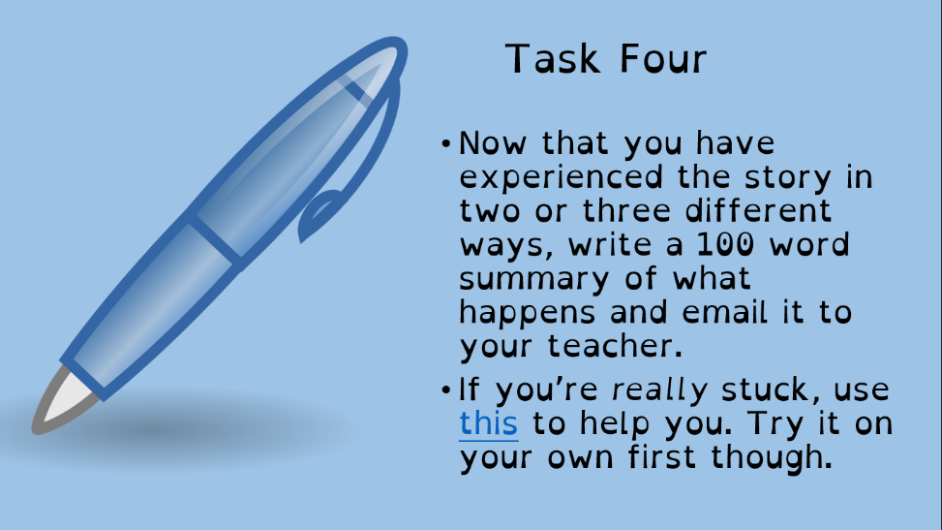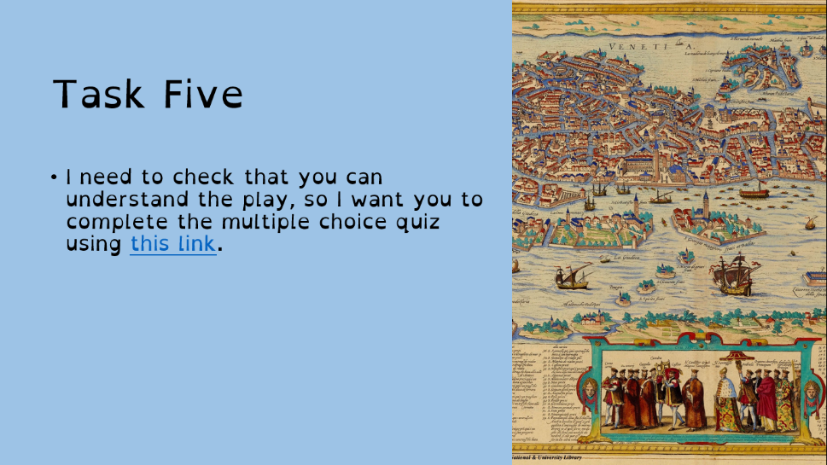
Maths | 8A1 | 8A2 |  | 8A3 | 8B1 | 8B2 |  | 8B3
 | Hi all – This week’s topic is surface area.  1) complete starter activity re-enforcing past knowledge.  2) Read the notes AND watch the integrated videos explaining the problems.  3) Complete the questions with full working out  4) attempt challenge questions.  Re-read any notes from previous weeks. Good luck! |  |  | Understanding tables and charts  Complete starters.  Read and understand powerpoint – use Mathswatch videos if you wish.  Answer the questions.
Science | 8A1 | 8A2 |  | 8A3 | 8B1 | 8B2 |  | 8B3
 | JSC Work is to continue with the topic of “light”, this weeks focus is reflection of light using mirrors and to look at how periscopes work using mirrors. | Students will complete a series of lessons to look at the skeleton, muscles and Joints in the human body |  | HLa – continue to revise B9 Muscle and Bone. I will email tasks and resources on Monday.  DMA- Start revision of the physics and chemistry topics. Work to be emailed by Monday | JSC Work is to continue with the topic of “light”, this weeks focus is reflection of light using mirrors and to look at how periscopes work using mirrors. | HLa – Continue to revise B9 Muscle and Bone, I will email tasks and resources on Monday. |  | DMA- To continue with last week's work on muscles and bones. I will email work my Monday.
Technology | Graphics |  | Resistant Materials |  | Textiles |  | Food Technology
 | Last week students in Graphics designed the logo or symbol and the rules for their activist group to follow. This week we are going to look at the kinds of images that could be used and the way in which they might be produced.  Tasks for this week:  1) Read through the presentation and video if you’re able to. Try downloading and ‘open with’ a media player if you’re having trouble.  2) Create a mood board full of images that relate to your campaign.  3) Use your mood board to create 3 sketches based on the images you have researched. You can do this either from observation or by tracing the image. You can use shading and/or colour.  4) For each of your sketches, write at least 3 annotations (neatly written comments next to the image) to explain why this image wold be suitable for your campaign and what the connotations of this image might be.  Please email me with any queries or questions you may have. |  | Using Doddle, Mr Hull’s classes have been assigned a unit of work on Smart Materials. (if for any reason Doddle does not work for you, use the internet to search for Smart Materials – you will get lots of resources to learn from). You will have seen some of these in use but perhaps not realised how they work. Next week we will be looking at smart materials in our everyday lives; perhaps get a head start now you know what you are looking for. |  | Using Doddle Mrs Miller’s groups have been assigned a unit of work on fibres to reinforce the work completed over the last two weeks. |  | Food Miles  Produce a one page-profile on Food Miles. Email this research piece to my school email please. What are Food Miles? How can we reduce our Food Miles? How do Food miles impact the environment? Suggest 5 ways in which we can reduce our Food miles. You could add pictures or a flow chart or a graph that represents Food travelled halfway round the world and finished in your kitchen looking at all the different methods of transport used for its journey.
Geography | Complete questions 19-20 in the Coasts booklet found in TEAMS in your Geography class under “files”.  Use the website below to help you answer the questions  HTTPS://WWW.BBC.CO.UK/BITESIZE/TOPIC.S/Z6BD7TY
History | Why are people arguing about old statues?  There has been a lot in the news, about a statue that was pulled down and thrown in the docks at Bristol. This week you are going to think about why that happened and what you think about it. There is a link between this event and the history topic that you studied after Christmas – the Atlantic Slave Trade.  - Watch the Newsround Special to gain an introduction to the events. Click on the link below:  https://www.bbc.co.uk/newsround/52978346  - Read the information in the Newsround article - Edward Colston: Why are people arguing about statues?  Click on the link below for the article:  https://www.bbc.co.uk/newsround/52965665  - Use the article to answer the questions – in your own words:  - Who was Edward Colston?  - Why do we have statues of people?  - What does the word ‘controversial’ mean?  - Why are some statues controversial?  - What are the arguments for and against removing statues?  - Having watched the Newsround programme and read the article – write a paragraph answering the question:  Do you think that it was right to remove the statue of Edward Colston? Explain your answer.
RE | You should work through the next booklet that includes information and tasks about Buddhist beliefs in the afterlife. This will be emailed to you and saved into your Teams group. The work also includes some case studies about people who believe they have past life memories and the evidence they give for this. You should then fill out the grid thinking about the question 'Is reincarnation real?'  Email your RE Teacher with your work.
PE | All work this week will be emailed to you, there are written tasks and practical tasks let us know how you get on.  It’s important that you are staying as active as possible whether it’s going out for a walk, run or bike ride or even doing a little workout at home.  Physical activity does wonders for our mental health and wellbeing.  Have a great week and check your emails for the powerpoint
ICT | Tasks have been set on Doddle for students to complete online. Please contact Mr Cassidy if you have any problems logging in to Doddle.  Tasks this week look at how to make more reliable searches online and also how to evaluate the effectiveness of ICT products...something many of us are getting to understand very well at the moment!  In addition to this, students should look at the following blogs and articles:  https://websitebuilders.com/how-to/learn-to-search/advanced-web-search/  https://blog.hubspot.com/marketing/google-advanced-search-tips
Art | Detailed work will be set by email on Office 365 and if possible, students should respond to the teacher’s email to let them know they have completed the work.  Main Task: Pop Art Packaging (examples will be emailed to students). This week, choose a type of packaging you can find in your house, e.g. crisp packet, tin, drinks bottle etc. and then draw the packaging/label/logo but inject a pop art style into the design. This could be through your style of lettering, the colours you use, a pattern like Ben Day dots or Lichtenstein-style lines, etc. If you have access to materials, you could even work directly on to an empty packet/box/tin to bring a 3D element to your work, or you could create the label/design in 2D on paper/card then attach it to the object.  Homework Drawing Challenge: Your school tie. Focus on the pattern, shape, and details. Use the whole page and add tonal shading/colour. Try to spend at least 20 minutes on the drawing.
Drama | KS3 Drama Booklet  - Your teacher should now have sent you or told you where to find the KS3 Drama Booklet that you can work on up until the summer.  - Try and focus 40 mins – 1hr a week - on your Drama work; think of it as a lesson.  - You can choose the order in which you complete each activity, but focus on 1 a week.  - If you can’t print the booklet do not worry, just create the work in any means you can.  - There are some actual booklets at school in reception if somebody can come and collect or Mrs McLeod will send some out in the post if you let her know.  - There are some extension tasks at the back that you can work on if you have more time.  Enjoy the work and let your teachers know how you are getting on, even if it’s just a quick message in teams or by email.
Music | Week 3  Polyrhythms  Polyrhythms means many rhythms.  Follow the PowerPoint and try clapping and saying the rhythms and then create 3 rhythms of your own and send them to your teacher.
French | Information for 8a1 / 8a2 / 8a3  - This half term we are learning about sport, directions, injury and illness and using 3 tenses.  - We will start module 5 by learning about popular sports in France.  - You will complete tasks in listening, reading and writing.  - You will be working from powerpoint, the electronic version of Dynamo 2 (rouge) and YouTube.  - Your work can be emailed or submitted on Teams.  - Your work for this week will be on Teams, dated Monday 15th June: “Le sport en France”.  Information for 8b1 / 8b2 / 8b3  - This half term we are working from module 5 and learning about sport in France, directions, illness and injury.  - We will revise and extend our knowledge of language around sport. You will complete tasks in listening, reading and writing.  - You will be working from powerpoint, the electronic version of Dynamo 2 (vert) and YouTube.  - Your work can be emailed or submitted on Teams.  - Your work for this week will be on Teams, dated Monday 15th June: “Le sport en France”.
German | Learning about the future tense  - This half-term we will be learning to talk about holiday plans and tourism in German.  - This week we will be learning how to recognise and use the future tense.  - We will be developing our language awareness and dictionary skills.  - You will be working from a powerpoint and an online dictionary.  - There is an extension task and a creative extra extension task for you to complete.  - You will find complete instructions for this week’s assignment, dated Monday 15th June, on TEAMS.

