Year 8 – Week Beginning 22nd June
Please look at the PSHE resources – https://www.waltonledale.lancs.sch.uk/curriculum/what-are-students-learning-now/pshe
Please look at the Weekly Reflection – https://www.waltonledale.lancs.sch.uk/curriculum/thought-for-the-week
If you need to catch up on previous weeks then you will find them at this link - https://www.waltonledale.lancs.sch.uk/curriculum/what-are-students-learning-now/other-curriculum-maps

English | The Merchant of Venice  Your study of The Merchant of Venice continues this week. Please make sure you completed the work on the first PowerPoint, then complete tasks 1 and 2 on the PowerPoint for this week and next. If you have any questions, please contact your English teacher via email or Teams.  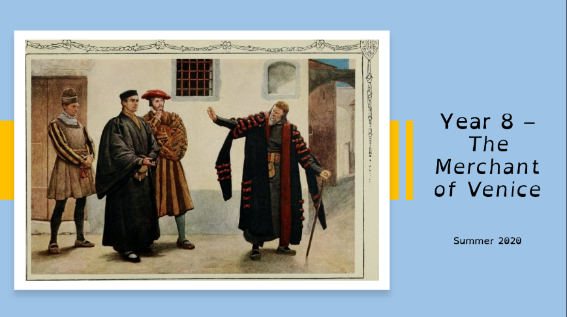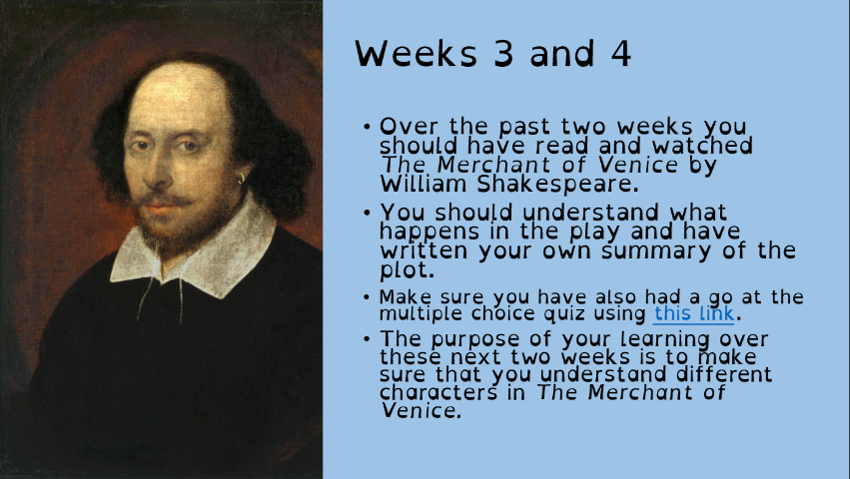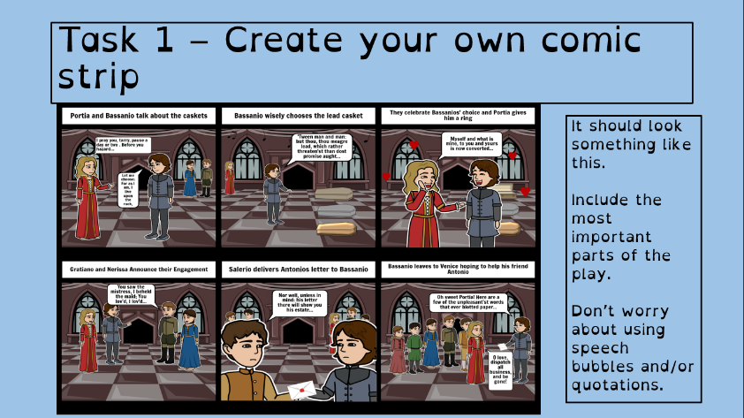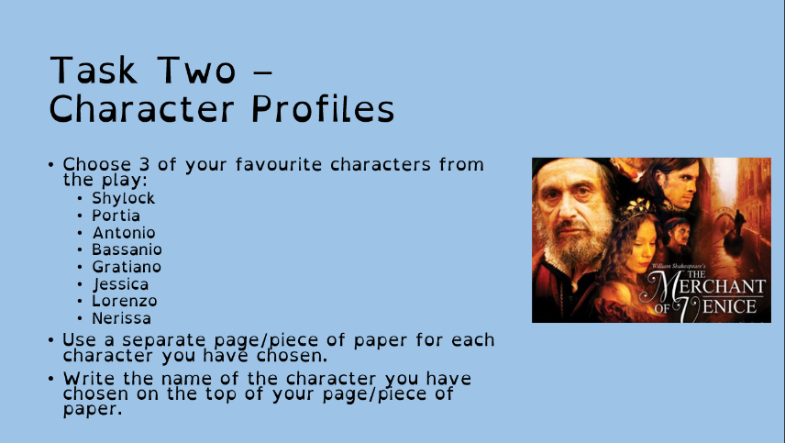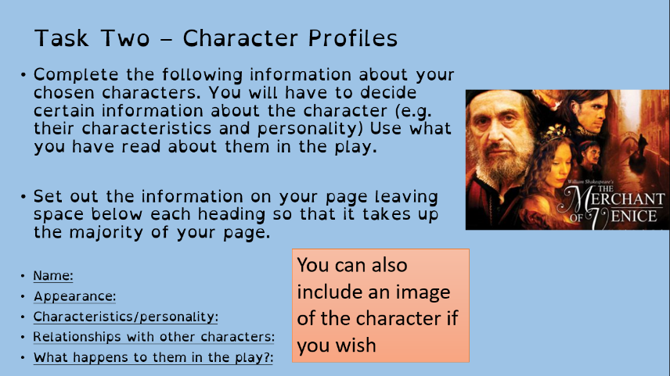
Maths | 8A1 | 8A2 |  | 8A3 | 8B1 | 8B2 |  | 8B3
 | Area and Circumference of Circles  1) Complete starter activity  2) Read all notes and watch all videos.  3) Complete task 1  4) Complete codebreaker activity  5) Complete mathswatch work  6) Return all work to your class teacher.  Thanks |  |  | This week’s topics are Stem and Leaf Diagrams and Pie Charts.  Complete the starters.  Understand the PowerPoint and watch Mathswatch videos.  Complete the tasks in the PowerPoint and Mathswatch.
Science | 8A1 | 8A2 |  | 8A3 | 8B1 | 8B2 |  | 8B3
 | JSC – Students will be working on the topic of light, specifically the colours that make up “white light” and how they are split producing the visible spectrum. | Students will be completing revision this week on the last 3 topics studied ready for a test next week:  B9 Muscles and bones  C9 Reactions with acids  P9 Light |  | Tri test 9 – Please complete the Educake. | JSC – Students will be working on the topic of light, specifically the colours that make up “white light” and how they are split producing the visible spectrum. | Tri test 9 – please complete the Educake |  | To revise topics for test and do educake test. Revision sheets will be emailed by Monday. Any problems let me know by email.
Technology | Graphics |  | Resistant Materials |  | Textiles |  | Food Technology
 | We are continuing with our project ‘Designing the Rebellion!’ Looking at the news in recent weeks it seems more appropriate than ever!  Last week, I asked you to complete a mood board. This should be a collection of images that will be relevant to your campaign.  This weeks’ tasks:  Complete tasks all about the environment on Doddle.  I have been conscious this week that some people need a little ‘catch up’ time in order to get fully up-to-date with work for this project. So please use this week to do so if that’s you. A list of tasks up to this point will be emailed out to everyone. Please ensure these are completed as part of this week’s work.  Further information will be emailed to students. Please contact Mr Cassidy with any questionsyou may have. |  | Last week using doddle (hopefully!) you learned about Smart Materials. This week let's build on that and look at them in use. What examples have you come across in everyday life? (Sunglasses that darken, frying pans with red spots, baby spoons that change colour etc.)  1) Make a list of one you can think of and add to it as you see more.  2) Also, enjoy having a look at the following links (copy and paste them into your internet browser)  https://www.youtube.com/watch?v=BvTkefJHfC0  https://www.youtube.com/watch?v=IhVuc6RNyaw  https://www.youtube.com/watch?v=gzm7yD-JuyM  https://www.youtube.com/watch?v=JJfppydyGHw  3) Now have a look on the internet for some examleps of your own. If you find something interesting, please email me the link. Thanks, Mr B.Hull@waltonledale.lancs.sch.uk  Extension – Invent your own smart / modern material. What would it do? Perhaps a super strong glue that could be ‘undone’ (great for practical jokes!), something that could conduct electricity without the need for wires? Get your imagination working. |  | Following on from the in depth look at fibres and fabrics over the last three weeks we will now focus our learning on their specific purposes and how we use them.  You will be sent an email via Office 365 on Monday with a booklet to complete which will require you to look carefully at different professions and how we as individuals protect our clothing.  Please return work via email or Teams if you are able to do so. As always if you have any questions do get in touch. |  | Food Air Miles  This is a research project. Produce a one-page profile on Food Air Miles. Add pictures from the internet. Send your work to my school email address please.  What are food Air Miles? Are Food Miles good or bad for the environment? How could we reduce Food Air Miles? Suggest 5 ways in which we could reduce our Food Air miles.  Extension work.  Research the foods that grow or are caught or are reared in Lancashire. What types of farms are there in Lancashire? Do you agree that more people could buy local foods? What would be the advantages of buying local?
Geography | Complete questions 19-20 in the Coasts booklet found in TEAMS in your Geography class under “files”.  Use the website below to help you answer the questions  HTTPS://WWW.BBC.CO.UK/BITESIZE/TOPIC.S/Z6BD7TY
History | Popular Protests  During the period 1750-1900 many people wanted to change peoples’ lives for the better. At this time, only the richest 5% of men in England could vote. People tried to bring about change in different ways – using political methods or using violent methods.  Work to do:  - Read the information on the PowerPoint and complete the activities on the PowerPoint.  - Choose one of the protest groups: Chartists, Luddites, Rebecca Riots or the Captain Swing Rioters and write a letter from a supporter. In the letter explain why they were protesting, what methods they were using and what changes they wanted. You could do it on paper and dye your paper brown with a teabag or you could illustrate it.  Send a photo or a copy of your work to your history teacher or upload it to TEAMS.
RE | Continue to work through the Buddhism and Reincarnation booklet. The booklet and PowerPoint will have been emailed to you and saved on Teams. Email your RE teacher if you need another copy. You should also learn and practice the key words at the front of the booklet. Try to use some of this vocabulary in your final answer.  You should email your completed work to your teacher.
PE | Joe wicks on Youtube – Monday, Wednesday and Saturday from now on, keep up the good work you have been doing. If you have not already done any physical activity, it's never too late. Go for a bike ride or a long walk, anything is better than nothing. All previous PE lesson by Joe Wick are available on his Youtube channel.  It’s National School Sports Week next week – Please look out for an email from Mrs Sweeney which will have an attachment giving you lots of different ways to take part in this week.
ICT | All work is set on doddle.  Students this week are learning about ICT applications in mobile apps. They are looking at how these applications are evolving and how they might be used in the future, including how they may be used to help fight the Coronavirus around the world. Please also read the following articles: https://www.itv.com/news/2020-05-04/smartphone-apps-being-used-to-fight-coronavirus/  https://www.wionews.com/opinions-blogs/explained-can-mobile-apps-aid-the-fight-against-coronavirus-293804  https://www.theguardian.com/world/2020/mar/27/watchdog-approves-use-uk-phone-data-if-helps-fight-coronavirus
Art | Detailed work will be set by email on Office 365 and if possible, students should respond to the teacher’s email to let them know they have completed the work.  Main Task: Pop Art Packaging (continued). Focus on completing the line drawing (we will add colour next week) of your pop art-style packaging and then send a photo of the drawing to your Art teacher. If you have chosen to work on something 3D then please also send a photo of your model to your teacher to receive feedback on how to improve it.  (Information from last week) Choose a type of packaging you can find in your house, e.g. crisp packet, tin, drinks bottle etc. and then draw the packaging/label/logo but inject a pop art style into the design. This could be through your style of lettering, the colours you use, a pattern like Ben Day dots or Lichtenstein-style lines, etc. If you have access to materials, you could even work directly on to an empty packet/box/tin to bring a 3D element to your work, or you could create the label/design in 2D on paper/card then attach it to the object.  Homework Drawing Challenge: Cushion or pillow. Focus on the creases, folds, pattern, shape, and details. Use the whole page and add tonal shading/colour. Try to spend at least 20 minutes on the drawing.
Drama | KS3 Drama Booklet  · Your teacher should now have sent you or told you where to find the KS3 Drama Booklet that you can work on up until the summer.  · Try and focus 40mins – 1hr a week on your Drama work, think of it as a lesson.  · You can choose the order in which you complete each activity, but focus on 1 a week.  · If you can’t print the booklet do not worry just create the work in any means you can.  · There are some actual booklets at school in reception if somebody can come and collect or Mrs McLeod will send some out in the post if you let her know.  · There are some extension tasks at the back that you can work on if you have more time.  Enjoy the work and let your teachers know how you are getting on even if its just a quick message in teams or by email.
Music | Week 4  Gumboot dancing.  Watch the clip on gumboot dancing. It is a fantastic way to make rhythms and sounds.  If you can perform a gumboot dance, record it and send it to your teacher.
French | Information for 8a1 / 8a2 / 8a3  - This half term we are learning about sport, directions, injury and illness and using 3 tenses.  - We will continue our work on Module 5 by learning about the correct verbs to use with sports. You will complete tasks in listening, reading and writing.  - You will be working from the power points provided, the electronic version of Dynamo 2 rouge, and YouTube.  - Your work can be emailed or submitted on TEAMS.  - Your work for this week will be on Teams, dated Monday 22nd June: “faire V jouer”.  Information for 8b1 / 8b2 / 8b3  - This half term we are working from module 5 and learning about sport in France, directions, illness and injury.  - We will learn about the correct verbs to use with sports. You will complete tasks in listening, reading and writing.  - You will be working from the power point provided, the electronic version of Dynamo 2 vert, and YouTube.  - Your work can be emailed or submitted on TEAMS.  - Your work for this week will be on Teams, dated Monday 22nd June: ”faire V jouer”.
German | - This half-term we are learning to talk about holiday plans and tourism in German.  - This week we will be continuing with our learning of how to recognise and use the future tense.  - We will be developing our language awareness and dictionary skills  - You will be working from powerpoint, online text book, audio transcript, YouTube and an online dictionary.  - There is an extension task and an extra extension task for you to complete.  - You will find complete instructions for this week’s assignment dated Monday 22nd June on TEAMS.

