Year 8 – Week Beginning 29th June
Please look at the PSHE resources – https://www.waltonledale.lancs.sch.uk/curriculum/what-are-students-learning-now/pshe
Please look at the Weekly Reflection – https://www.waltonledale.lancs.sch.uk/curriculum/thought-for-the-week
If you need to catch up on previous weeks then you will find them at this link - https://www.waltonledale.lancs.sch.uk/curriculum/what-are-students-learning-now/other-curriculum-maps
English | The Merchant of Venice  Your study of The Merchant of Venice continues this week. Please complete tasks 3 and 4 on the PowerPoint in Teams. If you have any questions, please contact your English teacher via email or Teams.  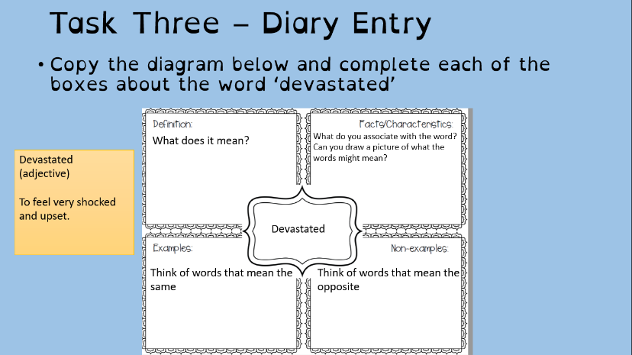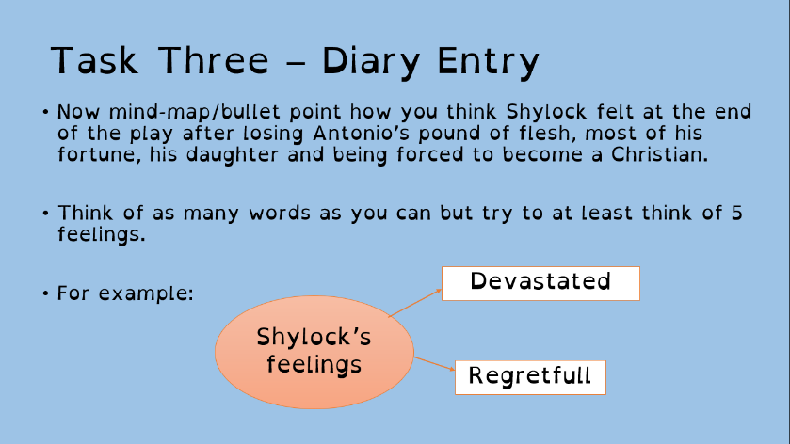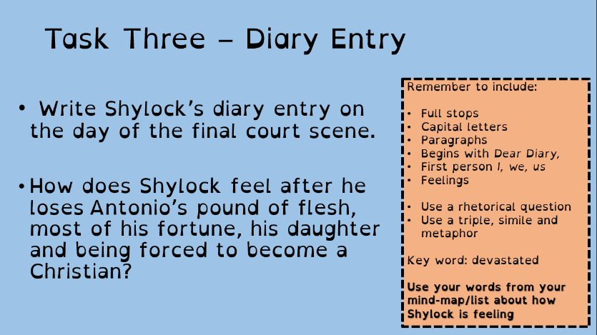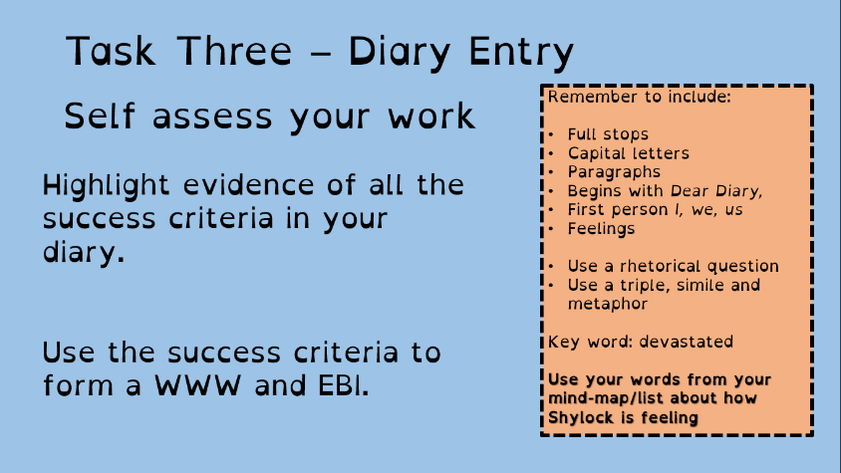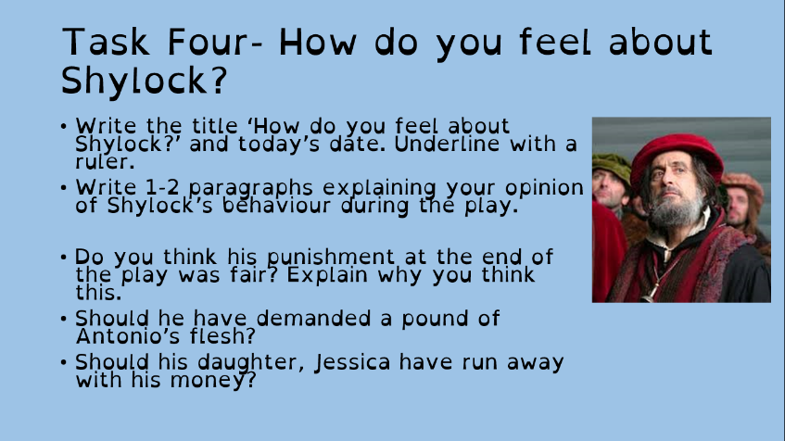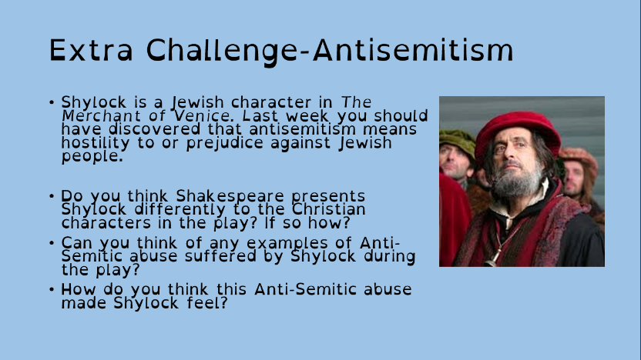
Maths | 8A1 | 8A2 |  | 8A3 | 8B1 | 8B2 |  | 8B3
 | Circles 2  - Complete the starter on basic algebra skills  - Read/ Watch all the information in the examples. Make sure the sound is on.  - Try the sample questions  - Complete the exercise questions  - Have a go at the challenge questions  - Complete the mathswatch work  - Upload all work to your teacher once complete. |  |  | Scatter Graphs, Frequency Diagrams, Frequency Trees  Complete the starter questions  Follow the PowerPoint examples. There is quite a lot to learn so make sure you understand.  Watch Mathswatch videos if you need to.  Answer questions  Work through Mathswatch tasks.
Science | 8A1 | 8A2 |  | 8A3 | 8B1 | 8B2 |  | 8B3
 | This week all Year 8 will be completing Tri Test 9 on educake
Technology | Graphics |  | Resistant Materials |  | Textiles |  | Food Technology
 | Designing the Rebellion  This week I would like you to create an A4 sheet of sketches of the images that you will use in your campaign. At this point in the project we would normally be getting our images ready to block print. In order to do this, our images need to be binary images, in other words they need to be made of just 2 colours, with no blending. Some examples of this are below.  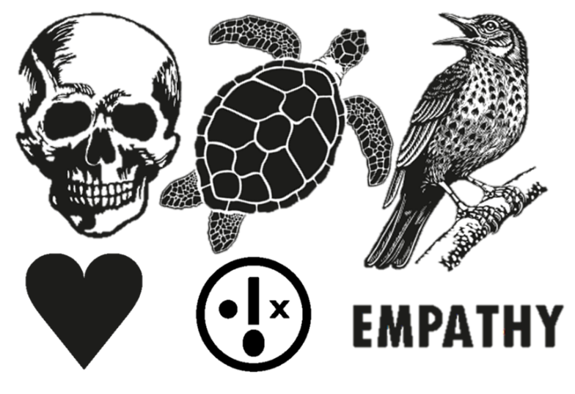  This week’s work:  1) On an A4 sheet write the heading ‘Binary Images for my Campaign, ‘ and draw out 4 binary images (see above examples but don’t copy them) that relate to your campaign.  2) Choose your favourite image(s) and say how this will represent your campaign and say what impact you hope your images would have on the viewer. |  | This week we are going to combine technology and history and make your own timeline.  1) Using Doddle learn there are a couple of interactive examples for you to have a go at (and hopefully learn something in the process – I know I did)  2) Look around you, everything man made was invented by someone at some point in history. Choose some items that interest you, look them up and write the objects name, the year it was invented and the inventors name (if you can find it) on a small piece of paper or post it note. When you have a few of them, put them in order. You could stick them around your room, peg them to a line etc. to show a timeline. Add to it as the days go by – perhaps a new item for every day of lockdown? They may be household items such as the invention of elastic bands, canned food, microwave, chocolate (!) or major events such as walking on the moon, building of the colosseum or periods of historical note. Enjoy learning about the world we are lucky enough to live in. |  | As you have completed a number of different theory tasks, I would like you to now design an apron for the DT department.  You will be sent the worksheet via your school email; you can complete the task digitally or by hand either by printing off the worksheet or drawing out on plain paper.  Please return work by email (using your school email address) or via Teams. |  | CULTURAL, RELIGIOUS and MORAL FOOD CHOICE  Many cultures and religions have their own customs related to what they do and don’t eat.  Research the customs around two of the following in terms of what can and cannot be eaten. Look at celebrations and festivals. Add pictures and any interesting facts. Send your work to my school email address.  - Islam  - Buddhism  - Judaism  - Hinduism  - Christianity  - Sikhism  - Rastafarianism
Geography | Coasts and Coastal Features  Complete questions 19-20 in the Coasts booklet found in TEAMS in your Geography class under “files”.  Use the website below to help you answer the questions  HTTPS://WWW.BBC.CO.UK/BITESIZE/TOPIC.S/Z6BD7TY
History | This week you will learn about Crime and Punishment in the Victorian Period.  Work to do:  Tasks 1-3 do not need to be typed up or written down, the tasks are there for information.  Tasks 4,5 and 6 can be typed up on a Word document and emailed or completed on paper and a photo uploaded.  Slide 2: task 1 Can you work out the criminal from the description?  slide 3: task 2 What were the punishments for these crimes?  slide 4 read the information  slide 5 read the information and watch the video (click on the box with a video camera in it)  slide 6: task 3 Can you put the crimes in order?  slide 7: task 4 watch the video and answer the questions  slide 8: task 5 answer the questions on slide 8 using the information about the 3 real crimes on slides 9, 10 and 11.  slide 12: task 6 complete the plenary task.  Take care and look after yourselves.
RE | This week you will be continuing to learn about Eastern religion and philosophy by researching Shintoism and comparing antient Japanese spiritual traditions to Buddhism. You will be emailed a booklet that includes some reading , questions and tasks. You could also find out more by copying the following links to watch a video clip and see some photos.  https://pixabay.com/photos/architecture-asia-building-shrine-1578120/  https://www.youtube.com/watch?v=LoQqxdAbRS0  The booklet will also be saved on Teams in your RE class folder, file, class material, ‘Eastern Religion and Philosophy-Shintoism'.
PE | The Lancashire School Games are approaching....this is when schools across Lancashire take part to represent their district  Obviously we can’t do this, so this year instead here’s a link which gives you some activities to take part in. I will also email it to you all on Monday  https://lancashireschoolgames.co.uk/resources-for-teenagers-secondary-schools/  I hope you are all well.
ICT | All work is set on Doddle. This week’s work includes revision tasks and so students are revisiting topics previously touched on throughout the year.  Please read through all presentations carefully and complete the assessment quizzes as fully as you can.
Art | Detailed work will be set by email on Office 365 and if possible, students should respond to the teacher’s email to let them know they have completed the work.  Main Task: Pop Art Packaging (continued). Focus on adding a wide range of BOLD colours to your pop art-style packaging. Think about how you can add this colour in a pop art-style (e.g. using Ben Day dots or straight lines instead of block colour). If you have chosen to work on something 3D then please also send a photo of your model to your teacher to receive feedback on how to improve it.  (Information from previous weeks) Choose a type of packaging you can find in your house, e.g. crisp packet, tin, drinks bottle etc. and then draw the packaging/label/logo but inject a pop art style into the design. This could be through your style of lettering, the colours you use, a pattern like Ben Day dots or Lichtenstein-style lines, etc. If you have access to materials, you could even work directly on to an empty packet/box/tin to bring a 3D element to your work, or you could create the label/design in 2D on paper/card then attach it to the object.  Pease email your Art teacher and show them your work to receive feedback on what to improve.  Homework Drawing Challenge: Something cold! See below for examples. Use the whole page and add tonal shading/colour. Try to spend at least 20 minutes on the drawing.  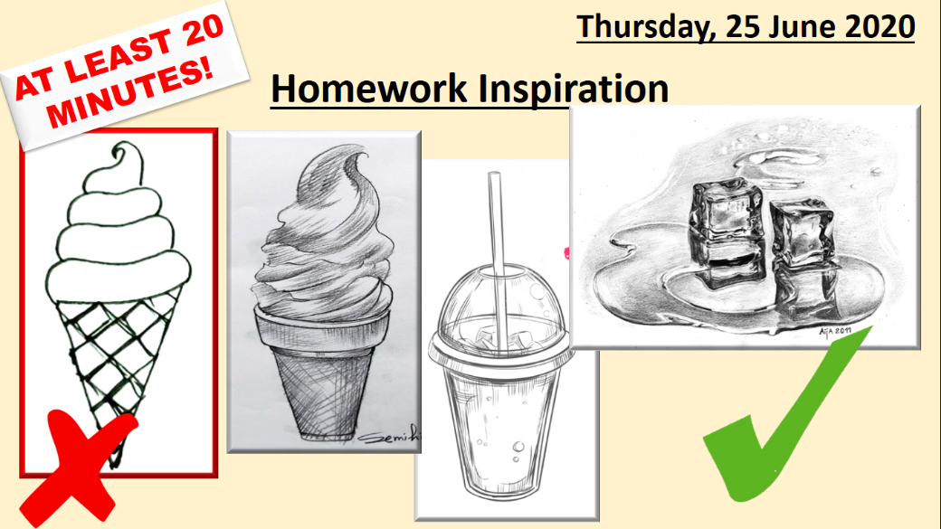
Drama | KS3 Drama Booklet  · Your teacher should now have sent you or told you where to find the KS3 Drama Booklet that you can work on up until the summer.  · Try and focus 40 mins to 1hr a week on your Drama work; think of it as a lesson.  · You can choose the order in which you complete each activity but focus on 1 a week.  · If you can’t print the booklet do not worry; just create the work in any means you can.  · There are some actual booklets at school in reception if somebody can come and collect or Mrs McLeod will send some out in the post if you let her know.  · There are some extension tasks at the back that you can work on if you have more time.  Enjoy the work and let your teachers know how you are getting on, even if it is just a quick message on teams or by email.
Music | Week 5  Creating a chant.  African musicians used chanting to communicate messages to people.  Can you create a chant about the importance of staying alert through the covid-19 crisis?  Send your chant as a sound clip/video or as a document to your teacher.
French | Information for 8a1 / 8a2 / 8a3  - This half term we are learning about sport, directions, injury and illness and using 3 tenses.  - This week we are learning to talk about how often you do sport and how to express a range of opinions. You will complete tasks in listening, reading and writing.  - You will be working from Powerpoint and the online text book.  - Your work can be emailed or submitted on Teams.  - Your work for this week will be on Teams, dated Monday 29th June: “ Tu es sportif/sportive?”  Information for 8b1 / 8b2 / 8b3  - This half term we are learning about sport in France, directions, illness and injury.  - This week we will be learning about how to say how often we do sports and also how to express a range of opinions.  - You will be working from Powerpoint, the electronic version of Dynamo 2 (vert) and YouTube.  - Your work can be emailed or submitted on Teams.
German | - This half-term we are learning to talk about holiday plans and tourism in German.  - This week we will be continuing with our learning of how to recognise and use the future tense.  - We will be developing our language awareness and dictionary skills  - You will be working from the online text book, Powerpoint and YouTube.  - There is an extension task and an extra extension task for you to complete.  - You will find complete instructions for this week’s assignment, dated Monday 29th June, on TEAMS.

