Year 9 – Week Beginning 6th July
Please look at the PSHE resources – https://www.waltonledale.lancs.sch.uk/curriculum/what-are-students-learning-now/pshe
Please look at the Weekly Reflection – https://www.waltonledale.lancs.sch.uk/curriculum/thought-for-the-week
If you need to catch up on previous weeks then you will find them at this link - https://www.waltonledale.lancs.sch.uk/curriculum/what-are-students-learning-now/other-curriculum-maps
English | This week I want you to continue to study ‘Romeo and Juliet’. Remember that this is a GCSE text and it is very important that you complete as much of the work as you can and keep in contact with your English teacher. This week you will be looking at characters and quotations. The work should take 2 weeks for you to complete. Your teacher will upload a PowerPoint for you to work through in the Assignments section on Teams. You are encouraged to work at your own pace, but as a guide I suggest that you work on Task 1, 2 and 3 this week. I have pasted a picture of the slides for these tasks below:  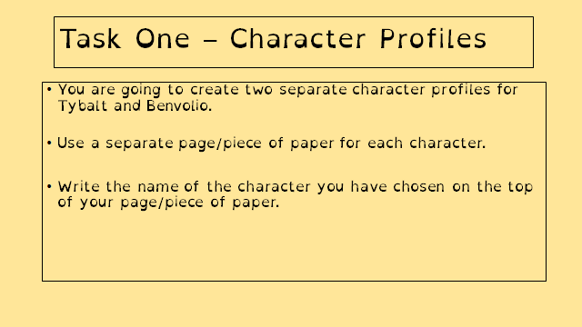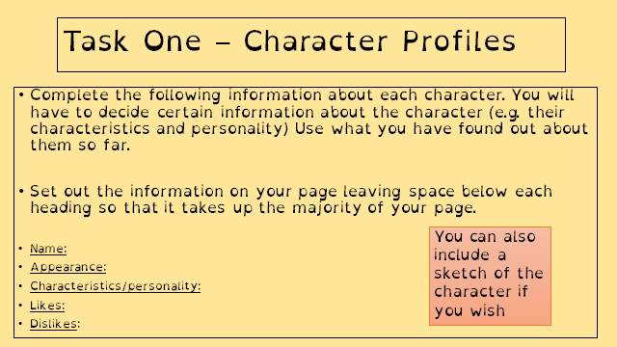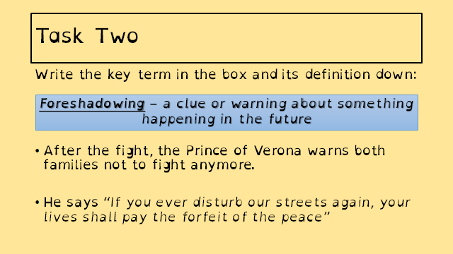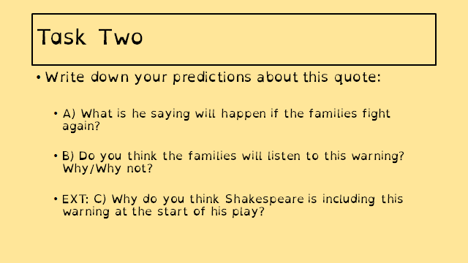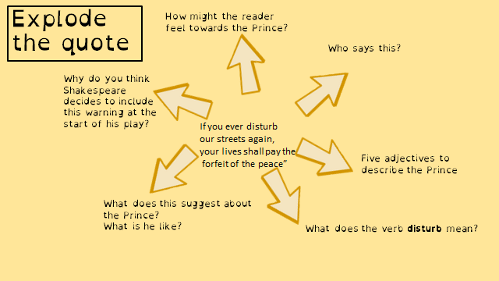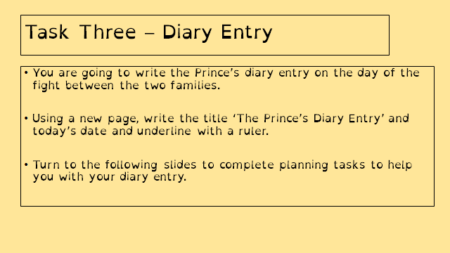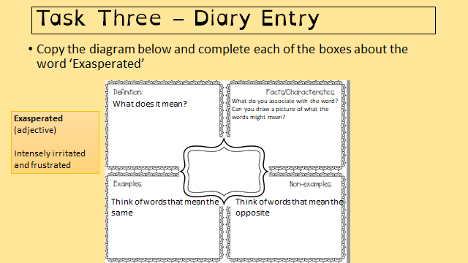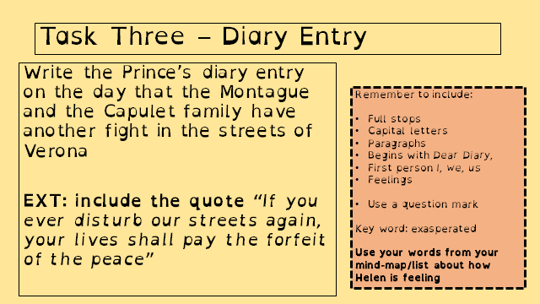  If you need any more work to complete, there are lots of daily lessons on BBC Bitesize and Oak National Academy that you can access using the links below:  https://classroom.thenational.academy/subjects-by-year/year-9/subjects/english  https://www.bbc.co.uk/bitesize/tags/zbjrrj6/year-9-and-s3-lessons  You can also access some audiobooks for free using the link below:  https://stories.audible.com/start-listen  Take care and stay safe. :)
Maths | 9A1 | 9A2 |  | 9A3 | 9A4 |  | 9B1 | 9B2 |  | 9B3
 | Vectors  Complete the starter  Watch the videos  Using column vectors and combining vectors B/S/G  More challenging vector applications. |  |  | Surface area and volume of cylinders  1) Complete the starter  2) Watch the videos and make notes where appropriate  3) Attempt all questions.  4) upload your work back to your teacher.
Science | 9A1 | 9A2 |  | 9A3 | 9A4 |  | 9B1 | 9B2 |  | 9B3
 | DMC - Students will be studying the next section in the P1 topic Energy. The tasks are related to generating energy with fossil fuels and renewable methods  Biology – complete the ‘working scientifically’ tasks set on Teams. | Students to continue with work set last week on transport in cells. |  | Complete the Seneca ‘6th July’ to revise the P1 Energy topic covered at the start of year 9. | We are finishing B1 topic and completing a “mini-test” on educake  Details emailed on Monday |  | Students to continue with work set last week on transport in cells. | Complete the Seneca ‘6th July’ to revise the P1 Energy topic covered at the start of year 9. |  | This week, we are recapping “how science works” on educake.  Details emailed on Monday.  DMA- I will be setting some work via a web-based app called Seneca, to help in the revision of the topics covered this year. Work to be emailed by Monday
Technology | Graphics |  | Resistant Materials |  |  | Textiles |  |  | Food Technology
 | Last week you should have completed the 2-point perspective task which is outlined in this video.  This week you will be learning how to describe different types of surfaces in your drawings. I would like you to watch the following video about Rendering.  You will be practising making 3D forms and then you will add a number of different types of rendering. You work might look something like this:  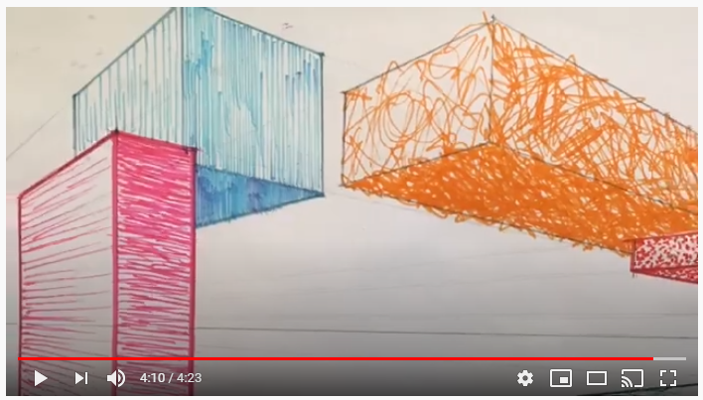  Please note that these two videos were made at the start of lockdown, when advice from the Government was quite different to current advice!  Please either upload photo of your work to your digital booklet or email work directly to Mr Cassidy. |  | Last week using Doddle you learned about Smart Materials. This week let's build on that and look at them in use. What examples have you come across in everyday life? (Sunglasses that darken, frying pans with red spots, baby spoons that change colour etc.)  1) Make a list of one you can think of and add to it as you see more.  2) Also, enjoy having a look at the following links (copy and paste them into your internet browser if needed)  https://www.youtube.com/watch?v=BvTkefJHfC0  https://www.youtube.com/watch?v=IhVuc6RNyaw  https://www.youtube.com/watch?v=gzm7yD-JuyM  https://www.youtube.com/watch?v=JJfppydyGHw  3) Now have a look on the internet for some examples of your own. If you find something interesting, please email me the link. Thanks, Mr B.Hull@waltonledale.lancs.sch.uk  Extension – Invent your own smart / modern material. What would it do? Perhaps a super strong glue that could be ‘undone’ (great for practical jokes!), something that could conduct electricity without the need for wires? Get your imagination working. |  |  | This week I would like you to focus on RECYCLING. A hugely topical and important part of SUTAINABILITY.  Work thorough the presentations and interactive tasks on Doddle all focussed upon recycling. The work will go live on Monday 6th July and is due by Monday 13th July. |  |  | Vitamins fat soluble.  Produce a one-page profile on the following fat-soluble vitamins.  Vitamin A, D, E and K.  Why do we need these vitamins? What foods are they found in? How much do we need of each per day? What happens if we have too much of each vitamin? What happens if we are deficient of these vitamins?  You can add pictures to make your work interesting.  Please send your work to my school email address.
Geography | - Complete the tasks assigned on Doddle.  - Tasks are on Tropical Rainforests.  - Read through the information and complete mini quizzes.
History | Women in WW1  Continuing with our study of the Home Front during WW1 this week we will be looking at the changing roles of women and the impact the war had on their lives. You need to work through the powerpoint, watch the recommended clips and use the word documents to complete the tasks. The work can be completed on a computer or paper (if on paper please can you take a photo and send to your teacher. The work will be emailed to you and will also be set on Assignments in TEAMS. If you have any problems with your work, then please contact your teacher who will happily give you any help you need.
RE | Year 9  This week we will be continuing with the medical ethics topic by thinking about organ donation. You should work through the instructions on each PowerPoint slide about organ donation. There is also a news article and a knowledge organiser. This will be emailed to you and saved into your Teams RE folder.
PE | EXPLORE – In rounders, the bowler is important in any team. Find a ball or an alternative. You will also need a hoop or piece of paper. Stand 10 yards away from a wall. How many times can you hit the same spot on the wall from the same distance? How many ways can you bowl the ball? Underarm? Overarm? Different arms? Different trajectories? In rounders, the ball must always be bowled underarm. Research the best technique and try this exercise out again using an effective under arm technique.  PRACTICE – You will need a family member. Bowl with the correct technique to your partner. Will they catch it between their head and knee? If so, that ball will count in a game. If not, it is a no ball. How many balls can you bowl correctly in 30 seconds? For a more difficult challenge, can you stand further away?  DEVELOP – Effective bowlers use different techniques to make it difficult for batters. You will now try a SPIN CHALLENGE. But a hoop or a piece of paper where the batter would stand. Spinning your wrist clockwise when you release the ball, can you still hit your target? Discuss with your family member why it may be difficult for the batter to hit this ball.
ICT | 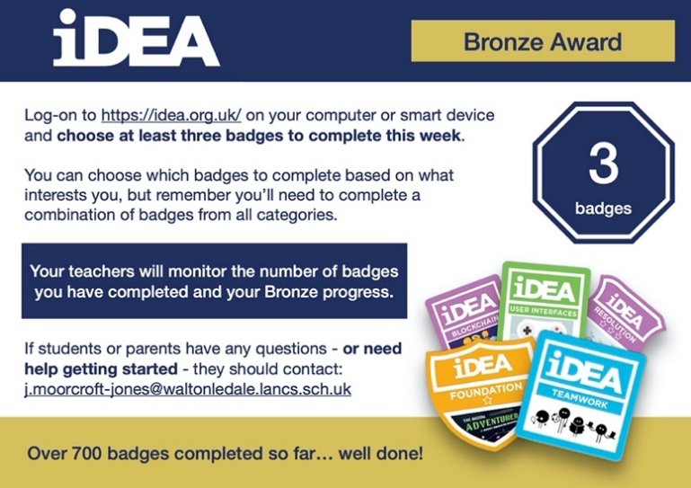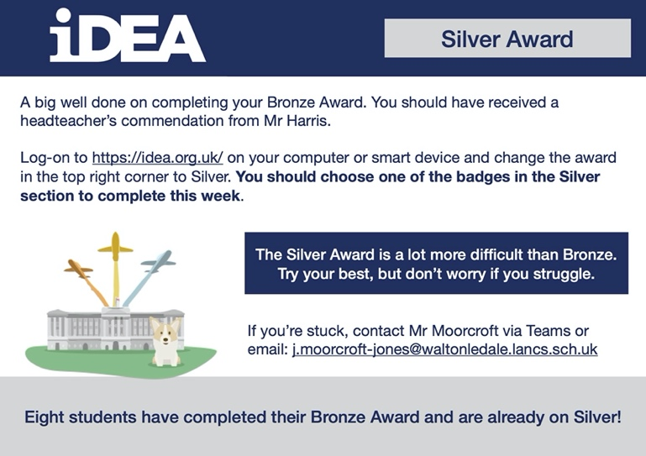
Art | Detailed work will be set by email on Office 365 and if possible, students should respond to the teacher’s email to let them know they have completed the work.  Main Task: Create an evaluation page for your ‘Graffiti’ and ‘Entomology’ projects to show all the things you have learnt this year. Your Art teacher will send you a list of topics/skills you have covered this year, along with further instructions and examples, and you will need to create your evaluation page based on these. This can be done digitally on a computer or by hand, and can include illustrations, drawings, images, colour, mind maps, etc. to make it more visually appealing.  Homework Drawing Challenge: Something summery! See below for examples. Use the whole page and add tonal shading/colour. Try to spend at least 20 minutes on the drawing.  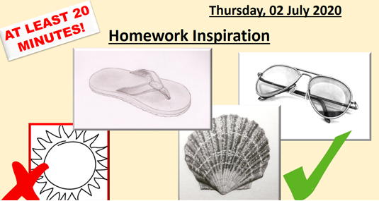
Expressive Arts  Music & Drama | KS3 Expressive Arts Booklet  · Your teacher should now have sent you or told you where to find the KS3 Drama Booklet that you can work on up until the summer.  · Try and focus 40mins – 1hr a week on your Drama work, think of it as a lesson.  · You can choose the order in which you complete each activity, but focus on 1 a week.  · If you can’t print the booklet do not worry just create the work in any means you can.  · There are some actual booklets at school in reception if somebody can come and collect or Mrs McLeod will send some out in the post if you let her know.  · There are some extension tasks at the back that you can work on if you have more time.  Enjoy the work and let your teachers know how you are getting on even if it is just a quick message in teams or by email.  Extension task for those students studying performing arts next year:  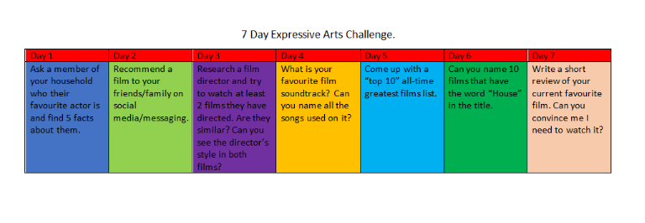
French | Information for 9a1 / 9a2 / 9a3 / 9a4  - This half term we are going to be starting module 3, learning about food and drink, meals, celebrations, clothes and shopping.  - We will continue with the topic of clothes.  - There will be tasks for you to revise language and consolidate language which you have learnt previously, as well as extending your range of vocabulary and using it in GCSE style exercises.  - You will be working from the electronic version of the text book, supported by a Powerpoint. You may also wish to access www.wordreference.com for vocabulary.  - There is an extension task for you to complete as well.  - Your work can be emailed or submitted on teams.  - Your work for w/c 6th July will be on Teams, dated Monday 6th July.  Information for 9b1 / 9b2 / 9b3 / 9b4  - This half term we are learning to talk in detail about food and drink, meals, shopping, celebrations and clothes.  - This week we are working on language related to clothes and colours.  - There will be tasks for you to revise and consolidate language which you may have learnt previously, as well as extending your range of vocabulary.  - You will be practising listening, reading and writing skills.  - You will be working from the Powerpoint provided, the online text book and YouTube.  - Your work can be emailed or submitted on Teams.  - Your work for this week will be on Teams, dated Monday 6th July.  PLEASE COMPLETE AS MUCH WORK AS YOU CAN.
German | - This half-term we are learning to talk about food and drink and healthy lifestyles.  - This week we will focus on healthy lifestyles.  - We will be extending our listening, speaking, reading and writing skills.  - You will be working from YouTube, Word and Powerpoint.  - You will find complete instructions on Teams for this week’s assignment, dated Monday 6th July.

