Year 9 – Week Beginning 11th May
English | Task 1  Weekly Writing Challenge: Aim to write 200 words. Include the word ‘Ubiquitous’-you will need to find out what this word means. Write down a definition.  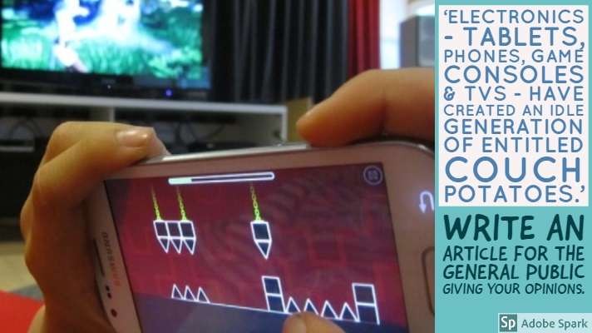  Task 2  Make a list of at least 5 things you have grown to appreciate more since the lockdown and coronavirus happened. You should draw or find an image to illustrate each item on your list. I think we have all appreciated lots of things. To help you get started, here are a few of mine:  - Family  - Hugs  - school  Task 3  Use the following link to access online lessons from the Oak Academy:  https://www.thenational.academy/online-classroom/year-9/english#subjects  Task 4  Use the following link to access English lessons from BBC Bitesize: https://www.bbc.co.uk/bitesize/articles/zmmr47h  If you fancy a bit of reading you can get lots of audiobooks for free from Audible: https://stories.audible.com/start-listen. You can listen to them and escape the world for a bit. There are some new activities available for you to complete on Doddle. Stay safe and take care.
Maths | 9A1 | 9A2 |  | 9A3 | 9A4 |  | 9B1 | 9B2 |  | 9B3
 | Complete the starter activity  Complete Bronze/silver/gold tasks on finding the nth term of a sequence.  Gold contains quadratic sequences.  Then complete Bronze/silver/gold on generating sequences.  Gold are quadratic sequences. |  |  | This week we will be working on substitution.  1) Complete starter activity working on key skills  2) Read through all examples and watch any necessary videos  3) Complete the exercises  Keep pushing yourself. Work to your best.
Science | 9A1 | 9A2 |  | 9A3 | 9A4 |  | 9B1 | 9B2 |  | 9B3
 | Continuing with topic P1  Lesson 1- understanding and calculating kinetic energy.  Lesson 2 – review and exam questions kinetic and gravitational energy  B1: Cells continued  Mitosis & the Cell Cycle  You will learn what the cell cycle and mitosis are, as well as being able to describe the process of mitosis, particularly being able to recognise pictures of cells at the different stages of mitosis.  Details on Teams. | JSC  Now we have completed all the topics in Physics 1 it is time to revise for next week. I will email tasks and information to use on Monday. |  | We have finished the chemistry topic now. This week I want you to revise the topic and complete a Seneca assignment to test your knowledge. The next topic is Biology (Cells and Microscopy) which we will be starting next week so I will set some revision from KS3 in preparation. I will email resources and tasks on Monday. | Chemistry: Looking at trends in group 7 of the periodic table and summarising the chemistry topic  Physics: Looking at renewable energy resources  All lessons emailed on Monday |  | JSC  Now we have completed all the topics in Physics 1 it is time to revise for next week. I will email tasks and information to use on Monday. | We have finished the chemistry topic now. This week I want you to revise the topic and complete a Seneca assignment to test your knowledge. The next topic is Biology (Cells and Microscopy) which we will be starting next week so I will set some revision from KS3 in preparation. I will email resources and tasks on Monday. |  | Biology: continuing with cell biology topic. Lesson 1: specialised cells  Lesson 2: recap of using microscopes and calculating magnification  All details emailed on Monday  Physics – Look at what power is and work through some questions. Email to be sent out by Monday.
Technology | Graphics |  | Resistant Materials |  |  | Textiles |  |  | Food Technology
 | It’s important for Graphic Designers to have a professional and exciting looking catalogue of their work. This is called a portfolio and it’s what convinces potential clients to choose you to design their products for them.  Have a good look at these Graphic Design portfolios.  This week I’d like you to present all of the work you’ve done in Graphics so far using one of the techniques you have seen in the above link. You can include drawings, paintings or other arty projects you have been doing whilst on lockdown.  Use any program you like to compose your portfolio. Alternatively, you could create your pages by hand (this will be a bit trickier as your pages will have to be big enough to mount all of your work!) It can be as many pages as you like, as long as every page is beautifully laid out and decorated. You can base your portfolio on any of the above and you can collage whatever you like onto your work: images from the internet or other photos you have taken as long as your work is clearly shown. I will email out my example for you to look at over the weekend.  Good luck everybody! I look forward to seeing what you create! |  | Last week using doddle (hopefully!) you learned about Smart Materials. This week let's build on that and look at them in use. What examples have you come across in use? (Sunglasses that darken, frying pans with red spots etc) Also enjoy having a look at the following links (copy and past them into your internet browser)  https://www.youtube.com/watch?v=BvTkefJHfC0  https://www.youtube.com/watch?v=IhVuc6RNyaw  https://www.youtube.com/watch?v=gzm7yD-JuyM  https://www.youtube.com/watch?v=JJfppydyGHw  Now have a look for some of your own. If you find something interesting, please email me the link. Thanks, Mr B.Hull |  |  | Create a ‘Guide to Textiles at WLD’ which could be given to the new Year 7 before starting in September. Create on an A4 piece of paper.  - What Health & Safety rules do you think they should definitely know?  - What textiles skills would you recommend them practicing before starting at WLD?  - Was there anything you wish you had known before starting Textiles?  Illustrate your guide with pictures and diagrams which help to explain your advice. |  |  | Type 2 Diabetes.  Produce a one-page profile on Type 2 Diabetes.  What is Type 2 Diabetes? How does diet affect this and how can diet change this condition?  What food choices need to change in order to take control of this condition? Are there any ways in which we cook food that can help this condition?  Any lifestyle changes?  Add pictures and email your work please to my school email address.
Geography |  | - Complete page 13 of the work booklet (Challenge of Resource Management) Previous pages of booklet covering Natural Hazards should have been completed already. (If not work on completing the previous section in addition to this work).  http://www.coolgeography.co.uk/gcsen/resource_management.php  - Go to Coolgeography.co.uk – click on GCSE, then click on Challenge of Resource Management. Click on Overview-Water supply and demand, and then Overview-water quality. Read through – play YouTube clip. Complete quiz at bottom of page. Repeat quiz to see how fast a time you can get. Make key notes for revision.
History | Kaiser Wilhelm II  Hope you all enjoyed the VE Day activities last week and even had a little bit of a celebration! This week we are returning to our study of WW1 and continuing with the causes of WW1 by looking at the leader of Germany, Kaiser Wilhelm II. You need to work through the powerpoint using the information and video clip to complete the 7 tasks. All tasks can be done on a computer or on paper.
RE | Complete the remote learning pack ‘Ultimate questions’.  This will be saved in your Teams group folder and can be emailed to you individually if you ask your RE teacher. Email your work to your teacher by Monday 25th May
PE | - Keep getting up and starting the day with Joe Wicks on Youtube  or  - Try a sally up challenge (see week two and youtube vid)  or  - Try a new fitness app  or  - Smash my 2.6k time or set your own and beat it. (see youtube vid)  or  - Try a skill challenge (week 6) or a different one  or  - Discover a great sports documentary and let us know about it
ICT | You should continue working towards your iDEA Bronze Award. Log-on to https://idea.org.uk/ on your computer or smart device and choose at least three badges to complete this week. You can choose which badges to complete based on what interests you, but remember you’ll need to complete a combination of badges from all categories. Your teachers will monitor the number of badges you have completed and your progress toward the iDEA Bronze Award.  A copy of the guide to set-up your account can be found here: http://mr.moorcroft.online/y9/iDEA  A copy of the guide to complete your first badge can be found here: http://mr.moorcroft.online/y9/iDEA-2  If students or parents have any questions, they should contact Mr J. Moorcroft: j.moorcroft-jones@waltonledale.lancs.sch.uk
Art | Detailed work will be set by email on Office 365 and if possible, students should respond to the teacher’s email to let them know they have completed the work.  Main Task: Create your own Banksy-style graffiti piece with an underlying meaning/message. After studying Banksy’s work and creating a pastiche and critique last week, hopefully you will have some ideas/inspiration about how you could plan a piece of your own Banksy-style artwork with an underlying meaning/message – you could also create a mood board or mind map, etc. to help get your ideas flowing.  Homework Drawing Challenge: Draw a flower from observation. Use the whole page and add tonal shading/colour. Try to spend at least 20 minutes on the drawing.
Expressive Arts  Music and Drama | Have a go at Mrs Rawson’s 14 day Music Challenge but try and do it in 7 days!!!  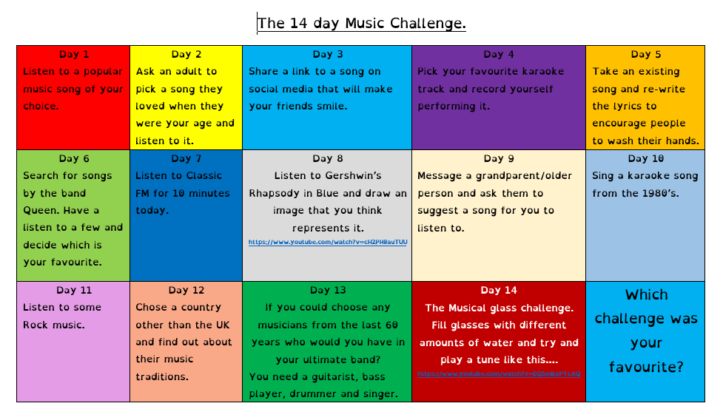
French | Information for 9a1 / 9a2 / 9a3 / 9a4  - This half term we are learning about leisure activities, digital technology, reading, music, habits and preferences.  - We will continue with this topic by learning language about sporting habits and opinions.  - There will be tasks for you to consolidate and revise language which you have learnt previously, as well as extending your range of vocabulary and using it in GCSE style exercises.  - You will be working from the electronic version of Studio for AQA (foundation) text book supported by a powerpoint. You may also wish to access www.wordreference.com for extra vocabulary.  - Your work can be emailed or submitted on teams.  - Your work for this week will be on Teams, dated Monday 11th May.  PLEASE NOTE: YOU SHOULD ALL COMPLETE THE FIRST TWO TASKS. HOWEVER, YOU MAY ALSO, OF COURSE, COMPLETE THE EXTRA TWO TASKS. THOSE OF YOU WHO HAVE OPTED TO TAKE GCSE FRENCH NEXT YEAR SHOULD COMPLETE ALL THE WORK, AS THIS IS PART OF THE GCSE CONTENT.  IF YOU ARE UNABLE TO ACCESS THE SOUND FILES, THERE IS AN ALTERNATIVE ON THE POWERPOINT.  Information for 9b1 / 9b2 / 9b3 / 9b4  - This half term we are learning about leisure activities, digital technology, reading, music, habits and preferences.  - We will continue with the topic and language about reading habits, opinions and types of books.  - There will be tasks for you to consolidate and revise language which you may have learnt previously as well as extending your range of vocabulary.  - You will be practising your listening, reading and writing skills.  - You will be working from the powerpoints provided and the online version of Studio for AQA (foundation) text book. You may also wish to access www.wordreference.com for extra vocabulary.  - Your work can be emailed or submitted on teams.  - Your work for this week will be on Teams, dated Monday 11th May.  - PLEASE COMPLETE AS MUCH WORK AS YOU CAN.
German | - This half-term we are learning how to talk about popular media.  - This week we will be learning about leisure time, with a particular focus on screen time.  - You will be completing tasks from the online text book Stimmt 2 and you will be completing a task on Doddle.  - You can turn in or email your work.  - Go to Teams to find complete instructions for this week’s assignment dated Monday 11th May.

