Year 9 – Week Beginning 8th June
English | The work over the next few weeks is very important because we will be studying the first of your GCSE texts, ‘Romeo and Juliet’!  The purpose of your work over the next two weeks is to ensure that you know the story of the play really well. Your teacher will email you a PowerPoint of activities to work through for the next 2 weeks and it will also be uploaded to the files area of Teams. There are lots of links to different video clips and you might need a pen and paper to complete some of the tasks. To make things easier, the first few slides of the PowerPoint are below:  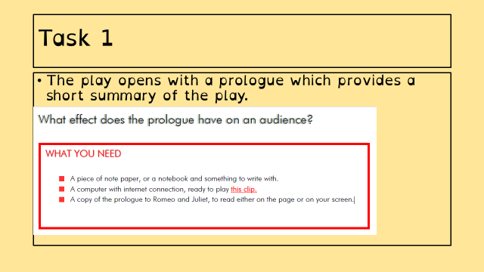  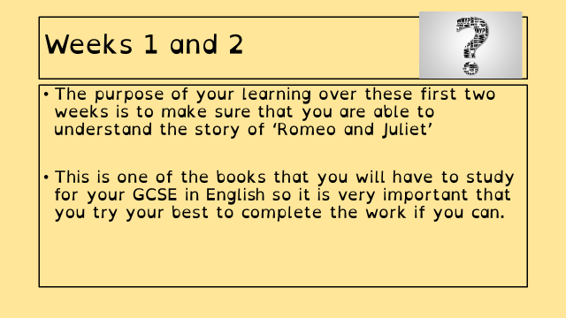  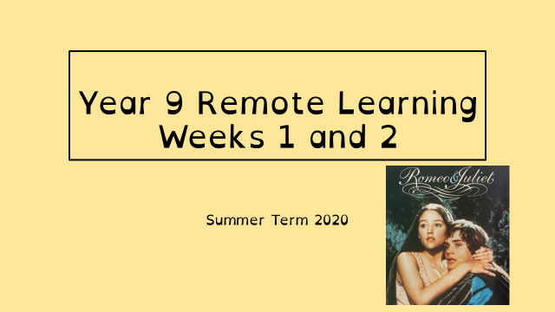  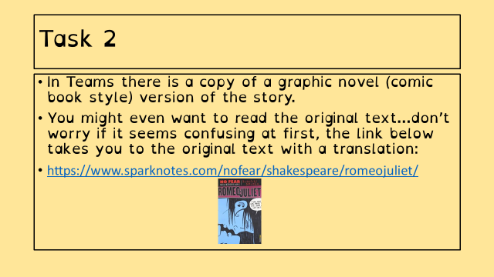  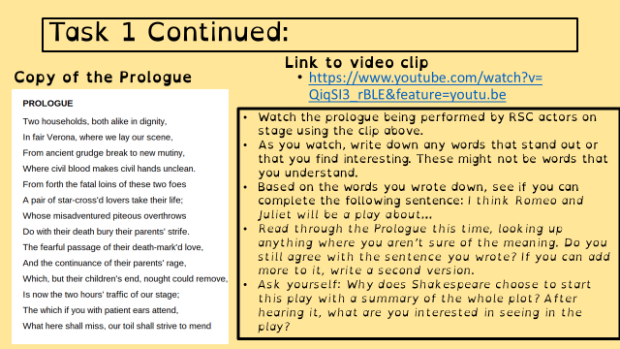  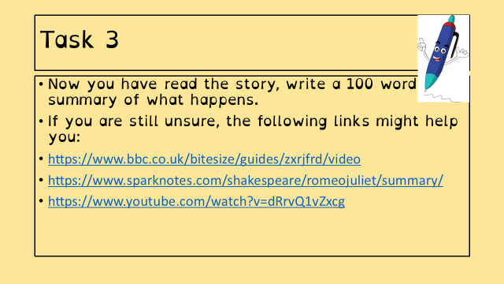  There are lots of activities you can complete on Doddle. If you need any more work to do, you can have a look at the daily lessons on BBC Bitesize: https://www.bbc.co.uk/bitesize/articles/znjbcqt  You can also have a look at the lessons provided by the Oak National Academy: https://www.thenational.academy/online-classroom/year-9/english#subjects  You can escape from the world for a bit and enjoy a good book with lots of free titles and audio books available from the following links:  https://stories.audible.com/start-listen  https://www.amazon.co.uk/b?ie=UTF8&node=21173577031  Stay safe and take care.
Maths | 9A1 | 9A2 |  | 9A3 | 9A4 |  | 9B1 | 9B2 |  | 9B3
 | You will need to complete the following on Volume.  1) Complete the starter page  2) Finding the volume of a sphere/hemisphere  3) Finding the volume of a cone/frustum  Each of the tasks has its own B/S/G questions for you to choose. |  |  | Hi all.  Following on from area, Volume this week.  1) complete starter activity.  2) Read through the notes  2b) re-read the formulae from last week  3) complete all questions that you can.
Science | 9A1 | 9A2 |  | 9A3 | 9A4 |  | 9B1 | 9B2 |  | 9B3
 | DMC – this week’s work is about a required practical to measure specific heat capacity and looking at ways to reduce heat loss in the home.  AHa - Active Transport  The third and final type of cell transport we need to study is active transport. Details will be shared on Teams as usual. |  |  | Continue with B1 Cells and Microscopy with 3 lessons: active transport, exchanging materials and cell division. See my email on Monday for more information. | We will be continuing with the new biology topic, looking at specialised cells and microscopy  All details emailed out on Monday |  |  | Continue with B1 Cells and Microscopy with 3 lessons: active transport, exchanging substances and cell division. See my email on Monday for more information. |  | Biology: Continue with B1 topic, looking at Osmosis this week.  Physics – We are looking at the use of electricity in the home and working out how much we use and how much it costs. Work to be emailed By Monday the 8th.
Technology | Graphics |  | Resistant Materials |  |  | Textiles |  |  | Food Technology
 | We spent some time last week looking at The Design Process and hopefully, gaining an understanding of the different stages. We also read through the design brief and gave the definitions for ACCESSFM along with some research. Please don’t forget to email last week’s work so I can give you some feedback!  Tasks for this week:  1) Read through the PowerPoint and watch the presentation video. Complete task 4 in your digital booklet by researching the names of 4 brands.  2) Next, I want you to mind map a name for your sports organisation. Fill out the mind map in Task 5 giving 5 categories and 3 suggested names for each category. Don’t forget to fill in your final name idea and give your reasoning.  3) Next using the design brief to help, read carefully and fill in the specification table for task 5 if not already done.  4) Further tasks are on Doddle. |  | 1) Think back to the structures you learned about from doddle learn last week (reminder - shell, framework, manmade and natural with the five forces – tension, compression, bending, torsion and shear (look back at Doddle or google them if needed).  2) Look around your world and see how many structures you can see – in your house, looking out your window and when getting exercise! Think what forces are they under and hence why are they made that way, what materials have been used and why? Could they be better?  3) Extension – using the internet search for amazing structures, and structural failures to learn from the work of others. You may find Mega Builds on the BBC interesting. Some of you may go on to be engineers or architects! |  |  | Following on from the introduction to sustainability last week I would like you to consider the human impact of the textiles industries. Please watch episode 4/4 of the Blood, Sweat & T-shirts documentary series  https://www.youtube.com/watch?v=8l-xXElC7iw  Then answer the questions on the second page of the document sent last week. |  |  | Water  Produce a one-page profile about water. This can be emailed to my school email address.  What is water? Why do we need it? How much do we need each day? What happens if we don’t drink enough water? What happens if we drink too much water?  You can add pictures to your work and any other interesting facts you find about water.
Geography |  | http://www.coolgeography.co.uk/gcsen/resource_management.php  - Go to Coolgeography.co.uk – click on GCSE, then click on Challenge of Resource Management. Click on Option 2 Energy. Energy- Factors affecting energy supply & Energy Impacts of energy insecurity. Read through – play YouTube clips.  - Complete quiz at bottom of page. Repeat quiz to see how fast a time you can get.  - Make key notes for revision.
History | Life in the Trenches  We are continuing with our study of the trenches in WW1. The week before half term you learnt about the structure of the trenches so building on this you will be learning about the conditions in the trenches and what it was like to live in them. Read through the powerpoint, and complete the three tasks using the resources provided. You can complete them on a computer or on paper. If you complete the work on paper if possible, can you please take a photo of it and email it into your teacher. The powerpoint and resources will be emailed to you by your teacher. If you have any difficulties in completing the work, please contact your teacher who will be happy to help you.
RE | Continue to work through the PowerPoint ‘God and Art’. Complete each task on a separate slide or word document then email your work to your RE teacher. Don’t forget to send in a photo of your art work. If you would like your piece to be entered into the National competition then email a photo to Ms Hill  v.hill@waltonledale.lancs.sch.uk  If you receive feedback with some ‘Next steps’ then make sure you have a go at the actions your RE teacher has given you.  For further reading and video clips see the website link  https://www.bbc.co.uk/bitesize/topics/zkdk382/articles/zjqcf4j
PE | As we move into the Summer season, we are going to focus on some Summer sports. This week, we will be focussing on Cricket fielding.  This week, we will be focussing on a Bronze, Silver and Gold skill, with each skill becoming more difficult as you move up the ranking.  Bronze: A ball is needed, a soft toy or some socks rolled up. Try and pass the ball around different parts of your body, such as your waist, head, legs etc. Change the direction. How many times can you do this in a minute? Which body parts are more difficult to move around and why? Extension: Can pass the ball through your legs in a figure of 8 motion? ONLY HAVING ONE HAND ON THE BALL AT ONE TIME!  Silver: More space will be needed for this activity. Firstly, put the ball on the floor and practice picking it up quickly in one hand and then putting it back down. How many times can you do so in a minute? Following this, put the ball on the floor and practice running up to it and picking up and getting into a throwing motion before putting it back down, how many times can you do this in a minute? Finally, either roll it yourself or get a family member to do so, and practice running towards a rolling ball, picking it up and getting ready to throw it at the stumps!  Gold: Fielding in Cricket and being able to throw it at the stumps is a vital part of the game. You are going to develop a turn and throw game to help you with this. Make a target (outside, or if inside, something that won’t break/soft ball), and practice turning around with the ball/turning around a picking up the ball and throwing it at the target. Ensure you make up a scoring system to help you gage your progress. If it's too easy, make the target smaller.  Extension task: Geography – In England, there are 18 County Cricket Clubs. Warwickshire Play in Birmingham. Find out where the other 17 Counties play, what city they play in, and find it on a map.
ICT | 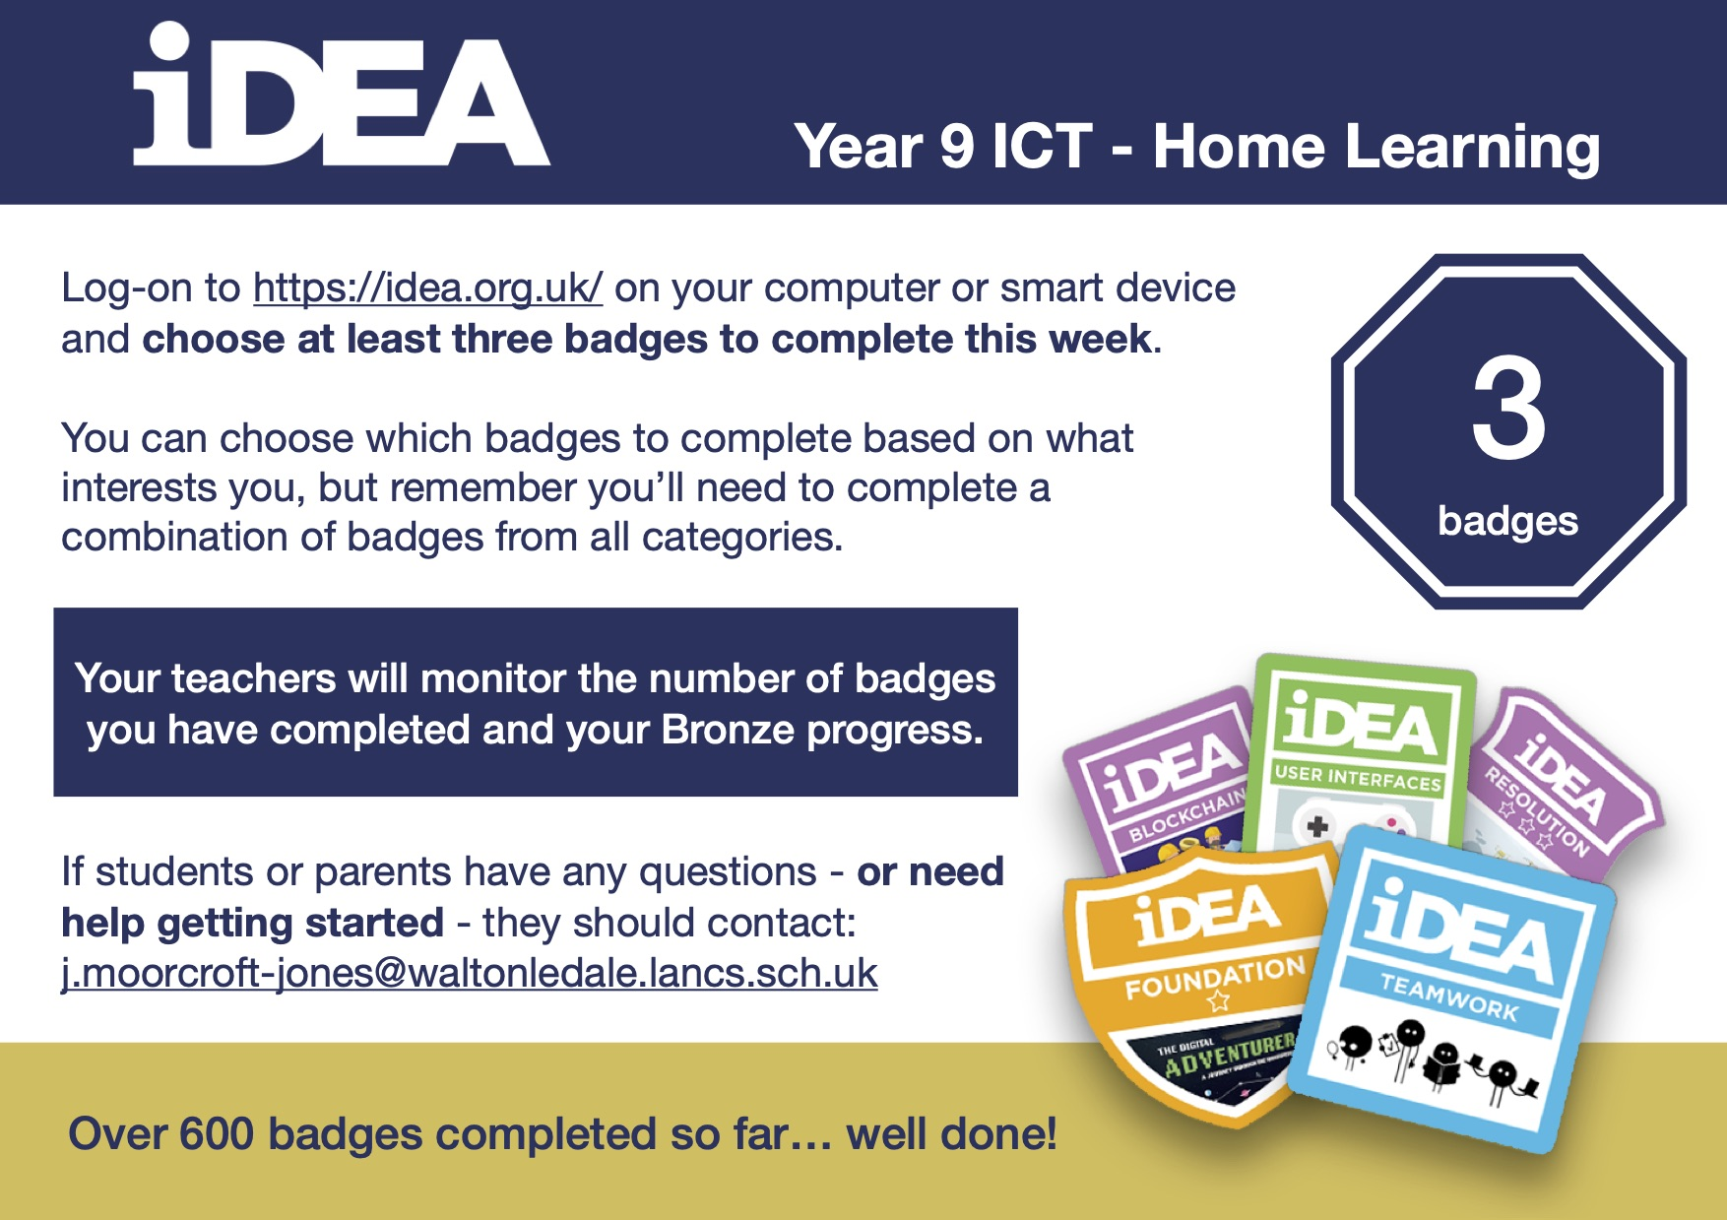
Art | Detailed work will be set by email on Office 365 and if possible, students should respond to the teacher’s email to let them know they have completed the work.  6-Week Mini Project: Plan and design a graffiti-inspired mural for the side of the Sports Hall which faces A-block. Your design must embody the ethos of WLD. The plan must include chosen graffiti/street art styles, if you think that styles could be blended, explain your reasoning. Use subject specific language within all of your planning. What challenges will you face working on such a large wall? What safety equipment would you require? Be as creative as you can with the presentation of your plan and design, could you use an old cardboard box to create a 3D model? Do you have access to design software on your computer/tablet? Could you create a virtual design as you would find in a modern architect’s studio? THIS WEEK’S TASK: Produce a plan which includes the following, 1. a roughly sketched design idea (you can do more than one!), 2. a piece of writing explaining the idea behind your design, what styles or artists you have been inspired by, how it embodies the WLD ethos, what materials and special equipment you would need to actually produce this mural in real life, and what challenges you would face producing this piece of artwork on such large scale. Photos and information will be emailed to you to help you in your planning. REMEMBER: THIS IS A 6-WEEK MINI PROJECT - YOU DO NOT PRODUCE THE ACTUAL DESIGN THIS WEEK.  Homework Drawing Challenge: A towel. Focus on the texture, folds, and creases! Use the whole page and add tonal shading/colour. Try to spend at least 20 minutes on the drawing.
Expressive Arts  Music & Drama | - For the next few weeks you are going to be working through a Drama Skills booklet tracking your skills and keeping a journal of your experiences.  - Your Drama teacher will email you the booklet.  - If you need a hard copy some will be available in reception or contact Mrs McLeod and she will send you one in the post.  - Log on to teams and the resources will be there for you to access.
French | Information for 9a1 / 9a2 / 9a3 / 9a4  - This half term we are going to be learning about leisure activities, digital technology, reading, music, habits and preferences  - We will continue with the topic and language about what you have done in your free time, revisiting the past tense.  - There will be tasks for you to revise and consolidate language which you have learnt previously, as well as extending your range of vocabulary and using it in GCSE style exercises.  - You will be working from the electronic version of Studio for AQA (foundation) supported by a powerpoint. You may also wish to access www.wordreference.com for vocabulary and structures.  - Your work can be emailed or submitted on teams.  - Your work for the week beginning 8th June will be on Teams, dated Monday 8th June  PLEASE NOTE: YOU SHOULD ALL COMPLETE THE TASKS ON SLIDES 1 - 5. HOWEVER, YOU MAY ALSO, OF COURSE, COMPLETE THE EXTRA TASKS.  THOSE OF YOU WHO HAVE OPTED TO TAKE GCSE FRENCH NEXT YEAR SHOULD COMPLETE ALL THE WORK, ALONG WITH THE WRITING TASK, AS THIS IS PART OF THE GCSE CONTENT.  Information for 9b1 / 9b2 / 9b3 / 9b4  - This half term we are going to be learning about leisure activities, digital technology, reading, music, habits and preferences.  - We will continue with the topic and language about what you have done in your free time, revising the past tense.  - There will be tasks for you to revise and consolidate language which you may have learnt previously, as well as extending your range of vocabulary.  - You will be practising listening, reading and writing skills.  - You will be working from the powerpoints provided, the electronic version of Studio for AQA (foundation) text book and YouTube.  - Your work can be emailed or submitted on teams.  - Your work for this week will be on Teams, dated Monday 8th June.  PLEASE COMPLETE AS MUCH WORK AS YOU CAN.
German | - This half-term we are learning how to talk about food and drink and healthy lifestyles  - This week we will be learning about traditional German food.  - You will be working from Stimmt 2 online text book, BBC Bitesize and powerpoint.  - There is a creative and cultural extension task for you to complete.  - You can turn in or email your work.  REMEMBER: YOU CAN STILL SEND YOUR WORK IN, EVEN IF YOU MISS THE DEADLINE.

