Year 9 – Week Beginning 15th June
Please look at the PSHE resources – https://www.waltonledale.lancs.sch.uk/curriculum/what-are-students-learning-now/pshe
Please look at the Weekly Reflection – https://www.waltonledale.lancs.sch.uk/curriculum/thought-for-the-week
If you need to catch up on previous weeks then you will find them at this link - https://www.waltonledale.lancs.sch.uk/curriculum/what-are-students-learning-now/other-curriculum-maps

English | This week I want you to continue to work through the remaining activities from the PowerPoint you started last week. Remember, the aim of the first 2 weeks of this scheme of learning is to ensure that you clearly understand the story of ‘Romeo and Juliet’. In order to do this, I want you to try and watch some of the theatre versions of the play. There are some available on YouTube here and the play is also available for you to watch on BBC iPlayer here. I would like you to complete tasks 3, 4 and 5. Task 3 requires you to write a summary of the story. This will help me to check that you understand what has happened. I also want you to complete the multiple choice quiz about the plot of ‘Romeo and Juliet’ (the link to this is in the PowerPoint but also here).  Below are some images of the tasks I would like you to complete this week:  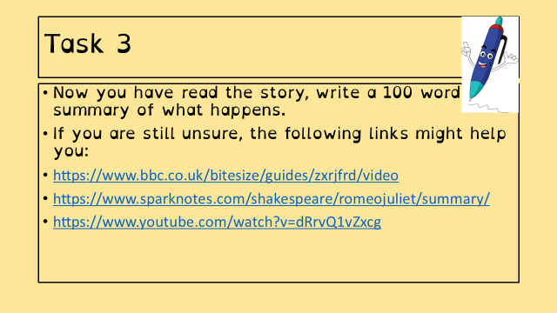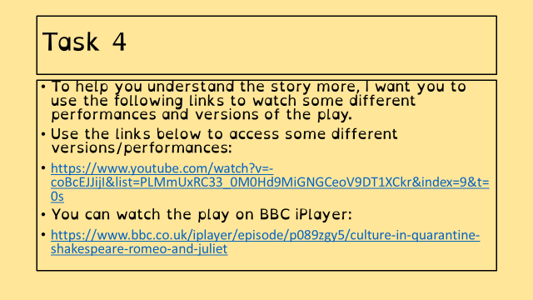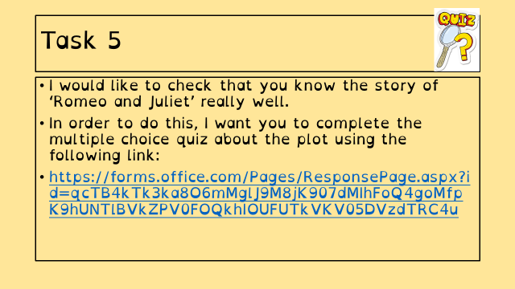  If you are still unsure you can use the following link to access a lesson on the plot of Romeo and Juliet from BBC Bitesize:  https://www.bbc.co.uk/bitesize/topics/zykncwx  There are also daily lessons from BBC Bitesize and the Oak National Academy that you can access using the links below:  https://www.bbc.co.uk/bitesize/articles/zrr48xs  https://classroom.thenational.academy/subjects-by-year/year-9/subjects/english  If you fancy escaping the world for a bit, why not pick up a book. There are free books available from audible and amazon kindle.  You can even borrow a book from your local library using Borrowbox:  https://stories.audible.com/start-listen  https://www.amazon.co.uk/b?ie=UTF8&node=21173577031  https://www.borrowbox.com/  Take care and keep working hard. ☺
Maths | 9A1 | 9A2 |  | 9A3 | 9A4 |  | 9B1 | 9B2 |  | 9B3
 | Last week we looked at volumes of spheres and cones. This week we will work on their surface areas.  - Complete the starter activity  - Find the surface area of the sphere and hemispheres B/S/G activity  - Find the surface area of the cones and frustums B/S/G/E activity.  - More related shapes thinking task. |  |  | Hi all – This week’s topic is surface area.  1) complete starter activity re-enforcing past knowledge.  2) Read the notes AND watch the integrated videos explaining the problems.  3) Complete the questions with full working out  4) attempt challenge questions.  Re-read any notes from previous weeks. Good luck!
Science | 9A1 | 9A2 |  | 9A3 | 9A4 |  | 9B1 | 9B2 |  | 9B3
 | This week students will learn about a required practical in insulation and how to calculate efficiency as part of their continued study of the topic P1 Energy for their GCSE’s  Exchange Surfaces  This week’s lesson will focus on the adaptations of different exchange surfaces that enable more efficient cell transport. Details will be shared on Teams as usual. | This week we will be continuing with the cells topic with work on cell reproduction and stem cells. Work will be emailed out on Monday. |  | This week we continue B1 Cells and Microscopy. We are looking at: cell division, growth and differentiation and stem cells. I will email all tasks and resources on Monday. | We are continuing with B1. Lessons this week will focus on magnification and stem cells.  All lessons emailed on Monday. |  | This week we will be continuing with the cells topic with work on cell reproduction and stem cells. Work will be emailed out on Monday. | This week we continue B1 Cells and Microscopy. We are looking at: cell division, growth and differentiation and stem cells. I will email all tasks and resources on Monday. |  | We are continuing with B1. Lessons this week will focus on the history and developments in Microscopes.  All lessons emailed on Monday.
Technology | Graphics |  | Resistant Materials |  |  | Textiles |  |  | Food Technology
 | Last week students conducted research on sports brands and should now have come up with a name for their own brand. This week students will be sketching and developing ideas for logos for their brand.  Tasks for this week:  1) Complete Task 7 in your digital booklet: Draw out a minimum of 4 design ideas for your logo onto a sheet of A4 paper. Include annotations (written comments about your designs) saying what is effective about each design consider your specification and ACCESSFM when writing annotations.  2) Complete Task 8 in your digital booklet: Draw out a minimum of 3 design ideas for how the text in your design would look. You must design the letters yourself and add annotations to record your thoughts about each one.  What do you think is next in this design process?  Please email Mr Cassidy with any questions or queries you may have. |  | Using Doddle Learn, students in Mr Hull’s classes have been assigned a Plastics and their Properties task. Look through the presentations then check your learning with the mini quiz. Note you can have more than one go at the mini quiz to improve your score. Enjoy learning about a material that is all around us. (NB you may have to ‘allow’ doddle to run on your computer) |  |  | Using Doddle Mrs Miller’s groups have been assigned a unit of work on sustainability to reinforce the work completed over the last two weeks. |  |  | Raising agents  Produce a one-page profile on the different raising agents used in baking. Yeast, baking powder, bicarbonate of soda and cream of tartar. Find out how each raising works, what products each raising agent is used in and why. Add pictures of the products made with these raising agents or scientific diagrams explaining how they work. Email your work to my school email address.
Geography |  | - Complete pages 17 & 18 of the work booklet (Challenge of Resource Management) Previous pages of booklet covering Natural Hazards should have been completed already. (If not work on completing the previous section in addition to this work).  http://www.coolgeography.co.uk/gcsen/resource_management.php  - Go to Coolgeography.co.uk – click on GCSE, then click on Challenge of Resource Management. Click on Option 2 Energy. Energy- Examples of non -renewable energy use & Energy Sustainable supplies. Read through – play YouTube clips. Complete quiz at bottom of page. Repeat quiz to see how fast a time you can get. Make key notes for revision.
History | Weapons of WW1  Carrying on with our study of WW1 and further building on our work on the trenches, we are now going to learn about the weapons used in the war. The tasks you will be completing will be focussed on the following learning objectives:  • Identifying different World War One weapons  • Describing the strengths and weaknesses of each weapon  • Assessing the effectiveness of the weapons  Read and work through the tasks on the powerpoint and the two Word documents. You can complete the work on the computer or paper. If you have any difficulties with the work set, please contact your teacher who  will happily help you.
RE | Miracles  You should work through the PowerPoint instructions to think about miracles. There will be case studies and philosophical arguments for and against miracles proving the existence of God. You should fill out the grid and then write a paragraph to answer the questions, ‘Miracles prove the existence of God’. Do agree? Explain why.  You can research more about modern miracles using the links on the PowerPoint
PE | All work this week will be emailed to you, there are written tasks and practical tasks let us know how you get on.  It’s important that you are staying as active as possible whether it’s going out for a walk, run or bike ride or even doing a little workout at home.  Physical activity does wonders for our mental health and wellbeing.  Have a great week and check your emails for the PowerPoint.  .
ICT | 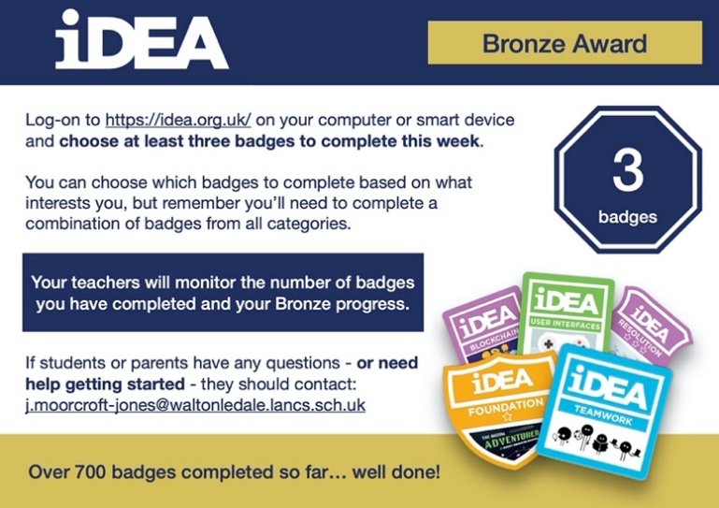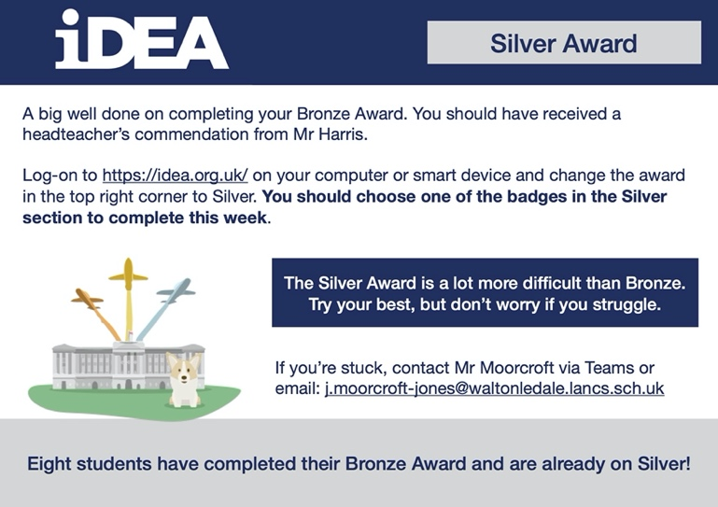
Art | Detailed work will be set by email on Office 365 and if possible, students should respond to the teacher’s email to let them know they have completed the work.  6-Week Mini Project (Continued): Plan and design a graffiti-inspired mural for the side of the Sports Hall which faces A-block. Your design must embody the ethos of WLD. The plan must include chosen graffiti/street art styles, if you think that styles could be blended, explain your reasoning. Use subject specific language within all of your planning. What challenges will you face working on such a large wall? What safety equipment would you require? Be as creative as you can with the presentation of your plan and design, could you use an old cardboard box to create a 3D model? Do you have access to design software on your computer/tablet? Could you create a virtual design as you would find in a modern architect’s studio?  THIS WEEK’S TASK: Use your plan from last week to help you start a more detailed drawing. We are only making a pencil line drawing this week – no shading or colour. You also need to decide how many sections of the sports hall you will fill with your mural – look at the photos to see the different sections. When you have finished your line drawing please send a photo of it to your teacher so they can give you feedback on your design before the next stage.  Homework Drawing Challenge: Your school tie. Focus on the pattern, shape, and details. Use the whole page and add tonal shading/colour. Try to spend at least 20 minutes on the drawing.
Drama | KS3 Drama Booklet  · Your teacher should now have sent you or told you where to find the KS3 Drama Booklet that you can work on up until the summer.  · Try and focus 40 mins – 1hr a week on your Drama work, think of it as a lesson.  · You can choose the order in which you complete each activity, but focus on 1 a week.  · If you can’t print the booklet do not worry just create the work in any means you can.  · There are some actual booklets at school in reception if somebody can come and collect or Mrs McLeod will send some out in the post if you let her know.  · There are some extension tasks at the back that you can work on if you have more time.  Enjoy the work and let your teachers know how you are getting on even if it’s just a quick message in teams or by email.
French | Information for 9a1/9a /9a3/9a4  - This half term we are going to be starting module 3. We will be learning about food and drink, meals, celebrations, clothes and shopping.  - We will start with a focus on the topic and language of food and meals.  - There will be tasks for you to revise and consolidate language which you have learnt previously as well as extending your range of vocabulary and using it in GCSE style exercises.  - You will be working from the electronic version of Studio for AQA (foundation) supported by a powerpoint.  - You may also wish to access www.wordreference.com for vocabulary.  - You will also use online resources such as YouTube and BBC Bitesize.  - Your work can be emailed or submitted on Teams.  - Your work for week beginning 15th June will be on Teams, dated Monday 15th June.  - PLEASE NOTE: YOU SHOULD ALL COMPLETE THE TASKS ON SLIDES 1 - 6.  - SLIDES 7 TO 13 ARE “STRETCH AND CHALLENGE” TASKS. HOWEVER, YOU MAY ALSO, OF COURSE, COMPLETE THE EXTRA TASKS.  - THOSE OF YOU WHO HAVE OPTED TO TAKE GCSE FRENCH NEXT YEAR SHOULD COMPLETE ALL THE WORK, ALONG WITH THE “BBC BITESIZE” TASK, AS THIS IS PART OF THE GCSE CONTENT.  Information for 9b1/9b /9b /9b4  - This half term we are working on module 3 and we will be learning about food and drink, meals, shopping, celebrations and clothes.  - We will focus this week on the topic and language for food, drink and meals.  - There will be tasks for you to revise and consolidate language which you may have learnt previously as well as extending your range of vocabulary.  - You will be practising listening, reading and writing skills.  - You will be working from a powerpoint and worksheet, the electronic version of Studio for AQA (foundation) and YouTube.  - Your work for this week will be on Teams, dated Monday, 15th June.  Your work can be emailed or submitted on Teams and you can still submit your work, even if you miss the deadline.
German | - This half-term we are learning about food and drink and healthy lifestyles.  - This week we will be revisiting the past tense in the context of food and drink.  - We will be extending our listening, speaking, reading and writing skills.  - You will be completing tasks from a powerpoint presentation and Doddle.  - You can turn in or email your work.  - You will find complete instructions on Teams for this week’s assignment, dated Monday 15th June.

