Year 9 – Week Beginning 22nd June
Please look at the PSHE resources – https://www.waltonledale.lancs.sch.uk/curriculum/what-are-students-learning-now/pshe
Please look at the Weekly Reflection – https://www.waltonledale.lancs.sch.uk/curriculum/thought-for-the-week
If you need to catch up on previous weeks then you will find them at this link - https://www.waltonledale.lancs.sch.uk/curriculum/what-are-students-learning-now/other-curriculum-maps

English | This week you are going to continue to look at your GCSE text ‘Romeo and Juliet’. It is very important that you try to complete as much of this work as you can because it is a story you will be tested on at GCSE, as well as being a story with lots of themes and ideas that are still as relevant today as when the play was first written. Last week you should have read the comic strip version of the play and tried to watch some performances to try and make sure that you understand what happens in the story.  Over the next 2 weeks you are going to look at the characters in the play and check that you understand who is who. Your teacher will send you a PowerPoint of activities to work through over the next 2 weeks. This will be emailed to you and saved into the files area for your English class on Teams. This week I want you to try and complete Tasks 1-4. I have put a picture of these activities below:  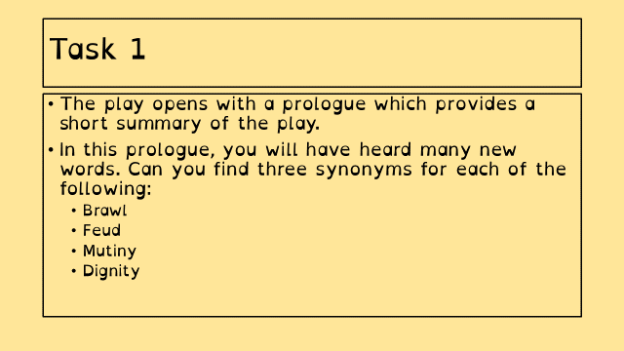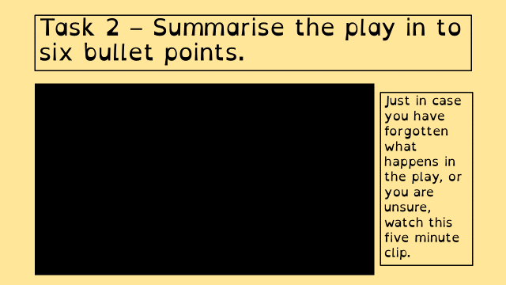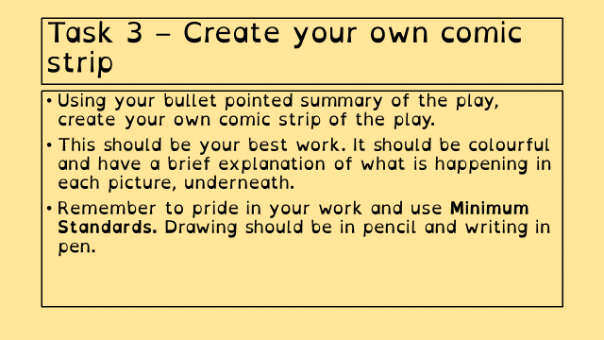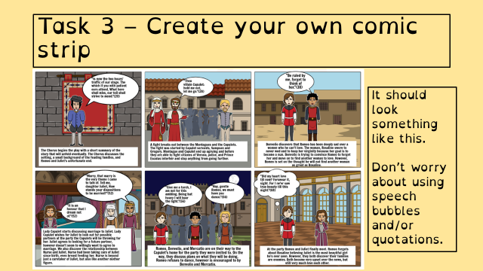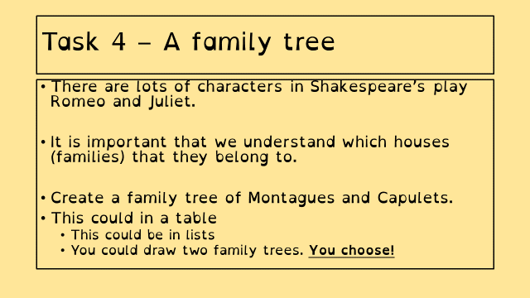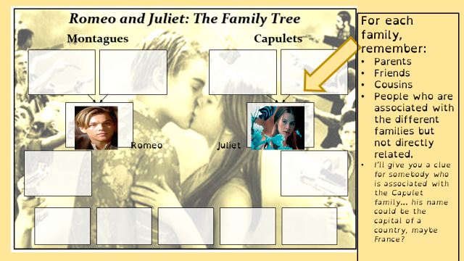  If you want to escape from the world for a bit, there are lots of free audiobooks and there are lots of free e-books available using the links below:  https://stories.audible.com/start-listen  https://www.amazon.co.uk/b?ie=UTF8&node=21173577031  You could also try to borrow and e-book from Lancashire Libraries using their Borrowbox service:  https://www.borrowbox.com/  You can also access daily lessons from BBC Bitesize and Oak National Academy, using the links below:  https://www.bbc.co.uk/bitesize/tags/zbjrrj6/year-9-and-s3-lessons  https://classroom.thenational.academy/subjects-by-year/year-9/subjects/english  Please keep in contact with your teachers and remember to submit any work that you complete.  Take care and stay safe.
Maths | 9A1 | 9A2 |  | 9A3 | 9A4 |  | 9B1 | 9B2 |  | 9B3
 | This week’s work is all about circles.  - Complete the starter.  - B/S/G task on area  - B/S/G task on circumference  - Circle theorems. (remember we are happy for you to “specialise” in just a few of these for now, but the more you can spot the better). |  |  | Area and Circumference of Circles  1) Complete starter activity  2) Read all notes and watch all videos.  3) Complete task 1  4) Complete codebreaker activity  5) Complete mathswatch work  6) Return all work to your class teacher.  Thanks
Science | 9A1 | 9A2 |  | 9A3 | 9A4 |  | 9B1 | 9B2 |  | 9B3
 | This week's tasks focus on reviewing work done on 2 important required practical's and reviewing some of the equations and calculations taught in this topic  B1 Revision  This week we will start to review the topic in preparation for an assessment. Details on Teams. | Students will be continuing with Topic Biology 1 – cell reproduction – details to be emailed Monday. |  | Continue with B1, this week’s lessons are: stem cells and the problems surrounding them. I will email resources and tasks to you on Monday. | Continuing with B1 topic. This week, we will be looking at how substances move in and out of cells.  Details emailed on Monday. |  | Students will be continuing with Topic Biology 1 – cell reproduction – details to be emailed Monday. | Continue with B1, this week’s lessons are: stem cells and the problems surrounding them. I will email resources and tasks to you on Monday. |  | Biology: We have completed the B1 topic so we will be revising and completing an educake “mini-test”. Details emailed on Monday.  Physics – This week I will send you some more equation practice questions. Sheets emailed by Monday.
Technology | Graphics |  | Resistant Materials |  |  | Textiles |  |  | Food Technology
 | Continuing with our branding project:  You should now have created at least 4 initial designs on paper, and photographed these and added them to your digital booklet.  This week, you will be generating ideas for the lettering for your brand. On paper, I’d like you to come up with at least 3 design ideas for the lettering. It could be the name of your brand or a suitable slogan. You must use guidelines and think carefully about the style and placement of your letters.  Once you have done this (Task 8 in your booklets) you should photograph your work and paste it into your digital booklet.  Please email all work to Mr Cassidy. |  | This will add to last week’s ‘plastics’ work on Doddle:  1) Look around the home at items and see what is made from plastic. Look carefully at it (perhaps underneath) You should see a number and / or letters inside a recycling symbol on rigid items or names of plastics on the label of fabrics (many of which are actually plastic!)  2) Google what the plastic recycling symbols mean.  3) Try to get better at guessing what the plastic item is made from before you look at the symbol.  4) Items going into your plastic recycling bin are a particularly good hunting ground!  5) Next time your shopping – try to avoid buying as much single use plastic packaging!  Extension – If you watch Netflix watch History 101 episode 4 about plastics, a 20 minute programme that is quite relevant. |  |  | You have been looking at the human impact upon sustainability in the textiles industry and working conditions. This week I would like you to get creative, reflecting upon what you have learnt so far and design a logo that would portray a message of sustainability.  You will be sent an email via Office 365 on Monday with a booklet to complete. If you are unable to print off, complete the tasks on loose paper.  Please return work via email or Teams if you are able to do so. As always if you have any questions do get in touch. |  |  | Raising agents  Produce a one-page profile of the 4 main raising agents used in cooking. Email your work to my school email address please. These 4 raising agents are yeast, bicarbonate of soda, baking powder and cream of tartar. How do each of these raising agents work. What types of foods are they added to and why? What are chemical and biological raising agents? Are there any other raising agents? What are they?  Plenty of information, pictures, diagrams scientific or other.
Geography | - Complete pages 17 & 18 of the work booklet (Challenge of Resource Management) Previous pages of booklet covering Natural Hazards should have been completed already. (If not work on completing the previous section in addition to this work).  http://www.coolgeography.co.uk/gcsen/resource_management.php  - Go to Coolgeography.co.uk – click on GCSE, then click on Challenge of Resource Management. Click on Option 2 Energy. Energy- Examples of non -renewable energy use & Energy Sustainable supplies. Read through – play YouTube clips. Complete quiz at bottom of page. Repeat quiz to see how fast a time you can get. Make key notes for revision.
History | WW1- Battle of the Somme  This week you will be studying one of the key battles of WW1, the Battle of the Somme. You need to read through the powerpoint and source sheet to complete the 4 tasks on the powerpoint.  There is also a link to a clip on the first slide of the powerpoint for you to watch. You will be focussing on what happened in the battle and making a judgement on whether it was a success or not. If you are unable to do the work on a computer then you can complete it on paper (if possible please could you take a photo and send it by email to your teacher).
RE | You should continue to work through the resources sent to you about miracles. These resources are also saved on TEAMS. There is a PowerPoint with information and instructions. There is also a word document containing a mixture of case studies for you to read through. You should then fill in the table with different views and arguments. Email your work to your RE teacher, also let them know if you need to work re-sending to you.
PE | Joe wicks on Youtube – Monday, Wednesday and Saturday from now on, keep up the good work you have been doing. If you have not already done any physical activity, it's never too late. Go for a bike ride or a long walk, anything is better than nothing. All previous PE lesson by Joe Wick are available on his Youtube channel.  It’s National School Sports Week next week – Please look out for an email from Mrs Sweeney which will have an attachment giving you lots of different ways to take part in this week.
ICT | 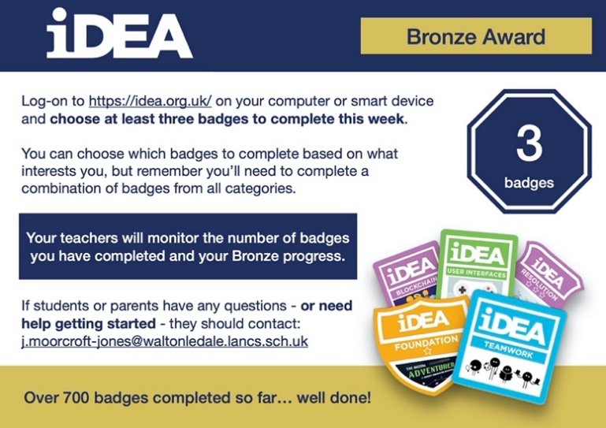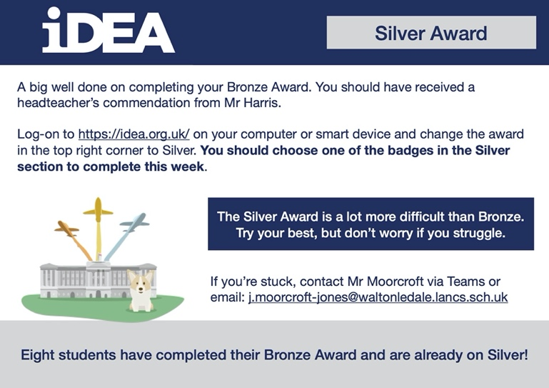
Art | Detailed work will be set by email on Office 365 and if possible, students should respond to the teacher’s email to let them know they have completed the work.  THIS WEEK’S TASK: Complete a full line drawing (no colour or shading) of your design proposal for the Sports Hall and send a photo of it to your Art teacher to receive feedback on how to improve it.  6-Week Mini Project (Information from previous week): Plan and design a graffiti-inspired mural for the side of the Sports Hall which faces A-block. Your design must embody the ethos of WLD. The plan must include chosen graffiti/street art styles, if you think that styles could be blended, explain your reasoning. Use subject specific language within all of your planning. What challenges will you face working on such a large wall? What safety equipment would you require? Be as creative as you can with the presentation of your plan and design, could you use an old cardboard box to create a 3D model? Do you have access to design software on your computer/tablet? Could you create a virtual design as you would find in a modern architect’s studio?  Homework Drawing Challenge: Cushion or pillow. Focus on the creases, folds, pattern, shape, and details. Use the whole page and add tonal shading/colour. Try to spend at least 20 minutes on the drawing.
Expressive Arts  Music & Drama | KS3 Drama Booklet  · Your teacher should now have sent you or told you where to find the KS3 Drama Booklet that you can work on up until the summer.  · Try and focus 40mins – 1hr a week on your Drama work, think of it as a lesson.  · You can choose the order in which you complete each activity, but focus on 1 a week.  · If you can’t print the booklet do not worry just create the work in any means you can.  · There are some actual booklets at school in reception if somebody can come and collect or Mrs McLeod will send some out in the post if you let her know.  · There are some extension tasks at the back that you can work on if you have more time.  Enjoy the work and let your teachers know how you are getting on even if it’s just a quick message in teams or by email.
French | Information for 9a1/9a2/9a3/9a4  - This half term we are learning about food and drink, meals, celebrations, clothes and shopping.  - We will continue with the topic and language of food and shopping.  - There will be tasks for you to revise language which you have learnt previously, as well as consolidating and extending your range of vocabulary and using it in GCSE style exercises.  - You will be working from the electronic version of Studio for AQA (foundation) text book, supported by a power point. You may also wish to access www.wordreference.com for vocabulary. You will also use online resources such as YouTube and BBC Bitesize.  - Your work can be emailed or submitted on Teams.  - Your work for the week beginning June 22nd will be on Teams, dated Monday 22nd June.  PLEASE NOTE: YOU SHOULD ALL COMPLETE THE powerpoint “le petit déjeuner 2”. HOWEVER, YOU MAY ALSO, OF COURSE, COMPLETE THE EXTRA TASKS.  9A3 SHOULD ALSO COMPLETE THE POWER POINT “ON FAIT DES ACHATS”.  THOSE OF YOU WHO HAVE OPTED TO TAKE GCSE FRENCH NEXT YEAR SHOULD COMPLETE ALL THE WORK ON BOTH POWERPOINTS, ALONG WITH THE YOUTUBE TASK.  Information for 9b1/9b2/9b3 9b4  - This half term we are learning about food and drink, meals, shopping, celebrations and clothes.  - We will continue with the topic and language about food , drink and meals with opinions.  - There will be tasks for you to revise language which you may have learnt previously as well as extending your range of vocabulary.  - You will be practising listening, reading and writing skills.  - You will be working from the powerpoint provided and YouTube.  - Your work can be emailed or submitted on TEAMS.  - Your work for this week will be on Teams, dated Monday 22nd June.
German | - This half-term we are learning to talk about food and drink and healthy lifestyles.  - This week we will focus on healthy lifestyles.  - We will be extending our listening, speaking, reading and writing skills.  - You will be working from Stimmt 2 online text book, powerpoint, two listening transcripts, BBC Bitesize and a profile of a famous German footballer.  - You can turn in or email your work.  - You will find complete instructions on Teams for this week’s assignment, dated Monday 22nd June.

