Year 9 – Week Beginning 29th June
Please look at the PSHE resources – https://www.waltonledale.lancs.sch.uk/curriculum/what-are-students-learning-now/pshe
Please look at the Weekly Reflection – https://www.waltonledale.lancs.sch.uk/curriculum/thought-for-the-week
If you need to catch up on previous weeks then you will find them at this link - https://www.waltonledale.lancs.sch.uk/curriculum/what-are-students-learning-now/other-curriculum-maps

English | This week I want you to continue studying ‘Romeo and Juliet’ by William Shakespeare. Remember that this is a GCSE text and therefore it is very important that you complete the work set. This week I would like you to complete tasks 5 and 6 on the PowerPoint. Your teacher will email these to you and you should make sure you submit your work to your teacher. It is really important we know you are able to understand the work we have been setting for you. The PowerPoint will also be available on Teams, but the slides I want you to complete this week are also below:  Remember, if you complete all of the work set, you can also access daily lessons from BBC Bitesize and the Oak national Academy. You can access these by clicking the links below:  https://classroom.thenational.academy/subjects-by-year/year-9/subjects/english  https://www.bbc.co.uk/bitesize/tags/zbjrrj6/year-9-and-s3-lessons  If you fancy some reading, you can access free audiobooks and free books using the links below:  https://stories.audible.com/start-listen  https://www.amazon.co.uk/b?ie=UTF8&node=21173577031  Take care and remember to keep in touch with your teachers.
Maths | 9A1 | 9A2 |  | 9A3 | 9A4 |  | 9B1 | 9B2 |  | 9B3
 | Similarity and Congruence  Complete the starter  The first task on similar shapes. The video will be useful if you can’t remember what to do. Try the B/S/G questions.  Move on to congruence. The aim is to be able to give the reason why two things are congruent.  (you can ignore any reference to the proofs of this – we will cover this at a later date) |  |  | Circles 2  - Complete the starter on basic algebra skills  - Read/ Watch all the information in the examples. Make sure the sound is on.  - Try the sample questions  - Complete the exercise questions  - Have a go at the challenge questions  - Complete the mathswatch work  - Upload all work to your teacher once complete.
Science | 9A1 | 9A2 |  | 9A3 | 9A4 |  | 9B1 | 9B2 |  | 9B3
 | This week will start with a Seneca task to review all of the P1 topic done so far. The second lesson will be an introduction to the rest of the unit on Energy resources  Biology – complete the B1 Seneca assignment. | This week we are revising all of the topics for Biology 1  Details will be emailed on Monday. |  | Revise B1 by completing the Seneca assignment ‘29th June’. | This week, we are completing B1 with 1 lesson on a required practical on osmosis. We will then do some revision of the topic. Details emailed on Monday. |  | This week we are revising all of the topics for Biology 1  Details will be emailed on Monday. | Revise B1 by completing the Seneca assignment ‘29th June’. |  | Chemistry: This week, we will revisit the C1 topic we completed in school. Details emailed on Monday.  Physics – I will send you some work to help revise topic 1 that we have covered during lockdown. Work to be sent by Monday.
Technology | Graphics |  | Resistant Materials |  |  | Textiles |  |  | Food Technology
 | We are continuing with our sports branding project:  All designers need to model their products and this week we will be developing the skills to draw in 3D in order to create some design sketches for our finished shoe box, complete with logo.  This week’s tasks:  Use the following video to help you practice drawing in 3D using a 2-point perspective technique. You need to produce a sheet containing a range of different sized boxes in 3D.  The video is here: https://www.youtube.com/watch?v=eio53HrxnNQ  Please email Mr Cassidy an image of your finished work when it is don.  As an extension task try this video: https://www.youtube.com/watch?v=1d2WKUjtrGY  Remember everyone who submits work will be awarded points on class charts. |  | Using Doddle Mr Hull’s classes have been assigned a unit of work on Smart Materials. (if for any reason Doddle does not work for you, use the internet to search for Smart Materials – you will get lots of resources to learn from) You will have seen some of these in use but perhaps not realised how they work. Next week we will be looking at smart materials in our everyday lives, perhaps get a head start now you know what you are looking for. |  |  | This week is the second half of the logo design task, if you have not done so already please finish designing 4 initial logo ideas which communicate their sustainable intentions.  You will be sent the final design worksheet via your school email, you can complete the task digitally or by hand either by printing off the worksheet or drawing out on plain paper.  Please return work by email (using your school email address) or via Teams. |  |  | Food Waste  Produce a one-page profile and email your work to my school email address.  List 10 foods that you throw away at home.  What are 3 reasons for this?  What is a sell by date and a best before date? What is the difference between them?  Produce a poster ‘How we can reduce food waste’  Add pictures, tips and ideas of what to do with the food you throw away each week.
Geography | This week Geography have set tasks from Doddle – they have been issued to all year 9. Pupils are to complete assigned tasks on Ecosystems. Remember there are also excellent resources available on BBC iPlayer that help to develop your wider understanding of ecosystems such as watching episodes of Planet Earth or Planet Earth II.  . 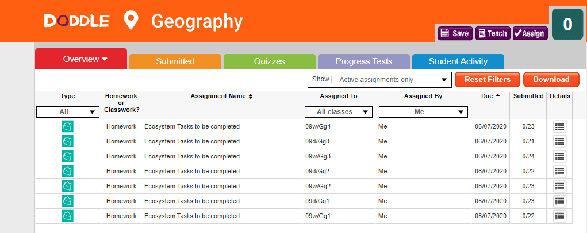
History | The Home Front During WW1  We are now going to move away from the fighting in WW1 to the Home Front. We are going to begin with studying Recruitment and Censorship. You need to read through the powerpoint and using the sources and information complete the 6 tasks. All tasks can either be completed on the computer or on paper (please email a photo of your work completed on paper to your teacher). This work will be emailed to you and will also be on TEAMS. If you have any problems with your work, please contact your teacher who will happily help you.
RE | You will be sent a PowerPoint about Medical Ethics. You should read through the information, instructions and complete each task. The final task is a piece of writing, which you can complete on a separate word document or handwrite and send a photo in.  Work will also be saved in RE, Files on Teams.
PE | The Lancashire School Games are approaching....this is when schools across Lancashire take part to represent their district  Obviously we can’t do this, this year instead here’s a link which gives you some activities to take part in. I will also email it to you all on Monday  https://lancashireschoolgames.co.uk/resources-for-teenagers-secondary-schools/  I hope you are all well.
ICT | 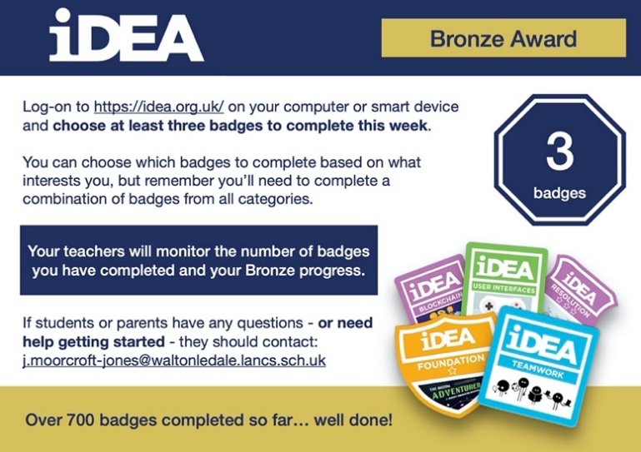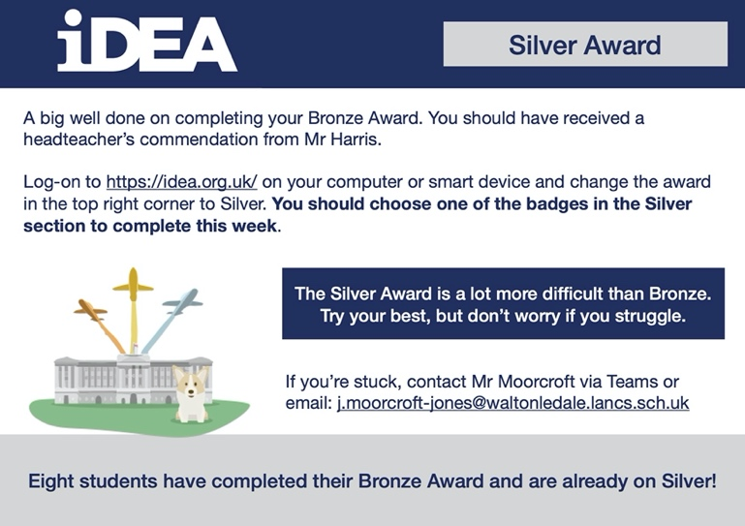
Art | Detailed work will be set by email on Office 365 and if possible, students should respond to the teacher’s email to let them know they have completed the work.  THIS WEEK’S TASK: Complete a full colour/shaded version of your design proposal for the Sports Hall (the design needs to cover the whole wall) and send a photo of it to your Art teacher to receive feedback on how to improve it.  Pease email your Art teacher and show them your work to receive feedback on what to improve.  Homework Drawing Challenge: Something cold. See below for examples. Use the whole page and add tonal shading/colour. Try to spend at least 20 minutes on the drawing.  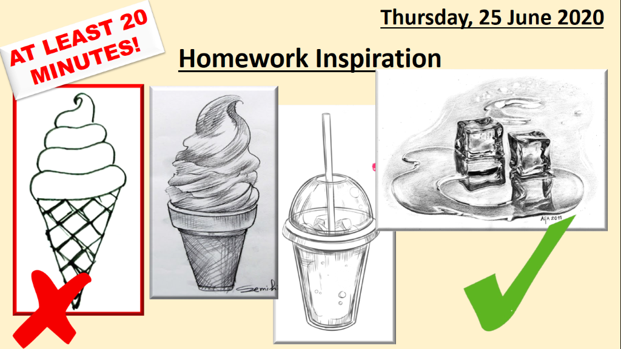
Expressive Arts  Music & Drama | KS3 Drama Booklet  · Your teacher should now have sent you or told you where to find the KS3 Drama Booklet that you can work on up until the summer.  · Try and focus 40 mins – 1 hr a week on your Drama work, think of it as a lesson.  · You can choose the order in which you complete each activity but focus on 1 a week.  · If you can’t print the booklet do not worry, just create the work in any means you can.  · There are some actual booklets at school in reception if somebody can come and collect or Mrs McLeod will send some out in the post if you let her know.  · There are some extension tasks at the back that you can work on if you have more time.  Enjoy the work and let your teachers know how you are getting on even if it is just a quick message in teams or by email.
French | Information for 9a1/9a2/9a3/9a4  - This half term we are learning to talk in detail about food and drink, meals, celebrations, clothes and shopping.  - This week we are working on the clothes topic.  - There will be tasks for you to revise and consolidate language which you have learnt previously, as well as extending your range of vocabulary and using it in GCSE style exercises.  - You will be working from the electronic version of the text book and a Powerpoint.  Your work can be emailed or submitted on Teams.  THOSE OF YOU WHO HAVE OPTED TO TAKE GCSE FRENCH NEXT YEAR SHOULD COMPLETE ALL THE WORK ON THE POWER POINT.  Information for 9b1/9b2/9b3/9b4  - This half term we are learning to talk in detail about food and drink, meals, shopping, celebrations and clothes.  - This week we will strengthen our learning about food shopping.  - There will be tasks for you to revise and consolidate language which you may have learnt previously as well as extending your range of vocabulary.  - You will be practising listening, reading and writing skills  - You will be working from Powerpoint, the online text book and YouTube.  Your work can be emailed or submitted on Teams.  Your work for this week will be on Teams, dated Monday 29th June.  PLEASE COMPLETE AS MUCH WORK AS YOU CAN WHEN YOU CAN.
German | - This half-term we are learning to talk about food and drink and healthy lifestyles.  - This week we will focus on sporting champions. We will be extending our listening, speaking, reading and writing skills.  - You will be working from Stimmt 2 online text book, YouTube and BBC Bitesize.  - You will find complete instructions on Teams for this week’s assignment, dated Monday 29th June.

