Who is Gustav Holst? Find 5 facts about Holst. He wrote the planets suite, but what else did he compose? Use the information to create either a fact file or a poster about him. Send it to your teacher. If you have not had chance yet why don’t you have a go at the 14 Day Music Challenge set by Mrs Rawson. Email Mrs McLeod if you would like another copy.

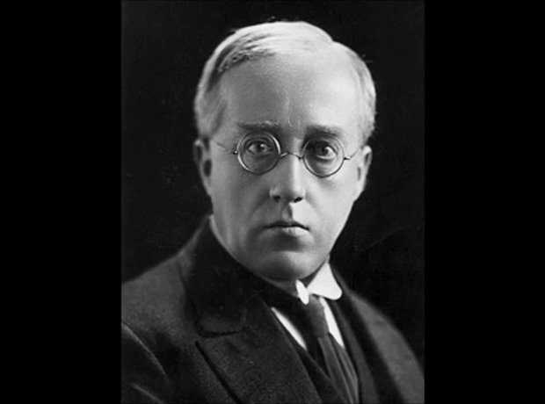

- Born in Cheltenham in 1874, Gustav Holst had professional musicians stretching back three generations in his family. Gustav hoped to be a pianist but was prevented by neuritis. He said that his right arm felt "like a jelly overcharged with electricity".
- At 12 years old, Gustav took up the trombone. Five years later, he was appointed organist at a Gloucestershire church. He also conducted a local church choir, providing him with invaluable experience.
- Holst studied composition at the Royal College of Music under Sir Charles Villiers Stanford, pictured. He wrote piano and organ pieces, songs and a symphony. His main influences were Mendelssohn, Chopin, Grieg and above all, Sir Arthur Sullivan. Later, like many musicians of his generation, Holst became an ardent Wagnerite.
- The two teaching posts for which Holst is probably best known were director of music at St Paul's Girls' School, Hammersmith from 1905 until his death, and director of music at Morley College from 1907 to 1924. In 1913, St Paul's opened a new music wing, and Holst composed his St Paul's Suite for the occasion. The new building contained a sound-proof room where he could work undisturbed.
- During a holiday in Spain, the writer Clifford Bax – brother of the composer Arnold Bax - introduced Holst to astrology, an interest that inspired his suite The Planets. Holst cast his friends' horoscopes for the rest of his life and referred to astrology as his ‘pet vice’.
- The first performance of The Planets was given on 29 September 1918 to an invited audience including Sir Henry Wood and most of the professional musicians in London. Five months later, Sir Adrian Boult - pictured - introduced The Planets to the general public, at a concert in February 1919; but he gave only five of the seven movements on that occasion thinking they would not be able to cope with the full work.

