Candidate Exam Handbook 2023/24

Year 11
Information for Candidates

- Coursework Assessments
- Non-examination Assessments
- On-screen Tests
- Written Exams
- Social Media
- Unauthorised Items
- Warning to Candidates
- Privacy Notice
- Preparing to sit your exams

Coursework Assessments
This document tells you about some things that you must and must not do when you are completing coursework.
When you submit any coursework for marking, you will be asked to sign an authentication statement confirming that you have read and followed these regulations.
If there is anything that you do not understand, you must ask your teacher.
In some subjects you will have an opportunity to do some independent research into a topic. The research you do may involve looking for information in published sources such as textbooks, encyclopedias, journals, TV, radio and on the internet.
You can demonstrate your knowledge and understanding of a subject by using information from sources or generated from sources which may include the internet and AI. Remember though, you must take care how you use this material – you cannot copy it and claim it as your own work.
The regulations state that:
‘the work which you submit for assessment must be your own’; ‘you must not copy from someone else or allow another candidate to copy from you’.
If you use the same wording as a published source, you must place quotation marks around the passage and state where it came from. This is called ‘referencing’. You must make sure that you give detailed references for everything in your work which is not in your own words. A reference from a printed book or journal should show the name of the author, the year of publication and the page number, for example: (Morrison, 2000, p29).
For material taken from the internet, your reference should show the date when the material was downloaded and must show the precise web page, not the search engine used to locate it. This can be copied from the address line.

For example: http://news.bbc.co.uk/onthisday/hi/dates/stories/october/28/newsid_2621000/2621915.stm - downloaded 5 February 2024.
Where computer-generated content has been used (such as an AI Chatbot), your reference must show the name of the AI bot used and should show the date the content was generated.
For example:
ChatGPT 3.5 (https://openai.com/blog/chatgpt/), 25/01/2024.
You should retain a copy of the computer-generated content for reference and authentication purposes.
You may be required to produce a bibliography at the end of your work. This must list the full details of publications you have used in your research, even where these are not directly referred to, for example:
Curran, J. Mass Media and Society (Hodder Arnold, 2005).
If you copy the words, ideas or outputs of others and do not show your sources in references and a bibliography, this will be considered as cheating.
Preparing your coursework – Good Practice
If you receive help and guidance from someone other than your teacher, you must tell your teacher who will then record the nature of the assistance given to you.
Your parent/carer may provide you with access to resource materials and discuss your coursework with you. However, they must not give you direct advice on what should or should not be included.
If you worked as part of a group on an assignment, you must each write up your own account of the assignment. Even if the data you have is the same, the description of how that data was obtained and the conclusions you draw from it should be in your own words.

You must meet the deadlines that your teacher gives you. Remember – your teachers are there to guide you. Although they cannot give you direct assistance, they can help you to sort out any problems before it is too late.
Take care of your work and keep it safe. Don’t leave it lying around where your classmates can find it or share it with anyone, including posting it on social media. You must always keep your coursework secure and confidential whilst you are preparing it; do not share it with your classmates. If it is stored on the computer network, keep your password secure. Collect all copies from the printer and destroy those you do not need.
Don’t be tempted to use any pre-prepared or generated online solutions and try to pass them off as your own work – this is cheating. Electronic tools used by awarding bodies can detect this sort of copying.
You must not write inappropriate, offensive or obscene material.
Plagiarism
Plagiarism involves taking someone else’s words, thoughts, ideas or outputs and trying to pass them off as your own. It is a form of cheating which is taken very seriously.
Don’t think you won’t be caught; there are many ways to detect plagiarism.
– Markers can spot changes in the style of writing and use of language.
– Markers are highly experienced subject specialists who are very familiar with work on the topic concerned – they may have read the source you are using, or even marked the work you have copied from!
– Internet search engines and specialised computer software can be used to match phrases or pieces of text with original sources and to detect changes in the grammar and style of writing or punctuation.

Penalties for breaking the regulations.
If your work is submitted and it is discovered that you have broken the regulations, one of the following penalties will be applied:
– the piece of work will be awarded zero marks;
– you will be disqualified from that unit for that examination series;
– you will be disqualified from the whole subject for that examination series;
– you will be disqualified from all subjects and barred from entering again for a period of time.
The awarding body will decide which penalty is appropriate.
REMEMBER – IT’S YOUR QUALIFICATION SO IT NEEDS TO BE YOUR OWN WORK!

Taken from - https://www.jcq.org.uk/wp-content/uploads/2023/08/IFC-Coursework_Assessments_2023_FINAL.pdf

Non-examination Assessments
This document tells you about some things that you must and must not do when you are completing your work.
When you submit your work for marking, the awarding body will normally require you to sign an authentication statement confirming that you have read and followed the regulations.
If there is anything that you do not understand, you must ask your teacher.
Preparing your work – Good Practice
If you receive help and guidance from someone other than your teacher, you must tell your teacher who will then record the nature of the assistance given to you.
If you worked as part of a group on an assignment, for example undertaking field research, you must each write up your own account of the assignment. Even if the data you have is the same, you must describe in your own words how that data was obtained and you must independently draw your own conclusions from the data.
You must meet the deadlines that your teacher gives you. Remember – your teachers are there to guide you. Although they cannot give you direct assistance, they can help you to sort out any problems before it is too late.
Take care of your work and keep it safe. Do not leave it lying around where your classmates can find it or share it with anyone, including posting it on social media. You must always keep your work secure and confidential whilst you are preparing it; do not share it with your classmates. If it is stored on the computer network, keep your password secure. Collect all copies from the printer and destroy those you do not need.
Do not be tempted to use pre-prepared or generated online solutions and try to pass them off as your own work – this is cheating.

Electronic tools used by awarding bodies can detect this sort of copying.
You must not write inappropriate, offensive or obscene material.
Research and using References
In some subjects you will have an opportunity to do some independent research into a topic.
The research you do may involve looking for information in published sources such as textbooks, encyclopedias, journals, TV, radio and on the internet.
You can demonstrate your knowledge and understanding of a subject by using information from sources or generated from sources which may include the internet and AI. Remember though, you must take care how you use this material - you cannot copy it and claim it as your own work.
Using information from published sources (including the internet) as the basis for your assignment is a good way to demonstrate your knowledge and understanding of a subject. You must take care how you use this material though – you cannot copy it and claim it as your own work.
The regulations state that:
‘the work which you submit for assessment must be your own’; ‘you must not copy from someone else or allow another candidate to copy from you’.
When producing a piece of work, if you use the same wording as a published source, you must place quotation marks around the passage and state where it came from. This is called ‘referencing’. You must make sure that you give detailed references for everything in your work which is not in your own words. A reference from a printed book or journal should show the name of the author, the year of publication and the page number, for example:
Morrison, 2000, p29.

For material taken from the internet, your reference should show the date when the material was downloaded and must show the precise web page, not the search engine used to locate it. This can be copied from the address line. For example:
http://news.bbc.co.uk/onthisday/hi/dates/stories/october/28/newsid_2621000/2621915.stm downloaded 5 February 2024.
Where computer-generated content has been used (such as an AI Chatbot), your reference must show the name of the AI bot used and should show the date the content was generated.
For example: ChatGPT 3.5 (https://openai.com/blog/chatgpt/), 25/01/2024.You should retain a copy of the computer-generated content for reference and authentication purposes.
You may be required to include a bibliography at the end of your piece of written work. Your teacher will tell you whether a bibliography is necessary. Where required, your bibliography must list the full details of publications you have used in your research, even where these are not directly referred to, for example:
Curran, J. Mass Media and Society (Hodder Arnold, 2005).
If you copy the words, ideas or outputs of others and do not show your sources in references and a bibliography, this will be considered as cheating.
Plagiarism
Plagiarism involves taking someone else’s words, thoughts, ideas or outputs and trying to pass them off as your own. It is a form of cheating which is taken very seriously.
Don’t think you won’t be caught; there are many ways to detect plagiarism.
– Markers can spot changes in the style of writing and use of language.

– Markers are highly experienced subject specialists who are very familiar with work on the topic concerned — they may have read the source you are using, or even marked the work you have copied from!
– Internet search engines and specialised computer software can be used to match phrases or pieces of text with original sources and to detect changes in the grammar and style of writing or punctuation.
Penalties for breaking the regulations
If it is discovered that you have broken the regulations, one of the following penalties will be applied:
– the piece of work will be awarded zero marks;
– you will be disqualified from that component for the examination series in question;
– you will be disqualified from the whole subject for that examination series;
– you will be disqualified from all subjects and barred from entering again for a period of time.
The awarding body will decide which penalty is appropriate.
REMEMBER – IT’S YOUR QUALIFICATION SO IT NEEDS TO BE YOUR OWN WORK

Taken from - https://www.jcq.org.uk/wp-content/uploads/2023/08/IFC-NE_Assessments_2023_FINAL.pdf

On-screen Tests

This document has been written to help you. Read it carefully and follow the instructions.
If there is anything you do not understand ask your teacher.
- Regulations – Make sure you understand the rules
1 Be on time for your on-screen test(s). If you are late, your work might not be accepted.
2 Do not become involved in any unfair or dishonest practice during the on-screen test.
3 If you try to cheat, or break the rules in any way, you could be disqualified from all your subjects.
4 Only take into the exam room the materials and equipment which are allowed.
5 You must not take into the exam room:
(a) notes;
(b) an iPod, a mobile phone, a MP3/4 player or similar device, a watch, AirPods or earphones/earbuds.
Unless you are told otherwise, you must not have access to:
(c) the internet, email, data stored on the hard drive, or portable storage media such as floppy disks, CDs and memory sticks;
(d) pre-prepared templates.
Remember: possession of unauthorised material is breaking the rules, even if you do not intend to use it, and you will be subject to penalty and possible disqualification.
6 If you have a watch, the invigilator will ask you to hand it to them.

7 Do not talk to or try to communicate with or disturb other candidates once the on-screen test has started.
8 If you leave the exam room unaccompanied by an invigilator before the on-screen test has finished, you will not be allowed to return.
9 Do not borrow anything from another candidate during the on-screen test.
- Information – Make sure you attend your on-screen test and bring what you need
1 Know the date and time of your on-screen test(s). Arrive at least ten minutes before the start of your on-screen test.
2 If you arrive late for an on-screen test, report to the invigilator running the test.
3 If you arrive more than one hour after the published starting time for the on-screen test, you may not be allowed to take it.
4 Your centre will inform you of any equipment which you may need for the on-screen test.

- Calculators, dictionaries and computer spell-checkers
1 You may use a calculator unless you are told otherwise.
2 If you use a calculator:
(a) make sure it works properly; check that the batteries are working properly;
(b) clear anything stored in it;
(c) remove any parts such as cases, lids or covers which have printed instructions or formulae;

(d) do not bring into the examination room any operating instructions or prepared programs.
3 Do not use a dictionary or computer spell checker unless you are told otherwise.
- Instructions during the on-screen test
1 Always listen to the invigilator. Always follow their instructions.
2 Tell the invigilator at once if:
(a) you have been entered for the wrong on-screen test;
(b) the on-screen test is in another candidate’s name;
(c) you experience system delays or any other IT irregularities.
3 You may be given a question paper or the instructions may be on screen. In either case, read carefully and follow the instructions. Do not open the question paper until you are instructed that the exam has begun.
- Advice and assistance
1 If on the day of the on-screen test you feel that your work may be affected by ill health or any other reason, tell the invigilator.
2 Put up your hand during the on-screen test if:
(a) you have a problem with your computer and are in doubt about what you should do;
(b) you do not feel well.
3 You must not ask for, and will not be given, any explanation of the questions.
- At the end of the on-screen test
1 Ensure that the software closes at the end of the on-screen test.

2 If you are required to print off work outside the time allowed for the on-screen test, ensure that you collect your own work. You must not share your work with other candidates. Make sure that another candidate does not collect your printout(s).
3 Do not leave the exam room until told to do so by the invigilator.
4 Do not take any stationery from the exam room. This includes rough work, printouts or any other materials provided for the on-screen test.

Taken from - https://www.jcq.org.uk/wp-content/uploads/2023/08/IFC-On-Screen_Examinations_2023_FINAL.pdf

Written Exams
This document has been written to help you. Read it carefully and follow the instructions.
If there is anything you do not understand, especially which calculator you may use, ask your teacher.
- Regulations – Make sure you understand the rules
1 Be on time for all your exams. If you are late, your work might not be accepted.
2 Do not become involved in any unfair or dishonest practice during the exam.
3 If you try to cheat, or break the rules in any way, you could be disqualified from all your subjects.
4 You must not take into the exam room:
- notes;

(b) an iPod, a mobile phone, a MP3/4 player or similar device, a watch, AirPods or earphones/earbuds.
Any pencil cases taken into the exam room must be see-through.
Remember: possession of unauthorised material is breaking the rules, even if you do not intend to use it, and you will be subject to penalty and possible disqualification.
5 If you have a watch, the invigilator will ask you to hand it to them.
6 Do not use correcting pens, fluid or tape, erasable pens, highlighters or gel pens in your answers.
7 Do not talk to or try to communicate with, or disturb other candidates once the exam has started.
8 You must not write inappropriate, obscene or offensive material.
9 If you leave the exam room unaccompanied by an invigilator before the exam has finished, you will not be allowed to return.
10 Do not borrow anything from another candidate during the exam.
- Information – Make sure you attend your exams and bring what you need
1 Know the dates and times of all your exams. Arrive at least ten minutes before the start of each exam.
2 If you arrive late for an exam, report to the invigilator running the exam.
3 If you arrive more than one hour after the published starting time for the exam, you may not be allowed to take it.
4 Only take into the exam room the pens, pencils, erasers and any other equipment which you need for the exam.

5 You must write clearly and in black ink. Coloured pencils or inks may only be used for diagrams, maps, charts, etc. unless the instructions printed on the front of the question paper state otherwise.

- Calculators, dictionaries and computer spell-checkers
1 You may use a calculator unless you are told otherwise.
2 If you use a calculator:
(a) make sure it works properly; check that the batteries are working properly;
(b) clear anything stored in it;
(c) remove any parts such as cases, lids or covers which have printed instructions or formulae;
(d) do not bring into the exam room any operating instructions or prepared programs.
3 Do not use a dictionary or computer spell checker unless you are told otherwise.

- Instructions during the exam
1 Always listen to the invigilator. Always follow their instructions.
2 Tell the invigilator at once if:
(a) you think you have not been given the right question paper or all of the materials listed on the front of the paper;
(b) the question paper is incomplete or badly printed.

3 Read carefully and follow the instructions printed on the question paper and/or on the answer booklet.
4 Do not start writing anything until the invigilator tells you to fill in all the details required on the front of the question paper and/ or the answer booklet before you start the exam. Do not open the question paper until you are instructed that the exam has begun.
5 Remember to write your answers within the designated sections of the answer booklet.
6 Do your rough work on the proper exam stationery. Cross it through and hand it in with your answers.
Make sure you add your candidate details to any additional answer sheets that you use, including those used for rough work.
- Advice and assistance
1 If on the day of the exam you feel that your work may be affected by ill health or any other reason, tell the invigilator.
2 Put up your hand during the exam if:
(a) you have a problem and are in doubt about what you should do;
(b) you do not feel well;
(c) you need more paper.
3 You must not ask for, and will not be given, any explanation of the questions.
- At the end of the exam
1 If you have used more than one answer booklet and/or any supplementary answer sheets, place them in the correct order.

Place any loose additional answer sheets inside your answer booklet. Make sure you add your candidate details to any additional answer sheets that you use.
2 Do not leave the exam room until told to do so by the invigilator.
3 Do not take any stationery from the exam room. This includes the question paper, answer booklets used or unused, rough work or any other materials provided for the exam.

Taken from - https://www.jcq.org.uk/wp-content/uploads/2023/08/IFC-Written_Examinations_Sep2023_FINAL.pdf

Social Media
– Taken from https://www.jcq.org.uk/wp-content/uploads/2023/04/JCQ-Social-Media-Infographic-v4.pdf

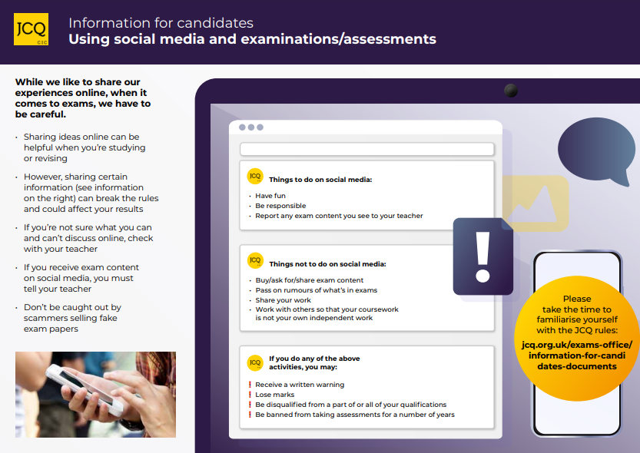

Unauthorised Items Poster
Taken from - https://www.jcq.org.uk/wp-content/uploads/2022/08/2022-Unauthorised-Items-poster-live-text_September22.pdf
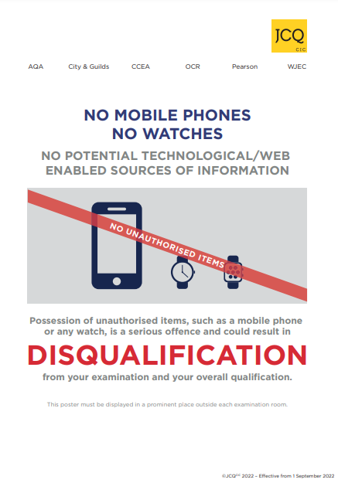

Warning to Candidates Poster
Taken from - https://www.jcq.org.uk/wp-content/uploads/2022/08/Warning-to-Candidates-2022_23.pdf

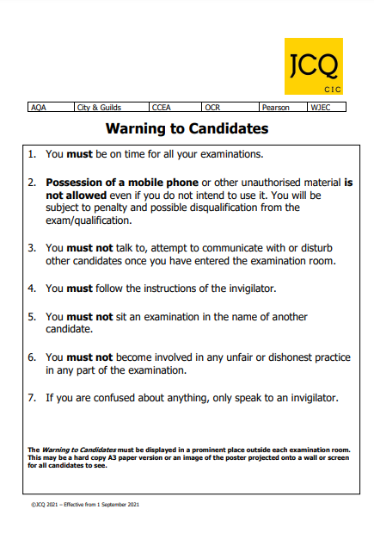

JCQ Privacy Notice
Information About You and How We Use It
You have entered general or vocational qualifications such as GCSE, A-level, functional skills qualifications etc with one or more of the awarding bodies listed above. In order to be able to provide examinations and assessments, the awarding body needs to collect and use information about you. This notice provides you with a high level summary of the information the awarding body is required by law to give you about what happens to that information. For more detail see each awarding body’s full Privacy Notice:
AQA https://www.aqa.org.uk/about-us/privacy-notice
CCEA https://ccea.org.uk/legal/privacy-notice
City & Guilds https://www.cityandguilds.com/help/help-for-learners/learner-policy
NCFE https://www.ncfe.org.uk/legal-information
OCR https://www.ocr.org.uk/about/our-policies/website-policies/privacy-policy/
Pearson https://qualifications.pearson.com/en/about-us/qualification-brands/gdpr.html
WJEC https://www.wjec.co.uk/home/privacy-policy/
Who we are and how to contact us
Each awarding body is a separate organisation. Your school or examination centre will be able to confirm to you which awarding body is delivering each qualification you are undertaking and you will receive a statement confirming what qualifications you have been entered for and which awarding body. You will find links to each awarding body’s website and information on how to contact them here:

https://www.jcq.org.uk/contact-our-members/
Information about you and from where it is obtained
Each awarding body whose qualifications you enter will need to use a variety of information about you. This includes obvious identification details such as your name, address, date of birth and your school or examination centre. It also includes information about your gender, race and health, where appropriate. This information is provided by you or your parents/guardians and/or by your school or examination centre.
Each awarding body will create certain information about you such as a candidate number, examination results and certificates.
You will find further information about this in the awarding bodies’ full Privacy Notice (see links above) or by contacting the awarding body (see above).
What happens to the information about you
The awarding bodies use the information about you to deliver the examinations and assessments which you have entered. This includes making a variety of arrangements for you to sit the examinations or assessments, marking, providing you and your school or centre with results and certificates. The awarding bodies also use some of the information about you for equality monitoring and other statistical analysis.
The awarding bodies may share information about your results with official bodies such as the Department for Education and the examinations regulators (e.g. Ofqual in England) and also relevant local authorities and the Universities and Colleges Admissions Service (UCAS). An awarding body may also use information about you to investigate cheating and other examination malpractice and will share information about malpractice with other awarding bodies.
The awarding bodies take the security of the information about you that they hold seriously.

You will find further, technical information about what the awarding bodies do with information about you, why and the legal basis in the awarding bodies’ full Privacy Notice, which can be accessed here (see links on page one) or by contacting the awarding body (see above).
Your Rights
The law gives you a number of rights in relation to the information about you that the awarding bodies hold. Those rights are:
• Access – you are entitled to ask each awarding body about the information it holds about you.
• Rectification – you are entitled to ask each awarding body to correct any errors in the information that it holds about you.
• Erasure – in certain circumstances you are entitled to ask each awarding body to erase the information about you that it holds.
• Object to or restrict processing – in certain circumstances you are entitled to ask each awarding body to stop using information about you in certain ways.
• Complain – you are entitled to complain to the Information Commissioner (the body regulating the use of personal information) about what each awarding body does with information about you.
You will find further information about your rights in relation to information about you in the awarding bodies’ full Privacy Notice, which can be accessed here (see links on page one) or by contacting the awarding body (see above).
How long the information about you is held
Each awarding body retains information about you only for as long as it is needed. Some of the information is needed only during the period in which you are undertaking the examination or assessment and is securely destroyed a short while afterwards. Other information about you, such as

your name, gender, address, qualification and subjects entered and the results, are held indefinitely and for at least 40 years.
Each awarding body has its own retention policy that sets out what information it retains, how it is retained and for how long. You can find out more about retention policies by contacting each awarding body (see above).
How to find out more about the information about you that the awarding bodies use
To find out more about the information about you that the awarding bodies collect and use, including what happens to that information and why, you can review the awarding bodies’ full Privacy Notice, which can be accessed here (see links on page one) or contact the awarding body. You will find links to each awarding body’s website and information on how to contact them here: https://www.jcq.org.uk/contact-our-members/.

Please note
It is important to note that this notice concerns only how the awarding bodies use information about you (called your “personal data”). Complaints about how an awarding body handles your personal data can be made to the Information Commissioner (www.ico.org.uk). Information about the examinations and assessments themselves, including the rules about assessments, can be found on the JCQ Exams Office pages (www.jcq.org.uk/exams-office). The awarding bodies are regulated by Ofqual (https://www.gov.uk/government/organisations/ofqual) in England; Qualifications Wales (www.qualificationswales.org) in Wales, and the Council for the Curriculum, Examinations and Assessment (http://ccea.org.uk/regulation) in Northern Ireland.

Taken from - https://www.jcq.org.uk/wp-content/uploads/2023/04/Information-for-candidates-Privacy-Notice_21-22.pdf

Preparing to sit your exams

AQA - (https://www.aqa.org.uk/student-and-parent-support/managing-stress) - Everyone gets nervous; it's a normal part of exams. While it's not so easy to stop feeling nervous, you can use relaxation techniques to keep your nerves under control and focus on what you want to achieve.
Here are some tips and techniques you can try if you feel stressed before and during exams.
- Being prepared and doing the work will always help you feel more confident about sitting your exams, so do as much revision as you can.
- Celebrate your successes in revision tasks and know when you do well.
- Meditation and exercise are great ways to help clear your mind, leaving you feeling refreshed and energised. Plan something for first thing in the morning – if you start your day well, you are more likely to stay calm.
- Use deep breathing to relax your body and mind.
- Eat the right foods and drink lots of water – for example, too much coffee and sugar can make you feel more anxious as they are stimulants.
- Use positive language with yourself and visualise your exams going smoothly.
- If possible, avoid classmates who are highly stressed or who want to talk about the exams.
- Practise your relaxation techniques so they are natural to you by exam day.
- Plan your exam day so you feel in control; allow for travel and proper meals.
OCR – (https://www.ocr.org.uk/students/exam-support/managing-stress/)
Revising, taking exams and getting your results is a stressful time for many students. Here are some tips about looking after yourself and helping you manage the anxiety you may be feeling:
- Get the balance right. You will feel less stressed if you prepare for your exams by revising but don’t overdo it. Give yourself time off.
- Exercise. Break up your day of revision with exercise. Even a short walk will clear your head.
- Food and drink. Don’t go into a morning exam without breakfast. Try to follow a healthy diet with some fruit and vegetables, and drink plenty of water.
- Get enough sleep. Keep a regular sleep-pattern and avoid all night revision sessions.
- Limit screen time. Try to restrict checking devices all the time. Constantly checking Snapchat or Instagram can be stressful if the only topic is exams. And avoid screens before bedtime.
- Calming nerves. Mindfulness, meditation or yoga may help you to calm your nerves. You can download apps for all of them, to see what works best for you.
- Be organised. Get everything ready the night before your exam. Set an alarm so you give yourself plenty of time to get to your exam hall on time!
- Don’t rush. When you open the exam paper, take a few deep breaths to calm yourself, so you read the instructions and questions carefully.
- Don’t give up. If you come out of an exam thinking it’s gone badly, try not to dwell on it (and don’t go into any chat rooms). Focus on the next one.

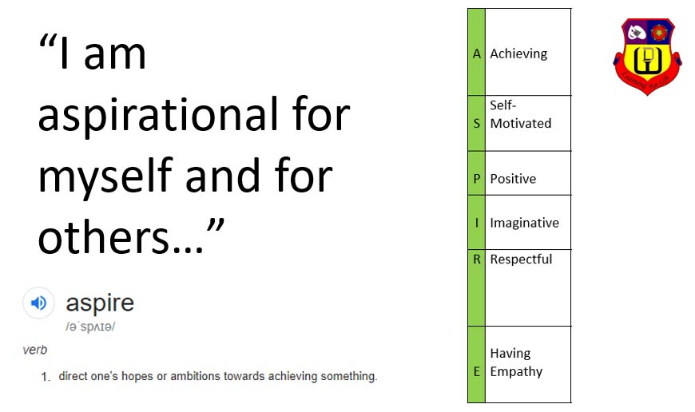

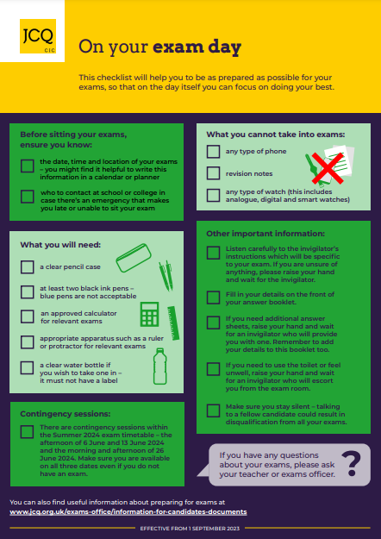
Taken from - https://www.jcq.org.uk/wp-content/uploads/2023/08/JCQ-Preparing-to-sit-your-exams-2023_24.pdf

CANDIDATE DECLARATION/CONFIRMATION FORM

Regulations concerning the conduct of examinations and assessments
I confirm that prior to my assessments and/or examinations taking place:
- (Regulation 5.8c) I have accessed the JCQ Information for candidates documents as they relate to the qualifications I am taking prior to my assessments and/or examinations taking place:
(Tick all of the boxes that apply)  Coursework (2023-24)  Non-examination assessments (2023-24)
 On-screen tests (2023-24)  Social media  Written exams (2023-24)
- (Regulation 5.8c) I am aware of the content of the JCQ Unauthorised items and Warning to candidates posters
Malpractice
To maintain the integrity of qualifications, strict Regulations are in place. Malpractice means any act or practice which is in breach of the Regulations.
(Regulation 6.3) Any person completing examinations/assessments where malpractice is suspected, or alleged, personal data about them will be provided to the awarding body (or bodies) whose examinations/assessments are involved. Personal data about them may also be shared with other awarding bodies, the qualifications regulator or professional bodies in accordance with the JCQ publication Suspected Malpractice – Policies and Procedures.
Examples of what constitutes malpractice include:
- collusion: working collaboratively with other candidates, beyond what is permitted
- copying from another candidate (including the use of technology to aid the copying)
- allowing work to be copied, e.g. posting work on social networking sites prior to an examination/assessment
- disruptive behaviour in the examination room or during an assessment session (including the use of offensive language)
- exchanging, obtaining, receiving, passing on information (or the attempt to) which could be assessment related by means of talking, electronic, written or non-verbal communication
- bringing into the examination room notes in the wrong format (where notes are permitted in examinations) or inappropriately annotated texts (in open book examinations)
- the inclusion of offensive comments, obscenities or drawings; discriminatory language, remarks or drawings directed at an individual or group in scripts, controlled assessments, coursework, non-examination assessments or portfolios
- plagiarism: unacknowledged copying from, or reproduction of, published sources or incomplete referencing
- use of social media for the exchange and circulation of real or fake assessment material
Personal data
The JCQ information for candidates document – (Privacy notice) Information About You and How We Use It explains how awarding bodies collect information about examination candidates and how the information is used.
- (Regulation 6.2) I confirm this notice has been brought to my attention
- (Regulation 5.8d, 6.7) I understand my personal data (where required by the awarding bodies for the purpose of examining and awarding qualifications) has been supplied within the terms of the General Data Protection Regulation, the Data Protection Act 2018 and the Freedom of Information Act 2000
Copyright
(Regulation 6.14-15) The copyright of any work created by candidates that is submitted to an awarding body for assessment (referred to as Assessment Materials) belongs to the candidate. By submitting this work candidates are granting the awarding body a non-exclusive, royalty-free licence to use their assessment materials (referred to as Assessment Licence). If a candidate wishes to terminate the awarding body’s rights for anything other than assessing his/her work, the awarding body must be notified by the centre and it is at the discretion of the awarding body whether or not to terminate such rights.

By signing here I am declaring I have read and understand the regulations concerning the conduct of examinations and assessments and the consequences of committing malpractice
Candidate Signature: Date of signature:

