Pupil premium strategy statement – Walton-Le-Dale High School (2023-24)
This statement details our school’s use of pupil premium (and recovery premium) funding to help improve the attainment of our disadvantaged pupils.
It outlines our pupil premium strategy, how we intend to spend the funding in this academic year and the outcomes for disadvantaged pupils last academic year.

School overview
Detail | Data
Number of pupils in school | 745
Proportion (%) of pupil premium eligible pupils | 34.3%
Academic year/years that our current pupil premium strategy plan covers (3 year plans are recommended) | 2023-24
Date this statement was published | 20 October 2023
Date on which it will be reviewed | 31 October 2024
Statement authorised by | Vicky Ardern
Pupil premium lead | Vicky Ardern
Governor / Trustee lead | Nicola Clayton

Funding overview
Detail | Amount
Pupil premium funding allocation this academic year | £252 540
Recovery premium funding allocation this academic year | £68 172
Pupil premium (and recovery premium*) funding carried forward from previous years (enter £0 if not applicable)  *Recovery premium received in academic year 2021 to 2022 can be carried forward to academic year 2022 to 2023. Recovery premium received in academic year 2022 to 2023 cannot be carried forward to 2023 to 2024. | £0
Total budget for this academic year  If your school is an academy in a trust that pools this funding, state the amount available to your school this academic year | £320 712

Part A: Pupil premium strategy plan

Statement of intent
Our intention is that all pupils, irrespective of their background or the challenges they face, make good progress and achieve high attainment across the curriculum.
It is a very important part of our ethos that students are treated as individuals and that we work hard to overcome their barriers to learning, whatever they may be
High-quality teaching is at the heart of our approach, with a focus on areas in which disadvantaged pupils require the most support. This is proven to have the greatest impact on closing the disadvantage attainment gap and at the same time will benefit the non-disadvantaged pupils in our school. Implicit in the intended outcomes detailed below, is the intention that non-disadvantaged pupils’ attainment will be sustained and improved alongside progress for their disadvantaged peers.
We are also aware that our disadvantaged students often have lower reading ages and literacy skills than their more advantaged peers and therefore a significant aspect of our strategy is to provide support to address these issues.
Our strategy is also integral to wider school plans for education recovery following the COVID-19 pandemic, notably in its targeted support through the National Tutoring Programme for pupils whose education has been worst affected, including non-disadvantaged pupils.

Challenges
This details the key challenges to achievement that we have identified among our disadvantaged pupils.
Challenge number | Detail of challenge
1 | Outcomes. There is a significant gap in results at GCSE between our disadvantaged and other learners (-0.68 compared to -0.45), this was particularly evident in Maths (-0.89 compared to -0.51)
2 | Attendance. Before the pandemic the persistent absence of our disadvantaged students was significantly higher than national – particularly disadvantaged girls. During the pandemic, whilst data is not directly comparable, disadvantaged students continued to be disproportionately absent.
3 | Literacy. Disadvantaged students have lower reading ages than their more advantaged peers. This leads to significant difficulties in accessing the curriculum.
4 | Behaviour. Disadvantaged students are more often suspended from school
5 | Cultural capital. Disadvantaged students have less access to co-curricular activities than their more advantaged peers

Intended outcomes
This explains the outcomes we are aiming for by the end of our current strategy plan, and how we will measure whether they have been achieved.
Intended outcome | Success criteria
Improved attainment among disadvantaged pupils across the curriculum at the end of KS4, particularly in EBacc subjects and with a focus on maths. | 2024/25 KS4 outcomes to demonstrate that disadvantaged pupils achieve improved attainment and progress 8 scores.
Improved reading comprehension among disadvantaged pupils across KS3. | Reading comprehension tests demonstrate an improvement in comprehension skills among disadvantaged pupils and a smaller disparity between the scores of disadvantaged pupils and their non-disadvantaged peers. Teachers should also have recognised this improvement through engagement in lessons and book scrutiny.
To achieve and sustain improved wellbeing for all pupils, including those who are disadvantaged. | Sustained high levels of wellbeing by 2024/25 demonstrated by:  - qualitative data from student voice, student and parent surveys and teacher observations.  a significant increase in participation in enrichment activities, particularly among disadvantaged pupils.
To achieve and sustain improved attendance for all pupils, particularly our disadvantaged pupils.

Activity in this academic year
This details how we intend to spend our pupil premium (and recovery premium) funding this academic year to address the challenges listed above.

Teaching (for example, CPD, recruitment and retention)
Budgeted cost: £44 547
Activity | Evidence that supports this approach | Challenge number(s) addressed
Ensure that Key Stage 4 is generously staffed to ensure continuity of provision by specialist teachers  Additional staffing costs £41 333 | Specialist staff expertise is a significant contributory factor in student success. This includes over staffing in the Core subject areas to allow specialist provision in our new alternative provision, “The Bridge” | 1,2,4
Strategic Leadership of alternative provision  Additional staffing cost £3214 | Leadership of curriculum provision within The Bridge and Reflect | 1,2,4

Targeted academic support (for example, tutoring, one-to-one support, structured interventions)
Budgeted cost: £ 101 964
Activity | Evidence that supports this approach | Challenge number(s) addressed
Reading programme and phonics  (£ 15 000) | EEF Reading comprehension strategies. | 1,3
Strategic leadership of literacy. (£3 169) | EEF research into impact of targeted academic support. Requires co-ordination across the school | 1,3
TA3 (£22000) & HLTA  (£32000)  Licences for IDL £5000  Licences for GL  Assessment £10000 | Whole school approach to literacy support – identified in “Brilliant Teaching and Learning” strand of the School Improvement Plan. This is based on the EEF “Improving Literacy in Secondary Schools” | 1,3
Tutoring  Subject support & Holiday schools  £14 795 | EEF research into tutoring as a means of raising attainment | 1,3

Wider strategies (for example, related to attendance, behaviour, wellbeing)
Budgeted cost: £ 174 201
Activity | Evidence that supports this approach | Challenge number(s) addressed
Provision of professional development to support the improvement of teaching and learning  (CPD funding £10,000) | Improved relationships is a key strategy in improving outcomes for disadvantaged students.  This is a focus for the whole school with the implementations of a behaviour curriculum and a focus on positive language.  Professional development is central to the improvement of behaviour and relationships  EEF Behaviour strategies | 1,2,4
Appointment of 5 House Achievement Leaders  (£130 000) | Low level intervention to address behavioural issues before they escalate reduce the number of days of suspension for disadvantaged students.  Improved relationships and trust in school to improve attendance of most vulnerable students. | 2,4
Counselling support  (£9 000) | Students benefit from one-to-one counselling to address individual personal issues and improve wellbeing and attendance. Provision in this area has been increased this year. | 2, 4
Lead Teacher – Behaviour  (£7847) | Appointment of a Lead teacher for Behaviour systems. This teacher has a significantly reduced timetable and TLR to implement a new behaviour curriculum and monitor conduct across school. Offer support to students and families experiencing difficulties. | 3
Lead Teacher – wider life of school  (£7847) | Appointment of a Lead teacher for Behaviour systems. This teacher has a significantly reduced timetable and TLR to implement a new behaviour curriculum and monitor conduct across school. Offer support to students and families experiencing difficulties. | 5
Associate Assistant Headteacher – Attendance  £3169 | AHT appointed to oversee and lead Attendance team with a particular focus on attendance of disadvantaged students | 2
Associate Assistant Headteacher – CPD  £3169 | AHT appointed to oversee and lead CPD across the school, with a particular focus on attendance of disadvantaged students | 1
Associate Assistant Headteacher - Data  £3169 | AHT appointed to create data tracking systems and analysis of student progress with a particular focus on attendance of disadvantaged students | 1
Behaviour support  TA3  £22 000  Classcharts licence  £3000  Schoolcomms licence  £5000 | Low level intervention to address behavioural issues before they escalate reduce the number of days of suspension for disadvantaged students. Software to swiftly monitor issues and to communicate with home is important. Behaviour interventions are identified in the EEF Toolkit | 4
Pastoral support  Uniform/bus passes  £32000  Breakfast provision  £20000 | Financial issues mean that some students are reluctant to attend school due to inability to purchase uniform or to travel. Students are arriving in school hungry and unable to focus. Integrated work between pastoral support, attendance and family support to address areas of need | 1,2

Total budgeted cost: £ 320 712

Part B: Review of the previous academic year

Outcomes for disadvantaged pupils
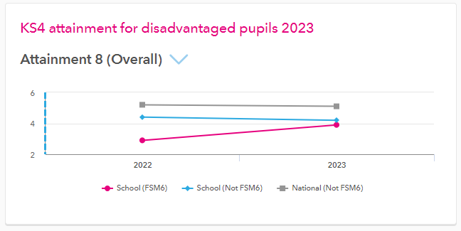

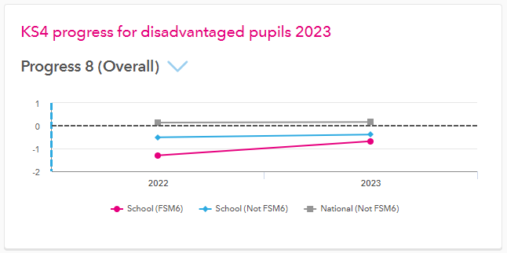
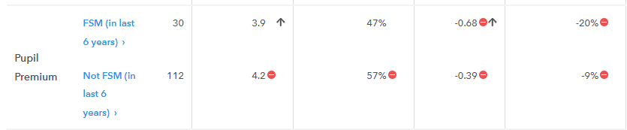
It can be seen from the data and diagrams above, that the focus on the quality of teaching across the school has had a positive impact on outcomes for disadvantaged pupils in 2023 results.
A key issue for disadvantaged students continues to be lower attendance. Moving into 23-24, therefore, the focus is on ensuring that students are in school and continuing with the focus on high quality teaching and learning.

Externally provided programmes
Please include the names of any non-DfE programmes that you used your pupil premium (or recovery premium) to fund in the previous academic year.
Programme | Provider

Service pupil premium funding (optional)
For schools that receive this funding, you may wish to provide the following information: How our service pupil premium allocation was spent last academic year
The impact of that spending on service pupil premium eligible pupils

Further information (optional)
It is our considered opinion, based on the work of Professor Becky Francis (now at the EEF), that improving teaching and learning is the key driver in improving the outcomes of our disadvantaged students. Our school improvement plan is sharply focused on that priority, and that is supported by this pupil premium strategy. As mentioned above, the strongest correlation in our results is between attendance and performance and therefore our improvement plan also prioritises attendance.

