Using Doddle – Homework
Go to: www.doddlelearn.co.uk
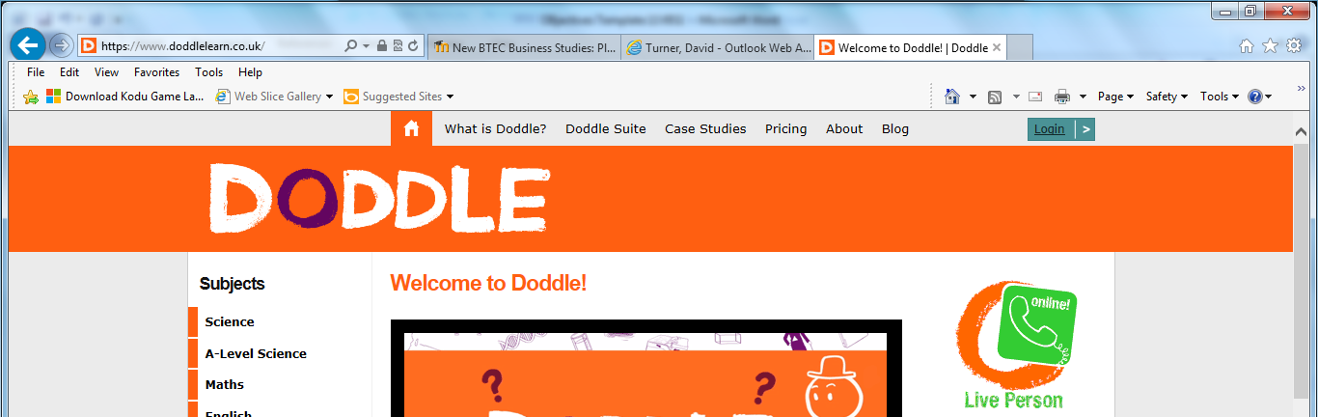
Log in
Type in school name and select school
Type in user name and passwords (Case sensitive). Password for everyone unless changed by the pupil is: walton
Username for Year 7s
FirstnameSurname19 Eg. DerekTurner19
Username for Year 8s
FirstnameSurname18 Eg. DerekTurner18
Username for Year 9s
FirstnameSURNAME17 Eg. DerekTURNER17
Username for Year 10s
FirstnameSurname16 Eg. DerekTurner16
Username for Year 11s
FirstnameSurname15 Eg. DerekTurner15
Select your work and complete
Office 365 – to access software and work from home
Go to: www.waltonledale.lancs.sch.uk/
Find ‘Office 365’. Log in.
Use your password and
Email address to log in
Email for Year 11 is: 2015surnameintital@waltonledale.lancs.sch.uk e.g 2015turnerd@waltonledale.lancs.sch.uk. Password is in your planner
Email for Year 10 is: 2016surnameintital@waltonledale.lancs.sch.uk e.g 2016turnerd@waltonledale.lancs.sch.uk. Password is in your planner
Email for Year 9 is: 2017surnameintital@waltonledale.lancs.sch.uk e.g 2017turnerd@waltonledale.lancs.sch.uk. Password is in your planner
Email for Year 8 is: 2018surnameintital@waltonledale.lancs.sch.uk e.g 2018turnerd@waltonledale.lancs.sch.uk. Password is in your planner
Email for Year 7 is: 2019surnameintital@waltonledale.lancs.sch.uk e.g 2019turnerd@waltonledale.lancs.sch.uk. Password is in your planner

Go to ‘Teams’

To find your work:

1 - Go to your class in ‘Teams’ then ‘Files’ and your files can be opened here
To hand in work:

1 - Select your subject and class e.g. 11CBS1 and go to ‘Assignments’

2 - Click ‘Add’ to add work.
3 - ‘Upload from my computer.’ Find your file from your computer device.

4 - Click ‘Turn In’ to send your work for marking and safe keeping.

