Activity 3

History

Do some online research to find out about what Britain was like in the stone age. Write down five facts about life on the British Isles in the Neolithic period.

Activity 2

DT

Design an outfit for a human living in the stone/bronze/iron age. What materials would they have used?

Activity 1

English

Write a leaflet - “How to survive in the Stone/Bronze/Iron Age”. You will need to research this topic.

Activity 5

DT

Try out some Stone Age recipes. Early Stone Age people were hunter gatherers, so their meals would have mainly consisted of meat and things they could forage, like fruit. Later in the Stone Age, people began to farm, so they began to eat crops, such as cereals and wheat.

Activity 4

Art

Design your own cave art.

Parent/career- Try taping paper to the underside of the tables and letting children draw while lying on their backs, as if they were working on the walls and ceiling of a cave. Pull down the blinds and turn the lights off to mimic painting in a dark cave.

Shadows and stones

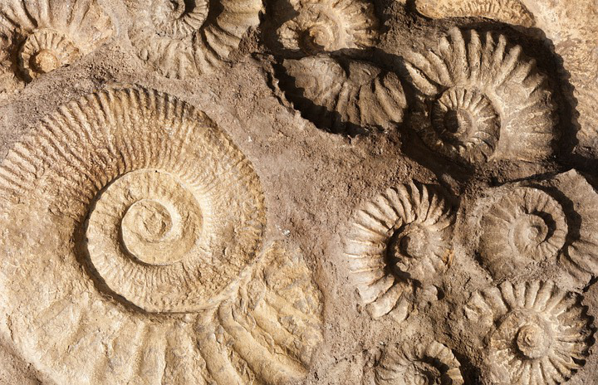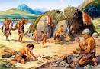

Activity 8 – ART

Create your own stone henge model.

Parent/carer, think about the type of materials they could use, toilet roll tubes, tape, cardboard, different papers.

Activity 6

History

Try flint knapping (is the making of flaked or chipped stone tools) using a piece of soap instead of the flint and some simple cutting tools (clay tools or table knives).

Activity 7 - English

Create a short story about how cave people would hunt for their food.   
  
TIP – Make sure you are practicing your extended sentences by using lots of adjectives and conjunctions.

Activity 10 – Geography

Try out making your own den,

Go out into the nature and create a den, think about what hunter gatherers may have had inside of their den (home), such as a fireplace and tools.

Activity 9 – RE/SMSC

Create your own ‘Neolithic ritual ceremony’ by making a poster showing five parts of the ceremony.

Potential examples: drawing the foods they eat, dances they may perform, gifts they may give to each other.