**DT – SKILLS**

**Shell structures:** [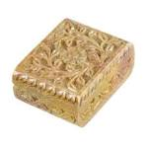](https://www.google.co.uk/url?url=https://www.idin-jewellery.co.uk/Jewellery%20Storage-Stone-92102.html&rct=j&frm=1&q=&esrc=s&sa=U&ved=0ahUKEwj-7pTwh5zcAhWKJ8AKHbe1A_wQwW4IHDAD&usg=AOvVaw1nNIrhuFw2km2BeordMHVg)

-Generate, develop, model and communicate ideas through discussion, annotated sketches, cross-sectional and exploded diagrams, prototypes, pattern pieces and computer-aided design.

-Investigate and evaluate a range of existing shell structures including the materials, components and techniques that have been used.

-Test and evaluate their own products against design criteria and the intended user and purpose.

# DT – ACTIVITIES

-Design and make a fossil or shadow theme gift box

-Evaluate ideas and products against their designs.

**DT – ACTIVITIES**

**Textiles** - Design and make tapestry inspired by the Bayeux Tapestry using decorative techniques.

**Food -** Create a Viking inspired broth using a range of traditional vegetables.

**Computing**

-Use logical reasoning to explain and correct simple algorithms.

-Use sequence, selection and repetition in programs.

# Computing – ACTIVITIES

Write a program in Scratch (or a similar platform) to create an animation.

## Science – SKILLS

**Rocks:**

-Compare and group rocks according to appearance and simple physical properties.

-Describe in simple terms how fossils are formed.

-Recognise that soil is made from rocks and organic matter.

**Light: [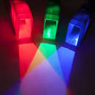](https://www.google.co.uk/url?url=https://www.onlinesciencemall.com/products/light-blox-elementary-light-color-and-shadow-kit-optics-demonstrations&rct=j&frm=1&q=&esrc=s&sa=U&ved=0ahUKEwiOwv_h45vcAhUIJcAKHVJzAuAQwW4IIjAG&usg=AOvVaw0lPEvnaqasi8O3penQWL1x)**

-Recognise we need light to see and dark is the absence of light.

-Notice that light is reflected from surfaces.

-Recognise that light from the sun can be dangerous and the need to protect their eyes.

-Recognise that shadows are formed when light from a source is blocked; identify patterns in how the size of a shadow changes.

## Science - ACTIVITIES

- Explore different soils discovering similarities and differences.

-Investigate what happens when rocks are rubbed together and what changes occur when they are in water.

- Explore what happens when light reflects of a mirror

-Design and create a fossil.

**Year 4- Autumn**

**Shadows and stones**

**Where did it all begin? How do changes take place?**

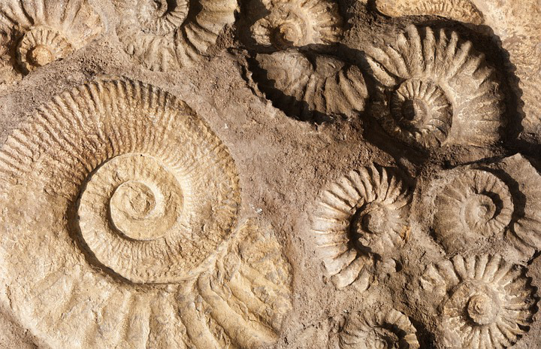[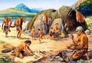](http://www.google.co.uk/url?url=http://knowmorething.com/what-you-understands-about-stone-age/&rct=j&frm=1&q=&esrc=s&sa=U&ved=0ahUKEwjSqbyT3KPcAhVCecAKHYWKDoUQwW4IHjAE&usg=AOvVaw05dUboQ5ehTIidUvqDvtgK)

**Awesome Opener:** Make a cave in our class.

**Marvellous middle:** Design and create unique fossils.

**Fantastic Finale:** Stone age experience

# Exploring religions:

**Christianity**-Explore the main features of a place of worship. Investigate the symbolism in the Nativity story.

Identify and value special times.

**Hinduism**- Explore the meaning of Divali ((Oct/Nov)

# Music – SKILLS

To sing with increasing confidence and control. Also to develop an understanding of musical composition, organising and manipulating ideas within musical structures

# Music - ACTIVITIES

To perform a solo. To perform in a group.

games

## Maths – SKILLS

Number-Place value

Find order and compare numbers to 1000. find 100 more or less than a given number. Write numbers to 1000 in numerals and words, solve number and practical problems.

Number- addition and subtraction

Add and subtract mentally including 3 digit numbers. Solve problems, add and subtract money to give change, and use inverse operations.

Number-Multiplication and division

Recall and use multiplication and division facts for the 3, 4 and 8 times table. Solving problems involving multiplication and division.

Measurement

Compare add and subtract lengths in *m,cm* and *mm.* Measure the perimeter of 2D shapes.

## English – SKILLS (Include but are not limited to below)

-Apply and develop knowledge of root words, prefixes and suffixes.

-Learn to use the different grammatical forms of sentence: question, command, statement

- create subordinating clauses and use a variety of verb forms.

-To use prepositions to join noun phrases

**English ACTIVITIES**

-Children will create character and setting descriptions, diary entries, recounts, narrative writing, Letter writing and create shared poems.

**English – Texts**

-**The Mystery of Harris Burdick** *by Chris Van Allsberg* (Science link-Light)

-**The first drawings** *by Mordicai Gerstein*

(History link-Stone age)

**-The Tear Theif** *by Caroll Ann Duffy and Nicoletta* 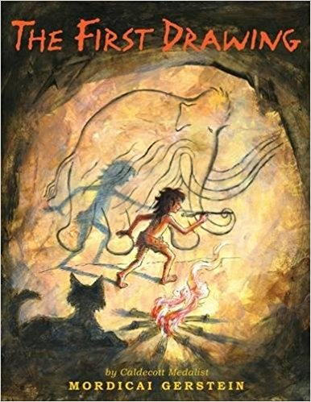

# History – SKILLS

**Stone age:**

-Explain why there are similarities and differences between ways of life and time periods

-Recognise historical influences on present day society

-Understand and use historical terms verbally and in written form

- **History- ACTIVITIES**

- Order events within a time period.

- Identify Changes in Britain from the Stone Age to the Iron Age

**Art – SKILLS**

-Use sketch books to record observations and use them to review and revisit ideas.

-To improve their mastery of art and design techniques, including drawing, painting and sculpture with a range of materials

**Art – ACTIVITIES** Include the study of Sir Christopher Wren (Architech) and include the use of Use clay to create fossils.

**PE – SKILLS**

- Kick and strike with confidence and control.

- Defend with accuracy and care.

- Create a ‘good’ invasion game using a set criterion

**PE – ACTIVITIES**

Invasion games and swimming