**English**

**Key Areas**

* Descriptive writing (Man on Moon focus)
* Narrative (Curiosity focus)

**Book Suggestions**

Man on the Moon by Simon Bartram

Curiosity: The Story of a Mars Rover by Markus Motum

**Activity Ideas**

-create own space creature, setting and plot (story)

-create own planet and profile (fact file)

-create own space suit (advert)

-diary of space travel adventure (Curiosity-narrative)

-modes of transport brochure

-Re-create a space travel expedition

**Geography/History**

**Geography Skills**

Climate differences

Global warming

Effect of habitat on survival needs

Countries/continents of the world

**Geography Activities**

-Create a class display of solar system-identify environments

-Posters to promote looking after the planet

-Create new creatures to suit habitats researched

-Create a world map identify space travel expeditions-update as researched

**History Skills**

Create a timeline

Modes of transport-research

Investigate famous people in history-question and reason

**History Activities**

Timeline for travel into space

Create a brochure for varied modes of transport

Choose a famous space explorer to create a mini project

**Maths**

**Key Areas**

* Telling the time/time intervals (MOTM)
* Days of the week-origin of names
* Timetable-day in the life of….
* Addition/subtraction
* Multiplication/division
* Space/shape measures

**Activity Ideas**

* Day in the life of bob timetable
* Dairy entries
* Use of stopwatch to time activities use results to create calculations
* Identify shapes for solar system focus
* 3d/2d shapes for rocket/robot project
* Measuring out ingredients to create ‘space snacks’

**Year 5- Autumn 2020**

*Out of this world! Where were you when I was looking for you?*

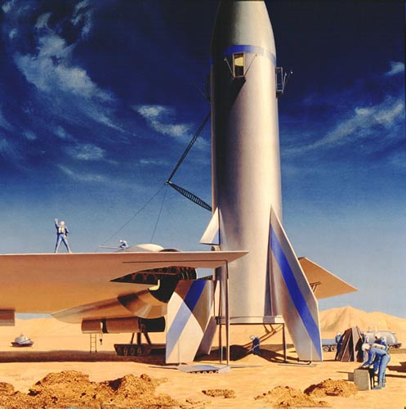

**Opener:** space snacks induced story time (in class tyres!)

**Middle:** Large scale display complete, invites sent to view (across school)

**End:** Record narrative of 4D space travel expedition

**Computing**

* Take photos-exercise and movement
* Create a poster/display for a ‘space suit’
* Save/print and retrieve work into and from a folder
* Design character and comic strip for space expedition
* Record 4D space travel narrative

**Music**

**Skills**

-create/adapt/compose own music theme tune

-select music instruments/piece of music for a purpose

**Activities**

* Create theme tune for space mission to read story aloud
* Create mood setting music for space creature created
* Create background track for recorded space mission narrative

**Science**

**Science Skills**

-Healthy eating

-Locate and Name planets of the solar system

-Effect of exercise (photographs MOTM)

-Investigation of materials

**Science Activities**

-Create a class display of solar system

-create space inspired snacks for story time

-Make/experiment with glow in the dark toys/sensory stimulus

-research and recreate own experiments with fair testing and predictions

**PSHE**

- Growth mind set activities weekly

- Create bank of coping strategies for each emotion (use planets to support this)

-Consideration for self-reflection activities

**SMSC**

-Antarctica, Roald Dahl Day, Democracy, Current Affairs Debate, Christianity, World Mental Health

**Art and DT**

* Study of artist- Chesley Bonestell
* Make your own rocket/robot project