**Activity 3**

Write a letter to one of your emotions, explain to them what you think about them existing and if you think they should stay or go.

**Activity 2**

Listen to some music that makes you feel happy-write down the name of it and draw a picture/write some sentences that explain what the song is about.

**Activity 1**

Create a model or picture of one of the emotions from the film. Challenge yourself to write as many words that could be used to describe the emotion you have created.

**Activity 7**

Make up phrases that you could say to someone when they are feeling each emotion.

For example, you could say this to Fear…take a deep breathe a try again.

**Activity 6**

Use counters, circles of paper, circular sweets (?) and think about some memories you have. Think of a memory connecting to each emotion. Can you make an image using these?

**Activity 8**

Think of how your body might look when you are feeling the different emotions. You could take some photos of you role modelling this, draw a picture of what you look like at this time or write a description of your body. This might help someone know how your feeling just by looking at you!

**Activity 5**

Think of another emotion and create your own character. Don’t forget to name them!

**Activity 4**

Think about the colour that the emotion characters are. Can you think of an object that is the same colour that makes you feel the same emotion? For example, Brussel sprouts are green, they disgust me!

**Emotive Memories**

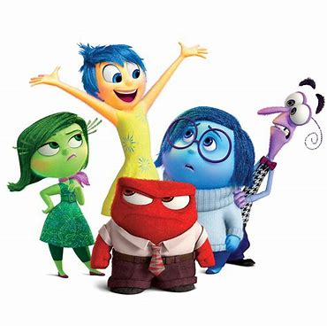

**Activity 9**

Think of 3 ways that you could make someone feel Joyful. See if you can manage to do these and make a record of them. You could video this, take a photo or write about it.

It’s nice to make people feel good.

**Activity 10**

It is ok to feel angry sometimes. It is what we do with our anger that effects ourselves and others. Can you think of a time when you managed your Anger really well? How did it make you feel afterwards?

Sometimes turning that frown upside down is tough-but you can get there!