**Geography**

**Geography Skills**

**-Use maps to research and then describe the features of an area**

**-Explain volcanoes, earthquakes and geography of mountains**

**-Locate the countries of Europe describe their principle features**

**-Make key comparisons between an area of the UK and one in Europe**

**Key Areas**

Climate differences

Global warming

Effect of habitat on survival needs

Countries/continents of the world

**Geography Activities**

-Create a class display of solar system-identify environments

-Posters to promote looking after the planet

-Create new creatures to suit habitats researched

-Create a world map identify space travel expeditions-update as researched

**Maths**

**Key Areas**

-Number and place value

-Addition and Subtraction

-Multiplication and division

-Measurement: Length and perimeter

**Maths Skills:**

**LA**

-Count to and across 100, forwards and backwards, from any given number

-Count, reads and writes numbers to 100 in numerals;

-Count in multiples of twos, fives and tens

-Identify one more and one less

-Number bonds and related subtraction facts within 20

**-** Compare, describe and solve practical problems for lengths

**MA**

**-** Count in steps of two, three, and five from 0, and in tens from any number, forward and backward

**-** Compare and order numbers from 0 up to 100

- < > and = signs

**-** Use place value and number facts to solve problems

**-** Solve problems with addition and subtraction

**-** Solve problems with addition and subtraction by applying an increasing knowledge of mental and written methods

**-** Recall and use addition and subtraction facts to 20 and 100, fluently up to 20.

- Recall and use multiplication and division facts for the two, five and 10 multiplication tables, including recognising odd and even numbers

- Solve problem involving multiplication and division using materials, arrays, repeated addition, mental methods, and multiplication and division facts, including problems in contexts

**Activity Ideas**

* Day in the life of bob timetable
* Dairy entries
* Use of stopwatch to time activities use results to create calculations
* Identify shapes for solar system focus
* 3d/2d shapes for rocket/robot project
* Measuring out ingredients to create ‘space snacks’

**English**

**Key Areas**

* Descriptive writing (Man on Moon focus)
* Narrative (Curiosity focus)

**Book Suggestions**

Man on the Moon by Simon Bartram

Curiosity: The Story of a Mars Rover by Markus Motum

**Writing skills**

**LA**

-Letters of the alphabet

-Sentences to form narrative

-Proof read work

-Spell words (using 40+ phonemes)

-Capital letters, full stops, question marks and exclamation marks

-Letter formation

-Sentences from memory

-spell some common exception words

**MA**

-phonic knowledge to attempt spelling

-write narratives from personal experience and others

-use adventurous vocabulary

-co-ordination and subordination

-joined handwriting formation

-past and present tense

-add suffixes

-use effective vocabulary choices

-beware of the reader

**Activity Ideas**

-create own space creature, setting and plot (story)

-create own planet and profile (fact file)

-create own space suit (advert)

-diary of space travel adventure (Curiosity-narrative)

-modes of transport brochure

-Re-create a space travel expedition

**Year 5- Autumn 2021**

*Out of this world!*

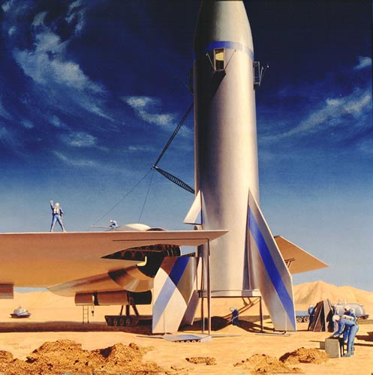

**Opener:** space snacks induced story time (in class tyres!)

**Middle:** Large scale display created as a class, invites sent to view (across school)

**End:** Record narrative of 4D space travel expedition

**Computing**

**Skills**

**-Can use a search engine with some discrimination and understand how it selects and ranks items**

**Activities**

-Use search engines to locate images to match learning

-Use of search engines to extend knowledge of topic

**Music**

**Skills**

-I**dentify the kind of music they have listened to and give a reasoned personal reaction to it**

**-** **Increase accuracy, control and expression through practice and rehearsal**

**Activities**

* Share music of own preference weekly (for each child)
* Select, practice and rehearse Christmas songs to share with families

**Science**

**Science Skills**

**-Recognise that living things can be grouped in a variety of ways**

**-Explore and use classification keys to help group, identify and name a variety of living things in their local and wider environment**

**-Recognise that environments can change and that this can sometimes pose dangers to living things.**

**Key Areas**

Living Things

**Science Activities**

-Create a class display of damage to environments-including photos taken by children in local environment

-Make 3D display of living things

-research and recreate own experiments with fair testing and predictions

**PSHE**

**Skills**

Acceptance and resilience

**Activities**

-Games-relating to being a good winner…and ‘loser’

-Highlight positive areas and encouraging peer praise-reward based (raffle tickets/positive points)

**SMSC**

Antarctica, Roald Dahl Day, Democracy, Current Affairs Debate, Christianity, World Mental Health

**Art and DT**

**Skills**

**-Experience a range of painting tools and materials and progress in 2D arts**

**-Explain, in basic terms, what is meant by a healthy and balanced diet and where the major risks to health lie**

**Activities**

-Create Christmas themed art work for display (incorporate topic)

-Establish healthy snacks for Christmas party ideas