**MUSIC**

1. Listening diary song: **Imagine – John Lennon**. Remember to draw whether you like the song or not using ☺ 😐 ☹ why you do/do not like it, what would make it better into your Listen Diary/the Google Doc attached.
2. Try the ‘Match the Rhythm’ game:

<https://www.classicsforkids.com/games.html>

**ENGLISH**

1. Read for 20 minutes a day.
2. Thinking back to the Music Listening Diary Song ‘Imagine’, think of 5 things you would like to change about the world. ‘Imagine’ what life would then be like following these changes and describe it in the Google Doc using descriptive language.

**PE**

1.Attempt The Socks in the Box and Figure of 8 challenges at:

<https://www.youthsporttrust.org/60-second-physical-activity-challenges>

2. Record your scores on the Google Doc and then challenge someone else to see if they can beat you!

Yr 9&10 HOME LEARNING TASKS - #10

**ART**

1.Take the quiz to see if you can work out what each microscopic picture is of.

<https://www.bbc.co.uk/newsround/45967758>

2. Create your own copy of one of the microscopic pictures and insert your picture into the Google Doc or attach to here/the stream.

**MATHS**

1. Complete weekly Mathletics tasks.
2. Attempt the Maths Puzzle of the week:

**Give me a break!!**

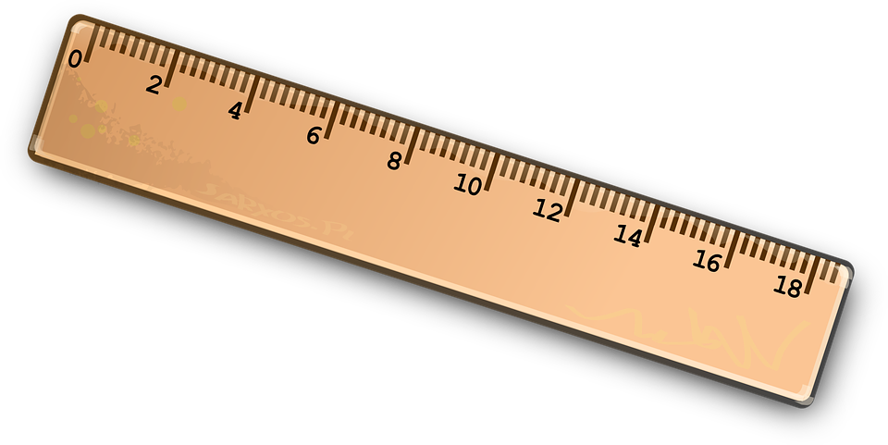

A 1-metre stick is broken into two pieces at random. What is the length of the shorter piece, on average?

(Write your answer on the Google Doc)

Feel free to try out more at:

<https://www.mathsisfun.com/puzzles/starter-puzzles-index.html>

**ICT**

1.Take a look at the list of smart phone/tablet- friendly apps and try a few out (age appropriate):

<https://www.stem.org.uk/sites/default/files/pages/downloads/Computing%20SmartPhone%20Apps.pdf>

2. On the Google Doc, write a short review of 3 of the apps, explaining what you thought of them and their usability.

**PSHE/SMSC**

1.Read the article about Marcus Rashford and Free School Meal Vouchers.

<https://www.bbc.co.uk/newsround/53068466>

2. Answer the questions about what Marcus Rashford achieved in the Google Doc.

**SCIENCE**

1.Complete the interactive Body Builder task following the link below:

<https://www.abpischools.org.uk/topic/bodybuilder/2>

2.On the Google Doc, state 3 facts that you have learned about organs/bones.

**FOOD TECH**

1. Read/watch the kitchen hygiene tips.

<https://www.funkidslive.com/learn/the-grain-chain/safety-and-peparation/#>

1. In the Google Doc, write the top 5 hygiene tips you can recall from the video/article.