**ART**

1.Create your own 3D hand sketch just like the one below!

[https://www.justcolor.net/art/op-art/?image=op-art__coloring-op-art-illusion-optique-main_](https://www.justcolor.net/art/op-art/?image=op-art__coloring-op-art-illusion-optique-main__1https://www.justcolor.net)

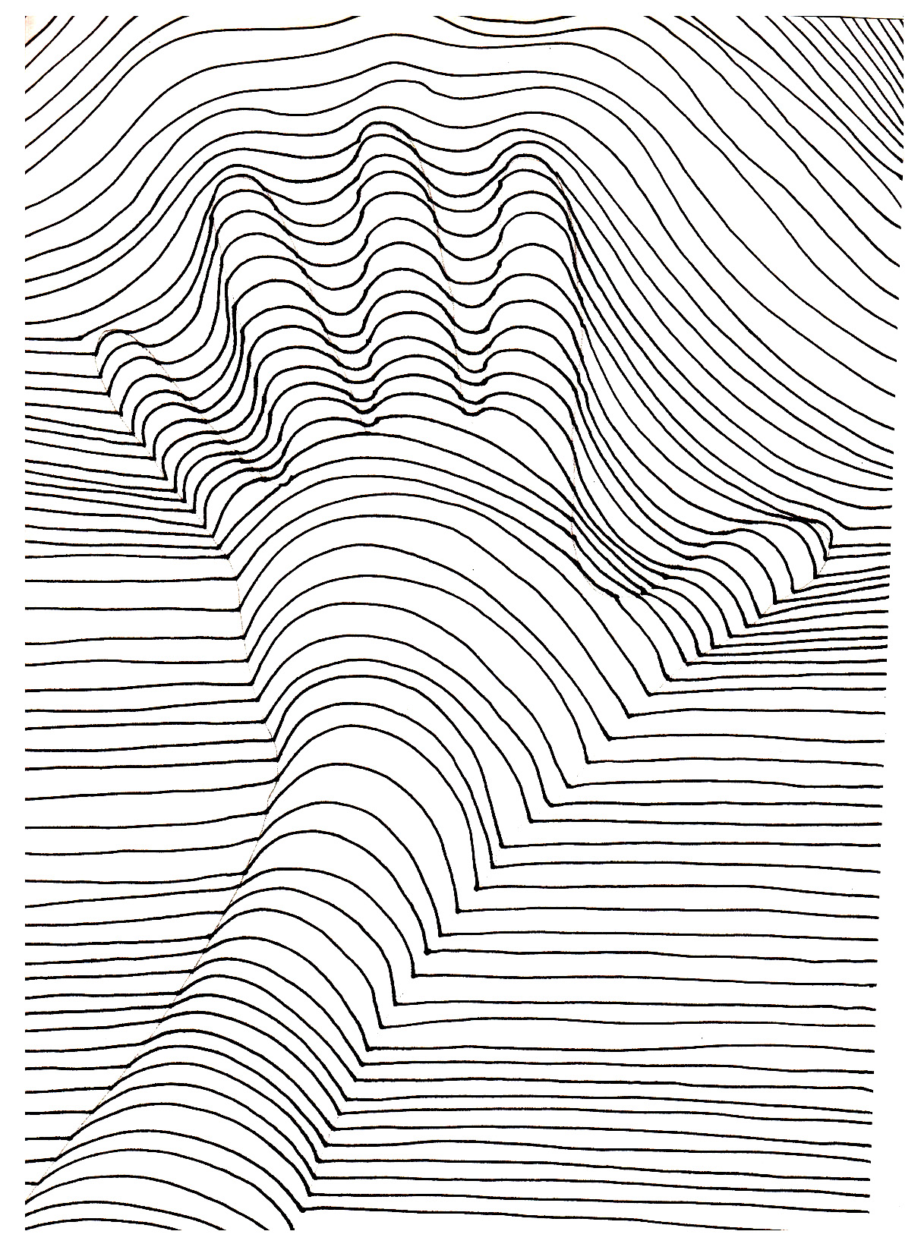

**PE**

1.Attempt The Speed Bounce and The Plank challenges at:

<https://www.youthsporttrust.org/60-second-physical-activity-challenges>

Challenge someone else to see if they can beat your score!

**ENGLISH**

1. Read for 20 minutes a day.
2. Complete any Literacy Planet tasks.
3. Read the article below in PSHE/SMSC about George Floyd. In the Google Doc, write a letter to the President of the USA, Donald Trump and explain what action you think he should take in response to the anti-racism protests that are now taking place globally.

Yr 7&8 HOME LEARNING TASKS - #7

**MUSIC**

1. Listening diary song: **Where is the love? Black Eyed Peas**. Remember to draw whether you like the song or not using ☺ 😐 ☹ why you do/do not like it, what would make it better on the Google Doc.
2. Take the ‘Orchestra Challenge’ at:

<http://www.musicgames.net/livegames/orchestra/orchestra2.htm>

**ICT**

1.Follow the slides on using Excel.

2.Copy Maya’s information to create an M&M pie chart of your own, in colour and insert into the Google Doc!

<https://www.slideshare.net/Mizyaya07/excel-for-kids>

**SCIENCE**

1. Learn about Light Refraction, following the instructions at:

<https://coolscienceexperimentshq.com/light-refraction/>

You’ll need: A piece of paper, a pen, a glass and some water.

1. Write a sentence explaining why the arrow changed direction on the Google Doc.

**FOOD TECH**

1. Continue with booklet if not complete.
2. Follow the recipe below to make something a little bit different for breakfast!!

<http://allrecipes.co.uk/recipe/43024/egg-in-a-hole.aspx>

Attach a picture of your finished product to the Google Doc!

**MATHS**

1. Complete weekly Mathletics tasks.
2. The Maths Puzzle of the week:

**A Calendar Riddle**

Three days ago, yesterday was the day before Sunday. What day will it be tomorrow?

Feel free to try out more at:

<https://www.mathsisfun.com/puzzles/starter-puzzles-index.html>

**PSHE/SMSC**

1.Read the article about the protests that have been taking place across the UK and the rest of the world, following the death of George Floyd in America.

<https://www.bbc.co.uk/newsround/52950491>

2. Choose 3 banners/posters that you can see people holding up and on the Google Doc explain what you think they mean.