**ICT**

1.Follow the slides on using Excel.

2.Copy Maya’s information to create an M&M pie chart of your own, in colour and attach to the Google Doc

<https://www.slideshare.net/Mizyaya07/excel-for-kids>

2.Using the same instructions, complete a chart showing average hours p/day of sleep you get.

**ENGLISH**

1. Read for 20 minutes a day.
2. Read the article below in PSHE/SMSC about George Floyd.
3. Now (in the Google Doc) write a letter to the President of the USA, Donald Trump and explain what action you think he should take in response to the anti-racism protests that are now taking place globally.

**PE**

1.Attempt The Speed Bounce and The Plank challenges at:

<https://www.youthsporttrust.org/60-second-physical-activity-challenges>

Challenge someone else to see if they can beat your score and write it on the Google Doc.

**ART**

1.Create your own 3D hand sketch just like the one below! Insert a pic on Google Doc.

[https://www.justcolor.net/art/op-art/?image=op-art__coloring-op-art-illusion-optique-main_](https://www.justcolor.net/art/op-art/?image=op-art__coloring-op-art-illusion-optique-main__1https://www.justcolor.net)

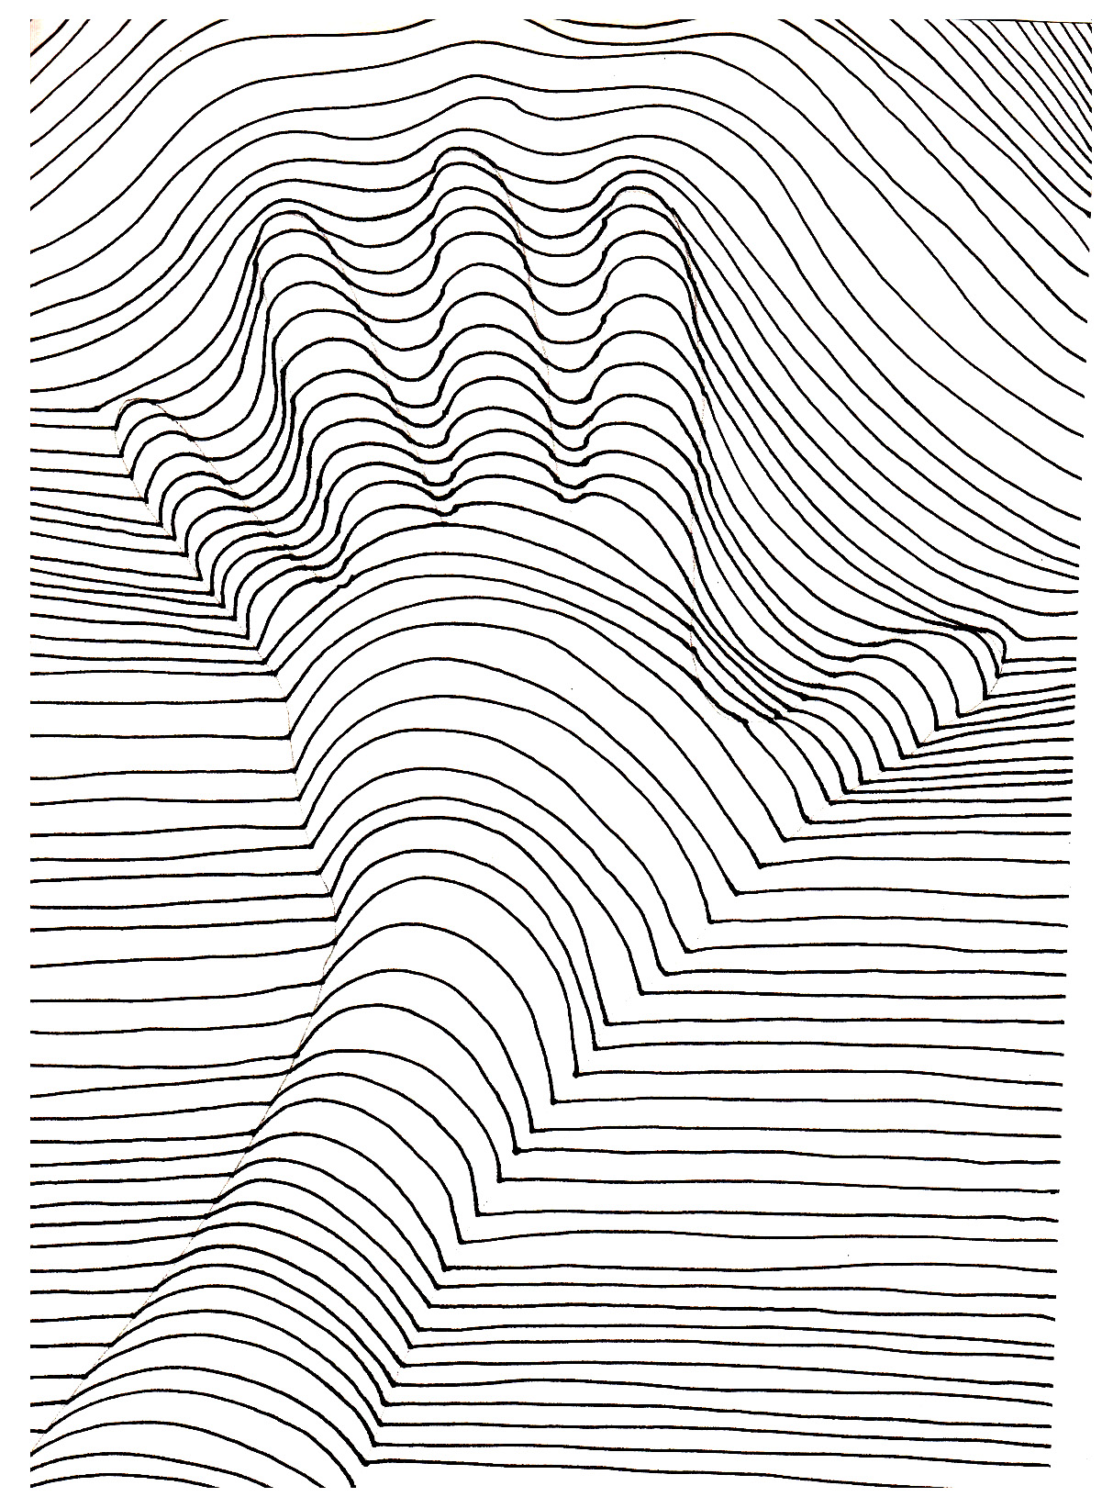

Yr 9&10 HOME LEARNING TASKS - #7

**MUSIC**

1. Listening diary song: **Where is the love? Black Eyed Peas**. Remember to draw whether you like the song or not using ☺ 😐 ☹ why you do/do not like it, what would make it better.
2. Take the ‘Orchestra Challenge’ at:

<http://www.musicgames.net/livegames/orchestra/orchestra2.htm>

**SCIENCE**

1. Follow the instructions to complete this short interactive activity sheet explaining Vertical Farming on the Google Doc.

<https://stemresources.raeng.org.uk/NetC.RAE/media/randoms/EaBW-Vertical-Farm_FINAL-WEB_3.pdf>

**PSHE/SMSC**

1.Read the article about the protests that have been taking place across the UK and the rest of the world, following the death of George Floyd in America.

<https://www.bbc.co.uk/newsround/52950491>

2. Choose 3 banners/posters that you can see people holding up and explain what you think they mean on the Google Doc.

3. Design your own idea for a banner that would have displayed an important message at a demonstration.

**MATHS**

1. Complete weekly Mathletics tasks.
2. The Maths Puzzle of the week:

How many triangles are there in this diagram? Bonus question: How many quadrilaterals?

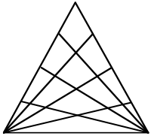

Feel free to try out more at:

<https://www.mathsisfun.com/puzzles/starter-puzzles-index.html>

Feel free to try out more at:

<https://www.mathsisfun.com/puzzles/starter-puzzles-index.html>

**FOOD TECH**

1. Continue with booklet if not complete.
2. Follow the recipe below to make a delicious creamy potato and sausage bake!!

<http://allrecipes.co.uk/recipe/22754/creamy-sausage-and-potato-bacon-bake.aspx>

1. Attach a picture of your finished product to the Google Doc!