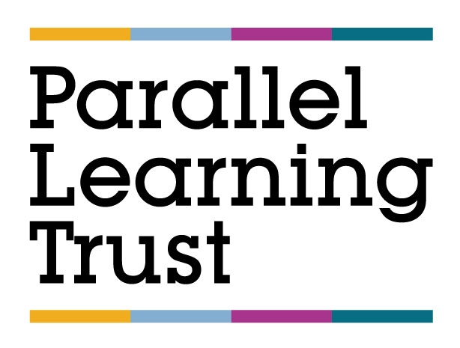

REMOTE LEARNING POLICY

Approved by: | E Muca | Date: 25/01/2021
Last reviewed on: | 25/01/2021
Next review due by: | 25/01/2024

Contents
1. Definition of Remote Learning ......................................................................................................... 3
2. Remote Learning Platform ............................................................................................................... 3
3. General Principals for Remote Learning .......................................................................................... 3
Roles and Responsibilities.................................................................................................................... 4
4.1 Teachers ........................................................................................................................... 4
4.2 Learning Support Assistants (LSA)................................................................................... 4
4.3 IT Support........................................................................................................................ 4
4.4 Pupils and Parents............................................................................................................ 4
Appendix 1 .......................................................................................................................................... 5
Appendix 2 .......................................................................................................................................... 5
Appendix 3 .......................................................................................................................................... 6

--------------------------------------------------------------------------------------------------------------------------------------

1. Definition of Remote Learning
There are 4 descriptions which fall under what is expected of ‘remote learning’:
- Remote Education: a broad term encompassing any learning that happens outside of the classroom, with the teacher not present in the same location as the pupils.
- Digital Remote Education: often known as online learning, this is remote learning delivered through digital technologies.
- Blended Learning: a mix of face-to-face and remote methods. An example would be the ‘flipped classroom’, where the main input happens remotely (e.g. through video), while practice and tutoring happen in class.
- Synchronous Education: this involves live lessons and an asynchronous element i.e. material is prepared by the teacher and accessed by the pupil at a later date.
Some myths exist about remote learning, which are not evidence-based. These include that:
- Remote learning is fundamentally different to other forms of teaching/learning.
- Remote learning is a different curriculum/offer to the content that would be delivered normally.
- The best forms of remote education are digital.
- The best way to deliver remote education is always through live lessons.
- The most important thing is pupils’ engagement.
For further details, refer to Ofsted’s Summary of Remote Learning
2. Remote Learning Platform
- At PLT, remote learning is delivered via Google Classroom.
- Google Classroom is all-in-one hub for the collaborative classroom. Is equipped with generic software, Doc, Slide and Sheet, which has similar features to Microsoft Word, Excel and PowerPoint. It allows teachers to host video and audio calls, share documents, conversations, files and notes, collaborate on virtual whiteboards and issue and mark assignments.
3. General Principles for Remote Learning
- Every effort will be made to ensure that curriculum quality, breadth and balance are not sacrificed where pupils are required to learn remotely.
- Remote learning will follow the normal school timetable. Pupils need learning routines and consistent expectations when working at home. Every effort will be made to ensure equality of curriculum provision and continuity between pupils learning at school and those learning at home.
- The principles and qualities underpinning effective teaching and learning are fundamentally the same, irrespective of whether learning takes place remotely or in the classroom.
- Online learning will be complemented with academic resources to support pupils’ acquisition of knowledge and consolidation of skills.
- Teachers will assess pupils’ remote learning in appropriate ways. Depending on the nature of the work that pupils are completing, some assessment may be immediate, such as through the use of the chat function in Google Classroom. Written assessments will be assessed through ‘Assignment’.
- Opportunities for breaks will be built into pupils’ remote learning day, just as the school day.

4 Roles and Responsibilities
4.1 Teachers
Curriculum lead is responsible for the implementation and monitoring of remote learning.
When providing remote learning, teachers must be available between 8.30 -16.00.
If teachers are unable to work e.g. due to sickness, they should report this using the normal absence procedure. The Timetabling Lead will arrange for the lesson to be covered which may involve assigning the teaching group to another member of staff.
During periods of school closure, teachers will have flexibility to deliver remote learning from home. A Staff Code of Conduct (Remote Learning) is included in Appendix 1.
4.2 Learning Support Assistants (LSA)
The SLT/Timetabling Lead is responsible for the deployment of LSAs. LSAs will be deployed to support vulnerable pupils attending school.
4.3 IT Support
The trust ICT team is responsible for the implementation and monitoring of IT support. IT support staff are responsible for:
- Assisting pupils with accessing their Google Classroom account e.g. resetting passwords etc.
- Fixing hardware and software issues.
- Assisting staff and pupils with technical issues, including accessing the internet or devices.
- Reviewing the security of remote learning systems and flagging any data protection breaches.
4.4 Pupils and Parents
A Parent and Pupil Code of Conduct (Remote Learning) is included in Appendix 2 and Appendix 3.
This 'Remote Learning Policy' is intended to promote consistency and high standards and the achievement of the Trust aims. At Parallel Learning we aim to provide a caring, supportive and stimulating environment with high quality teaching.

Appendix 1
Staff Code of Conduct (Remote Learning)
Staff should:
- Run daily google meets at 9.30 and remind pupils in their tutor group of their individual timetables.
- Ensure all pupils are invited to their groups.
- In advance, upload resources relevant to the lesson. Lesson must be scheduled invidually with the correxponding due date clearly assigned.
- Sign into Google Classroom before the lesson is due to begin, ensuring there are no issues in terms of access, content etc.
- Ensure settings are configured so that only they can present during the lesson and share their screen during live meetings.
- Ensure that e-mails are closed and only those programs that are necessary for the lesson are open.
- At the start and end of each lesson, open the camera/webcam facility to personalise the lesson.
- Where teaching from home, blur the background (or choose a background) to protect personal privacy, wear suitable professional clothing and try to teach from a place in the house that is quiet, with minimal disruption.
- At the end of each lesson, select ‘end the meeting’ (not ‘leave the meeting’) so that pupils cannot continue the meeting unsupervised.
- When teaching pupils online, ensure that all communication is through Google Classroom or school email. Never share personal details or contacts with pupils or communicate through social media or other channels. Private ‘chat’ with pupils is prohibited.
- Ensure that they model high professional standards at all times.
- Monitor attendance/engagement on the pupil monitoring form daily. Tutors to refer to this when contacting parents. Tutors are the key point of contact of pupils not attending/engaging. Tutors will refer serious non-engagement to Pastoral lead/SLT
- Provide follow up work to the lesson.
- Provide feedback e.g. verbal (through the audio facility) and written (through the ‘chat’ and ‘assignment’ facilities).
- Staff will follow the marking policy in both digital and paer based marking.

Appendix 2
Parent Code of Conduct (Remote Learning)
Parents should:
- Support their child’s personal organisation so that they attend lessons punctually, in accordance with their timetable.
- Encourage their child to participate fully in online lessons and to complete independent work set by their teachers.
- Ensure that no element of an online lesson is recorded by their child or family members.
- Avoid making any comments, or sharing any material, on social media that could identify their child, school or staff.
- Ensure that their child takes care of any equipment that they have been loaned by the Academy and uses it only for the purposes for which it was intended.

Appendix 3
Pupil Code of Conduct (Remote Learning)
Pupils should:
- Arrive on time to all their online lessons.
- Follow their school timetables when working remotely from home, as well as in school
- Engage with any allocated learning mentors and personalised learning lessons.
- Turn off their camera/webcam facility unless the teacher asks them to turn it on.
- Under no circumstances, record the lesson or share any images from the lesson on any platform.
- Keep their microphone muted unless the teacher asks them to speak and mute themself when they have finished.
- Only use the ‘chat’ function if directed to by the teacher and only for the purpose they specify.
- Gain permission from the teacher if they need to leave the lesson for any reason.
- Keep their passwords private.

