WHY CHOOSE ART?

PUPILS IN THE PAST HAVE ACHIEVED UP TO GRADE 5 AT GCSE

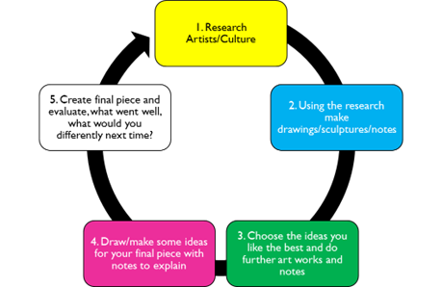
ART ENCOURAGES INDEPENDENT THINKING

LOTS OF USEFUL SKILLS SUCH AS SEWING

THERAPEUTIC, SUPPORTS EMOTIONAL DEVELOPMENT

OPPORTUNITIES TO LEARN FROM THE REAL WORLD

A CONTRAST TO OTHER SUBJECTS

BTEC ART & DESIGN LEVEL 1

A ONE YEAR COURSE

STUDIED IN YEAR 10

CAN CONTINUE IN YEAR 11

THREE LEVELS OF DIFFICULTY

NO EXAM

GCSE FINE ART

A TWO YEAR COURSE

STUDIED IN YEAR 10 & 11

UNIT 1 PORTFOLIO

UNIT 2 EXAM PREPARATION

10 HOUR EXAM MAY 2021

EXTRA 2.5 HOURS IF DIAGNOSED WITH SEN

