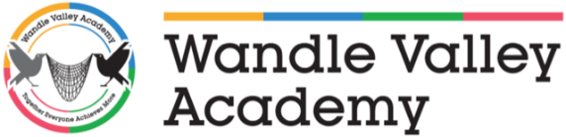

Wandle Valley Academy
Uniform Order Form

Measure child’s chest in order to find size.

KK403 Polo Charcoal Grey Full Logo - Price £12.85

Polo Size | XXS  28/30” | XS  32/34” | S  36/38” | M  40” | L  42” | XL  44”
Quantity

Gildan Sweatshirt Black Full Logo - Price £12.85

Jumper Size | Kids L 28/30” | Kids XL 32/34” | S  34/36” | M  38/40” | L  42/44” | XL  46/48”
Quantity

If a child’s size is not available on the form, please speak to the office.

Name of Pupil: _____________________________________

I have made payment of ___________________________ to Wandle Valley Academy by the following method (Please tick appropriate box):

E-Banking to Wandle Valley Academy Account Number 44054168 Sort Code 30-92-45 with my child’s surname and uniform as reference (WVAUniform).

By cheque payable to Wandle Valley Academy.

Enclosed money in a sealed envelope.

