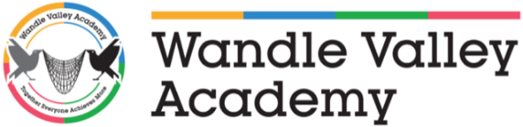

Wandle Valley Academy
Uniform Order Form

Measure child’s chest in order to find size.

KK403 Polo Charcoal Grey Full Logo - Price £12.85

Polo Size | Youth  S  5/6 (16”) | Youth  M  7/18 (17”) | Youth  L  9/11 (18”) | Youth  XL  12/14 (19”) | Adult  S  34/36” | Adult  M  38/40” | Adult  L  42/44” | Adult  XL  46” | Adult  XXL  48” | Adult  XXXL  50”
Quantity

Gildan Sweatshirt Black Full Logo - Price £12.85

Sweatshirt Size | Youth S  5/6 (17”)” | Youth M  7/8 (18”) | Youth  L  9/11 (19”) | Youth XL  12/14 (20”) | Adult  S  34/36” | Adult  M  38/40” | Adult  L  42/44” | Adult  XL  46/48” | Adult  XXL  50/52” | Adult  XXXL  54/56”
Quantity

If a child’s size is not available on the form, please speak to the office.

Name of Pupil: _____________________________________

I have made payment of _______________________________ to Wandle Valley Academy by the following method (Please tick appropriate box):

E-Banking to Wandle Valley Academy Account Number 44054168 Sort Code 30-92-45 with my child’s surname and uniform as reference (WVAUniform).

Enclosed money in a sealed envelope.

