Trauma-Informed Statement

WANDLE VALLEY ACADEMY

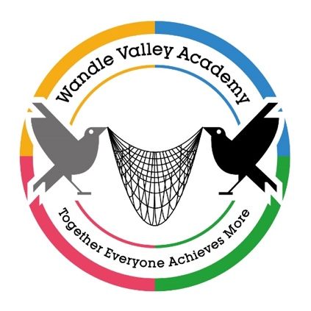

At Wandle Valley Academy, we are committed to being a trauma-informed school.

We recognise that many of our pupils have experienced adversity and trauma, which can impact their social, emotional and mental health, as well as their learning and behaviour. Our approach is rooted in understanding the impact of trauma and adversity, and in creating a safe, supportive, and nurturing environment where every pupil feels valued and understood.

Trauma Informed – has become the latest buzz word in education, but has been the underpinned way of working at Wandle Valley Academy for the last 10 years and, alongside Emotional Literacy and Speech & Language, are the foundations that make up the amazing environment that our pupils thrive in.

It is vital that those who visit Wandle Valley Academy are reminded that a majority of the pupils that attend our school have developed high level SEMH behaviours as a result of failed education, and many other factors, as well as their trauma background. One of the key foci of Wandle Valley Academy, is to support our pupils in developing appropriate and safe ways of dealing with this and, at times, this will mean that we have to prevent negative and dangerous outcomes from taking place. A large part of the work that we do at Wandle Valley Academy is in preparing our pupils for life outside Wandle and post 16. We want them and their families to have the tools to live safe, productive and happy lives.

Our commitment includes:

- Safety first: We prioritise the physical and emotional safety of all pupils and staff. Our routines and policies are designed to build trust and predictability.
- Relationships matter: We invest in positive, respectful relationships as the foundation for learning, healing and growth.
- Empowering pupils: We work with pupils to help them understand their own needs and emotions, promoting self-regulation and resilience.
- Staff awareness and training: Our staff are trained to recognise the signs of trauma and respond appropriately, using restorative, relational and de-escalation approaches.
- Whole-school culture: We foster a culture of empathy, inclusion and respect. All staff, governors and partners are expected to uphold these values.
- Working with families and agencies: We actively engage with families and external agencies to provide joined-up support for our pupils.

Our trauma-informed approach aims to support the wellbeing, behaviour, and academic outcomes of every pupil at Wandle Valley Academy.

