Activity 2

Create a fact file about a famous Person from your chosen European country.

Your fact file should have at least 5 interesting facts about the person. Split your information into paragraphs.

Activity 3

Can you find 4 different ways to make £5.00

Activity 7

Create a timetable of your day using 12 or 24 hour digital time. You could draw pictures or write what you are doing at each time. For example: 7:00 – I wake up, 7:30 – I brush my teeth

Activity 4

Make a picture of an object only using 2D shapes or writing numbers. For example, you could use the number ‘3’ turned on its side to create a bird flying in a sky scene.

Activity web

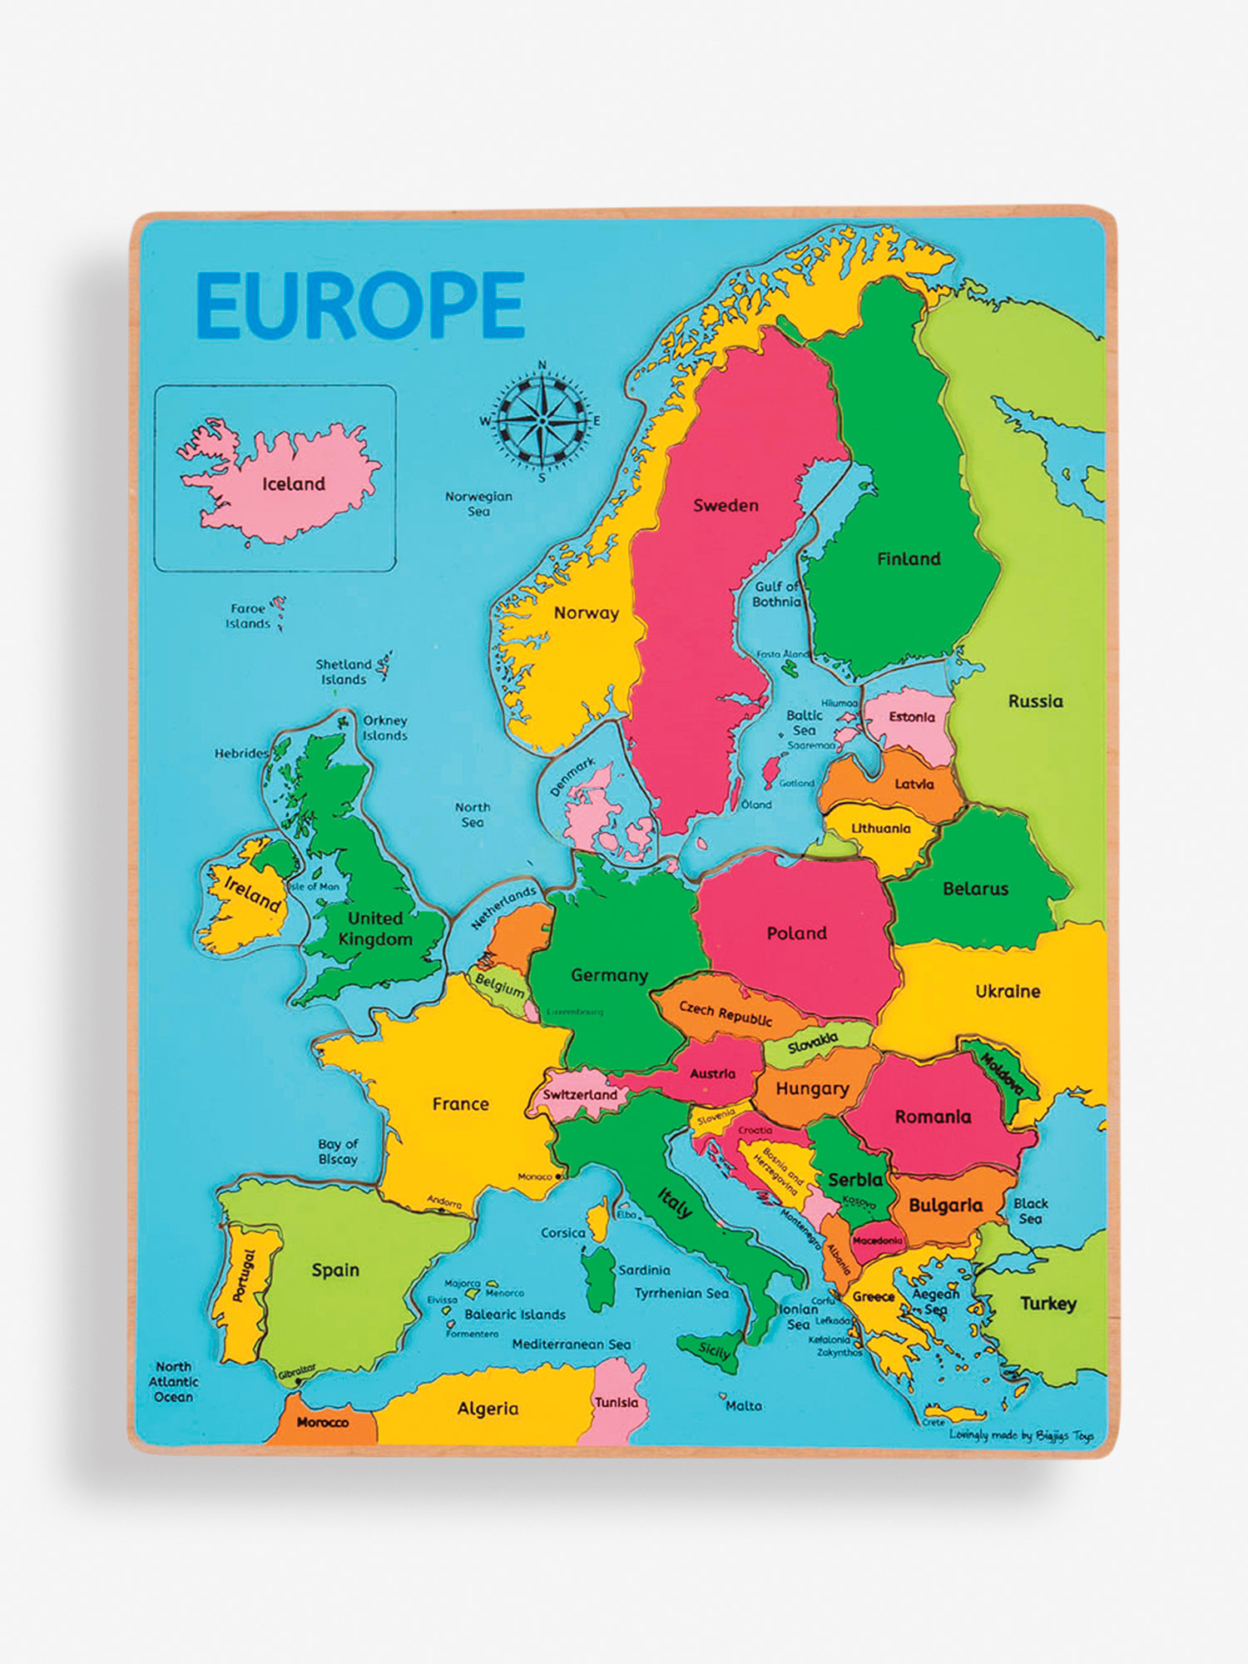

Activity 6

Login to Mathletics and complete the assigned activities.

Activity 10

Design and make your own Island using cardboard boxes and any other materials you have.

Activity 8

Talk to members of your family to find out what has changed since they were 10 years old. What things have changed and what has stayed the same? Is the world a better place now?

Activity 1

Research a country on the European continent.

Can you find out:

* What is the traditional dish?
* What is the weather like in the summer? (average temp)
* How can you travel there from England?

Activity 5

Find and cook a simple dish from your chosen European country.

Here is an example I chose Italy.



Activity 9

You have time travelled to the year 3000. Draw or write what you think would be different in the future.

You could think about: food, drink, computers, toys how would you travel around walking or flying cars.