**English**

**Key Areas**

* Creative development
* Reflective Writing
* Newspaper article
* Instructions
* Character description/comic Strip/adventure
* Letter writing

**Book Suggestions**

Inside Out (A chapter a day keeps the mind thinking a way)

Others TBC

**Activity Ideas**

* Create your own dream house (Chapter 2)
* Create own islands of personality
* Newspaper article about a memory
* Write a set of rules for a game created or played
* Create own character out of various materials and describe it/create its own adventure
* Write a letter to own feelings or about feelings to someone else

**Geography/History**

**Geography Skills**

Locate and Name continents of the world

Where do I live?

**Geography Activities**

Create a world map as a class for alternative names for countries using ideas from inside out

Find own home on Google Maps/make a map of own local area and use computer to create

**History Skills**

Look at different eras in history

Research various resources to develop understanding of how schools have changed-discipline/learning/styles etc

**History Activities**

Choose time period and create mini project about it (create an island/write a book/record a mini tv series-open options for showing learning)

Display/present findings from school based research

**Maths**

**Key Areas**

* Place Value (H, T and O)-3 weeks
* (recap to fill in gaps where needed-use intervention where possible)
* Addition and Subtraction-5 weeks
* (mental and written methods)
* Multiplication and Division-4 weeks
* (times tables/practical uses)
* Telling the time

**Activity Ideas**

* Minecraft points activities-make up new weapons, allocate points and total together etc
* Use individual interest to create work to complete in chosen order (3 level of choices with given time earnt for completion)
* Use of stopwatch to time activities/rolls of dice/flip coins and use results to create calculations

**Year 5- Autumn 2020**

*Through my own eyes*

**Opener:** Drive Thru Cinema (in class tyres!)

**Middle:** Large scale display

**End:** Performance to an audience

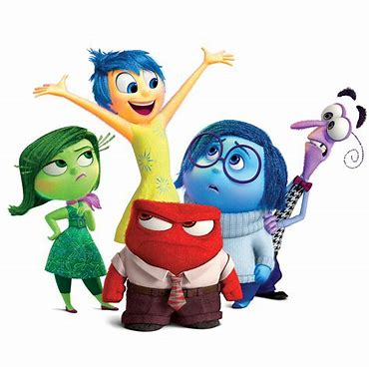

**Computing**

* Use computer program of choice to create own game with rules
* Create a poster/display for a ‘wanted’ emotion
* Save/print and retrieve work into and from a folder
* Design character and comic strip for adventure
* Create an animation for a lost emotion

**Music**

**Skills**

-create/adapt/compose own music theme tune

-select music instruments/piece of music for a purpose

**Activities**

* Create theme tune for character/game created
* Create entrance music for themselves on their game show
* Create a bank of music that creates each mood from Inside Out

**Science**

**Science Skills**

-Why do things glow in the dark? (chapter 2-glow in the dark stars)

-observe and question chemical changes

**Science Activities**

-Make/experiment with glow in the dark toys/sensory stimulus

-research and recreate own experiments with fair testing and predictions

**PSHE**

- Growth mind set activities weekly

- create bank of coping strategies for each emotion

-consideration for self-reflection activities (page 19)

**SMSC**

-Africa, Week South Africa Day (Week 4)

(British Values, Democracy, Egypt, Somalia, South Africa, Rwanda, Madagascar, DRC, Uganda)

**Art and DT**

* Create your own dream pizza (Chapter 3)
* Design and create own character using various materials