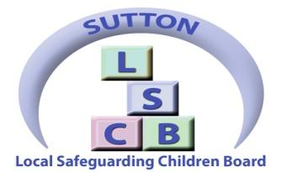

Multi-Agency Early Help assessment tool (EHAT)
Guidance Notes

Aware

Advise

Assess

Action

And so what?

Contents
Title Page 1
Contents 2
How to use the EHAT guidance document 3
Introduction 4
- Sutton’s Vision
- What is Early Help
- Sutton’s Early Help Objective
- Awareness, Advising, Assessment, Action, And so what?
What is an Early Help assessment? 5
- When to complete an Early Help assessment
- Undertaking an Early Help assessment
The Early Help Pathway flowchart 6
Before you start the assessment 7
Completing the Early Help assessment
- About the person completing the form
- Why this form is being completed
- Section A – Focus of Early Help assessment 8
- Section B – Family household members 9
- Section C – Known issues within the family
- Section D – Special Educational Needs and Disabilities 10
- Section E – Education
- Section F – Vulnerable Pupil Panel
- Section G – The family’s story - background information 11
- Section H – Professional relationships / agencies involved 12
- Section I – Child/ young person / family view 13
- Section J – Professional analysis 14
- Section K – Planning for change
- Reviewing and closing the assessment 17
Other Useful Information 18
- Lead Professional
- Regular meetings
- Stepping up to MASH
Appendices 19
- Drop-down lists
- Threshold documents 20
- Multi-agency TAF reporting template 21
- Invite to first TAF meeting 22
- TAF outcome letter 23
- TAF meeting agenda 24
- TAF minutes and action plan 25 Tools for capturing the voice of the child 29
- Cue cards for conversations 35
How to use the EHAT guidance document

This document will provide information and guidance to support you in using the EHAT document. Throughout, you will see the ‘I’ symbol indicating that you will find information to support you in completing the section in the EHAT guidance document.
There are a number of documents and templates that have been created to support you in completing an EHAT. Where you see the template symbol, there will be a document relating to that section.
T

Gaining consent:
The Early Help Assessment and multi-agency working process is voluntary support for a family. It is important that you gain consent at the start of the process from the family. This includes the child / young person and the parents / carers.
By providing consent they are allowing services that are involved to access the completed assessment and information gathered. If there is any service that they do not wish to share the assessment with, this must be clearly stated.
It should be made clear to families what the benefits are of consenting to sharing information to engage other services and appropriate support to be provided.
Where services are directly involved with older children / young people, professionals must consider the capacity of the child in order to make their own decisions where appropriate.
Refusing Consent:
Where families refuse consent you should consider the reasoning behind this. You should consider if the concerns for the child indicate that a referral should be made to Sutton MASH for possible statutory interventions.
If a referral to MASH is being made parents should be informed, unless doing so would place the child at significant risk of harm.
You may still share information without consent by following the guidance in this link: https://www.gov.uk/government/publications/safeguarding-practitioners-information-sharing-advice

Introduction
Sutton’s Vision
Children and Young People in Sutton live with resilient families, are happy, safe and healthy and grow up with the skills, knowledge and attributes to be confident and independent; ready for adult life.
What is Early Help?
Early help means providing support as soon as a problem emerges, at any point in a child’s life, from the early years through to the teenage years. Early help can also prevent further problems arising. Intervening early prevents difficulties arising and early help plays a significant role in preventing escalation of concern from conception and throughout life.
Sutton’s Early Help Objective
All services work together to provide a seamless offer to children and their families, preventing the escalation of need and ensuring targeted, timely interventions that are supported by effective multi agency practices of ‘Awareness’, ‘Advice’, ‘Assessment’, ‘Action’ and lastly, ‘And so what?’
Awareness is providing relevant and accessible information at key points in a child or young person's life and is a key strategy to promote positive attitudes towards health, self, the community and others. Those working with children, young people and their families should have services, resources and information readily accessible to enable them to understand needs and provide timely, sensitive interventions that prevent issues arising.

Advising means having an informed discussion with families around the options available to them and next steps to support them with any issues they may face. It also means providing advice and guidance to agencies where it may be needed.

Assessment is an ongoing formative process that allows frequent adjustments to provision and creates tailored packages to support. In Sutton this will take the form of a new single assessment for access to all early help services. This assessment will take into account the whole family and should be timely, appropriate and proportional.

Action is the means by which early needs and vulnerabilities are addressed. The delivery of services should be planned in accordance with need, local priorities and through pooling the resources of local agencies to target resources where they are most needed. This investment in early intervention should lead to a reduction in the number of issues presenting by preventing them from escalating at an early stage.
And so what? After taking action, officers should consider the outcomes from any interventions and consider any future support required.

What is an Early Help assessment?
The Early Help assessment is a tool to help identify the emerging needs of a child or young person. It also focuses on their strengths, promoting coordinated, timely service provision. The assessment is family-based which means that each individual person’s needs and strengths can be captured in one place, taking into account the whole family and its unique context.
Effective Early Help assessments ensure families and professionals work together, providing a forum for everyone involved to form an accurate assessment of the current situation for the child or young person. This reduces the need for families to have to repeat their stories and ensures that the right people are in place quickly to provide appropriate support and services.
The assessment should always be undertaken in a sensitive and supportive manner. It may seem an intimidating process for families so you may want to speak to them several times about the process before starting the assessment.

When to complete an Early Help assessment
If you:
- are worried about a behaviour or incident
- require more information to help you plan next steps to address an issue
- believe the child, young person or family’s needs cannot be met by a single agency
- are made aware that a parent expresses concerns

Undertaking an Early Help assessment
Will help you to:
- identify emerging multiple needs
- address any immediate concerns
- initiate Early Help services if required
- create packages of tailored support
- coordinate support and involvement through a named lead professional
- share information between families and professionals effectively
- reduce the number of times a family needs to tell its story

Before undertaking a new Early Help assessment it is important to find out if one has already been initiated, if there is a lead professional assigned, or if Social Services are already involved.
To do this contact EHAT@sutton.gov.uk or call 0208 770 4128.

Concern about a child, young person or family requiring more than a standard response

Hold a Team Around the Family (TAF) meeting

Safeguarding concern -
contact MASH
The Early Help Pathway

Identified needs require another / multiple agencies
If at any point you are concerned about the safety or welfare of the child or young person seek immediate advice by contacting MASH on 0208 649 0418

Discuss with child, young person or family and gain consent for an EHAT to be completed

Undertake Early Help assessment using EHAT form

Identified need can be met by my agency

Send completed EHAT to Early Help coordinator

Create an action plan and deliver coordinated support and services

Deliver support and services

Review EHAT

Review EHAT

Close EHAT or discuss next steps with Early Help coordinator

Before you start the assessment

Think about thresholds.
Review the London Continuum of Need and keep a copy to hand.

Find out if an EHAT already exists for the child or family by contacting
EHAT@sutton.gov.uk or calling 0208 770 4128.

Talk to the child, young person and family so that they understand the purpose
and process of the assessment
Get signed consent to proceed (see page 3)
If you do not have consent - STOP

Plan the practicals:
- Where will the assessment take place?
- What would be the most convenient time?
- Which family members need to be invited? How will you ensure everyone is involved?
- Are there any communication or additional needs you need to consider?
- What help and support might you need to complete the assessment?
- Who else outside the family might you need to talk to?

Feel prepared:
- Ensure you have age appropriate materials or tools to support you
- Remember not to use jargon or agency-specific acronyms
- Talk to the Early Help coordinator for future guidance where necessary
- Are the family clear about why you are completing the assessment with them?

Completing the Early Help assessment
About the person completing the form:
Please provide your details as the person completing the form with the family. Filling in these details does not mean that you will be assigned as the lead professional as this can be decided once a Team Around the Family meeting has been convened. These details allow the Early Help coordinator to contact you if necessary.
Why this form is being completed:
There may be many reasons for an EHAT that can be identified later in the form. Please choose the main reason for undertaking the assessment here using the drop-down list shown here.
If you are completing a paper copy of the EHAT please refer to Appendix A for a list of items within the drop-down box and write your answer in.

Section A - Focus of Early Help assessment:

This section will enable you to collect basic information about the child you are completing the assessment for. Please try and record information in all of the boxes.
Address: This should be the child’s main home. However, it may be necessary to include more than one address if the child regularly stays elsewhere or is temporarily staying at a different location.
Religion: Please discuss with the child and their parents how they would describe their religious beliefs.
Ethnicity: Please discuss with the child and their parents how they would describe their ethnicity and choose from the relevant drop down box.

Section B: Family household members:
This section will enable you to collect basic information about other household members who will form part of the assessment. It is important to also fill out other significant people who are not living in the household. If you do not have all the information at the start of the assessment, it can be completed at a later date
Relationship to the child: i.e. mother, brother, maternal grandmother etc. Please make sure the relationship is to the child the EHAT is written about and not to the parent.
Parental responsibility: An explanation of parental responsibility can be found here: https://www.gov.uk/parental-rights-responsibilities/what-is-parental-responsibility

Section C: Known issues within the family:
In this section you can choose the current known issues relating to the parent and the child who you are completing the assessment for. You may indicate multiple issues.
Legal status/immigration status: please state if the parent does not have leave to remain in the UK. Further information can be found here: https://www.gov.uk/guidance/immigration-rule
Communication needs: This may include English as additional language or a disability. Please list any additional support requirements eg. an interpreter.

Section D: Special Education Needs and Disabilities of the child:
If you are unsure about these details please contact Access Point on 0208 770 4690 who will be able to locate any unknown details. Further information can be found at https://www.sutton.gov.uk/info/200247/supporting_disabled_children_and_their_families/1396/disabled_childrens_services/2
Section E: Education:
Please add any information you have about the children’s school attendance and any reasons for poor attendance.

Section F:
This section refers specifically to children of school age who may be experiencing difficulties in their educational placement that need further investigation. Please only complete this section if you would like to put forward the case to the Vulnerable Pupil Panel. please note, that completing the EHAT is the only way a case will be reviewed at the VPP.

Section G: the family’s story - background information:

Parenting: Any information in relation to basic care, ensuring safety, emotional warmth, stimulation, guidance and boundaries, stability. Are the child’s needs met and are they protected from harm or danger.
What else is affecting the family: Information relating to the living conditions, housing, employment status, finance, legal status and use of community resources and networks.

Basic care – food, warmth, shelter, clothing, personal hygiene
Ensuring safety – is the child kept safe - in the home environment, in the community, is the child able to take appropriate risks, is the child’s behaviour deemed risky without parental intervention?
Emotional warmth – can the child identify and express their feelings appropriately?, is there appropriate physical contact within a secure, stable and affectionate relationship?
Stimulation – is there access to age appropriate toys and activities in relation to stages of development?, is school attendance good and homework completed?
Routine - is there some degree of predictablility and regularity?
Guidance and boundaries – are there consistent and appropriate boundaries for age / stage of development?
Stability – does the family have a pattern of moving around?

Parental history – life experience of parent as a child as well as any other factors such as substance misuse, mental health, domestic abuse, physical illness, bereavement
Family relationships – what is the family composition, who is the child close to that can provide support, are there family members who are a negative influence or risk?
Any history with Early Help/Statutory Services

Living conditions – home environment, composition of the household, neighbourhood
Housing – current housing, does this meet the family’s needs?
Family routine/lifestyle
Employment - impact of pattern of work
Finance – impact of benefits, income meeting child's needs, expenditures, budgeting, financial difficulties, debt/credit repayments
Legal status
Use of community resources
Networks – family and friends network and support available

Section H: Professional relationships/ Agencies involved:

If there are any other professionals working with the child or family they should be logged in this section. Please clarify whether the working relationship has ceased, is ongoing or is planned for the future. If the work has not yet started, please give an indication of the referral and expected start dates. If you know the outcome of the interventions, these can also be added to the form to indicate what support has already been offered and the effect it had.

Section I – child / young person / family view:

In this section, you can ensure that your discussion takes into account how the child, young person and parent/carer feel about the current situation. Feedback from children may not always be possible so this information can be be added at your discretion.

Child and Young Person:
What is going well – Please refer to the documents below for practical tools and conversation prompts to support your discussion. What is not going well – What would you like to change, what could make things better?
There are resources to help you gauge the views of a child in the appendix.

Parent or Carer:
What is going well – help the parent consider what is going well. It is very easy to focus on negative issues so please try to include some things that the parent can agree are successful for any reasons. Any events or factors which have impacted on the child, parent or family life. This could involve both current and historic events of significance.
What is not going well – be aware that parents may be reluctant to answer this question if they are worried about possible consequences. You may wish to refer back to some of the issues already raised during the assessment for guidance.

At the bottom of the page, there are two rating systems for the parent and/or child/young person to complete. These give an indication of their current impression of their situation in order to demonstrate expected progress when the case is reviewed before closure. This gives the family an opportunity to visibly see the improvements that have been made. it is really important these ratings are completed by the family and not by professionals.

Section J – Professional analysis

The professional completing the EHAT also has a chance to state their views on the family’s situation. please make sure this is done in collaboration with the family and they are fully aware of what you are wish to write here. There are four separate areas to complete to gauge negative and positive views and suggestions.

What is working well?
Positive factors in the child/young person’s life that are supporting their health and development and keeping them safe

What is not working well?
Any issues that have been identified that are or could impact negatively on the child’s health, development or safety

What is unknown?
Information that is currently missing or that it would be helpful to find out

What needs to change?
Key issues that need to change that will enable the child to reach their full potential and keep them safe

Section K - planning for change

Team around the Family (TAF) / Team around the Child (TAC)
The Team around the Family meeting should include any services which are invited to work together to support the family and should be set up within 10 working days after the assessment has been completed. During this meeting, a support plan will be created and a lead professional will be agreed amongst the agencies involved in consultation with the family.
If you are unsure about which services you should invite to the TAF meeting, or have any further questions about the process, please contact the Early Help coordinator on EHAT@sutton.gov.uk or 0208 770 4128. The documents used for a TAF can be seen here and templates are listed in the appendix.

T
Invite to first TAF TAF Agenda

TAF Report TAF Minutes and Action Plan

Action Plan:
As part of the TAF meeting you will need to prepare an action plan to take steps to resolve issues and improve outcomes. The actions can be for anyone at the meeting including the child, young person, family and the professionals involved. The actions should be specific and achievable. The action plan should be reviewed at every subsequent meeting.

Desired outcome  (measurable and agreed with child, young person, family) | Action | Who will do this? | By when? | How will we know things have improved? | Progress & comment  (for completion at review stage) | Date action closed
What is it that we would want to see – be specific in order that the outcome can be measurable – try to avoid terminology such as ‘improvement in’ | List actions to be taken – including referrals, pieces of work, agreements with child and family members | This includes professionals, family members and the child/ young person themselves | Try to add a start and finish date, try to avoid ‘ongoing’ | Outline what success would look like
Example:  S needs to stop playing on his DS in bed as this means he is waking up late for school | Remove DS from bedroom at bedtime  S to be provided with an alarm clock to wake in the mornings | S’s parents  S’s parents | From the 30th August | S is on time for school everyday

Section L - Information sharing agreement:

Gaining consent:
It is vital that the parents/ young people provide consent for an Early Help assessment to take place. By providing consent they are allowing services that need to be involved to access the completed assessment and information gathered. If there is any service that they do not wish to share the assessment with, this must be clearly stated.
Signatures and storage of EHAT

A copy of the completed Early Help assessment form needs to be sent to the Early Help coordinator at EHAT@sutton.gov.uk. The original copy should be kept by you in the child’s file. The parent / carer and child / young person must have a copy of the original Early Help assessment.

Please scan the back page of electronic copies with the parent’s signature to the above email address. Hard copies can be photocopied and posted to the Early Help coordinator at the Civic Centre to be held on file.

Reviewing and closing an EHAT:

The EHAT needs to be reviewed regularly to ensure it is effective and making progress towards resolving the issues identified at the start. The lead professional should complete a review form (EHAT-R) after 3 months, 6 months and 12 months if the case has remained open. A copy of each review form should be emailed to the Early Help coordinator to monitor and file.

EHAT-R form

When the lead professional, and any other professionals involved, agree that the EHAT is ready to close, a final closure form (EHAT-C) needs to be completed. It is really important that a copy of this form is logged with the Early Help coordinator in order to check the status if each case.

EHAT-C form

Please note that EHATs can still be closed once a child or family has been referred to another agency and notification has been received if this is the only issue identified. This includes requests for short breaks from the Children with Disabilities team. If an EHAT is opened by a school and the child moves to a different setting, please send a review form to the Early Help coordinator to clarify this, making it clear who the new lead professional will be.

If you are concerned about closing a case with an open referral, please do discuss further with the Early Help coordinator at any time.

Other useful information
The Sutton LSCB website has a useful professional information section where you can download and print guidance and documents you can access these by following the link http://www.suttonlscb.org.uk/practitioners_files.php
Lead professional
A lead professional can be any professional from any service / agency who is a part of the Team around the Family. It is important that the family are involved in the discussion of who is best placed to coordinate the support and services being offered to the family. Being the lead professional involves:
- developing a positive and productive relationship with the family
- acting as a single point of contact for the child and their family
- organising regular TAF meetings
- using the Early Help Assessment to set actions and monitor outcomes
- coordinating the delivery of effective early intervention support
- working in partnership with other professionals
- reviewing and monitoring the support plan during the TAF meetings
It is important to note that the lead professional is responsible for the actions linked with their agency. They are not responsible for carrying out actions for other agencies.
Regular meetings
The lead professional will need to arrange regular review meetings approximately every 6-12 weeks. During these meetings they will need to gain updates from all professionals involved as well as family members and the child.
As a group, you will need to consider if changes need to be made to the action plan or if additional services need to be sought. Where there is evidence that the support being provided is not achieving the desired outcomes within a reasonable timescale, you should consider one of the following actions:
- amend the plan and set a review date
- engage additional services
- contact the Early Help coordinator
- step up the case to statutory services*

If you are not the lead professional but you are concerned about how the Early Help Plan is being managed - that outcomes are not being met or the risk of the child/family has increased - share your concerns with the lead professional to convene an immediate TAF meeting or escalate the case to MASH.
Stepping up to Multi-Agency Safeguarding Hub*
Sometimes the process of completing and EHAT can highlight new concerns or risks that require statutory intervention. If at any point you are concerned about the safety or welfare of the child or young person seek immediate advice by contacting the MASH on 0208 649 0418.

Appendix
- Drop-down lists
Page 1: Primary Reason for Assessment:
- Anti-social Behaviour
- Behaviour
- Benefits/ low income
- Child Protection
- Crime
- Domestic Violence and Abuse
- Emerging or Undiagnosed Developmental Difficulties or Delay
- Inadequate Housing
- Mental Health
- Not in Education, Employment or Training
- Parenting Issues
- Physical Health
- Poor School Attendance
- Refugee/Asylum Seeker/No Recourse to Public Funds
- School Exclusion
- Self Harm/Suicide
- Social Isolation
- Special Education Needs or Disabilities
- Substance Misuse
- Unresolved Loss/Grief
- Young Carer
- Other
Page 1 and 2: Ethnicity:
- Asian or Asian British – Bangladeshi
- Asian or Asian British - Indian
- Asian or Asian British - Pakistani
- Asian or Asian British – Other
- Black or Black British - African
- Black or Black British – Caribbean
- Black or Black British – Other
- Chinese
- Irish Traveller
- Mixed – White and Asian
- Mixed – White and Black African
- Mixed – White and Black Caribbean
- White – British
- White – Irish
- White – Other
- Other

b) Threshold documents

The Levels of Need:

The Continuum identifies four levels

Level 1 No identified additional needs - response services are universal services.

Level 2 Low risk to vulnerable - child's needs are not clear, not known or not being met. This is often the threshold for beginning a Early Help Assessment. Response services are universal support services and/or targeted services.

Level 3 Complex - complex needs likely to require longer term intervention from statutory and/or specialist services. High level additional unmet needs -this will usually require a targeted integrated response, which will usually include a specialist or statutory service. This is also the threshold for a child in need which will require Children's Social Care intervention.

Level 4 Acute - acute needs, requiring statutory intensive support. This, in particular, includes the threshold for child protection which will require Children's Social Care intervention.
Detailed guidance for each of the four levels along with descriptors to help professionals understand what sort of issues and challenges are likely to be found at each level, can be found in the Sutton LSCB threshold document and should be used in conjunction with the London Child Protection Procedures and their associated threshold guidance: http://www.londoncp.co.uk/.

c) Multi-Agency TAF reporting template

Multi Agency TAF reporting template

Date of TAF Meeting:

Summary of work undertaken / current situation:

What has been achieved:

Next steps / ongoing goals:

Date report completed: | Name of Worker:
Agency: | Role:

d) Invite to first TAF Meeting
Insert your logo here

(Address)

(Your Contact Details)
(Date)
Dear,
Invitation for agencies to attend a Team around the family meeting (TAF)
I would like to invite you for a TAF meeting (Date & Time) held for (name).
The purpose of this meeting is to:
- share common assessment information so it can be analysed and understood
- identify how support can be offered to the child and family to meet needs assessed through the use of a EHAT (Early Help assessment tool).
- jointly agree possible solutions and appropriate actions, including actions for the family and child to undertake where appropriate.
- record these actions and timescales on a action plan
- provide copies of the plan to all TAF members (including the family of the child/young person as appropriate)
- arrange as necessary, additional requests for involvement/referrals, supported by EHAT, as a pathway to other targeted and specialist services
- decide if a Lead Professional is needed to coordinate the actions of agencies and to liaise with the family. If a Lead Professional is needed, consideration must be given to the views of the child/young person and or family as to who this is.

It is imperative that best efforts are made to attend this meeting, please could you confirm your attendance via telephone or email. If you are unable to attend, please inform me if someone else is able to attend in your absence. If this is not possible, please send through a report prior to the meeting.
If you have any questions about the EHAT or TAF process then please contact the Early Help coordinator on 0208 770 4128.
I look forward to seeing you at the meeting.

(Name)
Role

e) TAF outcome letter
Insert your logo here

Address) (Your Contact Details)
(Date)
Dear,

Action Plan from the Team around the Family meeting

Please find an action plan following the Team around a Family meeting, held for (name).
This action plan has been distributed to all professionals involved, and a copy of the action plan has also been sent to the family/young person. It will be clear on the plan the actions for each professional.
Please contact me if you need to update or want to discuss any of the action points.
The next Team around the Family review will be on (Date & Time).
If you have any questions about the EHAT or TAF process then please contact the Early Help coordinator on 0208770 4128.
I look forward to seeing you at the meeting.

Yours sincerely

(Name)
Lead Professional

f) TAF meeting agenda

Team around the Family - Agenda

Date:
Time:
Venue:

- Welcome (attendees to sign in)
- Apologies given
- Family provide a update on current situation
- Reports provided by professionals unable to attend
- Updates from other professionals
- Update of action plan points
- Review, remove or add points to action plan
- Set new date for review or close TAF
- Closure of meeting

g) TAF minutes and action plan

TAF Minutes and Action Plan

Childs name: |  | D.O.B: | Meeting Date:
Attendees | Job role/relationship to child or young person & work setting |  | Email
Lead professional: | Job role/relationship: | Setting: | Email:
Address: |  |  | Contact no:

Meeting discussion:

Desired outcome  (measurable and agreed with child, young person, family) | Action | Who will do this? | By when? | How will we know things have improved? | Progress & comment  (for completion at review stage) | Date action completed

Child or young person’s comment on the review and actions identified:
Parent or carer’s comment on the review and actions identified:

Can the EHAT case be closed? | Yes |  | No |  | Were the outcomes:
Reason for closure: |  |  |  |  | Fully met
 |  |  |  |  | Partially met
 |  |  |  |  | Not met
 |  |  |  |  | Have the needs increased/got worse?
 |  |  |  |  | Did the case escalate to social care?
 |  |  |  |  | Date of next meeting

h) Tools for capturing the voice of the child

Communication worksheets

Understanding children’s wishes and feelings is an integral part of completing the Early Help Assessment. Without hearing the children/young person’s voice the support is meaningless and therefore their situation cannot be improved.
The tools below can be used to gain an understanding of a child, listening to what they have to say and be used as a part of the action plan to highlight where and how support needs to be implemented. You do not need to use all of these tools, you can pick and choose what to use to suit the child and or young person’s needs.

1.Assessment Triangle for older children
This resource can prompt an older child to think about their circle of support and what they need to succeed.
2.The Three Houses:
Children are able to use these houses by drawing or writing or a combination of both to illustrate the things that you are worried about, the things that are going well in your life, and the things that you would like to happen in the future. You can develop your own way of using the three houses to suit your style and also to suit the child/young person.
3. My Wish:
The child/young person is able to draw or write what they would like to change if they had a magic wand.
4. Feelings:
Cartoon faces of different feelings can be used for children to illustrate how they feel in certain situations/on that day. Emotion cards can be found online, please print emotions which you think are relevant.
5. Good day / bad day:
This tool can be used for the child/young person to show what happens on a good day, bad down and how they can make their bad day better.
6. Cue cards for conversation:
These headings can help to start conversations with children and families and ensure all information has been gathered.

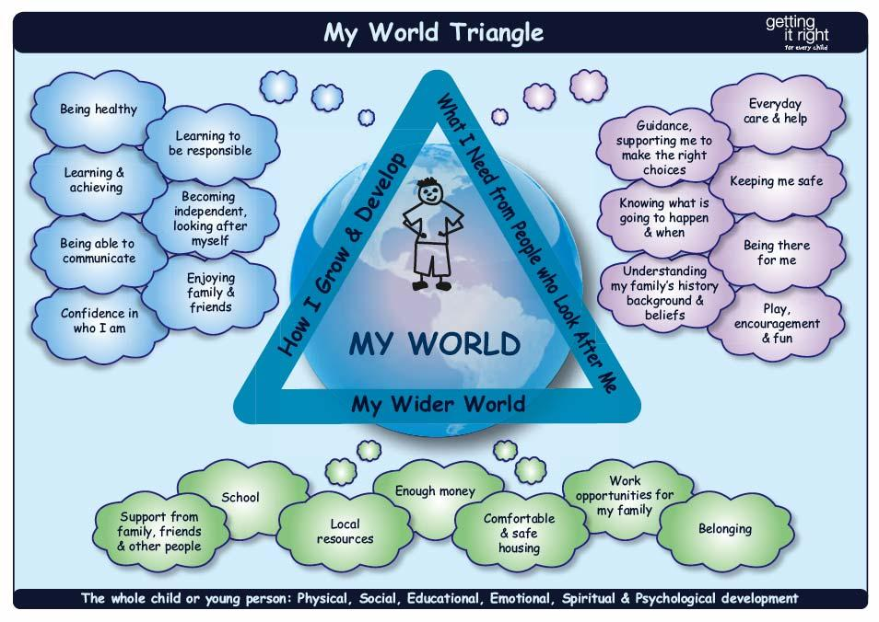
- Assessment Triangle

2. The Three Houses
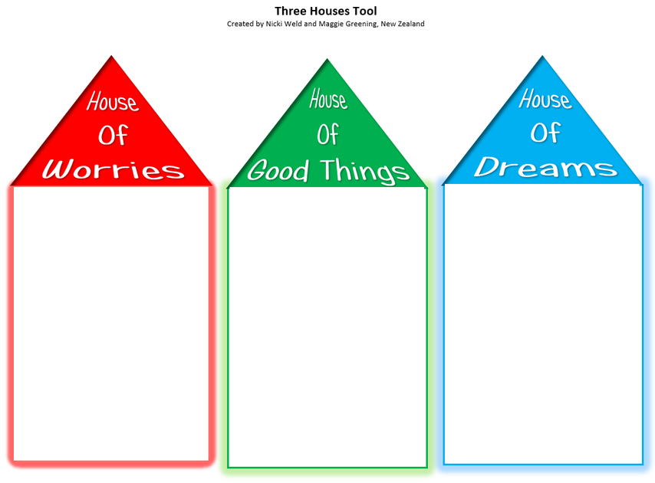
3. My Wish

4. Feelings

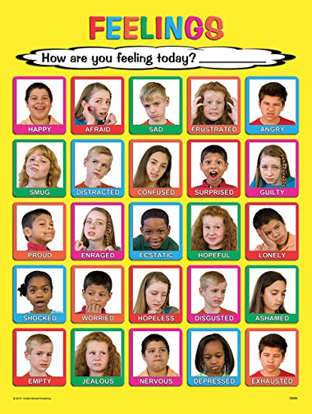

5. Good day / bad day
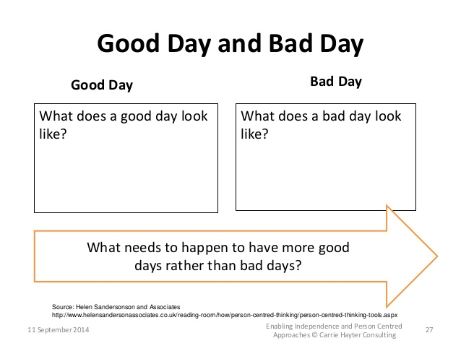

6. Cue cards for conversation

Home
Finance (e.g. income, benefits, debt)
Housing (e.g. type, stability, relationship with neighbours, conditions, fit for purpose?)
Play and leisure opportunities
Animals

Health
Physical (e.g. current health/medical issues, regular health checks, immunisations, allergies, dentists, opticians, nits)
Diet and nutrition (e.g. balanced diet, food intolerance)
Sexual health
Substance/alcohol misuse
Smoking
Exercise and physical activity
Developmental milestones
Speech and Language development

Emotional health / feelings
Anxiety/stress
Self esteem
Self care (e.g. appearance, self harming, sleeping patterns, relationship with food, risky behaviours)
Mental health (e.g. depression, eating disorders)
Coping strategies/resilience
Bereavement and loss (including relationship breakdown/change)

Behaviour / development
Citizenship (e.g. role in community as a community champion, active group member, religion)
Anti-social behaviour
Response to authority
Coping strategies
Online activity
Sanctions (e.g exclusion permanent or temporary)
Developmental milestones

Family
Who is in my family?
Relationships within family
Family identity
Caring responsibilities
Parenting style/approach/boundary setting/routines
Significant events/changes for family (e.g. experience of domestic violence, prison)
Culture

Learning / work
Aspirations
Work – current and previous
Work patterns (e.g. shift work)
Volunteering
Opportunities and barriers to working/studying
Training
Learning style and its impact
Developmental milestones
Attainment at school
Targets at school/college
Gifted and talented

Identity / me
Cultural
Sexuality
Language spoken/understood
Transitions (e.g. from child to young person, school move)
Hobbies and interests
Role/position in family (e.g. eldest child, stepparent, carer)
Level of independence
Impact of significant life events (e.g. domestic violence, bereavement and loss, illness)

Relationships / community
Key support mechanisms/friendships
Problematic relationships
Sexual/intimate relationships
Community connections
Harassment/bullying/victimisation (e.g. racial, sexuality, religious)
Communications/interpersonal skills

