**English**

**Key Areas**

- Non-fiction texts/non-chronological report

- Letter writing

- Poetry

- Instructions

- Persuasive writing/debating.

**Book Suggestions**

-*Wolves*

*­-The Tadpoles Promise*

*-A Walk in London*

**Activity Ideas**

-Non Chronological report on a city of choice.

-Letter to an imaginary pen friend.

-Instruction writing for how to make an erupting volcano.

- Information poster about how to survive earthquakes.

-Diary of a climb up Everest.

- Writing a tourist guide for our local area.

- Explanation texts of life cycles.

-Fact files about wolves and their lifestyle and habitats.

-Warning posters about Wolves.

- Newspaper report on deforestation.

-Recounts of anything natural children have done over Christmas.

**Geography/History**

**Geography Skills**

Understand the key features of Mountains.

Understand the key features of Rivers.

Understand the key features of Lakes.

To explain the characteristics of a continent.

To compare and contrast land uses of a region

**Geography Activities**

Make a poster about a Mountatin/River/Lake.

Make a PowerPoint about the characteristics of a continent of choice.

Paper Mache Globes.

**History Skills**

Question the reliability of a range of sources.

Begin to think critically about how the past is constructed from a range of sources. Local area.

Compare the impact of historical influences on present day sources.

**History Activities**

Study of local history.

Study of the impact that different geographical features have of different communities and settings.

**Maths**

**Key Areas**

- Data collection

- Coordinates.

- Apply learning to solve problems.

- Number and place value

- Translation and rotation.

- Tables and graphs

- Mapping

- Shape

-Weight and measure

**Activity Ideas**

-Research information about a local river. Record this information in a table.

-What 2D and 3D shapes can we see in the natural environment?

-Bird watching. Children can take part in the Big Schools’ Birdwatch. Children can count the birds they see and record the information in a table.

-Weigh and record the weight of natural objects.

-Worded problems involving populations etc.

-Translation of shapes.

-Converting improper fractions to proper fractions.

Extreme Earth

Awesome Opener: Paper Mache Globes

Marvellous Middle: Erupting Volcanoes

Ending: Habitat/Den Building

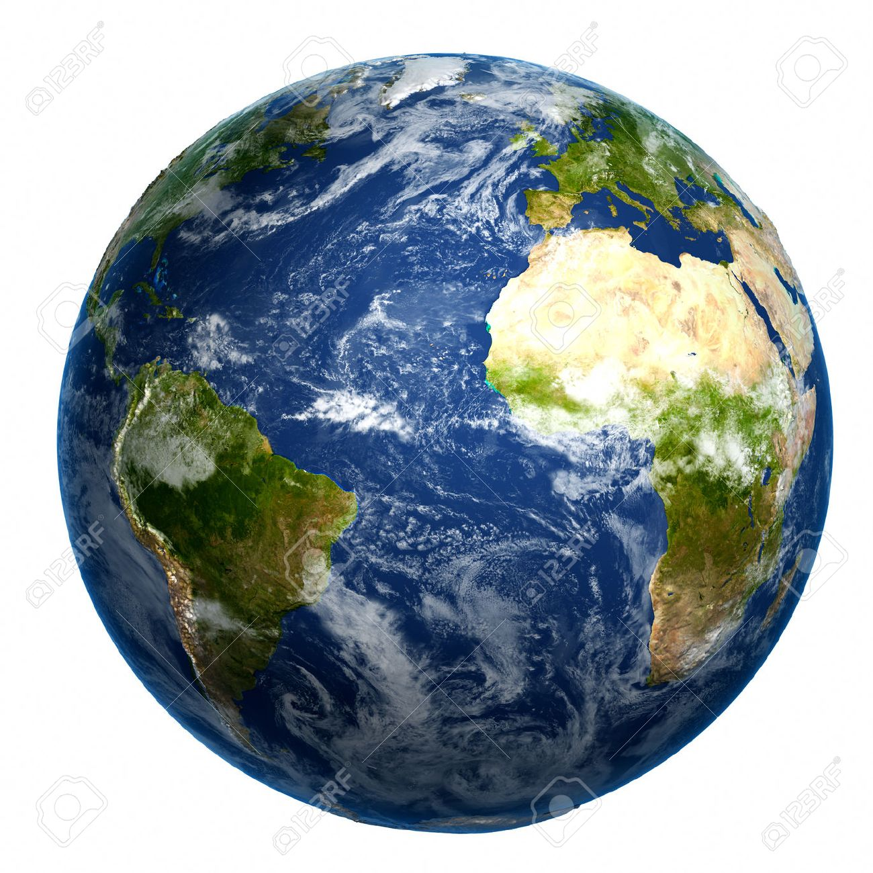

**Computing**

E-Safety

Basic keyboard skills.

Operating equipment, simple program use & following instructions, Using digital camera and video editing. Weather reports

Retrieving information.

Label and poster making.

English and maths support. Talking Stories.

**Music**

**Skills**

To sing and perform individually and in unison.

To create sound effects using instruments and everyday objects.

**Activities**

Making rainforest sounds.

**Science**

-Erosion experiments.

-Exploding Volcanoes.

-Studying life cycle of tadpoles etc.

-Learning about habitats of different animals.

-

**PSHE and SMSC**

**SMSC**

Discriminate between the different symbols associated with Easter (Easter eggs, bunnies and Christian symbols)

Outline how popular customs at Easter can detract from the real message of Easter.

Identify why Easter is important to Christians

Examine how Christians across the world celebrate Easter

**PHSE**

**Art and DT**

-Paper Mache globes.

-Decorating a map and coming up with a key.

-Den Building.

-Create flags from different countries.