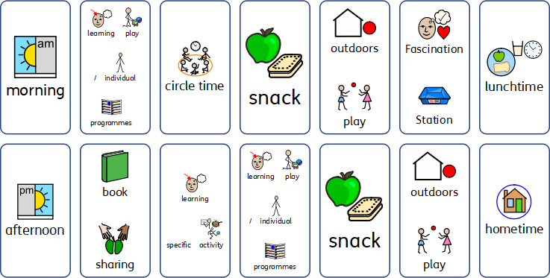

Above, is a typical Early Years daily timetable. The day always starts with a long ‘learning play’ session whereby children have free access to the different classroom areas that are carefully planned and resourced around the children’s interests and developmental levels.
Once settled, children may work 1:1 with an adult on therapy programmes or individual learning activities. Children and staff will gather together for circle time and say hello to one another, and choose songs to sing and dance to. At snack time, children are offered healthy snacks and given the chance to work on their request making through personalised communication strategies.
During outdoors play, sand and water play activities are set up and children are given access to active play toys such as bikes and scooters. Exciting and interesting materials and objects are made available to the children at the ‘Fascination Station’ which helps to promote early play, exploration and communication skills.
In the afternoon, the children are given the opportunity to look at books and listen to stories. A learning specific group activity (e.g. literacy, maths) will then take place, followed by more play activities chosen by the children. Adults will join in with the children’s play and scaffold and support their learning by modelling new skills and ideas.
At afternoon snack, children and staff sit together and reflect on the day; reviewing all the exciting activities that have taken place followed by another chance to access the outdoors play area before going home

