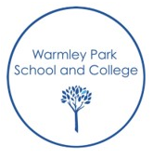
Literacy
“The teaching of Literacy promotes learning across the curriculum and encompasses all aspects of communication including non-verbal, verbal and written. It underpins pupils’ achievements and participation in all aspects of their lives.”
Intent
To support every child on their individual Literacy Journey.
Our priority is to give our children a voice to communicate and a means to express themselves.
We aspire to give our children literacy skills to help navigate and understand the world around them as independently as possible.
Implementation
Our children are immersed in literacy rich learning environments using total communication.
Exposed daily to stories, language and communication in a variety of ways adapting to the complex needs of our children to develop passion for reading, sharing and listening to stories.
Given daily opportunities to experience and build awareness and knowledge around communication, phonics, reading and writing skills tailored to the individual child.
Giving children the appropriate resources to support independent learning
Having high expectations for each child’s potential.
Continuously assessing and identifying the next step; identifying children that need interventions to support progress.
Impact
Our children will have the skills and confidence to communicate effectively using appropriate means of communication.
A love for engaging with stories/reading that feeds the imagination.
Able to use literacy skills to support independence to navigate the real world effectively.

