Mathematics Curriculum at Warmley Park School and College.
Intent
Our vision is Aspire, Believe, Enhance, Achieve.
We believe in and value every individual and what they can aspire to. We will inspire them to do this by enhancing learning and encouraging everyone to achieve together.
At Warmley Park School and College we believe maths is accessible for all children regardless of their background, needs or abilities.
The mathematics intention is to prepare learners for their future outside of Warmley Park School and College, equipping them with functional skills that they need for living fulfilling lives, making sure all of our learners have a voice. The guided curriculums and schemes of work are sequentially planned across every key stage and topics are revisited to build on prior learning and knowledge so that children develop a deeper sense of number, pattern, calculation and shape, space and measure. Learners then use and apply these skills in KS4 and college to help to prepare them for the future and support them in having a better understanding of the world around them.
We want learners to be mathematicians, we don’t want to just teach them maths…

It interlinks with our overarching curriculum drivers:
Communication- Mathematical language can support learners to make links across areas of mathematics but also across the curriculum as a whole and within real-life situations. Learners at Warmley Park School and College acquire skills to be able to express themselves, improve interactions, ask questions, make choices, develop and present justifications, problem solve and use mathematical language. All of our learners are given the confidence to comment and have a say.
Independence- Learners are given opportunities in their journey through school to develop as independent confident and competent mathematicians. Learners will develop a sense of number through practical activities and are provided with a strong foundation to reason, think logically and problem solve with resilience so that they are fully prepared for the future. Learners at Warmley Park School and College acquire functional maths skills and learn to try new experiences, build confidence and learn to problem solve independently.
Relationships- Mathematics at Warmley Park School and College enables learners to develop the social skills they need for effective collaboration with others and to become aware of and appreciate the different perspectives they may have. Creating good relationships with our learners is at the heart of what we do at Warmley Park School and College, we are able to challenge our learners by understanding and knowing them well. We encourage learners to have a go and support them to build resilience when mistakes are made.

Implementation
The Warmley Park School and College Curriculum is designed to provide a platform for the teaching and achieving of Education, Health and Care Plan outcomes. A young person’s EHCP and Individual Education Plan form the core of their personalised curriculum which is enhanced and expanded by elements of the National Curriculum delivered at personalised adapted levels.
In Early Years, we provide stimulating opportunities and experiences that promotes play and ignites a love of learning. Children develop self-confidence and self-belief so that they are resilient and develop strong roots, making way for a lifetime of learning. At the other end of their education, students in the college are preparing for life in the wider world, with an emphasis on equipping them with communication skills that they can use functionally, independence strategies, social interaction skills, an awareness of safe behaviour, and how to look after themselves physically and emotionally. An ambitious and well sequenced curriculum that enables the broadening of knowledge, skills, physical, creative, cultural and imaginative value of mathematics is therefore enriching for all of these life essentials.
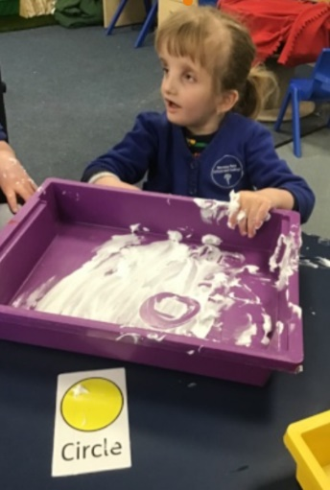
Mathematics can be widely incorporated into Education, Health and Care Plan provision and outcomes as it enriches opportunities for development of:
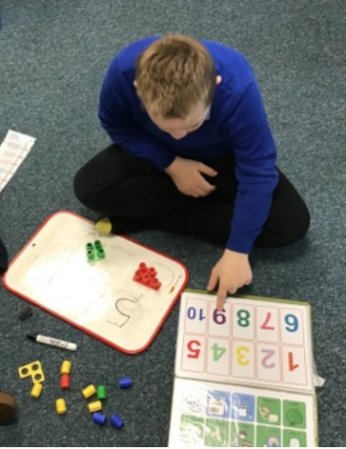
• Communication and interaction
• Social skills
• Hand eye coordination
• Gross motor skills
• Fine motor skills
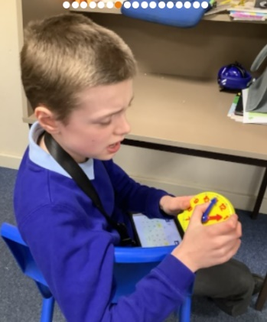
• Creative thinking
• Emotional expression and connection
• Mental wellbeing
• Cognition - acquiring knowledge and understanding
• Sensory exploration
• Problem solving and persistence
• Collaboration and team working
• Planning and evaluating
• Independent skills

"Tell me and I forget. Teach me and I remember. Involve me and I learn." – Benjamin Franklin- (1706–1790)
The guided mathematic curriculums have been written specifically for the pupils at Warmley Park School and College. We have considered carefully the adaptations required for all of our learners to make sure we have a varied curriculum offer that is accessible for all and is ambitious and challenging for our most able learners. The CPA approach is implemented throughout our school, it is woven through our mathematics curriculum showing the progression and steps needed for children to succeed in learning to be able to use abstract numbers and symbols. It goes hand in hand with the Numicon approach that helps pupils to develop a deep understanding of maths as part of mastery learning. We are committed to embedding Numicon as our main approach to Numeracy: Number, pattern, and calculation, we also use Numicon to support children’s learning in geometry, measure and statistics. The curriculum supports pupils to explore, use their senses, be creative, ask questions, evaluate, problem solve and work collaboratively.
The schemes of work in KS4 support the progression into college by using and applying the mathematical knowledge and skills learnt in previous years. These skills based projects are carefully planned around life skills and future careers to support the transition to the college and future aspirations.
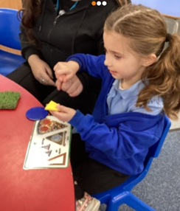
The Warmley Park School mathematics tracker supports teaching and learning by enabling staff to know where pupils are, any gaps in learning and guides staff in the planning of next steps.

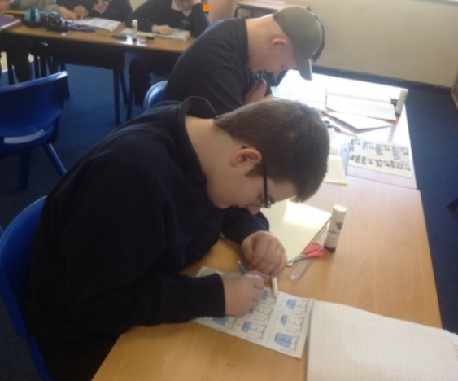
Impact
Teachers and support staff know where learners are and the journey they are going on.
Our learners have the skills and confidence needed to prepare them for their futures and to live as independently as possible.
A love of maths is seen around school and learner engagement is high.

