TERMLET: | 2
SPECIAL EVENTS | Diwali (12th Nov)  Bonfire Night (5th Nov)  Nursery Rhyme Week (13th- 17th Nov)  Children in Need (17th Nov)  Carols by candlelight (7th Dec)  Winter festival of light (12th Dec)  Christmas Jumper Day (7th Dec)
MAIN STORY OPTIONS  Chosen story shall become overarching topic for term. Extended play and learning opportunities to be provided in each planned learning area of the classroom (this includes outdoors area). | Choose a book that will fit the interests of your class  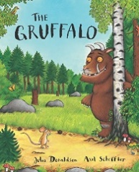  Books that rhyme:  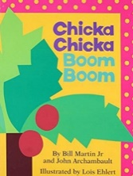  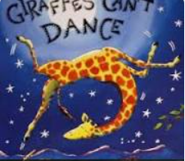  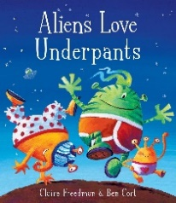  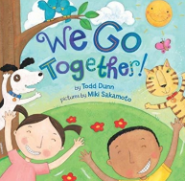
END OF THE DAY STORIES  Books from classroom collection or library that relate to special events listed above. Include non-fiction books too. | Nursery rhyme stories/stories relating to special events:  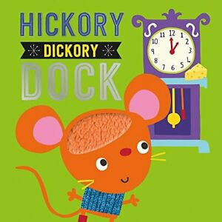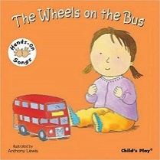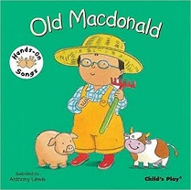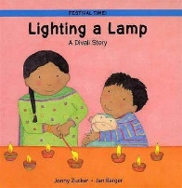

Physical Development | (Gross motor): We all go Travelling by
PSED | (Managing-Self): This is the Way we Get Dressed
Maths | (Number): I Can Count  (Numerical Pattern): This Feels Heavy!
Literacy | (Phonics): Rhythm and Rhyme  (Comprehension): Nursery Rhymes  (Writing): link to sound of the week
Understanding World | (P,P,C): My Kind of People  (NW): Seasonal Exploration: Walking in a Winter Wonderland
Expressive Art and Design | Story related role play.  Art and musical activities relating to special events.

Curriculum areas left off this list e.g. Communication and Language, shall be embedded across all planned activities or carried out as part of individual or small group sessions relating to pupil’s EHCP outcomes. Please refer to Guided Curriculum/IEPs and use this information to inform daily planning.

