TERMLET: | 4
SPECIAL EVENTS | Pancake Day (13th Feb)  Rocktopus event (20th Feb)  World Book Day (7th March)  Red Nose Day (15th March)  Holi Festival (25th March)  Mother’s Day (10th March)  Springtime Begins (20th March)  Maths Day (27th March)
MAIN STORY OPTIONS  Chosen story shall become overarching topic for term. Extended play and learning opportunities to be provided in each planned learning area of the classroom (this includes outdoors area). | 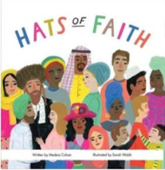  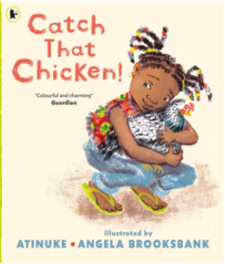  Stories from other cultures:  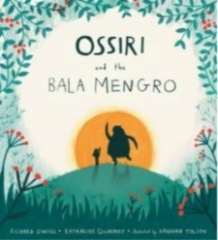  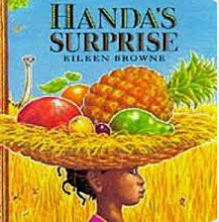  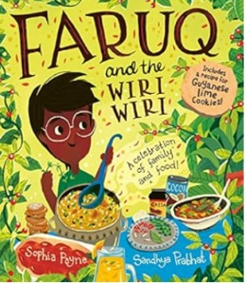
END OF THE DAY STORIES  Books from classroom collection or library that relate to special events listed above. Include non-fictions books too. | 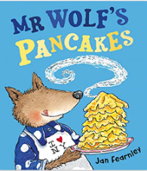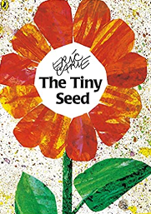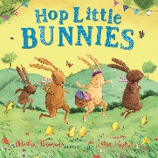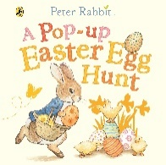

Physical Development | (Gross motor): The Mountain Climber  Climbing and negotiating spaces
PSED | (Managing-self): Zip-a-dee-do-da  Fastenings
Maths | (Number): In and Out- Container Play  (Numerical Pattern): Cause and Effect
Literacy | (Phonics): Rhythm and rhyme  (Comprehension): Stories from Different Cultures  (Writing): Link to sound of the week
Understanding World | (P,P,C): My Country and Beyond  (NW): Spring has Sprung
Expressive Art and Design | Story related role play  Art and musical activities relating to special events

Curriculum areas left off this list e.g. Communication and Language, shall be embedded across all planned activities or carried out as part of individual or small group sessions relating to pupil’s EHCP outcomes. Please refer to Guided Curriculum/IEPs and use this information to inform daily planning.

