Updated February 2024

early years curriculum intent

Warmley Park Early Years Department Curriculum Intent
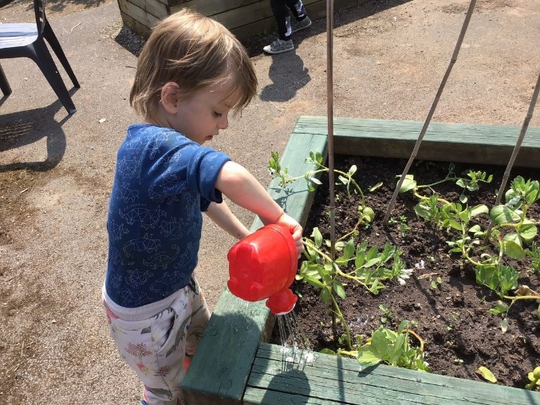
‘Setting the roots for lifelong learning’

Vision
We strive to provide a stimulating and exciting Early Years curriculum that promotes play and ignites a love of learning. We endeavour to instil confidence and self -belief in our children so that they are resilient and develop strong roots, making way for a lifetime of learning.

Mission
We prioritize the emotional wellbeing of each pupil and provide them with the opportunity to develop warm and trusting relationships with staff. We work in close partnership with parents and professionals and make it our mission to ensure that each child is given the best possible start to life. We focus on pupils developing skills in the EYFS Prime Areas. We plan teaching and learning opportunities around individual interests and needs.

Link to Whole School Ethos
We endeavour to instil confidence and self-belief in our children from the day that they start with us. We aspire for our children to believe that they can do anything, whether this be putting their shoes on, fitting the last piece into the jigsaw puzzle, requesting for a preferred object or activity or walking a short distance without their walking frame. Learning is enhanced through providing an active and exploratory environment, aimed at provoking awe and wonder. We strive to form warm and trusting relationships with each child and acknowledge and celebrate all achievements.
Comments from parents of our Early Years pupils:
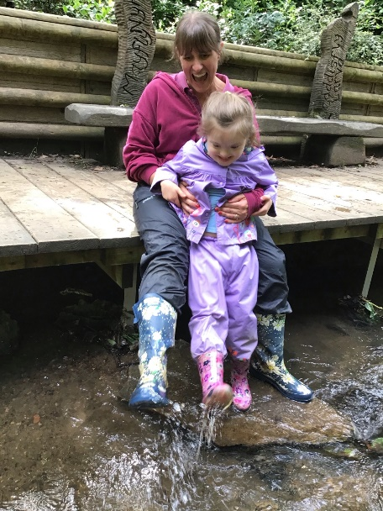
‘It was my opinion when choosing the right school for x that we would be met with difficulties surrounding her attendance due to the nature of her complex health and other needs, this could not have been further from my experience. The staff at Warmley Park are kind, thoughtful and understanding, and I would not feel safe or content entrusting the care of her to anyone else.’

‘From day one, he has been settled and happy at school, I have no qualms or worries about him being at Warmley Park’.
‘He is not the same child as he was before starting school. I thank you for my new boy’.
‘He has made outstanding progress this year- he has come on so much. He will often now sit and chat to us and this is lovely for us to see’.

(Parental quotes from Annual Review Meetings).

Curriculum Aims
Children from Nursery-Year 2, follow our Early Years curriculum which concentrates on developing key skills within the 3 EYFS Prime Areas:
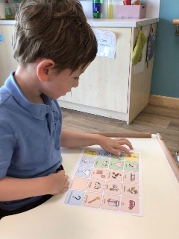
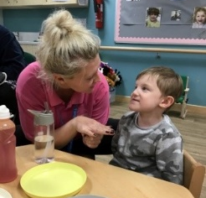
Communication and Language: we use a Total Communication approach to help children to develop early communication skills (including listening, attention and receptive understanding) with an overall aim to establish at least one form of expression communication e.g. Makaton, eye pointing, use of symbols. Staff model core vocabulary related to curricula activities and teach terminology relating to the underlying concepts of safety.
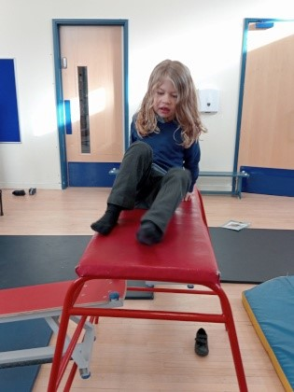
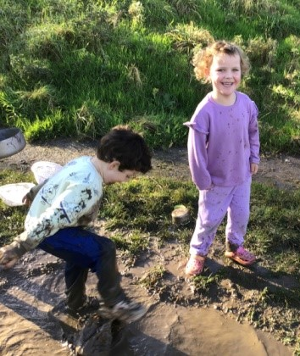
Physical Development: children are encouraged to become more aware of their own bodies and are given the opportunity to experience a range of gross motor movements through activities such as dance and sensory workouts. We aim for each pupil to become more confident in their physical ability and provide access to a range of specialist equipment, and work with physiotherapists to deliver individual physio programmes. We set up regular opportunities for children to develop and refine their fine motor skill through engaging in a range of fun, hands on play based activities.
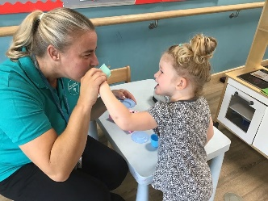
Personal, Social and Emotional Development: children are encouraged to form positive and secure relationships with staff and their peers, with a particular emphasis placed on emotional wellbeing. Children are taught about their emotions through play, songs and stories. Behaviour for Learning is embedded across the whole curriculum, with the overall aim for children to develop the skill required to access more formal learning higher up the school. Children are introduced to self-help tasks; working towards becoming less reliant on adult support. This includes teeth brushing, feeding and drinking skills.

In addition to this, children will also be given the chance to experience learning in the 4 Specific Areas of Leaning: (Literacy, Maths, Understanding the World and Expressive Art and Design) which starts at a sensory play level and progresses onto more structured activities and programmes as the child develops their readiness for learning skills.
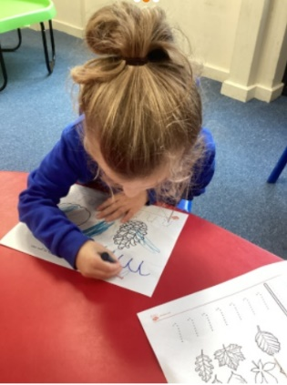
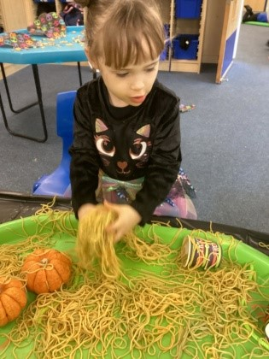
The curriculum is delivered through a range of child-initiated and adult-led activities. This includes exploratory and sensory play, imaginative play, water and sand play, physio, OT and SaLT programmes, music and songs, stories and art. Every term, each Early Years class chooses a story (in line with the children’s interests) and uses this as a focal point which helps to bring the curriculum to life in a way that is meaningful to the children.

How Does This Look in Practice?
When walking into an Early Years classroom, you will see:
Children | Adults | Environment
Engaged in play | Following pupil’s interests | An exciting and motivating learning space
Leading their own learning | Joining in with play | Interesting resources that have been selected in response to individual needs
Exploring their surroundings | Interacting with children | Individual communication aids
Making choices | Modelling skills and core vocabulary | Displays sharing the children’s engagement in learning
Interacting with others | Responding to children’s emotional needs | Clearly labelled resources
Listened to by adults | Working 1:1 with children on focused activities | A freely accessible outdoors space
Comforted when upset | Encouraging children to engage in activities | Materials to facilitate a variety of play experiences
Carrying out tasks independently | Providing individual support when needed | A daily visual timetable
Having fun! | Instilling a ‘can do’ attitude | An accessible calm and quiet space
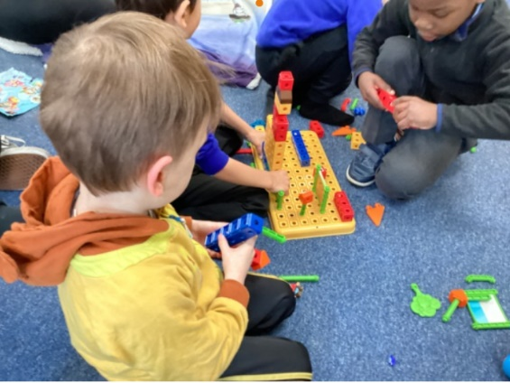
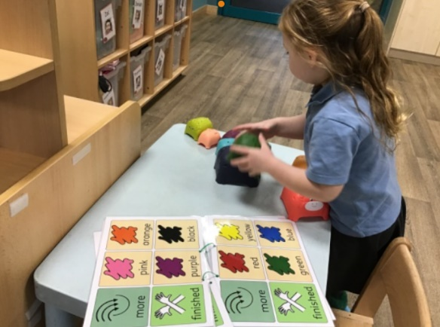
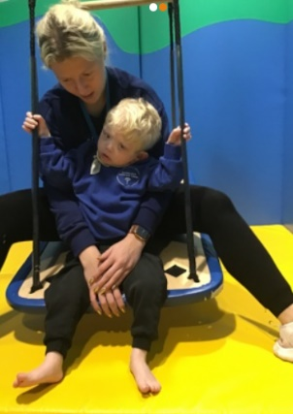

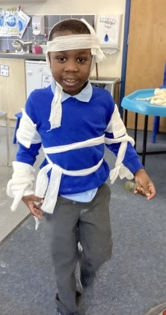
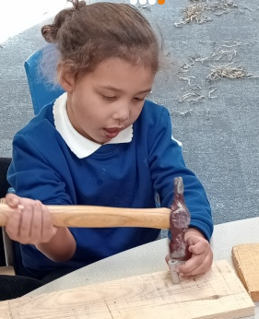
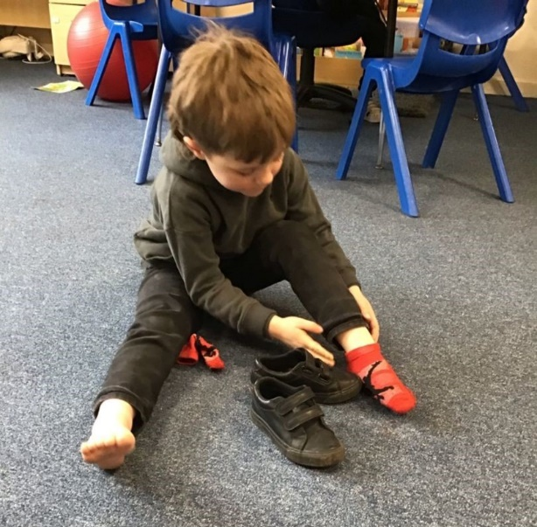

Pedagogy

We ensure that we provide high quality teaching and learning in Early Years through:

Once these key principles have been established, adults can facilitate learning during both adult-led and child-initiated activities. When following the lead of the child, adult will use a scaffolding approach to take the learning forward through use of modelling and questioning. During more structured times, adults can use their knowledge of the child to focus on pre-established ‘next steps’ or targets.
By really getting to know and understand each child, we are able to determine how they learn, which helps us to identify barriers to learning and ways in which to support each child. We spend lots of time observing children, finding out about their learning styles and track their development using our own adapted Early Years assessment tracker. By accurately pinpointing where each child is at in terms of their development allows us to then create personalised learning opportunities. The learning environment is also adapted according to identified needs and in consultation with professionals from the wider multi-disciplinary team e.g. Visual Impairment Teacher, Therapists and families and carers.
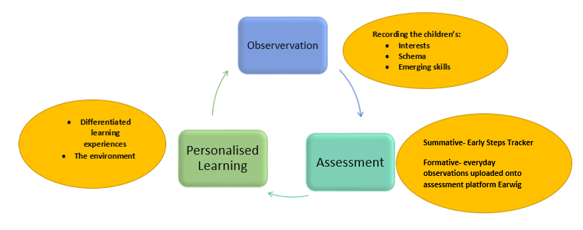

We help children to understand their own learning styles and strengths through use of specific praise; letting the child know what led to them becoming successful (and back this up through use of symbols or Makaton). We promote metacognition in Early Years by introducing mental vocabulary and empathetic awareness though stories and we create regular opportunities for structured dialogues that address concepts such as ‘think’ and ‘remember’. Children are also given the chance to develop their thinking skills through symbolic and pretend play as well as being given time each day to reflect on their experiences.

