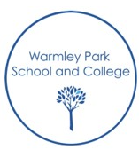
Warmley Park Reading Journey
EYFS | KS1 | KS2 | KS3 | KS4 | KS5
Supporting pupils to develop a love of reading – engaging and sharing books, sensory stories, listening to stories.
Teaching of early reading behaviours and reading strategies to support the development and progress in reading.
First Skills for learning Framework, Early reading skills & Level 1 phonics  Learners at this stage will use the First Skills for Learning Framework and Warmley Park Early Phonics and Reading progression skills document. These documents support the teaching and planning of next steps. |  |  |  | Functional reading for communication and Independence  Learner’s individual EHCP Medium term targets will inform termly targets. | Functional reading for communication and Independence  Learner’s individual EHCP Medium term targets will inform termly targets.  Learning Pathways  Preparing for adulthood objectives including reading in the community, workplace etc.
Level 2/ 3/ 4/ 5/ 6 Twinkl phonics
Warmley Park uses accredited phonics programme as a guideline to support Warmley Park’s systematic synthetic phonic approach to delivering and teaching phonics for reading.

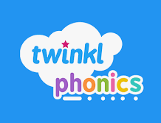

Symbol or whole word Readers
Learners at this stage will follow the ‘See and Learn’ programme. Learners’ progress will be assessed and next steps will be planned for using this document for guidance.
Proficient Reader

