09th December 2020

Dear parents/carers

Yesterday, the Department for Education sent out advice to all education providers that face to face teaching could end on Thursday 17th December. South Glos CAH department have stated ‘we would advise putting in place a remote learning offer for the Friday rather than introducing an inset day.’ The rationale for this is that ‘Public Health England have agreed a 6 day window after the final day of teaching in which schools and further education providers are asked to remain contactable so they can assist with contact tracing when necessary. This will allow enough time for positive Covid-19 cases to be identified and confirmed by a test and for relevant contacts in the education setting to be traced.’

In light of this announcement and in consultation with our Chair of Governors and a Strategic Lead in CAH, we have taken the decision to follow this advice and conduct remote learning on Friday 18th December. In essence, this means that the school will be closed and your child’s teacher will be providing home learning packs and Teams sessions during the day which will have a festive theme. Further details about how to join the Teams sessions and the learning that will be provided, will be sent out by individual class teachers.

If you have any questions, please contact the main school office on 01454 867272.
Kind regards
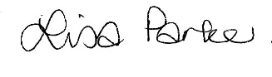

Lisa Parker
Headteacher

