





Build the array with counters.

Complete the sentences.

There are ____ apples in each row.

There are ____ rows.

____+____+____=____

There are ____ apples altogether.

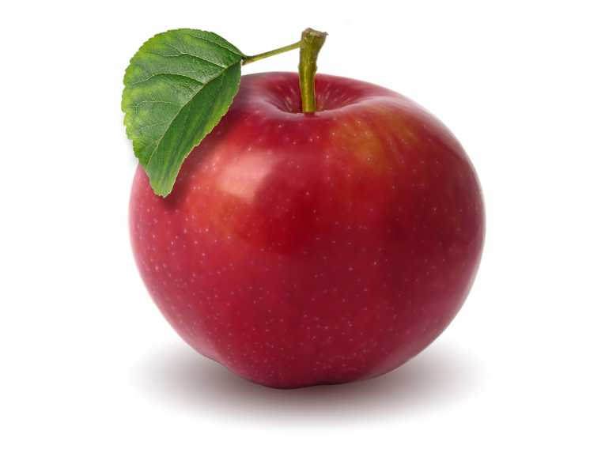





Build the array with counters.

Complete the sentences.

There are ____ apples in each row.

There are ____ rows.

____+____+____=____

There are ____ apples altogether.

Build the array with counters.

Complete the sentences.

There are ____ apples in each row.

There are ____ rows.

____+____+____=____

There are ____ apples altogether.









Build the array with counters.

Complete the sentences.

There are ____ apples in each row.

There are ____ rows.

____+____+____+____=

There are ____ apples altogether.















































Build the array with counters.

Complete the sentences.

There are ____ apples in each row.

There are ____ rows.

____+____+____+____+____

There are ____ apples altogether.

Build the array with counters.

Complete the sentences.

There are ____ apples in each row.

There are ____ rows.

__+__+__+__+__+__=

There are ____ apples altogether.

Build the array with counters.

Complete the sentences.

There are ____ apples in each row.

There are ____ rows.

____+____+____+____+____

There are ____ apples altogether.

Build the array with counters.

Complete the sentences.

There are ____ apples in each row.

There are ____ rows.

____+____+____+____

There are ____ apples altogether.